America’s Revolt

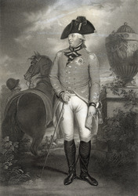
1. Introduction
In 1770, the colonists of New York City erected a large statue of King George III on horseback. The 4,000-pound statue stood in Bowling Green, a public park near the southern tip of Manhattan. It was made of lead and was gilded to shine like pure gold. Over the next few years, the statue dominated the green, symbolizing loyalty to the king.

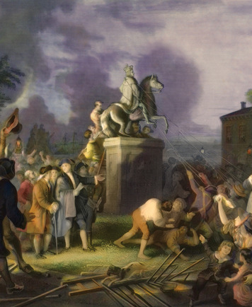
On July 9, 1776, the newly written Declaration of Independence was read aloud at a public gathering in New York City. The reading of the Declaration spelled doom for the King George statue. In a burst of patriotism, angry New Yorkers swarmed Bowling Green. They flung ropes around the statue and pulled it down. They cut off the king's head and set it aside, planning to impale it on a spike later. Then they chopped the rest of the statue into pieces. In the midst of all the chaos, someone stole the head; to this day, it has never been found. Many of the remaining lumps of lead were melted down to make bullets to fire at British soldiers.
What caused the conversion of these colonists from loyal British subjects to unruly vandals? Actually, their change in attitude was gradual and cumulative. Trouble had been brewing in the colonies for years.
By 1776, most colonists belonged to one of three groups, based on their views of British rule. One group was the Loyalists, who staunchly supported the British government. A second group was the Patriots, who opposed British rule and believed the colonists should separate from Britain immediately and by any means necessary. These were the people who tore down the statue of the king. The third group was the Moderates. The Moderates were unhappy with aspects of British rule, but they were cautious about the possible effects of severing ties with Britain. They hoped that the problems could be resolved peacefully. A peaceful solution was a tall order, though, given the growing antagonism between Britain and the colonies.

2. The Road to Revolution
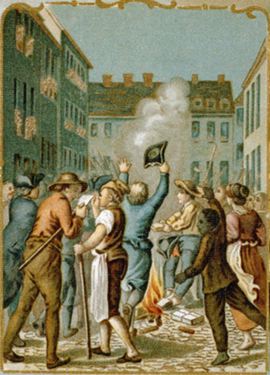
The toppling of the King George statue came on the eve of the American Revolution. But there had been discontent in the colonies for more than two decades. Some problems dated back to a war that took place in North America from 1754 to 1763. That war was part of a worldwide struggle between France and Britain for territory and power. Because many American Indians fought on the side of France, colonists called it the French and Indian War. Britain won the war, but that victory set it on a collision course with its 13 American colonies.
Britain Imposes New Regulations and Taxes
Britain now had to control a much larger empire in North America and wanted to prevent further conflict with the tribes who had been France's allies. Therefore, Parliament passed the Proclamation of 1763, which declared that colonists could not settle west of the Appalachian Mountains. However, many colonists continued to move west.
To help keep peace on the western frontier, Britain built a long chain of forts and sent more troops. It thought the colonies should help pay for this protection, but the colonists believed they could defend themselves. They also mistrusted having a large British army in their midst during peacetime.
Nevertheless, Parliament decided to raise revenue from the colonies to pay for the troops. At the time, citizens in Britain paid heavier taxes than they did in the colonies, and Parliament thought the colonists should pay their share. In 1764, it passed the Sugar Act, which placed customs duties on sugar and other non-British imports. In the past, such sales taxes were designed to regulate trade and encourage colonists to buy British goods. Also, these taxes were not enforced. The Sugar Act was the first tax by Parliament that was enforced by Britain. Colonial protests were limited, though, because the law mainly affected merchants in New England and the Middle Colonies.
In 1765, however, Parliament caused an uproar throughout the colonies by taking a new step to raise revenue. It passed the Stamp Act [Stamp Act: an act passed by Parliament in 1765 requiring colonists to pay a stamp tax on newspapers and documents; the first direct tax imposed on the colonies, prompting protests of "no taxation without representation"] , which required colonists to buy a stamp for every piece of paper they used. Newspapers and documents had to be printed on stamped paper. Even playing cards had to carry a stamp. Stamp taxes were already common in Britain, but this was the first stamp tax that Parliament levied on the colonists. Furthermore, unlike the Sugar Act, the Stamp Act affected a wide range of people throughout the colonies.
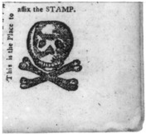
The colonists argued that as British citizens they could be directly taxed only by their elected representatives. They were represented in the colonial legislatures but not in Parliament. They recognized that Parliament could regulate trade, but they saw its direct taxes as tyranny [tyranny: the unjust use of government power] , or unjust use of government power. Patrick Henry, a Virginia lawyer and legislator, railed about "dying liberty." "No taxation without representation!" became the rallying cry for colonial protests.
After months of colonial unrest, Parliament repealed the Stamp Act in 1766. At the same time, however, it passed the Declaratory Act reaffirming its right to govern the colonies. The act stated that the colonies "have been, are, and of right ought to be, subordinate unto, and dependent upon the imperial crown and Parliament of Great Britain." Parliament declared that it could make laws binding the colonies "in all cases whatsoever." Over the next several years, it imposed new taxes and regulations, causing colonial resentment to rise.
The Colonies Increasingly Resist British Authority The colonists were not used to Parliament asserting its authority. For 150 years, Britain had maintained an unofficial policy of salutary neglect, or healthy disregard, letting the colonies pretty much run themselves. While each colony had a royal governor, it also had its own legislature, laws, and taxes. Although the colonists were subject to British laws, they often ignored the inconvenient ones. During this long period, they had come to believe that they had the ability and right to manage their own affairs.
In 1767, Parliament passed the Townshend Acts, a set of customs duties on British glass, lead, paints, paper, and tea. Since the colonists had admitted Britain’s right to regulate trade, Parliament thought they had little reason to protest. However, these duties were intended to raise revenue, so the colonists saw them as direct taxes in disguise. Samuel Adams of Boston was one of the key leaders who rallied colonists to defy the British.
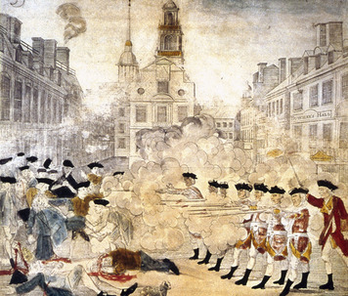
One main form of protest was a boycott [boycott: a peaceful protest in which people refuse to buy or use certain goods] . This was a peaceful protest in which people refused to buy or use British goods. By boycotting British goods, the colonists hoped to influence British merchants to put pressure on Parliament to change its policies.
Relations with the British were very tense in Boston. On March 5, 1770, a group of residents confronted British soldiers on the street. A fight broke out, and the soldiers opened fire, killing five colonists. Samuel Adams called the killings a massacre. Paul Revere, a local silversmith, made an engraving that showed soldiers firing at peaceful, unarmed citizens. Prints were distributed throughout the colonies, and the event became known as the Boston Massacre.
On the same day as the Boston Massacre, Parliament repealed most of the Townshend duties, partly in response to colonial boycotts. Parliament retained the tea tax, though, to reaffirm its authority. The repeal of most of the Townshend duties appeased many colonists, so tensions died down. Adams tried to keep the spirit of protest alive, however, by organizing groups of letter writers—known as committees of correspondence [committees of correspondence: groups of letter writers who spread news about British actions throughout the colonies] —to spread news about British actions to towns throughout Massachusetts. Eventually, committees of correspondence formed in every one of the colonies.
In 1773, Parliament unintentionally sparked new protests by passing the Tea Act, which gave the British East India Company the sole right to sell tea in the colonies. The act was intended to help the struggling company, but angry colonists saw this complete control of the tea trade as a threat to colonial merchants. Committees of correspondence spread the word to boycott the company’s tea. Some colonists took stronger action by destroying tea shipments, most famously in Boston. On the night of December 16, men dressed as Mohawk Indians boarded three British tea ships in Boston Harbor. They broke open the tea chests and threw about 90,000 pounds of tea into the water.
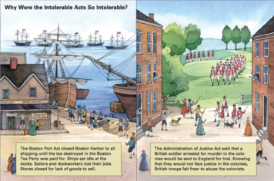
This protest, which became known as the Boston Tea Party [Boston Tea Party: the dumping of tea in Boston harbor in 1773 to protest the Tea Act] , brought down the wrath of the British government. In 1774, Parliament passed a series of laws so harsh that the colonists called them the Intolerable Acts [Intolerable Acts: laws passed by Parliament in 1774 to punish Massachusetts for the Boston Tea Party by closing Boston harbor, shutting shown civilian courts, forcing colonists to house British troops, and placing the colony under the rule of an appointed governor] . These laws closed Boston Harbor, shut down the civilian courts, and placed Massachusetts under firm British control. More troops were sent to Boston.
These measures prompted anger throughout the colonies. George Washington, a Virginian, called the policies “repugnant to every principle of natural justice.” Many men and women throughout the colonies began to think of themselves firmly as Patriots working together to oppose British rule.
The Fighting Begins After the Intolerable Acts, the colonists organized another boycott of British goods. They also began to set up militias [militias: groups of citizens who volunteer to be soldiers during emergencies ] . These were groups of men, mostly local farmers and laborers, who volunteered to be soldiers during emergencies. In New England, the militias called themselves Minutemen because they claimed that they could be ready to fight in 60 seconds.

4. Fighting for Independence
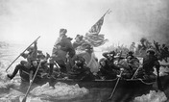
At the war's start, the Patriots' prospects were not promising. Britain had a professional, well-trained army of about 40,000 soldiers. It also employed 30,000 German mercenaries [mercenaries: a professional soldier for hire] , professional soldiers for hire. The Continental Army, on the other hand, was constantly short of soldiers. General Washington seldom had more than 20,000 troops at one time. He had to supplement his regular troops with militia forces. Many of them would fight for a while and then go home to take care of their farms and families.
The Americans Get Off to a Shaky Start In the summer of 1776, it looked as if Britain might force a quick end to the war. Soon after the Declaration of Independence was signed, the British massed their forces for an attack on New York City. Washington's army tried to hold them off, but the outnumbered, inexperienced Americans were no match for the British professionals. Suffering heavy losses, the Continental Army was forced to retreat.
The battle for New York City was the first of many American losses in the weeks that followed. Time and again, the Americans had to pull back as British forces pursued them out of New York, through New Jersey, and across the Delaware River into Pennsylvania.
By December 1776, Congress had fled Philadelphia in despair. Many of Washington's troops had gone home. Of the few thousand who were left, many were weak and ill. But Washington would not give up. Instead, he planned a surprise attack on German mercenaries wintering in Trenton, New Jersey.
Late on December 25, about 4,000 Americans crossed the ice-choked Delaware River to march on Trenton. There they took the 1,400-man force of Germans by surprise. The mercenaries surrendered after only a brief fight. A week later, the Americans defeated a British force at Princeton, New Jersey. Nathanael Greene, one of Washington's most trusted officers, wrote modestly to Thomas Paine, "The two late actions at Trenton and Princeton have put a very different face upon affairs." Indeed, the two victories gave Americans hope that the cause of liberty was not dead.
Military Strategies Evolve As the war continued, military leaders on both sides developed new strategies. After his losses around New York, Washington avoided large battles that could put his army at risk. He fought a defensive war by trying to wear out the British rather than soundly defeat them.
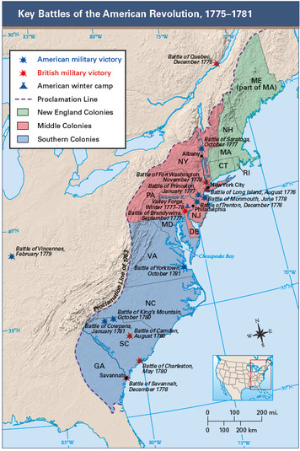
The new British strategy was to cut New England off from the rest of the colonies by taking control of New York's Hudson River valley. To do this, Britain sent General John Burgoyne with about 8,000 men south from Canada to Albany, New York. Burgoyne's troops were supposed to join up there with a second British column of about 2,000 men sent to Albany from the west.
Victory at Saratoga Brings Foreign Assistance Burgoyne's march was dogged by problems. The army's route crossed rugged terrain, and the heavily laden troops had to chop down trees, build bridges, and lay out log roads through swamps. Along the way, there were several battles with militias.
When the British reached Saratoga Springs 30 miles north of Albany, militia troops were there to meet them. Meanwhile, British reinforcements from New York had failed to arrive. Finding himself surrounded, Burgoyne surrendered on October 17, 1777. This decisive American victory in the Battle of Saratoga [Battle of Saratoga: the decisive American victory in 1777 that was a major turning point in the revolution, prompting France and Spain to enter the war against Britain] was a major turning point in the revolution. Until then, the Americans had fought alone. The defeat of Burgoyne encouraged France to enter the war against Britain. French support became critical to the revolution's success.
Washington's Army Winters at Valley Forge In the winter of 1777–78, the British still occupied Philadelphia. Washington and his army made camp at nearby Valley Forge, Pennsylvania. During that harsh winter, about one fourth of Washington's troops—2,500 men—died from disease and exposure.
Still, Washington held his ragtag army together and continued to train them for battle. When the British abandoned Philadelphia to return to New York City, Washington's forces were ready. In June 1778, they attacked the British at Monmouth, New Jersey. The battle was an American victory, and the British escaped to New York. This was the last major clash in the North.
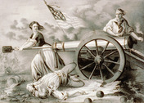
The War Shifts to the South Having stalled in the North, the British turned to the South. In December 1778, they captured the key port of Savannah, Georgia, and gained control over the Carolinas. But they did not keep their grip for long.
Wherever they went, the British were harried by American troops fighting in a style that later came to be called guerrilla warfare [guerrilla warfare: hit-and-run attacks by small, mobile groups of soldiers] . Such fighting features small, mobile groups of soldiers who attack swiftly and then shrink back into the landscape. The South, with its tangle of deep woods and swampy terrain, was perfect for guerrilla warfare. The most successful of these fighters was Francis Marion, known as the Swamp Fox. His band of guerrillas frustrated the British by attacking without warning and quickly fading back into the swamps.
Meanwhile, regular American forces in the South engaged the British. After a long season of battles, Lord Charles Cornwallis, the British commander, brought his troops to Yorktown, Virginia.
In the fall of 1781, American troops converged on Yorktown, joined by French soldiers and naval forces. In total, more than 16,000 troops surrounded the 8,000-man British army. The Battle of Yorktown [Battle of Yorktown: the American victory in 1781 that ended the revolution] began on October 6 and lasted about two weeks. On October 19, 1781, Cornwallis surrendered.
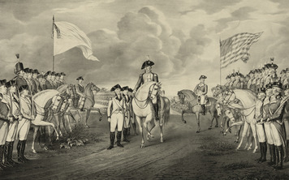
The War Ends Yorktown was the last battle of the war, but it took Britain several months to accept defeat. Peace talks began in Paris in 1782, and in September 1783, American and British representatives signed the Treaty of Paris, ending the war. In this treaty, Britain recognized American independence. It also gave up its claims to all lands between the Atlantic coast and the Mississippi River, from Canada south to Florida.
Victory had come at a great cost. At least 6,500 Americans were killed in combat, while another 10,000 died from disease. An additional 8,500 died as British prisoners.
Even so, most Americans savored their victory and looked forward to healing the nation's wounds. That was a big challenge in itself. But Americans faced an even larger and more daunting task: to begin creating a society that embodied the ideals of liberty, equality, and opportunity set forth in the Declaration of Independence. As a first step, they would struggle with the practical issues of forming a government based on the consent of the governed.

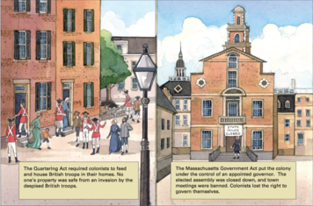
On the evening of April 18, 1775, the Minutemen were called into action. About 700 British soldiers were marching from Boston to seize a stockpile of Patriot munitions in Concord, Massachusetts. In the early morning, they reached the village of Lexington, where 70 to 80 Minutemen were waiting for them. No one is sure who fired first, but a shot rang out. The British then unleashed a volley of bullets, killing 8 colonists and wounding 10.
The British continued six miles to Concord, where they ran into several hundred Minutemen. In a short battle at Concord’s North Bridge, the colonists routed the British and sent them fleeing back to Boston. During their retreat, the British were constantly assaulted, losing over 200 men. News of the battles quickly spread throughout the colonies. Within days, militia troops by the thousands were camped around Boston, daring the British to fight again.

Summary
Beginning in the 1760s, many American colonists grew increasingly unhappy with British rule. Eventually they rebelled and declared independence. During the revolution, American forces wore down and defeated the larger and more experienced British army. In 1783, the United States became an independent country.
The Stamp Act After the French and Indian War, Britain passed the Stamp Act to raise revenue in the colonies. Protests against "taxation without representation" led to its repeal.
Differing loyalties Patriots like Samuel Adams resisted all efforts by the British to exert more control over the colonies. Loyalists, in contrast, supported British rule. Moderates had mixed feelings but hoped the differences with Britain could be settled peacefully.
The Intolerable Acts Following the Boston Tea Party, Britain cracked down on resistance with laws known in the colonies as the Intolerable Acts. Boston became an occupied city.
Lexington and Concord Tensions between colonists and British troops in Massachusetts led to armed conflict in Lexington and Concord. These battles helped spark a wider war.
Declaration of Independence On July 4, 1776, the Continental Congress approved the Declaration of Independence. It asserted that the colonies were "free and independent states."
Saratoga The Continental Army suffered defeats in the early days of the war. But victory at Saratoga in 1777 turned the tide and brought France into the war as an American ally.
Yorktown The British defeat at Yorktown in 1781 ended the long war. Two years later, Britain recognized American independence in the Treaty of Paris.

