An Enduring Plan of Government

1. Introduction
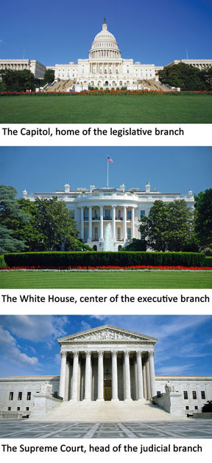
On September 17, 2003, the nation's leaders met in the Rotunda of the National Archives building in Washington, D.C. The heads of the three branches of the national government were there. The leaders of the Senate and the House of Representatives represented the legislative branch. The president represented the executive branch. The chief justice represented the judicial branch.
These leaders were attending a ceremony to celebrate the unveiling of some newly restored historical documents. The documents had been carefully preserved with the latest tools and technology. They rested on cushions of handmade paper and were encased in frames of titanium and aluminum. They were further protected by sapphire windows, traveling light beams, and precisely positioned mirrors set up to detect any changes that could harm the documents.
Why were these documents given such importance? They are the "Charters of Freedom" upon which our government was founded: the Declaration of Independence, the Constitution, and the Bill of Rights. In a speech at the unveiling ceremony, President George W. Bush said, "The courage of America's first leaders gave us the Declaration. Their patience and wisdom gave us the Constitution . . . The supreme law of this land is the work of practical minds addressed to practical questions."
When the president spoke of "the supreme law of this land," he was referring to the Constitution. Although this plan of government was written over 200 years ago, its rules and principles still guide our political system. The Constitution has weathered the centuries because it is a flexible, "living document" that can be interpreted and amended to meet changing needs.
An archivist at the ceremony noted why more than a million people a year come to see the Charters of Freedom. It is "not just because they are historical documents," he said, "but because they are a living part of the democracy we live in today."

2. A Strong Yet Balanced Government
In 1789, Benjamin Franklin wrote, "Our new Constitution is now established, and has an appearance that promises permanency; but in this world nothing can be said to be certain except death and taxes." Franklin's words were prophetic, but they also sounded a note of caution. While our constitutional government has survived for more than two centuries, there is no guarantee that it will continue to endure. Its survival depends on our upholding the principles of the Constitution.
The framers of the Constitution worked hard to set up a political system that would last. They wanted a government that was strong enough to govern, but not so strong that it endangered citizens' freedoms. They also wanted ordinary Americans to understand and support the Constitution. For this reason, they organized it very carefully.
The Constitution has three parts. The first part, the Preamble [Preamble: the first part of the Constitution, which states the purposes of the new plan of government] , describes the purpose of the document and the government it creates. The second part, the articles, establishes how the government is structured and how the Constitution can be changed through amendments. The third part, the amendments, includes the Bill of Rights and other changes to the Constitution.
The Preamble Establishes the Purposes of the Government A preamble is an introduction explaining the purpose of a document, typically a legal document. The Preamble to the Constitution begins with the phrase, "We the people . . ." These words announce that the Constitution's authority is based on the people themselves. The power to form the government did not come from an existing government, or the states, or a supreme being. "We the people" echoes the idea in the Declaration of Independence that governments should derive "their just powers from the consent of the governed."
The next phrase, "in Order to form a more perfect Union," shows the framers' determination to improve upon the government established under the Articles of Confederation. They wanted the union of states to become stronger so that the states would work together, rather than fight among themselves.
The rest of the Preamble lists goals for the new government. The framers wanted to "establish justice" by creating a government that would establish and carry out fair laws that applied equally to all people. They wanted to "insure domestic Tranquility." In this phrase, "domestic" refers to the internal affairs of the nation. By insuring domestic tranquility, the framers hoped to establish a country of peace and order. They also wanted the government to "provide for the common defense," the protection of the country as a whole against foreign enemies.
The framers wanted the United States to have a society and an economy in which people could thrive and prosper. So they declared that the government should "promote the general Welfare." They also wanted to "secure the Blessings of Liberty to ourselves and our Posterity." By posterity, they meant future generations.
The framers knew that achieving these goals required a strong central government. However, they recognized that the Constitution must also limit that government's powers.
The Articles Define the Powers of Government The Constitution has seven articles. The first three lay out the structures and powers of the three parts of the government: the legislative, executive, and judicial branches.
Dividing the government into three branches sets up a strong central government, yet also distributes power. The system of checks and balances ensures that no branch becomes too powerful. Each branch can limit the power of another. For example, the president can veto a bill, but the bill can still become law if a two-thirds majority of Congress votes to override the veto. In this example, the executive branch checks the power of the legislative branch, which then checks the power of the executive branch.
To give another example, when the Supreme Court rejects a law as unconstitutional, it is checking the power of the legislative and executive branches. Checks and balances also extend to the appointment of key officials. For example, the president's nominations of Supreme Court justices are subject to the Senate's approval.
Through the system of checks and balances, Congress has the power to impeach and convict the president, vice president, and any civilian official of the United States. To impeach [impeach: to charge a government official with an offense committed while in office] an official is to charge that person with an offense committed while in office. Only the House of Representatives can vote to impeach—to accuse an official of committing what the Constitution calls "Treason, Bribery, or other High Crimes and Misdemeanors." However, only the Senate can convict. If the Senate votes by a two-thirds majority to convict, the official is removed from office. Two presidents have been impeached, but neither was convicted.
The Constitution does not only divide power among the three branches of the national, or federal, government. As you will see, it also divides power between the federal government and state governments.

3. The Legislative Branch Makes the Laws
The framers wanted to establish a fair way to make laws and to ensure that lawmakers are accountable to the people. Therefore, Article I of the Constitution defines the basic structure, procedures, and powers of Congress [Congress: the legislative branch of the federal government, consisting of the Senate and House of Representatives] .
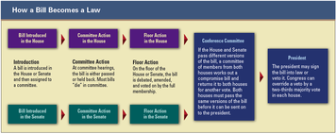
The Structure of Congress To balance the powers of small and large states, the framers set up Congress as a bicameral, or two chamber, legislature. The two chambers are the Senate and the House of Representatives.
The membership of the Senate is based on equal representation of the states. It is made up of 100 senators, two from each state. Senators serve a six-year term.
Representation in the House is based on state population. There are 435 members. Every 10 years, a census determines how that number is apportioned by state. Each state is then divided into congressional districts. As of the 2010 census, the most populous state, California, had 53 districts. In contrast, some states consist of only one district. The people of each district elect one House representative, who serves a two-year term.
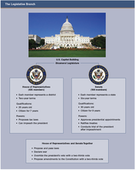
How Congress Does Its Job The main function of Congress is to make laws. Most laws begin as bills, proposals for new laws. Tax bills must begin in the House. Other bills can be initiated in either chamber. If the House and Senate pass a bill, it goes to the president, who has 10 days to sign or veto it. Congress can override a veto with a two-thirds majority vote in each house.
Congressional Powers Article I grants certain powers to Congress. For example, Congress can coin and regulate money, collect taxes, maintain an army and navy, declare war, pay government debts, and regulate foreign trade. In addition, it may "make all laws which shall be necessary and proper" to carry out such powers. This clause has been called the elastic clause because it gives Congress flexibility to fulfill its duties. In 1791, for example, Congress created a national bank to help collect taxes, pay debts, and regulate trade. Some people, however, think that Congress sometimes "stretches" its powers too far.

4. The Executive Branch Enforces the Laws
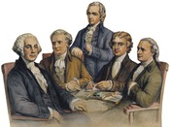
Article II describes the election, powers, and duties of the president. As chief executive, the president is the head of the largest branch of the federal government. Under the Constitution, the president and the rest of the executive branch must "take Care that the Laws be faithfully executed."
Powers of the Chief Executive In addition to enforcing laws, the president proposes legislation, including the annual federal budget. As commander in chief, the president is head of the military and has considerable authority in war. The president also oversees foreign relations, a power that includes making treaties and appointing ambassadors with the Senate's consent. The president's judicial powers include appointing Supreme Court justices, again with Senate approval, and granting pardons to people who have broken federal laws.
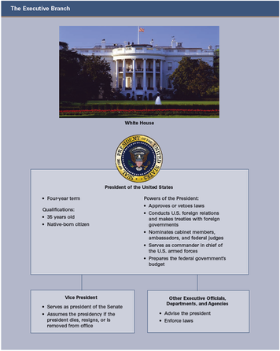
The Role of Other Executive Officials, Departments, and Agencies Many other officials help carry out executive duties. The vice president, the White House staff, and other close advisors help the president make key policy decisions. The president also gets advice from the cabinet, a group that consists mainly of the heads of executive departments that enforce the laws. These department heads, such as the secretary of state and attorney general, are appointed by the president and approved by the Senate. Their number has risen from four in George Washington's first cabinet to 15 today.
Cabinet members advise the president on policy matters relating to their departments. For example, the secretary of state gives advice on foreign affairs, and the secretary of labor advises on polices relating to the workplace. Some other executive departments are those of defense, education, agriculture, transportation, and energy. One of the newest is the Department of Homeland Security, created to prevent terrorism and respond to natural disasters.
Within each executive department are agencies that address different issues. For example, the Centers for Disease Control and Prevention (CDC), the Food and Drug Administration (FDA), and the National Institutes of Health (NIH) are three agencies within the Department of Health and Human Services.
There are also independent agencies outside the executive departments. Some are executive agencies that report to the president, such as the National Aeronautics and Space Administration (NASA). Others are regulatory commissions formed by Congress, such as the Consumer Product Safety Commission (CPSC). Other semi-governmental agencies, such as the U.S. Postal Service, provide specific services.

5. The Judicial Branch Interprets the Laws
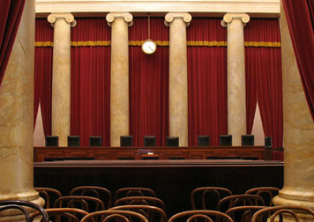
The judicial branch interprets the Constitution, the "supreme Law of the Land." Article III establishes the Supreme Court and gives Congress authority to set up "inferior," or lower, federal courts. The Supreme Court and lower federal courts make up the federal judiciary [federal judiciary: the federal court system, consisting of the Supreme Court and lower federal courts] , or federal court system.
The Federal Judiciary The federal courts have been called "the guardians of the Constitution" because they judge whether laws and actions conform to constitutional principles. However, a court may address a legal issue only if a relevant case comes before it. It cannot try to solve legal problems on its own.
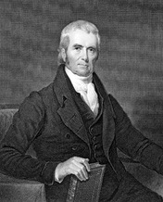
Most legal disputes involve state and local laws and are addressed in the state court systems. The federal court system hears cases involving issues that are not limited to one state, such as violations of the U.S. Constitution or federal laws. Other examples are cases in which the United States, a state, or a foreign nation is a named party.
Most federal cases are first heard in the lower courts, starting with a U.S. district court. That court's decision can be appealed to a U.S. court of appeals. The final appeal is to petition the Supreme Court to hear the case. The Supreme Court may also choose to hear an appeal of a state supreme court decision involving a state or local law. Such cases usually raise an important constitutional issue affecting the nation as a whole.
Higher courts agree to hear an appeal only when they believe that a lower court may have incorrectly applied the law. The appeal process does not involve witnesses or juries. Instead, an appeals court reviews a case based on court records and oral arguments from attorneys and then makes its decision.
The Supreme Court The U.S. Supreme Court is the highest court in the land. It consists of nine justices, including a chief justice. Like other federal judges, they are appointed for life, and their salaries cannot be lowered. The framers wanted to ensure an independent judiciary [independent judiciary: a system in which judges cannot be removed or have their salaries reduced for making unpopular decisions] —a system in which judges cannot be removed or have their salaries reduced for making unpopular decisions.
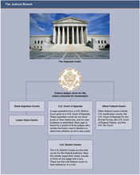
The Supreme Court is the last stop in the judicial system. Its decisions are final and binding on lower federal courts and on state courts. Every year, it receives about 7,000 petitions to hear cases and accepts about 100 to 150. Its rulings become precedents [precedent: a court decision used as a guideline in deciding similar cases] , court decisions used as guides in deciding similar cases. State courts, lower federal courts, and the Supreme Court itself are guided by precedents set by Supreme Court decisions.
The Power of Judicial Review A key authority exercised by the Supreme Court is judicial review, the power to review an action of the legislative or executive branch and declare it unconstitutional. This power stems from an 1803 Court case, Marbury v. Madison, in which the Court overturned an act of Congress. In that case, Chief Justice John Marshall ruled that Congress, in passing the law, had acted outside the bounds of its constitutional power. Judicial review has sparked debate over the years. Some argue that the Court should take an active role in making policy by overturning laws, whereas others urge restraint.

6. Federalism: A System of Divided Powers
As you have seen, the Constitution defines different powers for the legislative, executive, and judicial branches of the federal government. The Constitution also establishes the principle of federalism [federalism: the division of power between the federal and state governments] , the division of power between the federal and state governments. Both the federal and state governments have some exclusive powers of their own, while sharing others.
Click to read caption
The Powers of the National Government Article I, Section 8, lists the powers granted to Congress and therefore to the national government. Among these delegated powers [delegated power: a power that the Constitution delegates, or grants, to Congress and therefore to the national government] are the powers to borrow money, coin money, raise an army and navy, declare war, make treaties, establish post offices, and protect patents and copyrights. The elastic clause enables Congress to make laws necessary to carry out these and other delegated powers.
Some of the delegated powers are given to the national government alone and specifically denied to the states. For example, only Congress has the power to coin or print money. The framers wanted to avoid the monetary confusion that existed under the Articles of Confederation, when many states produced their own currency. Also, it is appropriate that only the national government can declare war or make treaties with other nations. Another example is the power to regulate trade with other nations and between the states. By regulating interstate commerce, Congress helps to create a national market with few internal barriers to trade and finance.
The Powers of the States The Constitution is much less specific about state powers. In fact, the only power specifically granted to the states, in Article V, is the power to ratify amendments. On the other hand, Article I specifies those powers that are denied to the states, including taxing imports or exports without the consent of Congress, coining money, and making treaties.
During the ratification debates, many Americans expressed concern that the lack of delegated state powers in the Constitution might leave the federal government with too much power. This concern resulted in ratification of the Tenth Amendment, which declares, "The powers not delegated to the United States by the Constitution, nor prohibited by it to the States, are reserved to the States respectively, or to the people." In other words, any power not expressly granted to the national government would remain with the states and the people. These powers are called reserved powers [reserved power: a power that the Constitution does not delegate to Congress or deny to the states and is therefore reserved to the states or the people] .
Reserved powers include those that are appropriately handled at the state or local level. Providing police and fire protection, establishing schools, and regulating businesses within the state are all reserved powers. So are issuing marriage and driver's licenses, conducting elections, and establishing local governments.
Article IV says that states must give "full Faith and Credit" to the laws and decisions of other states. This means that states, for the most part, must accept the legal documents and actions of other states. States also have certain responsibilities to each other. For example, they must allow a child born in another state to attend their public schools. They must also help each other track down criminals.
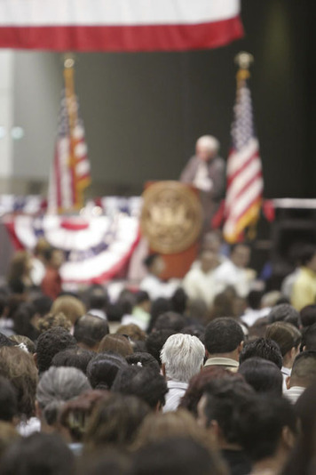
Shared Powers of the Federal and State Governments Some of the powers delegated to Congress are not denied to the states. These are called concurrent powers [concurrent power: a power that the Constitution delegates, or grants, to Congress but does not deny to the states] because the federal government and the state governments can independently exercise them at the same time. For example, the federal and state governments both collect taxes. Both build roads, establish courts, borrow money, make and enforce laws, and spend money for the general welfare.
Their overlapping responsibilities often require the state and federal governments to work together. For example, Congress sets the date for national elections, and the states register voters and run the elections. The states count the ballots, and Congress organizes the Electoral College vote. Federal and state officials also coordinate efforts to provide such services as law enforcement and disaster relief.
The sharing of power can also create conflict between the federal and state governments. The Constitution provides the general framework for concurrent powers, but it does not spell out every one of them. Nor does it resolve all the issues that arise when powers are shared. Through the years, the system of shared powers has evolved through new laws, amendments to the Constitution, and court decisions.
The Law of the Land Article VI contains a very important clause that declares, "This Constitution, and the Laws of the United States . . . shall be the supreme Law of the Land; and the Judges in every State shall be bound thereby, any Thing in the Constitution or Laws of any State to the Contrary notwithstanding." Since this clause affirms that the Constitution and federal laws are the supreme law of the land, it is often called the supremacy clause [supremacy clause: the constitutional clause affirming that the Constitution and federal laws are the supreme law of the land] .
The supremacy clause establishes that federal law must be followed in cases involving a conflict between federal and state law. A state's constitution, laws, and judicial decisions cannot conflict with the U.S. Constitution or with the laws and treaties of the United States.

7. Amending the Constitution
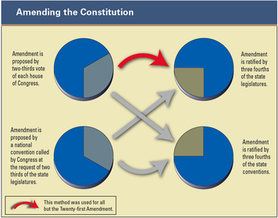
The framers knew that the Constitution would have to change over time to remain relevant and useful to succeeding generations. As Thomas Jefferson wrote, the Constitution "belongs to the living and not to the dead."
Changing the Constitution Even before the Constitution was ratified, there were calls for amendments, especially in the form of a bill of rights. Article V sets up a procedure for amending the Constitution. The framers wanted to keep the government long lasting and stable, though, so they made changing the Constitution difficult.
There are two ways to propose amendments to the Constitution. Congress can propose an amendment with a two-thirds vote in each house. Alternatively, two thirds of state legislatures can ask Congress to call a national convention to draft an amendment. Either way, an amendment must have the approval of three fourths of the states to become part of the Constitution.
The Bill of Rights When ratifying the Constitution in 1788, five states included a list of amendments they wanted added to the document. Many other states and individuals also agreed that certain amendments were necessary. The main demand was for the explicit protection of individual liberties and freedoms.
The new Congress listened to the concerns of the states and the people. James Madison then put together a set of constitutional amendments. By 1791, 10 amendments protecting rights had been ratified, becoming part of the "supreme Law of the Land." They are known as the Bill of Rights.
Many people consider the First Amendment to be the most important amendment in the Bill of Rights. It protects five freedoms: the freedoms of religion, speech, the press, and assembly, and the right to petition the government.
The next three amendments are designed to protect citizens from abuses of power by the federal government. The Second Amendment refers to the necessity of a "well-regulated militia" and to "the right of the people to keep and bear arms." Debate continues over whether this right was meant to apply to individuals or to members of a state militia. The Third Amendment states that homeowners cannot be forced to provide room and board to members of the military in times of peace. The Fourth Amendment guards against unreasonable searches, seizures of property, and arrests.
The next four amendments lay out rights and protections for people who are accused of crimes or are involved in other legal disputes. The Fifth Amendment is the longest one in the Bill of Rights. It says that people cannot be held for committing a crime unless they are properly indicted, or charged. It states that no person can be tried twice for a crime if the punishment is "loss of life or limb." People cannot be forced to testify against themselves, and they cannot be deprived of life, liberty, or property without "due process of law." Finally, it says that the government cannot take private property without paying a fair price for it.
The Sixth Amendment guarantees the right to a speedy and fair trial in criminal cases. The Seventh Amendment ensures the right to trial by jury in certain types of federal civil cases, those involving disputes between people or businesses. The Eighth Amendment prohibits cruel and unusual punishments and forbids courts to impose excessive bail or fines.
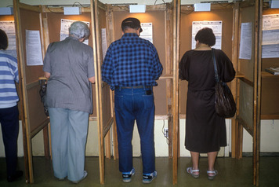
The last two amendments are quite general. The Ninth Amendment says that the people have other rights in addition to those listed, and that those rights must not be violated. The Tenth Amendment says that powers not delegated to the federal government belong to the states or to the people.
Further Amendments Thousands of additional amendments have been proposed over the years, but only 17 have been ratified, bringing the total number of amendments to 27. One amendment—the Eighteenth, which banned the making and selling of alcohol—was ratified and then later repealed by the Twenty-first Amendment.
Four of the additional amendments—the Twelfth, Seventeenth, Twentieth, and Twenty-second—concern the election and terms of office of public officials. Many of the other amendments stem from efforts to expand civil rights and the right to vote. The Thirteenth Amendment abolished slavery. The Fourteenth Amendment confers citizenship on all persons born or naturalized in the United States, thereby barring states from denying citizenship to blacks. This amendment also affirms that all citizens have "equal protection of the laws." The Fifteenth Amendment states that race, color, and previous condition of servitude cannot be used to deny voting rights. The Nineteenth Amendment says that gender cannot be used to deny the vote. Finally, the Twenty-sixth Amendment sets the voting age at 18.

8. Popular Participation in Government
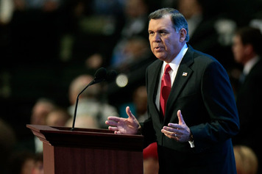
Our nation was founded on the ideal that government should be based on the will of the people. In the early years, "We the People" did not include all members of American society. Today there are many ways for all citizens to have a say in government. Participation is the key to an effective democracy.
"We the People," Past and Present The U.S. government exists to serve its citizens. By electing our local, state, and national representatives and leaders, "we the people" have a say in government.
When "we the people" vote, we are using the principle of majority rule to make decisions. In our early history, with very few exceptions, only white property-owning males could vote. As a result, they were the ones who made the decisions. Today "we the people" includes all citizens, regardless of race, culture, or gender. The diversity of voters now makes the government much more representative of the people.
The Role of Political Parties in Government A political party is an organized group of people who have similar ideas about government. The first two American political parties emerged during the 1790s. One party, led by Thomas Jefferson, wanted to give the states more power, help small farmers, and reduce the size of the federal government. The other, led by Alexander Hamilton, favored a strong federal government that could help businesses. These parties drew more citizens into the electoral process.
Over the years, the names and beliefs of political parties have changed, but typically two parties have been dominant. Since the mid-1800s, the two parties have been the Republican and Democratic parties. Today they largely control American politics, especially at the state and national levels. Even those who consider themselves "independents" often show loyalty to one of the two parties. A candidate has a better chance of winning an election if he or she is a member of one of the two major political parties, rather than a small third party. The two-party system is so dominant that it plays a significant role in shaping public policy.
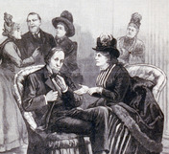
Political Participation Beyond Voting Despite the dominance of political parties, Americans also participate in the political process as individuals. They campaign for candidates they support or run for office themselves. They volunteer with public service organizations. They attend town meetings, public hearings, and demonstrations. They write and promote ballot measures, which are proposed laws or amendments initiated and voted on by the public, not the legislature. They also join committees, organizations, and professional societies.
Some people join special interest groups [special interest groups: an organization whose members share an interest or concern and want to influence policymaking] to make their feelings known to the government. Special interest groups are organizations whose members share a specific interest or concern and want to influence policymaking. Groups like the American Medical Association (AMA), the National Wildlife Federation (NWF), the National Rifle Association (NRA), and the American Civil Liberties Union (ACLU) spend a lot of time and money lobbying the government on behalf of their causes.

Summary
The framers of the Constitution wanted to create a strong yet balanced government that guaranteed individual freedoms.
The "supreme Law of the Land" The Constitution is the supreme legal document of the United States. It consists of three parts: the Preamble, the Articles, and the amendments.
Three branches of government The first three articles establish the legislative, executive, and judicial branches of government. A system of checks and balances ensures that powers are distributed among the branches.
The legislative branch The main function of this branch of government is to enact laws. Congress consists of two houses, the Senate and the House of Representatives. The elastic clause of the Constitution gives Congress the flexibility it needs to carry out its duties.
The executive branch The main task of this branch is to enforce the laws. The president is the chief executive, or head of the executive branch. This branch also includes many other executive officials, departments, and agencies.
The judicial branch The federal judiciary is made up of the Supreme Court and many lower courts across the country. These courts interpret and apply laws in cases that come before them. The power of judicial review allows the Supreme Court to judge whether acts of Congress are constitutional.
Federalism The Constitution establishes a federal system that balances national and state powers, but it grants controlling authority to the national government in its supremacy clause.
The amendment process As a "living document," the Constitution can be amended. The first 10 amendments make up the Bill of Rights. Seventeen more amendments have been added over the years.
Political participation Citizens can participate in government in many ways. They can vote, join political parties, run for office, and exert political influence through public meetings, interest groups, and other means.

