Changes in a Young Nation

1. Introduction
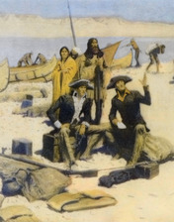
In 1803, two army officers, Captain Meriwether Lewis and Lieutenant William Clark, arrived in the frontier outpost of St. Louis, Missouri. The two men were on a mission from President Thomas Jefferson to explore western rivers for a route to the Pacific Ocean. On the way, they were to collect information about the Louisiana Territory, a huge expanse of land the United States had just purchased from France.
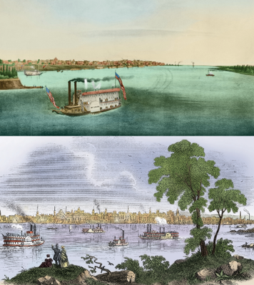
At the time, St. Louis was a sleepy town of around 200 houses, perched on a bluff above the Mississippi River. There were no shops or hotels. The town's residents were mainly French settlers who lived by farming, fur trapping, and trading along the river. Traders would dock their boats by the river's edge and travel the grid of dirt roads that led away from the river.
Very likely, no one in St. Louis in 1803 thought much about what Lewis and Clark's arrival would mean for the little town. However, by opening the West to settlement, Lewis and Clark's expedition brought big changes to St. Louis.
By 1850, St. Louis had grown to a bustling city of more than 70,000. Its ideal location near the junction of the Mississippi and Missouri rivers made St. Louis a center of trade and commerce. Along the waterfront, wharves and brick warehouses replaced the sandy beach where small boats once landed. Dozens of large, paddle-wheel steamboats lined the docks. One visitor wrote, "The whole of the levee is covered as far as the eye can see, with merchandise landed or to be shipped; thousands of barrels of flour and bags of corn, hogsheads of tobacco, and immense piles of lead."
The makeup of St. Louis's population also changed. Once a town of trappers and fur traders, St. Louis now had prosperous merchants and bankers who rubbed shoulders with farmers and workers. Between 1840 and 1860, a wave of immigration from Germany and Ireland reshaped the ethnic mix of the city. St. Louis had become a cosmopolitan city and the "gateway to the West."

2. The First Years of the New Nation
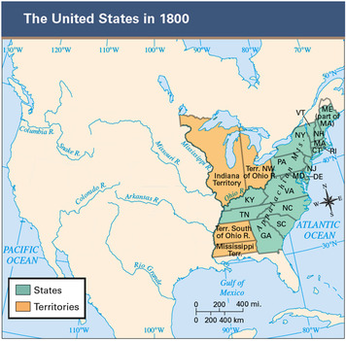
In 1790, the United States was beginning its new life as a nation. It had a Constitution and its first president, George Washington. That year, the government took its first national census and learned that the country had nearly 4 million people. Most Americans were still clustered along the eastern seaboard, but some hardy pioneers had begun to move inland.
The Country Expands Beyond Its Colonial Borders In these early years, the United States was predominantly a rural nation. However, it did have a number of flourishing cities, including the old colonial centers of Philadelphia, New York, and Boston.
The country was also expanding beyond its original 13 states. Between 1790 and 1800, three new states entered the Union: Vermont, Kentucky, and Tennessee. Many settlers were migrating west across the Appalachian Mountains into the area known as the Northwest Territory. This territory would later become the states of Ohio, Indiana, Illinois, Michigan, and Wisconsin. Settlers were also moving into the area of present-day Mississippi and Alabama. By the early 1800s, American settlements were scattered across a large territory, from the Atlantic Ocean in the east to the Mississippi River in the west.
Agriculture Is the Center of the Nation's Economy In states old and new, farming was the nation's most important economic activity. Most Americans farmed on small plots, producing food for themselves and their families. If they produced a surplus, they might sell it in nearby towns or cities.
The United States had little industry at this time. Most farmers made their own clothing and tools. In urban areas, artisans produced manufactured goods by hand in small workshops. In the Northeast, there were a few small textile mills that spun cotton by machine, but large factories did not yet exist.
Lack of good transportation kept most states and regions remote from each other. Moving people or goods across great distances was expensive and difficult. The few roads linking towns and cities were deeply rutted in dry weather and treacherous swamps in wet weather. Most long-distance travel took place on rivers or the ocean.
George Washington Gives Shape to the Office of President When George Washington took the oath of office as the nation's first president in 1789, he faced a delicate task. On the one hand, as he said in his inaugural speech, he was determined to provide Americans with "the benefits of an united and effective government." On the other hand, he had to reassure those "fellow-citizens" who feared a strong president could mean the return of a monarchy. President Washington had no road map, other than the Constitution, to guide him. "I walk on untrodden ground," he said. "There is scarcely any part of my conduct which may not hereafter be drawn into precedent."
The first test of Washington's authority as president came in 1791, when Congress passed a tax on whiskey to raise money. Western farmers, who turned their grain into whiskey for sale, were outraged. Many refused to pay the tax. Angry farmers in western Pennsylvania rose up in rebellion, attacking tax collectors and setting buildings on fire. Washington saw the Whiskey Rebellion as a threat to the federal government's authority. In 1794, President Washington sent a militia force across the Appalachians to stamp out the protests. In doing so, he made it clear that the federal government would enforce its laws.
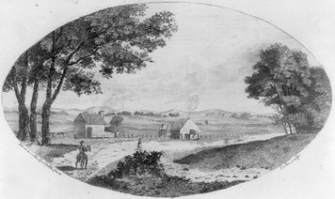
One of Washington's first official actions was to sign Congress's Federal Judiciary Act into law. This act created the federal court system, with its district and circuit courts, that we still live under today. Washington also created the first cabinet, or group of department heads that meets to advise the president.
Political Parties Emerge Washington's most prominent cabinet members were Treasury Secretary Alexander Hamilton and Secretary of State Thomas Jefferson. Both were brilliant thinkers, but their ideas often clashed. "Hamilton and myself were daily pitted . . . like two fighting cocks," Jefferson wrote of their growing hostility. These differences led to the creation of the country's first political parties, the Federalists and the Democratic-Republicans.
Hamilton's Federalist Party supported a strong central government with wide powers. The Federalists believed that a powerful government was needed to keep order among the states. They had little faith in the wisdom of the average citizen and thought that a capable, educated elite should run the country.
In contrast, Jefferson's Democratic-Republican Party favored a small central government with limited powers. The party believed that states had the right to judge whether Congress was overstepping its constitutional powers, a view known as the states' rights theory. The Democratic-Republicans had great confidence in the ability of ordinary people to make good decisions. They also believed that political power should lie with the majority of voters rather than with a wealthy elite.
In general, Washington favored Federalist ideas. Nonetheless, in his Farewell Address, delivered near the end of his second term in 1796, he warned of "the danger of parties" and spoke of "the immense value of your national union to your collective and individual happiness." Once Washington left office, however, debates between the two parties grew increasingly acrimonious.
John Adams, a Federalist, succeeded Washington as president. In 1800, Adams ran for a second term against Thomas Jefferson. During the campaign, partisan feelings ran so high, some worried the new nation might self-destruct. Nevertheless, the 1800 election took place without serious disturbance. Thomas Jefferson won the presidency, and power shifted peacefully from one party to the other. The country had survived a major political test.

3. Geographic Changes
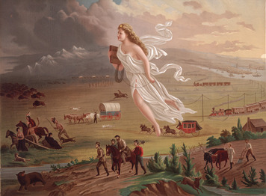
In May 1804, Lewis and Clark set out from St. Louis on their journey to the Pacific Ocean. They paddled up the Missouri River and into the unexplored world of the American West, crossing vast plains and snowcapped mountains. They discovered plants and animals they had never seen before. They encountered American Indian tribes and learned about their ways of life. They even found the remains of a prehistoric dinosaur. Two years and four months later, they were back in St. Louis. The news of their expedition thrilled Americans and helped promote western settlement.
From Sea to Shining Sea: Acquiring the West Much of the area that Lewis and Clark explored was part of the Louisiana Purchase. In 1803, Jefferson had bought the Louisiana Territory from France for $15 million, which was a large sum of money at the time. The Louisiana Purchase Treaty pushed the western boundary of the United Sates from the Mississippi River to the distant Rocky Mountains, at a cost of about four cents an acre.
Many people criticized Jefferson's action. Some thought the country did not need any more undeveloped land. Others protested that the purchase was unconstitutional, because the Constitution did not give the president the power to buy foreign territory. But Jefferson could not pass up an opportunity to double the size of the United Sates. The Louisiana Purchase furthered his vision of an "empire for liberty" stretching from sea to sea.
Many Americans had good reasons for supporting national expansion. The country's population was growing rapidly. Good farmland in the settled, eastern part of the country was becoming less plentiful. As a result, more and more people were moving west in search of cheap land. Many also believed expansion would make the country safer by reducing the threat of foreign invasion from the west. The idea of a larger, more powerful country also appealed to the American sense of nationalism.
This combination of nationalism and expansionism gave rise in the 1840s to a belief known as manifest destiny. The term means "obvious fate," and it seemed obvious to many Americans that the United States was meant to spread its founding ideals and democratic way of life across the continent and beyond. One politician at the time wrote, "Nothing less than a continent can suffice as the basis and foundation for that nation whose destiny is involved in the destiny of mankind."
The idea of manifest destiny inspired further expansion. Spain was persuaded to cede Florida to the United States in 1819. In 1845, Texas joined the Union as a state, after first gaining independence from Mexico. The United States and Great Britain signed a treaty in 1846 giving the United States control over about half of Oregon Country. That same year, the United States went to war with Mexico over a border dispute in Texas. At the end of the Mexican War, the United States gained most of the American Southwest in the Treaty of Guadalupe Hidalgo. The Gadsden Purchase of 1853, which added a portion of present-day southern Arizona and New Mexico, completed the nation's continental expansion at that time.
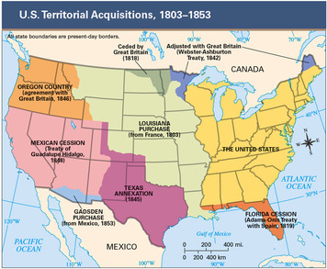
Settlers Find Opportunity and Liberty in the West As the United States expanded, American settlers moved into the newly acquired territories. Some traveled by wagon along the Santa Fe Trail, which was an old trade route from the Missouri River to Santa Fe, New Mexico. Many more headed west on the Oregon Trail, which stretched from Independence, Missouri, to Portland, Oregon. The journey along the Oregon Trail, across the Great Plains and the Rocky Mountains, took many months and cost countless settlers their lives. Those who made it found fertile farmlands in the green valleys of Oregon.
One group that made the journey west in the 1840s was made up of the Mormons. This religious group traveled over the Oregon Trail to Utah to escape persecution. They settled on the desert lands surrounding Great Salt Lake and created a thriving, prosperous community.
American Indians Face a Forced Westward Migration Although westward expansion provided new opportunities for settlers, it spelled tragedy for many American Indians. As the United States added new territories, it also brought many Indian homelands within its national borders. Settlers who coveted these lands agitated for the removal of tribes to less desirable areas.
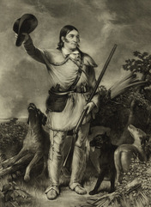
In 1830, Congress passed the Indian Removal Act to clear Indians from lands east of the Mississippi River. The plan was to move the tribes west to Indian Territory, which later became the state of Oklahoma. In a message to Congress entitled "On Indian Removal," President Andrew Jackson praised the act for placing "a dense and civilized population in large tracts of country now occupied by a few savage hunters."
Although most tribes reluctantly went along with removal, some resisted. The Cherokees attempted a legal defense, claiming they were protected from removal by earlier treaties. When Georgia refused to recognize the treaty rights, the Cherokees appealed to the Supreme Court. In Worcester v. Georgia, the Court upheld the Cherokees' treaty rights. President Jackson, however, refused to enforce the Court's decision. Other tribes, such as the Seminoles of Florida and the Sauk and Fox Indians of Wisconsin Territory, turned to armed resistance. These tribes were nearly wiped out by army troops.
In the end, the tribes that resisted removal were moved by force. The most famous forced migration was that of the Cherokees in 1838. On the journey to Indian Territory, about 4,000 of the more than 17,000 Cherokees died from starvation, disease, and harsh winter weather. This tragic journey is remembered today as the Trail of Tears.
The Country Develops Sectional Identities As the United States expanded, the three main sections of the country—North, South, and West—began to develop distinct identities. These identities were influenced by the different geographic characteristics of each section and by the people who settled there.
The North included the states that stretched from Pennsylvania north to New England and from the Atlantic to the Appalachians. In New England, cold winters and poor soil led many people to turn to commerce, shipbuilding, and fishing for a living. Elsewhere, most northerners farmed for a living. However, by the mid-1800s, some northerners were leaving their farms to work in the growing number of mills and factories. Many new immigrants also flocked to northern cities in search of jobs.
The South stretched from the Chesapeake Bay south to Florida and west to the Mississippi River. With the South's mild climate and rich soil, agriculture was the dominant occupation through the mid-1800s. Although most southerners were small farmers, plantation agriculture was becoming more and more important. Plantation owners relied on slave labor to cultivate cash crops, such as cotton and tobacco. The most successful planters lived lives of great affluence.
In the early 1800s, the West meant the lands between the Appalachians and the Mississippi River. By the 1840s, however, the West meant the area west of the Mississippi. Early settlement of the West was motivated by farmers' desire for cheap, fertile land. Americans, as well as immigrants from many countries, crossed the continent in search of new opportunities in the West. As they mixed with Indians and Mexicans already living there, new patterns of life emerged.

4. Political Changes in an Emerging Democracy
From 1790 to 1830, there was an expansion of democracy in the United States. Few Americans represented this change better than Andrew Jackson. Born into poverty in the Carolina backcountry, Jackson managed to prosper as a planter, buying land and slaves. He went on to become a judge, a U.S. senator, and a military hero. Despite his wealth and fame, Jackson maintained a common, man-of-the-people image. This image and a new spirit of democracy in the country helped sweep Jackson to the presidency in 1828.
Democracy for the Common Man—But Not Woman Jackson owed his victory in part to an expansion of suffrage, or voting rights. By 1828, most states had dropped the requirement that voting citizens must own property. The number of popular votes increased from around 350,000 in 1824 to some 1,155,000 the year Jackson was elected president. Although these changes marked an expansion of democracy, many Americans were still denied this most basic political right. No states allowed women, American Indians, or slaves to vote. Only a few granted suffrage to free African American men.
Other changes were also making the election process more democratic. In many states, secret paper ballots were replacing the more public voice-vote system. This change encouraged people to vote without fear of intimidation at the polls. By 1832, open national conventions had replaced private party meetings, called caucuses, to nominate candidates for president and vice president.
Political parties made politics more democratic by involving more people in election campaigns. By the 1820s, parties were using newspapers, campaign songs, and get-out-the-vote rallies to drum up interest in voting. The percentage of eligible voters who actually went to the polls increased sharply as campaigns became more interesting.
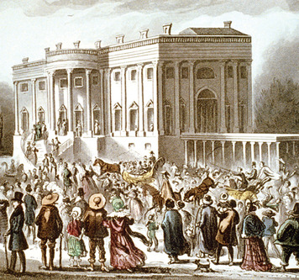
Jackson Loses, Then Wins, the Presidency Jackson first ran for president in 1824. That year, four candidates ran for president, all of them claiming to be Democratic-Republicans. Each candidate represented the interests of a different section of the country. Jackson managed to attract enough voters in all sections to win the popular vote. However, he did not have enough votes in the Electoral College to win the presidency. In accordance with the Constitution, the election went to the House of Representatives, which chose John Quincy Adams to be president. Jackson's supporters vowed revenge in the next election.
Jackson knew there would be many new voters in 1828, most of them "common people." To gain their support, he formed a new political party known as the Democratic Party. Democrats claimed to speak for ordinary farmers and workers, rather than for the wealthy and privileged few. This new party supported a decentralized government and states' rights.
Jackson's opponent, John Quincy Adams, also headed a new party, the National Republican Party. The National Republicans represented business, shipping, and banking interests in the Northeast. This party favored a strong central government that would fund internal improvements, such as roads and canals, to grow the economy. Southerners feared that they would be taxed in the form of high tariffs to pay for these improvements. They also worried that a stronger federal government might be tempted to interfere with slavery.
Both parties tried to win voters by avoiding sectional issues and flinging nasty charges at one another. When the mudslinging was over, Jackson's "common man" appeal won him a landslide victory. At his inauguration, Jackson threw open the White House doors to his followers. They tromped through the residence with muddy boots and spilled punch on the furniture. It was a raucous celebration of popular democracy.
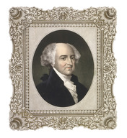
Once in office, Jackson rewarded his loyal supporters with government jobs. Those who lost their jobs to make way for Jackson supporters denounced this practice as a spoils system. The name comes from the ancient wartime saying, "To the victor belong the spoils [prizes] of war." Jackson, however, defended "rotation in office" as a democratic reform. Government jobs, he argued, were not the property of an elite few but should be open to all.
Nullification: Defining the Limits of State and Federal Powers A key issue facing the young republic was the balance between state and federal power. This issue first came up in 1798, when Congress passed two controversial laws known as the Alien and Sedition Acts. Believing the laws to be unconstitutional, Thomas Jefferson and James Madison penned protests known as the Virginia and Kentucky resolutions. The resolutions called on states to nullify, or declare void, any federal law that violates the Constitution. This principle of nullification would become a flash point in a later battle over states' rights.
Meanwhile, the Supreme Court under Chief Justice John Marshall made a number of rulings that affirmed federal power. The first ruling came in 1819 in McCulloch v. Maryland, which arose when Maryland tried to tax the Baltimore branch of the Bank of the United States, a national bank created by an act of Congress. The Marshall Court ruled that "the power to tax involves the power to destroy." Under the Supremacy Clause, no state had the right to destroy or in any way nullify what Congress had enacted. In Gibbons v. Ogden, the Supreme Court reaffirmed the power of Congress to regulate interstate commerce. The case arose when the New York legislature granted two men the exclusive right to run steamboats on the Hudson River. New Jersey, which shares the river with New York, protested. The Court rejected New York's effort to control boat traffic on the river, on the ground that it interfered with interstate commerce.
The issue of states' rights reached a boiling point in 1832, when South Carolina tried to nullify two federal tariff laws. Like many southern states, South Carolina relied on imports of cheap manufactured goods, and tariffs raised the prices on these goods. As the nullification crisis heated up, state leaders threatened to withdraw from the Union if the tariff laws were enforced. President Jackson stood his ground, preparing to use force if necessary. At the same time, he rushed a lower tariff bill through Congress. The crisis passed, but the tension between states' rights and federal power did not go away.

5. Economic Changes in a Developing Nation
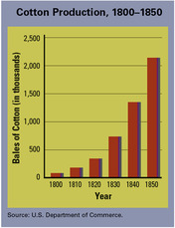
In 1789, a young Englishman named Samuel Slater came to the United States looking for opportunity. Unlike most immigrants, however, he was not seeking land to farm. Instead, he came to set up a cotton-spinning mill using the latest technology. While working in an English textile mill, Slater had memorized the designs for machines that spun cotton fiber into thread. Soon after arriving in the United States, he built a mill in Rhode Island and was on his way to fame and fortune. Slater's mill marked the beginning of industrialization in the United States. Industrialization is the move from producing goods by hand to producing them by machine.
New Inventions Make Production More Efficient Slater was not alone. Other inventors in the United States were working on new machines that would spur industrialization. One of the most successful of these inventors was a New Englander named Eli Whitney. While visiting a Georgia plantation in 1793, Whitney observed how slaves spent hours cleaning the seeds from cotton. Within days, he had invented the cotton gin, a machine that could clean 50 pounds of cotton in the time it took to clean one pound by hand.
Whitney's cotton gin revolutionized cotton production, making cotton the nation's leading cash crop. The cotton gin also revolutionized slavery. Until then, many had expected slavery to die out in the South, as it had in the North. Instead, as cotton production increased, so did the demand for slave labor.
Whitney also introduced the idea of interchangeable parts. Until then, musket parts were made by hand, and each part was slightly different. Whitney showed how muskets could be put together using identical parts that could be made in quantity and interchanged from one gun to another. Whitney's system made musket manufacturing much faster and paved the way for the mass production of goods. Mass production is the making of goods on a large scale in factories.
In the 1830s, new machines increased productivity—the rate at which goods can be produced—in agriculture. John Deere invented the steel-tipped plow, which drastically reduced the labor required to plow a field. Around the same time, Cyrus McCormick created a mechanical reaper that could harvest grain much faster than traditional methods with less labor. In response, farmers began to focus on cash crops, using the money they made to buy the expensive new machines and other goods they needed.
The Factory System Changes How People Work New technology brought new ways of working. Boston merchant Francis Cabot Lowell, father of the factory system, opened his first cotton mill in 1814. Lowell's factory used a series of machines, housed in one building, that turned raw cotton into finished cloth. He hired young women from local farms to tend his machines. Many of these "mill girls" were happy to leave their unpaid farm work for a factory job with wages.
The new factory system was a far cry from the old system of handmade goods produced at home or in small workshops for local use. Factories churned out large quantities of goods for consumption across the country. The mass production of goods helped bring about a change from a traditional to a market economy. This change was known as the market revolution. In a traditional economy, people make most of the things they use. Goods are often traded by barter or other informal types of exchange. In a market economy, people buy and sell goods for money, rather than producing them for themselves.
These economic developments had positive and negative effects. As productivity increased, living standards usually improved. Americans with cash in their pockets had more goods to choose from when they shopped. However, many factory workers had to work for low wages in unsafe, unhealthy conditions to produce these goods.
Canals, Roads, and Rails: Connecting the Country The growth of the market economy sparked a transportation revolution. In the early 1800s, good roads were hard to find anywhere in the United States. By the mid-1800s, however, American engineers had built all-weather roads that had stone surfaces and proper drainage. The most ambitious project was the National Road, which stretched across the Appalachians from Maryland to the Mississippi River. On this road, a trip from Maryland to Illinois that once took weeks could be completed in days.
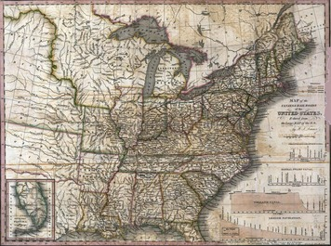
Traveling by river was cheaper than building roads, but traveling upstream was a problem. In 1807, Robert Fulton attached a steam engine to two huge paddle wheels mounted on a raft. This steam-powered riverboat, the Clermont, chugged up the Hudson River from New York to Albany, launching a steamboat craze. By 1830, approximately 200 steamboats were traveling the nation's waterways, hauling freight and passengers.
Canals extended water travel to places rivers did not run. In 1817, when construction of the Erie Canal began, most canals were 2 or 3 miles long. In contrast, the Erie Canal, which linked the Hudson River to Lake Erie, stretched 363 miles. Once the canal was completed, goods could travel from New York City to the Midwest by river, through the canal, and onto the Great Lakes. The canal helped make New York City the country's biggest and most prosperous city. The success of the Erie Canal prompted dozens of other canal projects throughout the country.
Railroads were another key element in the transportation revolution. Inspired by steamboats, engineers built steam-powered locomotives that hauled freight and passenger cars along railroad lines, even in winter when rivers and canals froze. By the mid-1800s, thousands of miles of track stretched across the nation.

6. Social Changes in the Young Republic
The first half of the 19th century was a time of great change in American life. The country was expanding, the economy was growing, and the political system was becoming more democratic. These developments filled many people with hope for the future. But not all Americans benefited from these changes. Many continued to suffer from poverty, limited opportunity, and a lack of rights. As a result, various reform movements arose to tackle problems in American society.
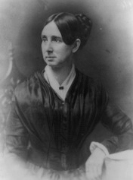
The Second Great Awakening Inspires Reformers The reform efforts of the early 1800s found inspiration in a religious revival known as the Second Great Awakening. Preachers traveled from town to town, holding revival meetings and calling on people to embrace the Christian faith. These preachers urged people to turn from the sins of their selfish lives and receive God's love and forgiveness. Revivalists preached an egalitarian message: God's love and redemption were open to everyone. They taught that Christians could transform society by working for justice. This optimism and outpouring of religious fervor helped fuel the reform movements of the early 1800s.
Few reformers accomplished more than Dorothea Dix. Deeply religious, Dix found her calling after visiting a Boston jail. She was shocked to see inmates locked in small, dark, unheated cells. Among the inmates were mentally ill women who had not committed any crime. Dix made a two-year study of other jails and found the same inhumane conditions. Children, debtors, and the mentally ill were all treated like hardened criminals. Her reform efforts brought substantial change in the penal system and in mental health care across the United States.
The spirit of reform and Jacksonian democracy affected education. In the early 1800s, few children had the chance to go to school. Horace Mann, an early American educator, believed that free, public education would strengthen democracy and help young people escape poverty. Mann pushed for a public school system in Massachusetts. His idea soon caught on in other states as well. By 1850, many states were promoting public education.
Another reform effort fueled by the Second Great Awakening was the temperance movement. Many reformers blamed crime, poverty, and mental illness on alcohol abuse. They called for temperance, or moderation in drinking habits. The American Temperance Union attracted more than a million members within a year of its formation. It also became a training ground for leaders in other areas of reform.
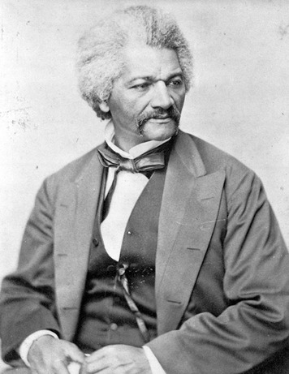
Reformers Push to Abolish Slavery One reform movement came to overshadow all others: the movement to end slavery. Opposition to slavery had existed since the first Africans were brought to Virginia in the early 1600s. Congress banned the importation of slaves in 1808, and opponents of slavery hoped slavery would eventually just die out. Instead, the rise in cotton production that followed the invention of the cotton gin fueled a dramatic expansion of slavery.
In the early 1800s, free African Americans in the North formed several antislavery societies. Their efforts got a big boost from the religious fervor at revival meetings. Revivalists attacked slavery on the grounds that it was immoral. They also helped people see that slavery went against such ideals as liberty and equality, which lay at the heart of American democracy. Although some antislavery reformers believed slavery should be ended gradually, others called for immediate abolition, or the end of slavery, everywhere.
Abolitionists gave speeches, wrote pamphlets, and lobbied government officials in an effort to end slavery. The abolitionist movement gained power and public attention in the 1830s through a newspaper called The Liberator, published by William Lloyd Garrison. Garrison advocated not only an immediate end to slavery but also full equality for African Americans, a radical idea at the time. Another important abolitionist was Frederick Douglass, a former slave whose autobiography recounted his own struggle for freedom. Douglass's personal story and his dynamic stage presence made him a powerful spokesman for abolition.
As the abolition movement grew, supporters of slavery—both northern and southern—went on the attack. Mobs attacked abolitionists, burned their homes, and destroyed their printing presses. In spite of these attacks, abolitionists continued their work, making slavery the most crucial issue of their time.
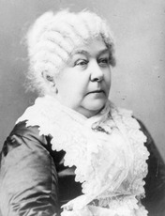
Women Demand Equal Rights A number of abolitionist leaders also joined the growing movement for women's rights. One was a former slave named Sojourner Truth. A tall, striking woman who knew how to stand up for herself, Truth was not afraid to speak out. At one gathering, after hearing men portray women as being weak, she exclaimed, "Look at my arm! I have plowed and planted and gathered into barns, and no man could head [outdo] me—and ain't I a woman?"
In the mid-1800s, women were still second-class citizens in America. They were denied many of the rights and privileges given to men, including the right to vote and to control their own money or property. Most women were expected to stay at home and not try to "better" themselves by pursuing an education or a career. But a growing number of women began to challenge these restrictions. Their efforts gave rise to the first women's movement.
In 1848, supporters of women's rights gathered for the Seneca Falls Convention, in Seneca Falls, New York. There they drafted a statement called the Declaration of Sentiments, which was based on the Declaration of Independence. It began, "We hold these truths to be self-evident: that all men and women are created equal." The statement went on to list various acts of tyranny by men against women.
In the years after the Seneca Falls Convention, reformers like Elizabeth Cady Stanton and Susan B. Anthony continued to struggle for women's rights. Progress was slow, but over time, states began to change their laws. New York, for example, gave women control over their property and wages. Other states passed more liberal divorce laws. Getting the right to vote would take much longer, but eventually, in 1920, that barrier to women's rights would also fall.

Summary
The United States experienced political, geographic, economic, and social changes in the first half of the 1800s. During this time, the nation expanded from 13 states along the Atlantic coast to a huge nation that spanned a continent.
Manifest destiny Inspired by the belief that their nation was destined to expand, Americans acquired vast western lands and began a movement to settle these new territories.
Indian Removal Act As settlers moved westward, they pushed Indians out of their homelands and forced their removal to lands set aside as Indian Territory in present-day Oklahoma.
Jacksonian democracy As voting rights expanded, the United States became more democratic. In 1828, Andrew Jackson was elected president as the champion of the common man.
Marshall Court In the ongoing struggle between states' rights and federal power, the Marshall Court made key decisions that strengthened the federal government's power.
Factory system New machines and ways of organizing work in factories made production more efficient and changed the way Americans worked. A market economy began to develop.
Second Great Awakening A major religious revival movement inspired reform movements in many areas of American life, including prison reform, temperance, public education, and the abolition of slavery.
Seneca Falls Convention At an 1848 meeting in Seneca Falls, New York, a women's movement was launched that would last for decades. Its goal was equality under the law for both men and women.

