Creating the Constitution

1. Introduction
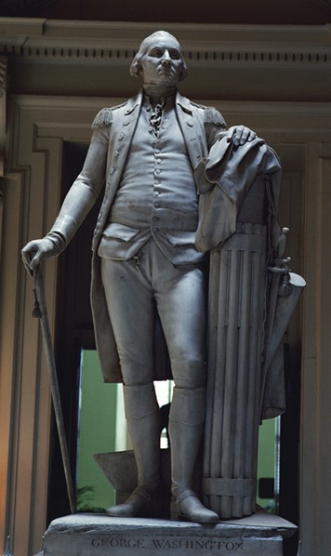
In 1782, an army officer wrote a letter to George Washington. In it, he expressed his hope, shared by many of his fellow officers, that the independent American states would be joined into "a kingdom with Washington as the head." The general was appalled. He had spent years in bloody battle working to sever ties with a monarchy. Washington wrote back, "Be assured Sir, no occurrence in the course of the War, has given me more painful sensations than your information of there being such ideas existing in the Army . . . banish these thoughts from your mind."

Like Washington, most Americans did not want to be ruled by a monarch. What they did want, though, was an effective government. In the minds of many, that was not what they had under the Articles of Confederation, the nation's first constitution. Troops who wanted Washington to be king were suffering from Congress's inability to meet the army's basic needs. "On the general subject of supplies," wrote a member of Congress, "we need hardly inform you that our Army is extremely clamorous, we cannot pay them—we can hardly feed them."
Over the next few years, many Americans believed that things were going from bad to worse for the new nation. In 1786, a group of rebellious farmers who could not pay their debts shut down several courthouses in Massachusetts. Congress could not help the state government deal with the rebellion. Some Americans saw this as a sign that the nation was sliding into anarchy.
If a more effective government was needed, how should it be structured? That was the question facing delegates called to a special convention in Philadelphia in 1787. This Constitutional Convention took place in the room to the left, in a building now known as Independence Hall. Presiding over the convention was none other than George Washington, the man who would not be king.

2. A Confederation of States
In 1776, the Declaration of Independence had asserted that the colonies were independent states. Even as the war got underway, the legislatures of the 13 states began to write their own constitutions. Within a year, almost all of them had new plans of government reflecting the principles in the Declaration of Independence. In fact, the words of the Declaration were written right into the New York state constitution. However, it was not until almost the end of the war that the states agreed to form a loose confederation.
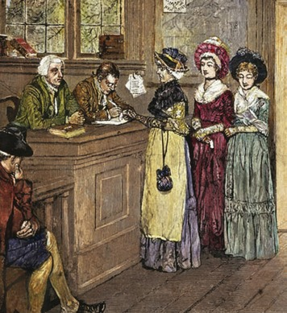
Comparing State Constitutions The state constitutions were similar in many ways. They all began with a statement of rights. These rights were guided by three founding ideals expressed in the Declaration of Independence: equality, freedom, and democracy. Each state constitution separated the powers of government into executive, legislative, and judicial branches.
However, the state constitutions were far from being completely democratic. They did not establish governments by consent of all of the governed. They typically limited voting rights to white men who paid taxes or owned a certain amount of property. Only New Jersey gave voting rights to women and African Americans who owned property. None of the original 13 states' constitutions outlawed slavery, and all states south of Pennsylvania denied slaves equal rights as human beings.
Decisions in Forming a National Government While the states were writing their constitutions, the Continental Congress was trying to decide how the nation as a whole should be governed. When Congress first met in 1774 to resolve disputes with Britain, it had no authority over the colonial legislatures. Even when directing the war effort, it had no authority over the states, often begging them for soldiers and supplies. Therefore, many members of Congress wanted to form a national government, one that had powers to govern the states. However, they knew this would be a tricky undertaking. After being controlled by Britain for so long, Americans were not inclined to hand over power to another central government—even one they elected.
When Congress drafted the nation's first constitution in 1777, it knew that many Americans feared a powerful national government. For that reason, the proposed Articles of Confederation created a framework for a loose confederation of states. Within this alliance, each state would retain "sovereignty, freedom, and independence." Any power not specifically given to Congress was reserved for the states. This meant that each state could often develop its own policies.
On paper at least, the Articles did give Congress several key powers. Only Congress could declare war, negotiate with foreign countries, and establish a postal system. It could also settle disputes between states. But it had no power to impose taxes, which explains why the Continental Army was so starved of funds. In addition, the Articles did not set up an executive branch to carry out the laws or a judicial branch to settle legal questions.
But even with the war still raging, some states were hesitant to approve a plan of government that would give Congress any control over their affairs. It took three and a half years for ratification [ratification: the approval of a plan of government or of a constitutional amendment] of the Articles by all 13 states.
Two Ordinances Lay the Foundation for Land Policy Despite its limited power, Congress recorded some notable achievements under the Articles of Confederation. Perhaps its most important success was the creation of policies for the settlement of western lands.
In the Treaty of Paris ending the Revolutionary War, Britain gave up control of a region known as the Northwest Territory. No government had yet been established for this large territory that stretched from the Appalachian Mountains west to the Ohio and Mississippi rivers. Congress wanted to organize this land and sell it to raise revenue. To do so, it passed the Land Ordinance of 1785. An ordinance [ordinance: a law that sets local regulations] is a law that sets local regulations.
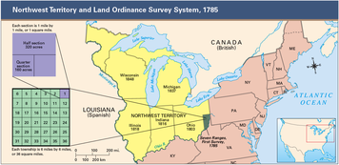
The Land Ordinance of 1785 set up a system for surveying and dividing land in the new territory. After being surveyed, the land was to be divided into 36-square-mile townships. Each township would be divided into 36 numbered sections of 1 square mile each. Each section would then be divided for sale to settlers and land dealers. Section 16, however, was always set aside for schools.
In 1787, Congress passed the Northwest Ordinance [Northwest Ordinance: a law passed by Congress in 1787 specifying how western lands would be governed] to specify how these western lands would be governed. This ordinance declared that the region would be divided into three to five territories. When a territory had 5,000 free adult men, those men could elect a legislature. When the population reached 60,000 free inhabitants, the legislature could write a constitution and form a government. If Congress approved both, the territory would become a state.
A number of the ordinance's provisions reflected the principle of equality. Each new state would have equal standing with the original states, and its people would enjoy the same freedoms and rights. Furthermore, slavery would be banned in any state formed from the region.
The Northwest Ordinance set up a system that became a general guide for admission of future states. For that reason alone, it is considered the most important law passed during the period of confederation.

3. The Confederation in Crisis
Although Congress under the Articles of Confederation had notable successes, many Americans saw problems with the confederation. Most of these problems stemmed from the fact that the Articles gave so much authority to the states and so little to Congress. George Washington declared that the Articles were no more effective at binding the states together than "a rope of sand."
Trouble with Foreign Countries Congress's weaknesses were recognized not only at home but also abroad. The lack of central authority made relations with foreign countries more difficult. For example, one British official said it would be better to negotiate with each state than to do business with Congress. When Congress tried to reach a trade agreement with Britain in 1785, Britain refused because it knew the states wouldn't agree to be bound by the accord.
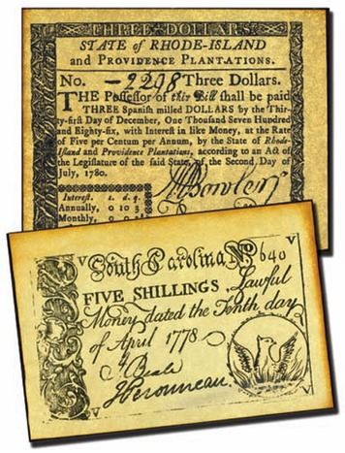
Many foreign countries also questioned the nation's financial stability. The United States had accumulated a huge war debt, mostly to foreign lenders. But Congress lacked funds to pay its debts. The Articles directed the state legislatures to pay taxes to the national treasury based on the value of each state's land. However, Congress could not force the states to pay.
To make matters worse, overseas trade shrank under the confederation. Britain restricted American trade by closing some of its ports to American vessels. These actions hurt the American economy, which depended heavily on the British market. Meanwhile, the United States had little success boosting trade with other countries.
Another problem was national defense. In the Treaty of Paris, Britain had agreed to withdraw troops from the Northwest Territory. Once it saw how weak Congress was, however, it refused to pull them out. Britain and Spain supplied arms to American Indians and urged them to attack settlers. Having disbanded the Continental Army after the war, Congress had no military force to counteract this threat.
Quarrels Between the States There were troubles between the states, too. As foreign trade declined, the economy relied more on interstate commerce [interstate commerce: trade between states] , trade between states. But states often treated each other like separate countries by imposing tariffs [tariff: a tax on imported goods] , or import taxes, on each other's goods. In theory, Congress had authority to settle tariff disputes between the states, but the states often ignored its decisions.
Money was another divisive issue. The Articles allowed Congress to issue currency, but the states were still allowed to print their own paper money. Because there was no uniform currency, people had little faith in the money. In some cases, it was worth little more than the paper it was printed on. Gold and silver coins were readily accepted as payment, but they were in short supply. The lack of confidence in paper money made interstate commerce and travel even more difficult.
The combination of high debt, weak currency, and falling trade caused the country to slide into an economic depression [economic depression: a drastic decline in the economy, marked by business failures and unemployment] . This drastic decline, marked by business failures and unemployment, caused discontent to spread throughout the country.
Discontent Fuels Shays' Rebellion in Massachusetts Farmers were among those who suffered most from the economic depression. Falling crop prices and the loss of foreign markets left many farmers with crippling debts they could not repay. Farmers in western Massachusetts were hit especially hard. Some had their property auctioned off by local courts for nonpayment of debts and taxes. Others were sent to debtors' prison when they could not pay their debts.
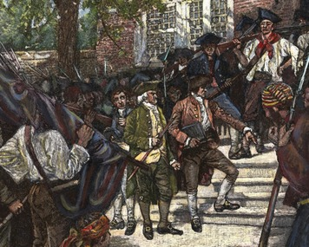
In the summer of 1786, armed and angry farmers occupied a courthouse to prevent the court from doing business. In the following weeks, these rebels took over other Massachusetts courts, hoping to prevent trials and imprisonment of debtors. This uprising, known as Shays' Rebellion after its main leader, Daniel Shays, quickly mushroomed. In September 1786, Shays led hundreds of farmers to occupy the courthouse in Springfield, Massachusetts. A few months later, he led about 1,200 farmers to try to seize a weapons stockpile in the same city. This time, the Massachusetts militia stopped them, and the rebellion collapsed.
To face the threat of Shays' Rebellion, Massachusetts had needed funds to hire and supply a larger militia. But Congress had been unable to send money. Instead, private donations from wealthy people had helped the state militia put down the revolt. In the aftermath of Shays' Rebellion, rich businesspeople and landowners were particularly worried about Congress's weakness. They feared that anarchy would engulf the nation. Many Americans were not so pessimistic but did agree that the government should be strengthened.
A Call for a Constitutional Convention While Shays' Rebellion was erupting in Massachusetts, delegates were gathering at a convention in Annapolis, Maryland. This formal assembly was called to fix trade problems between the states. But the delegates knew they had more serious problems to address.
Two important political leaders, Alexander Hamilton of New York and James Madison of Virginia, were among the delegates. They drafted a request that all states send representatives to a constitutional convention to be held in Philadelphia in May 1787. The purpose would be to revise the Articles of Confederation to create a stronger, more effective system of government.

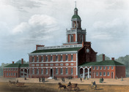
4. The Constitutional Convention
The Constitutional Convention opened on May 25, 1787. Delegates from every state but Rhode Island gathered in the room where the Declaration of Independence had been signed 11 years before. Congress had instructed them to revise, not replace, the Articles of Confederation. However, many delegates were already convinced that a new constitution was needed. Through months of debate, the delegates would work out this plan of government and then set it forth in a document called the Constitution of the United States.
A Distinguished Group of Delegates The 55 delegates were the cream of American political life. Historian James McGregor Burns has described them as the "well-bred, the well-fed, the well-read, and the well-wed." All were white men. Among them were former soldiers, governors, members of Congress, and men who had drafted state constitutions. Their average age was 42.
The delegates represented a wide range of personalities and experience, and many were eloquent speakers. At 81, Benjamin Franklin was the senior member. The wisdom and amicable wit of this writer, inventor, and diplomat enlivened the proceedings. George Washington, hero of the Revolution, lent dignity to the gathering. Alexander Hamilton, his former military aide, brought intellectual brilliance. Other delegates, like Roger Sherman of Connecticut, contributed law and business experience. James Madison of Virginia was perhaps the most profound political thinker and the best prepared of all the delegates.
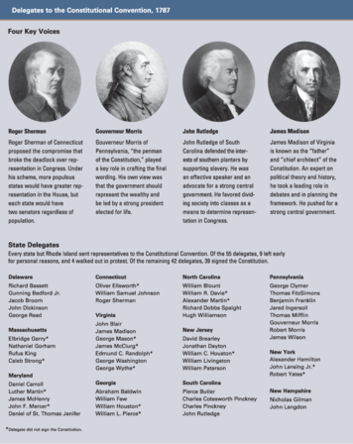
A few key leaders of the Revolution did not attend. Thomas Jefferson and John Adams were serving as representatives of the United States in Europe. Reading a list of the delegates in Paris, Jefferson described them as "an assembly of demigods." Other leaders, like Samuel Adams, were not there because they opposed efforts to strengthen the national government. Patrick Henry was named as a Virginia delegate but chose to stay home, saying he "smelt a rat." Indeed, many Americans remained fearful of giving a central government too much power.
The Ideas Behind the Constitution No one had a greater role than Madison. He worked tirelessly to develop and promote the new plan. For his role in shaping the new framework, he is called "the Father of the Constitution."
The delegates' political views were strongly influenced by Enlightenment thinkers. English philosopher John Locke's ideas about natural rights and the social contract helped shape the Declaration of Independence. They would also be guiding principles for drafting the Constitution.
The delegates also looked to the ideas of the Baron de Montesquieu, another Enlightenment thinker. He favored a three-part government with separation of powers between executive, legislative, and judicial branches. These branches would work together in a system of checks and balances, each branch limiting the power of the others. This would prevent tyranny by keeping each branch from seizing excessive power.
The delegates discussed these and other ideas for almost four months. Day after day, through a long, sweltering summer, they would debate, argue, write, revise, and debate some more. As they met, they knew that, once again, they were making history.
The Convention Begins with a Plan from Virginia The first thing the delegates did was to elect George Washington as presiding officer. Next, they adopted rules of procedure. One was the rule of secrecy. The delegates needed to speak freely and frankly, and they could not do so if the public were watching. So despite the intense summer heat, they shut the windows, drew the drapes, and posted a sentry outside.
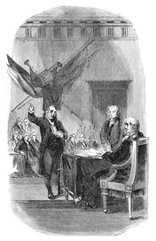
The Virginia delegates wanted to establish a strong national government and promptly proposed a plan. The Virginia Plan, written mainly by James Madison, was clearly meant to replace the Articles, not revise them. It called for a national government with three branches, just as Montesquieu had described. The legislative branch would make laws, the executive branch would carry out the laws, and the judicial branch would interpret the laws.
Under the Virginia Plan, the new government would have a bicameral legislature, a lawmaking body made up of two houses. In contrast, the Articles of Confederation had established Congress as a unicameral, or one-house, legislature. The Virginia Plan proposed that representation in the two houses of Congress should be based on the population of each state. This would give the more populous states more delegates, and therefore more influence, than states with smaller populations.
New Jersey Introduces a Rival Plan For about two weeks, the delegates discussed the Virginia Plan. Some thought it gave too much power to the national government. Some opposed a bicameral legislature. Moreover, smaller states did not like their representation in Congress being limited by population.
On June 13, William Paterson of New Jersey introduced an alternative to the Virginia Plan. The New Jersey Plan proposed a series of amendments to the Articles of Confederation. It called for a less powerful national government with a unicameral Congress in which all states had equal representation.
Delegates of the smaller states welcomed the New Jersey Plan. But after several days of debate, the convention voted to reject this proposal and return to discussion of the Virginia Plan.
Discontent, Debate, and the Great Compromise For the next month, the delegates debated the Virginia Plan point by point. They continued to argue about the critical issue of representation in the legislature. Debate grew so heated that delegates from some states threatened to leave the convention.
Finally, Roger Sherman of Connecticut came forward with a compromise designed to satisfy all sides. His plan called for a bicameral legislature with a different form of representation in each house. In the Senate, the states would have equal representation. In the House of Representatives, states would have representation based on their populations. Sherman's plan, known as the Great Compromise, resolved the thorny issue of representation in Congress.
Slavery and Commerce Issues Divide the States Other issues also divided the delegates. Those from northern and southern states differed strongly on questions of slavery and commerce. A number of northern states wanted to include a provision for abolishing slavery. But most southerners opposed ending a system of labor on which their agricultural economy depended.
Differences over slavery generated strong debate on representation and taxes. Since most slaves lived in the South, southern states wanted slaves to be counted in determining representation in the House of Representatives. Yet they did not want them counted when determining each state's share of taxes to support the national government. In contrast, the northern states wanted slaves to be counted for taxation but not when determining representation.
In the end, the delegates reached another important compromise. For representation in the House, every five slaves would be counted as equal to three whites. The Three-Fifths Compromise settled the dispute, but the contradiction between the ideals of the Declaration of Independence and the practice of slavery would haunt the country in the decades to come.
North and South also argued over commerce. Northerners favored giving Congress broad powers to control trade. Southerners worried that Congress might outlaw the slave trade and place heavy taxes on southern exports of crops such as cotton and tobacco. Again, the delegates reached a compromise. Congress would have the power to regulate foreign and interstate commerce, but it could not tax exports and it could not outlaw the slave trade until 1808.
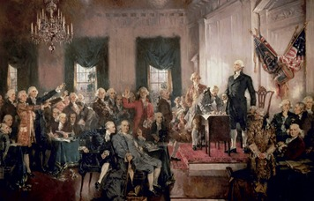
Creating the Executive Branch Another major issue concerned the formation of the executive branch. Some delegates wanted a single executive to head the government. Others were concerned that giving power to a single leader might lead to monarchy or tyranny. They favored an executive committee made up of at least two members. In the end, though, the delegates voted for a single president.
The next question was how to elect the president. Some delegates thought Congress should do it, while others favored popular elections. They finally decided to set up a special body called the Electoral College. This body would be made up of electors from each state who would cast votes to elect the president and vice president. Each state would have as many electors as the number of senators and representatives it sent to Congress.
On September 17, 1787, after months of hard work, the Constitution was signed by 39 of the 42 delegates present. The Constitutional Convention was over, but the Constitution still needed to be ratified by the states. The document began with the ringing words, "We the people of the United States, in order to form a more perfect union . . ." Now each state would decide whether this plan of government was indeed "more perfect" and thus worthy of becoming the law of the land.

5. Ratifying the Constitution
The proposed Constitution included a provision for ratification. To go into effect, the plan of government would need to be approved by 9 out of the 13 states. Ratification would take place at state conventions, but it was by no means assured. Many Americans were concerned that the Constitution gave too much power to the national government. As a result, supporters of the Constitution would have to work hard to win its ratification.
Federalists and Anti-Federalists The people who supported the Constitution called themselves Federalists. They favored a federal government—a strong central government that shared power with the states. Those who preferred a loose association of states with a weaker central government were called Anti-Federalists. The battle between Federalists and Anti-Federalists would be played out in the press, in state legislatures, and at the state ratifying conventions.
Alexander Hamilton, James Madison, and John Jay led the Federalist campaign. Using the pen name "Publius," they wrote a series of 85 essays designed to win support for the Constitution. These essays, known as The Federalist Papers, were published over the course of several months and made a strong case for the new plan of government. Some historians have called their publication one of the most powerful public relations campaigns in history.
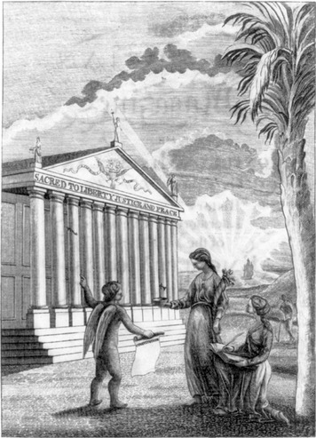
Click to read caption
In The Federalist Papers, Hamilton, Madison, and Jay provided detailed explanations of key parts of the Constitution. On the issue of central power, for example, Madison explained how the system of checks and balances would ensure that no one branch of government would have control over the other two. He also explained why such a system was needed:
If men were angels, no government would be necessary. If angels were to govern men, neither external nor internal controls on government would be necessary. In framing a government which is to be administered by men over men, the great difficulty lies in this: you must first enable the government to control the governed; and in the next place oblige it to control itself.
—James Madison, The Federalist No. 51, 1788
Because The Federalist Papers explain the purpose of the Constitution, people who read these essays today can gain insight into the intentions of the Constitution's original drafters.
The Call for a Bill of Rights By January 1788, Delaware, Pennsylvania, and New Jersey had ratified the Constitution. Georgia and Connecticut soon followed. But a bitter debate in Massachusetts brought to the forefront a major Anti-Federalist concern about the Constitution: the lack of a bill of rights.
Anti-Federalists in Massachusetts complained that the Constitution did not adequately protect individual rights and freedoms against encroachment by the national government. They argued that it should be altered to include such rights as the freedoms of speech, religion, and the press. They also wanted guarantees that every citizen would have such rights as the right to trial by jury and protection against unreasonable seizure of property. The lack of such guarantees became a sticking point in many states as the ratification process wore on.
After much debate, Massachusetts agreed to ratify if amendments were added after ratification to protect fundamental rights. A number of other states ratified the Constitution with the same understanding. By the summer of 1788, all but two states had ratified. North Carolina joined the new union in 1789 and Rhode Island in 1790.
With James Madison leading the way, the first Congress of the new government framed the proposed amendments. Madison himself believed that individual rights were already protected by the Constitution, making the amendments unnecessary. However, his friend Thomas Jefferson helped change his mind. Jefferson wrote from France that "a bill of rights is what the people are entitled to against every government on earth, general or particular, and what no government should refuse." He argued that the great strength of such a bill of rights was "the legal check which it puts into the hands of the judiciary."
On December 15, 1791, enough states had ratified 10 amendments to make them part of the Constitution. These 10 amendments are known collectively as the Bill of Rights. Over the course of the nation's history, 17 more amendments have been added to the Constitution.
Today the Constitution is the oldest written framework of national government in use anywhere in the world. Forged over the course of a few months in the summer of 1787, the Constitution of the United States has more than stood the test of time.

Summary
After the Revolution, the states first formed a loose confederation. However, many Americans thought this arrangement did not satisfy the need for a strong central authority. Delegates from the various states came together to write a new constitution that would provide the basis for a durable and balanced government.
The Articles of Confederation The nation's first constitution established a governing framework that gave the states more power than the national government. This lack of central authority contributed to various problems, including a poor economy and weak national defense.
The Northwest Ordinance This land policy established rules for the creation of governments in the Northwest Territory and the eventual admission of western states.
The Constitution of the United States Frustrated by weaknesses of the confederation, delegates met in Philadelphia in 1787 for the Constitutional Convention. Instead of revising the Articles, they wrote a new constitution that established a national government with three branches.
The Electoral College After much debate, the delegates decided that a single executive, a president, should lead the executive branch. A body called the Electoral College, made up of electors from each state, would elect the president and vice president.
Ratification After the Constitution was completed in September 1787, it was sent to the states for ratification. During the debate over ratification, supporters agreed to add amendments to guarantee basic freedoms. With this assurance, the Constitution was ratified in 1788 and became law. The first 10 amendments, known as the Bill of Rights, were ratified in 1791.

