Era Overview: Expanding Interactions 300-1500 C.E (Continued)

4. The Mongol World
By the mid-900s, the Muslim Empire had fractured. An Umayyad prince governed Spain, while a Shi’a dynasty called the Fatimids ruled Egypt. The Abbasid caliphs still reigned in Baghdad, but they were controlled by a Persian dynasty to the east. Later, in 1055, Turkish nomads known as Seljuks conquered the Persians and gained control over the Abbasid caliphate. Muslim civilization would continue to flourish for several centuries, but the Muslim Empire was over.
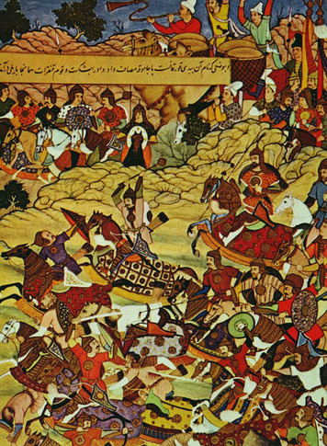
One final blow remained, however. In 1258, Mongol conquerors stormed into Baghdad and killed the last Abbasid ruler. A new empire had been born.
The Mongol Empire The Mongols were a group of nomadic tribes from the plains of Central Asia. For centuries they had lived as herders in the grasslands north of China. They slept in felt tents, called yurts, and survived on meat and milk from their animals. They also raided and fought with other tribes.
In 1206, a Mongol leader, or khan [khan: Mongol tribal leader] , managed to unite the Mongol tribes into a powerful fighting force. His name was Temujin, but he took the title of Genghis Khan, or “Universal Ruler.” Under his leadership, the Mongols began a campaign of conquest that would create the largest empire the world had ever known.
Genghis first turned his army south, toward China. After several years of fighting, he had taken a large portion of northern China. He then moved west, capturing the lands of Central Asia and gaining control over the Silk Road. Crossing the Himalayas, he also occupied parts of modern-day Pakistan.
Several factors contributed to Genghis’s success.
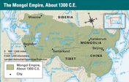
• First, the Mongols were fierce warriors and excellent horsemen. They could ride far and fast, and even sleep while riding.
• They were also well trained and highly disciplined. Genghis organized his troops on the decimal system, dividing them into groups of 10, 100, 1000, and 10,000.
• Genghis was a skilled military strategist who knew how to deceive his enemies. At times he would appear to retreat, only to draw his enemy into a trap.
• Genghis could also be ruthless. If a city rebelled after being conquered, he would return and raze it to the ground, leaving no survivors. His reputation for brutality caused some enemies to surrender without a fight.
In 1227, Genghis died. Power then passed to his son and grandsons, who continued the conquests. The Mongols took the rest of China, all of Russia, and most of Southwest Asia. Their westward advance was finally halted at the gates of Vienna and the shores of the Mediterranean. By 1260, Mongol lands extended across Eurasia, from China to Europe. In half a century, the Mongols had created an empire more than twice as large as the Muslim Empire, and six times larger than Rome at its height.
Mongol Rule Because the Mongols were nomads, they had no real experience with governing. They did have a strong moral code, however, which they enforced through their own legal system. Among other things, this code forbade theft, lying, betrayal, and defiance of authority. The penalty for violating this code could be death.
The Mongols could also be flexible. They allowed conquered peoples to maintain their own customs and traditions. In many cases, they adopted local customs themselves. They practiced religious tolerance. One of Genghis’s grandsons reportedly said, “We believe in one God. . . . But just as God has given different digits [fingers] to the palm, so He has given different religions to men.”
In 1265, the Mongol Empire split into four parts, called khanates. The largest and most important of these, the Khanate of the Great Kahn, included China and the Mongol homeland. Its ruler, Kublai Khan (KOOH-bly KAHN), united China and ruled like a Chinese emperor. He also maintained ties with the other khanates and kept the empire connected.
During this period, a huge network of exchange developed across the Mongol world and beyond. This network relied on the Pax Mongolica, the peace and security that prevailed under Mongol rule. The Mongols expanded trade routes and built a courier system to speed communication throughout the empire. As a result, trade increased dramatically across Afro-Eurasia. A growing volume of goods flowed along the Silk Road, from China to Europe and Africa. Ideas and inventions traveled, too. Paper and gunpowder—two Chinese inventions already adopted in the Muslim world—made their way to Europe during this period.
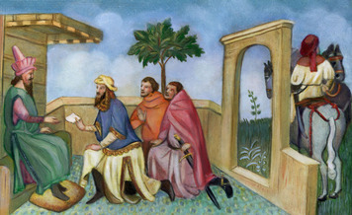
Of course, people also made the journey. The most famous traveler on the Silk Road, the Venetian trader Marco Polo, became an adviser to Kublai Khan and later wrote about the marvels of the khan’s royal court. Among the innovations he noted was paper money, which the Mongols used to promote trade. This new currency, Polo said, could be used to “buy anything, including pearls, precious stones, gold, or silver.” The Mongols also issued a kind of passport and credit card for travel throughout the empire. This document indicated the traveler’s importance and the level of service that person should receive along the way.
Under the Mongols, travelers could journey the length of Asia, from China to Europe, with little concern for their safety. As a Chinese writer noted at the time, “The land within the Four Seas [Asia] had become the territory of one family, civilization had spread everywhere, and no more barriers existed.”
The Mongol Collapse The Mongol Empire lasted for around a century. Then, like all giant empires, it collapsed. Political disunity among the khanates was one problem. Another was the tendency of the Mongols to adopt the customs and culture of the people they ruled. Over time, they lost the warrior spirit that had driven their conquests.
The main cause of the collapse, however, was disease. Like Han China and imperial Rome, the Mongol Empire was stricken by a deadly illness that spread along trade routes. The disease was bubonic plague [bubonic plague : a deadly bacteria responsible for the Black Death of the 1300s; transmitted by fleas living on infected rats] , also known as the Black Death. It began in the 1330s in China, where it killed as much as half of the population in just twenty years. From there it spread west along the Silk Road, killing millions more. It devastated the populations of Southwest Asia and Europe, where at least a quarter of the people died. The plague was most deadly in cities, where people lived close together. But it also ravaged the countryside. The Black Death brought down the Mongol Empire. It reduced populations and disrupted trade and commerce. Movement along the trade routes slowed to a trickle. As a result, links between the four parts of the empire were broken. Each khanate faced mounting pressures. Two were overthrown quickly: the Persian khanate in 1335 and the Chinese khanate in 1368. The Mongols who ruled Russia—known as the Golden Horde—broke into smaller groups that declined in power over the next few centuries.
Only in Central Asia did Mongol rulers remain in power. In the late 1300s, a warrior known as Timur Lang, or Timur the Lame, took control. Attempting to revive the Mongol Empire, he expanded into Southwest Asia, seizing lands from India to the Mediterranean. He was a brutal ruler, however, who governed through terror. In the early 1500s, his descendants would conquer India and establish the Mughal Empire.

5. Expanding Networks of Exchange

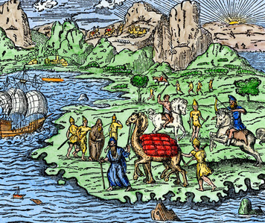
During the centuries from 300 to 1500, the various regions of the world became increasingly connected. People, ideas, and goods began to move more freely within regions and around the world. Religions also spread beyond their lands of origin to become established in new places.
Trade Networks Several major trade networks flourished during this era. The largest network connected the various parts of Asia with each other and with Africa and the Mediterranean. The Silk Road was the major land route in this network. It carried an enormous amount of trade over the centuries, particularly during the time of the Han and Mongol empires. The use of camel caravans—an Arab innovation—enhanced overland travel through desert regions.
Sea routes were also important. Merchant ships sailed from Korea, Japan, and China through the South China Sea to the ports of Southeast Asia and India. They crossed the Indian Ocean, the Arabian Sea, and the Persian Gulf to the shores of Southwest Asia and East Africa. They also moved up the Red Sea to link with trade routes in the Mediterranean.
A second major trade network crossed Europe. Although the fall of Rome disrupted trade for centuries, by the year 1000 merchants were starting to revive European trade. The Vikings—a warrior people from Scandinavia—helped launch this network in the 800s by expanding along sea and river routes. They crossed the Baltic and North seas and traveled around Spain into the Mediterranean. They also moved down the rivers of Russia to the Black and Caspian seas. They traded furs, lumber, salt, glass, horses, woolens, and many other goods. They also brought slaves from Britain and the Slavic lands of eastern Europe to trade in the Muslim world.
A third major trade network linked Africa’s Mediterranean coast with the lands south of the Sahara Desert. This network, called the trans-Saharan trade route, was based on the exchange of two valuable products: salt and gold. Traders carried salt from the northern desert and traded it for gold from south of the desert. This trade supplied two-thirds of the world’s gold and supported the powerful kingdoms of Ghana, Mali, and Songhai.
Other, smaller trade networks existed in the Americas and the South Pacific. In the Americas, a loose trading system spanned the continents but centered on the high civilizations of Mesoamerica and the South American Andes. In the South Pacific, the island groups of Polynesia, Melanesia, and Micronesia were conducting sea trade by the 1400s.
World Religions Exchange networks and the growth of empires also helped spread religious beliefs across Afro-Eurasia. As a result, the major faiths—Buddhism, Hinduism, Judaism, Christianity, and Islam—became world religions. Traders and missionaries carried Buddhism throughout Asia. Hinduism traveled with Indian traders to Southeast Asia. Islam spread over a large region from West Africa to Central Asia. It also gained a foothold in India and Southeast Asia. Christianity spread across Europe and Russia, and also took root in Egypt and Ethiopia. Judaism became established in communities stretching from western Europe to Central Asia and beyond.
These religions expanded during a period of change and upheaval throughout Afro-Eurasia. Their promise of salvation or spiritual peace offered comfort to people unsettled by urban life and the rise and fall of empires. In many cases, the religions interacted peacefully. In the Muslim world, for example, Jews, Christians, and Muslims often lived side by side, with little conflict.
Religious tensions and conflicts did develop, however. Muslims showed little tolerance for Hinduism, with its belief in many gods. When Muslim conquerors invaded India, they tried to convert Hindus to Islam. Tensions also developed between the two branches of the Christian faith: Roman Catholicism and Orthodox Christianity. In 1054, the two churches split officially.
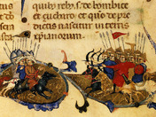
The biggest conflicts, however, occurred between Christian and Muslim armies. In 1095, the Catholic Church launched the Crusades in an effort to oust Muslims from the holy lands of the Eastern Mediterranean. Christian armies also sought to retake Spain from the Muslims. By 1250, they had recaptured most of the Iberian Peninsula.
Exchanging Knowledge Ideas and technologies also moved through exchange networks. It would be impossible to list all the ideas spread during this era. But such a list would include writing systems and discoveries in math, astronomy, and medicine. It would also include technologies in such areas as irrigation, navigation, printing, and papermaking.
The system of Arabic numerals is one example. The Muslims adopted this system from India and later passed it along to Europe. Arabic numerals were much more practical than the Roman numerals used in Europe at the time. Based on the decimal system, they allowed for the development of modern math.
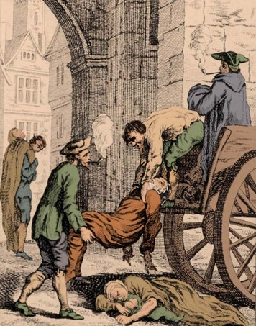
One important technology that spread widely at this time was the camel saddle. Devised in Arabia, this invention made camels useful for transport in desert areas. This, in turn, had a great impact on overland travel and the development of trade in Afro-Eurasia.
Environmental Factors The growth of exchange networks also had environmental effects, including the spread of disease. Populations suffered from devastating plagues that were transmitted along trade routes. Deadly diseases like smallpox, measles, and the bubonic plague helped cause the collapse of the Han, Roman, and Mongolian empires. As networks expanded, so did the danger of infectious disease.
As a result, the world population fluctuated greatly. It fell from an estimated 257 million in 200 C.E. to 206 million in 700 C.E. By 1000 C.E., the population had recovered and was growing rapidly. But the plague of the 1300s caused another sharp decline. By 1500, the population was rising again.
Increased prosperity from trade and agriculture boosted the world population. But this prosperity had environmental consequences. Farmers cut down forests to raise more rice and wheat, causing deforestation in some areas. Expanded cultivation also produced soil erosion and flooding, as soils ran off into rivers and raised water levels. This problem was evident in China’s Huang He River valley, the nation’s breadbasket. There, frequent flooding over the years caused terrible destruction and loss of life. As a result, the Huang He was known as “China’s Sorrow.”

Summary
In this lesson, you read about major developments in the world between 300 and 1500 C.E. During this period, the growth of empires and exchange networks increased connections among the regions and peoples of the world.
Cultural Interaction Contact and interaction among cultures expanded with the growth of empires. The Muslim Empire brought many different peoples together and forged a culture that reflected many influences. The Mongol Empire promoted the exchange of ideas and customs across Afro-Eurasia. World religions spread widely during this period.
Political Structures Classical empires fell, but new states arose to take their place. The Muslim and Mongol empires ruled vast territories and created new political structures. They could not hold their empires together, however, and fractured into separate states.
Economic Structures Agriculture and trade were the main economic activities. Trade expanded with the growth of trade routes and new forms of transport. Growing prosperity helped strengthen the Muslim and Mongol empires. The disruption of trade, however, led to the Mongol collapse.
Social Structures Societies suffered with the collapse of civilizations in China, Rome, and India. Europe, in particular, entered an age of disorder with the end of the Roman Empire. The rise of Islam imposed new social structures on large portions of Afro-Eurasia.
Human Environment Interaction Expanded agriculture and trade had environmental effects. Diseases followed trade routes, killing millions and reducing the world population. Rising food production helped populations recover but led to deforestation, erosion, and floods in some areas.

