GHANA: A WEST AFRICAN TRADING EMPIRE

1. Introduction
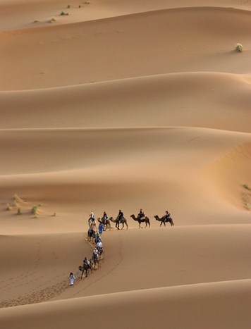
The early West African societies of Ghana, Mali, and Songhai all created empires that gained much of their wealth from trade. In this lesson, you will learn more about the role of trade as you explore Ghana, the first of West Africa’s empires.
The kingdom of Ghana lasted from sometime before 500 C.E. until its final collapse in the 1200s. It arose in the semidesert Sahel and eventually spread over the valley between the Senegal and Niger rivers. To the south was forest. To the north lay the Sahara. Today, this region is part of modern nations Mali and Mauritania (maw-reh-TAIN-ee-uh). The modern country of Ghana takes its name from the old kingdom, but it is located far to the south.
The earliest writings about the kingdom of Ghana come from Arab scholars. These scholars recorded information they had gathered from travelers to Ghana. By the time they began writing about Ghana in the 9th century, it was already a flourishing empire.
Historians do not know for certain how Ghana developed into an empire. Possibly, a group of warriors used iron weapons to defeat their neighbors. In fact, the word ghana means "war chief." We do know that control of trade, particularly the gold trade, made the king of Ghana and his people very wealthy. West Africans still sing songs about the majesty of ancient Ghana.
In this lesson, you will first learn about Ghana’s government and military. Then you will learn how Ghana’s people acquired wealth by participating in trans-Saharan trade. You will examine how trade led to Ghana’s wealth and success. Finally, you will find out how Ghana declined and a new empire, Mali, arose in West Africa.

Themes
Cultural Interaction Trade brought the cultures of West Africa and North Africa into contact, often with the mediation of Muslim merchants.
Political Structures Ghana was ruled by a powerful king who served as a military, judicial, and religious leader.
Economic Structures The power and wealth of Ghana was based on taxation of the trans-Saharan trade of gold and salt.
Human-Environment Interaction Salt and gold were natural resources which generated enormous trade and wealth in Ghana. The kingdom of Ghana declined when other natural resources grew scarce.

2. Ghana’s Government and Military
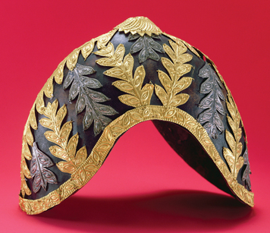
Arab scholars described Ghana as a fabled "land of gold." Their accounts paint a picture of a rich kingdom with a strong government and a large and powerful army.
The King and His Government Ghana was ruled by a powerful king. The king was the head of the army and had the final say in matters of justice. He also led the people in religious worship.
Ghana’s king acquired great wealth through control of the gold trade. Gold was especially plentiful in areas to the south of Ghana. As you will see, Ghana's government collected taxes on the gold that passed through the kingdom.
To preserve his wealth, the king tightly controlled the supply of gold. All the gold nuggets, or chunks, found in the kingdom had to be given to the king. Ordinary people could have only gold dust. One of the king’s gold nuggets is said to have weighed almost forty pounds. According to legend, another was large enough to be used as a hitching post for his horse.
Each day, the king held court with his people. The king arrived at court to the beating of royal drums. He was splendidly dressed in colorful robes, gold jewelry, and a cap decorated with gold. His people showed their respect for him by kneeling and throwing dust on their heads as he approached.
Once at court, the king conducted the business of his empire and heard the people’s concerns. One Arab historian described the scene at the court like this:
Behind the king stand ten pages [young servants] holding shields and swords decorated with gold and on his right are the sons of the vassal kings of his empire wearing splendid garments and their hair plaited [braided] with gold. The governor of the city sits on the ground before the king and around are ministers seated likewise. At the door . . . are dogs of excellent pedigree [ancestry] who hardly ever leave the place where the king is, guarding him. Round their necks, they wear collars of gold and silver.
A large group of officials was paid from the kingdom’s wealth to help the king govern. These officials were probably in charge of different parts of Ghana’s society, such as the armed forces, industry, tax collection, and foreigners. The king appointed governors to rule some parts of his empire, such as the capital city and some conquered areas.
When the king died, his son did not inherit the throne. The royal inheritance was matrilineal, which means that it was traced through women’s bloodlines rather than men’s. Therefore, in Ghana, the son of the king’s sister was the heir to the throne.
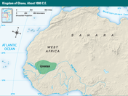
Ghana’s Military Ghana’s military included a regular army, reserve forces, and elite soldiers. The regular army was made up of several thousand career soldiers. They kept the borders secure, put down minor revolts, and maintained peace and order. These soldiers wore knee-length cotton pants, sleeveless tunics (long shirts), sandals, and headdresses adorned with feathers. The color of a soldier’s tunic and the number of feathers in his headdress indicated his rank. The soldiers used weapons such as spears, daggers, swords, battle clubs, and bows and arrows. They were well paid and highly respected.
During wartime, the king called up additional reserve forces and the troops of other governors under his rule. Every man in the empire was required to complete military training so that he would be ready to serve when called. Stories tell of a king who could call up an army of 200,000 warriors. This number no doubt grew as the story was passed on, but the king certainly could summon a sizable army.
Special groups of soldiers were selected for their courage, honesty, and intelligence. These soldiers served the king as bodyguards, escorts, and military advisors.

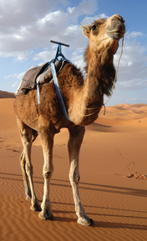
3. Trade: The Source of Ghana’s Wealth
Ghana was located between two areas that wanted to trade—North Africa and West Africa. Traders from North Africa crossed the Sahara with salt, copper, and cowrie shells—a type of seashell that was used as money. The merchants traded these and other goods for kola nuts, hides, leather goods, ivory, slaves, and gold from the southern forests of West Africa. Then they returned to North Africa, bringing the goods from the south to markets at home.
Ghana’s location allowed it to control this trans-Saharan trade. Traders going to and from the south had to pass through Ghana. Each time, they paid heavy taxes on their goods. These taxes helped to make Ghana rich.
The History of Trans-Saharan Trade Trans-Saharan trade has a long history. Archeologists have found evidence that North Africans brought back gold from the southern forests of West Africa as long ago as 400 to 500 B.C.E. Travel across the Sahara, however, was especially challenging for these early peoples.
Centuries later, two factors led to the growth of trans-Saharan trade. The first was the introduction of the camel to the Sahara. The second was the spread of Islam.
Camels were first brought to the Sahara by Arab traders around 300 C.E. These animals are well suited for desert travel. A camel can drink up to twenty-five gallons of water at a time. As a result, it can travel several days in the desert without stopping. Also, camels have double rows of eyelashes and hairy ear openings that help keep out blowing sand.
The introduction of camels allowed traders to establish caravan routes across the Sahara. By the 4th century C.E., large amounts of gold were being made into Roman coins in North Africa. It is likely that that gold came from West Africa.
Trade expanded even more because of the spread of Islam. In the 7th century, Muslims invaded Ghana’s empire. Besides wanting to convert West Africans to Islam, Muslims hoped to control trade in West Africa. Ghana turned back the invaders, but many Muslims settled in West African towns and became merchants.
Control of the trans-Saharan trade made Ghana wealthy and powerful. By the year 1000, Ghana’s empire dominated the trade routes between North and West Africa.
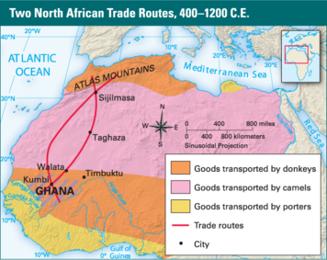
The Journey South The traders who traveled to West Africa faced a long, difficult journey. The trans-Saharan caravan routes began in North Africa along the northwestern border of the Sahara. From there they stretched across the desert, passed through Ghana, and continued south to the Gulf of Guinea and east to present-day Chad.
In 1352, a Muslim historian and traveler named Ibn Battuta (ib-ehn bat-TOO-tah) crossed the Sahara with a trade caravan. Battuta’s account of his trip shows what the traders’ journeys were like.
Battuta’s caravan began at the oasis city of Sijilmasa (see-jeel-MAH-sah), on the northern edge of the Sahara, in the foothills of the Atlas Mountains. Donkeys carried goods from Europe, Arabia, and Egypt to Sijilmasa from the Mediterranean coast. Then camel caravans took the goods south.
Battuta and his caravan stayed in Sijilmasa for a few months, waiting for the rainy season to end. When the watering places were full and there was grass for the animals to eat, the traders set out. The caravan traveled from oasis to oasis. Each day, the traders walked until the afternoon, when the sun was high in the sky. Then they rested until the sun went down.
Walking across the Sahara was challenging and dangerous. Caravans sometimes lost their way, and some traders died in the desert. During one stretch of Battuta’s trip, the travelers could not find water, so they slaughtered some of their camels and drank the water stored in the animals’ stomachs.
On its way through the desert, the caravan stopped at Taghaza, a village where salt mines were located. There, it took on a load of salt. When the traders reached the town of Walata, at the edge of the desert, they transferred their salt and other goods from the camels to donkeys and to porters, people who carry goods for a living. Then they continued south, passing through Ghana on their way to markets on the Gulf of Guinea, near the southern forests. The entire journey took about two months.

4. The Gold-Salt Trade
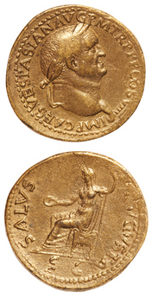
Many items were traded between North Africa and West Africa, but the two goods that were most in demand were gold and salt. The North Africans wanted gold, which came from the forest region south of Ghana. The people in the forests wanted salt, which came from the Sahara. Ghana made most of its money from the taxes it charged on the gold-salt trade that passed through its lands.
Wangara: The Secret Source of Gold Gold has long been a source of wealth in much of the world. In the time of Ghana’s empire, people in Muslim lands and in Italy made coins from gold. Muslims also needed gold to purchase silk and porcelain from China, which would accept only gold in exchange.
In an area known as Wangara, gold was plentiful. Wangara was located near the forests south of Ghana, but no one except the people of Wangara knew its exact location. The Wangarans kept the locations of their gold mines secret. According to ancient stories, merchants occasionally captured a gold miner and tried to force him to reveal the location of Wangara. The miners would give up their lives rather than reveal the secret.
In one story, after the capture of a miner, the Wangarans stopped trading for three years. They wanted to make sure no one had discovered Wangara’s location. To this day, no one knows for certain exactly where Wangara’s mines were located.
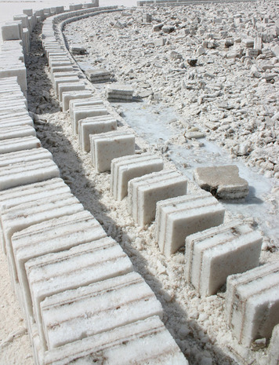
Taghaza: A Village Built with Salt To West Africans, salt was more precious than gold. Their culture had little use for gold, except as an item for trade. But they craved salt, and for good reason. Salt is an important part of a person’s diet. When people and animals perspire, or sweat, they lose salt in their perspiration. People who live in hot climates, like West Africa, perspire a lot and must replace the salt they lose. West Africans also needed salt to keep their food from spoiling and to give to their cattle. In addition, people liked the taste.
West Africans had no local source of salt. They had to obtain it from Taghaza and other places in the Sahara.
Salt was produced in two ways in the Sahara. One method was through evaporation. Water was poured into holes in the salty earth. The water slowly drew out the salt and then evaporated in the sun. The salt that remained was scooped out and packed into blocks. The second way to get salt was through mining. At Taghaza, salt deposits were found about three feet below the surface of the earth. Miners, enslaved by Arab merchants, reached the salt by digging trenches and tunnels. Then they cut it out in large blocks.
Taghaza would not have existed without salt. It was a dismal place, without crops or vegetation. People lived there for one purpose only: to mine and sell salt. Even the houses and mosque were built of salt blocks. Trade caravans passed through Taghaza on their way through the Sahara. There, they picked up salt to sell in Ghana and the southern forests. Because no food was produced in Taghaza, the miners had to rely on caravans to bring food, such as camel meat, dates, and a type of grain, called millet. If the caravans didn’t come, the miners starved.
Ghana’s System of Taxes Traders paid taxes to Ghana on all the goods they carried through the empire. Goods were taxed both when traders entered Ghana and when they left. Ghana charged one-sixth of an ounce of gold for each load of salt that came into the kingdom from the north. It then charged one-third of an ounce of gold for each load the traders took out of the kingdom to the south. The traders also paid taxes for carrying other types of goods. For every load of copper, they were charged five-eighths of an ounce of gold. They paid a little more than one ounce of gold per load of general merchandise.
The taxes enriched Ghana’s treasury. They also helped pay for armies that protected the kingdom and allowed the king to conquer other territories. Traders benefited as well, because Ghana secured the trade routes against bandits who might rob the caravans.

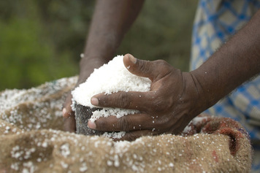
5. The Exchange of Goods
When trade caravans entered Ghana, they brought their goods to the great marketplace in the capital city of Kumbi. From there, they headed to the southern forests to trade with the Wangarans.
Kumbi had the busiest market in West Africa. Many local crafts-people sold their goods there. Ironsmiths sold weapons and tools. Goldsmiths and coppersmiths sold jewelry. Weavers sold cloth, and leatherworkers sold leather goods. There were blue blouses from Spain and robes from Morocco, in North Africa. People could also buy cattle, sheep, honey, wheat, raisins, dried fruit, ivory, pearls, and slaves. All goods, including slaves, were paid for with gold dust.
Kumbi had one of the largest slave markets in West Africa. The slaves were captured by raiders along the southern border of Ghana. Many were bought at Kumbi by Arab merchants, who took them across the Sahara and sold them to North Africans or Europeans.
Trade with the Wangarans took place along a river in the southern forests. Traders carried out their business using a system of silent barter, or trade. The caravans arrived bringing wool, silk, cotton, dates, figs, grains, leather, and salt. They spread out their goods along the river. The traders beat on a drum to announce that they were making an offer to trade. Then they walked several miles away from the site.
When the Wangarans heard the drum, they traveled to the site by boat. They put some gold dust next to the goods, beat a drum, and left. Later, the traders returned. If the amount of gold dust was acceptable, they took it and left. If not, they went away again and waited for the Wangarans to return and leave more gold dust. The groups bargained back and forth in this way without ever meeting in person.
This system of silent barter had two advantages. First, it allowed people who spoke different languages to trade. Second, it allowed the Wangarans to protect the secret location of their gold mines.

Summary
Trade played a key role in the growth of kingdoms and empires in West Africa. The first of these was Ghana.
Cultural Interaction The spread of Islam resulted in increased trade as Muslim traders settled in North African towns. Trade between North Africa and West Africa brought increased cultural contact. In Wangara a system of silent barter was developed, which allowed people who spoke different languages to trade with each other.
Political Structures Ghana was ruled by a powerful king who served as the military and religious leader and had final say in judicial matters. Government officials in charge of different aspects of government helped to govern. Ghana used its great wealth to build up its army, conquer other peoples, and build an empire.
Economic Structures Ghana became wealthy and powerful by taxing the trade that came through its kingdom. Gold from Wangara and salt from the Sahara region were especially important commodities. Ghana’s wealth paid for armies who secured trade routes, which made travel and trade safer and easier for merchants.
Human-Environment Interactions Ghana’s wealth was based on exploitation of natural resources. Gold was mined in West Africa and salt was produced in the Sahara, and these commodities were transported across Ghana. The introduction of camels as pack animals in this period allowed traders to cross the dry Sahara more easily than they had before. Ghana’s decline was brought about by the depletion of natural resources in their environment. Trees and water became scarce as the population grew, and people were forced to migrate to other areas.

6. The Decline of Ghana and the Rise of Mali
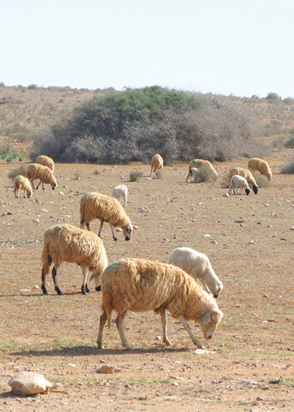
Ghana’s empire reached its height around the year 1000 C.E. War and the loss of natural resources led to the West African empire’s downfall, and the rise of a new power.
In the second half of the 11th century, Muslim warriors known as Almoravids began attacking Ghana’s empire. In 1076, they captured the capital city of Kumbi. Ghana’s king regained power in 1087, but the old empire had broken apart.
The loss of natural resources further weakened Ghana. The growing population had put great stress on scarce resources, such as trees and water. Trees were cut down to provide charcoal for iron-smelting furnaces. Water became so scarce that farmers could no longer grow crops and keep flocks. People were forced to leave in search of better conditions. The empire came to an end in 1203, when a rival kingdom took over Kumbi.
The end of Ghana’s empire opened the way to the rise of a new power, Mali. Around 1240, a group of West Africans called the Mande conquered Kumbi. Their homeland of Mali was south of Kumbi, closer to the Niger River. The Mande built an empire that reached from the Atlantic Ocean to beyond the Niger River, and from the southern forest to the salt and copper mines of the Sahara.
Like Ghana, Mali gained much of its wealth from the control of trade, particularly in gold. Its leaders had accepted Islam, and under their rule, the Muslim faith went on to become even more influential in West Africa.

