Unit 1: Collection 1
Vocabulary Development Skill Builder
The Most Dangerous Game Richard Connell
Activity 1: Semantic Mapping
Creating a semantic map can help you represent different types of word knowledge in graphic form. Based on the example, create a semantic map for each of these vocabulary words from “The Most Dangerous Game” on your own paper: receding, disarming, surmounted, invariably.
Example
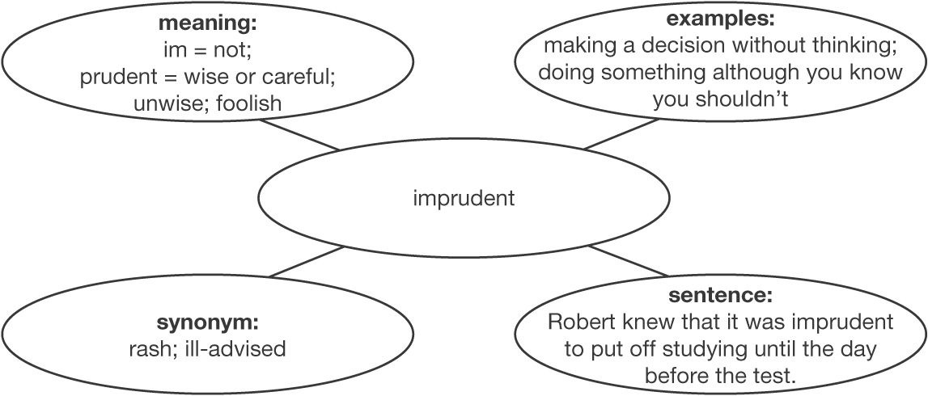
Activity 2: Exploring Deeper Meanings
Choose the statement that provides an accurate example of the meaning of the vocabulary word.
1. receding
A) The tide is going out and is moving away from the shore.
B) The young girl was dieting and her waist was growing smaller each day.
2. disarming
A) We wanted to believe what he said, but there was something about him that bothered us.
B) We were quite fearful at first, but his kind words soon put our minds at ease.
3. surmounted
A) Over the years she has had her share of problems, but she has been able to overcome them.
B) She had thoroughly memorized her speech, but I could tell she was still nervous when she went on stage.
Unit 1: Collection 1, Vocabulary Development continued
Activity 3: Changing Contexts
Each vocabulary word from “The Most Dangerous Game” is used at least once in the following sentences. Fill in each word where it best fits the context.
Example Robert was invariably late to every football game this year.
receding | disarming | imprudent | surmounted | invariably
4. It might be _______________________ of me to say so, but that interpreter does not seem to understand French.
5. The suspect was so _______________________ that no one suspected she had stolen the jewelry.
6. His hairline has been _______________________ for years now.
7. Every day I get up early to catch the bus, but I _______________________ miss it by mere seconds.
8. The temperature was so hot that we were relieved when the heat finally began _______________________.
9. The climber stayed determined and _______________________ the cliff face.
10. Marilyn decided to study acting, even though her family thought her decision was _______________________.

