New dietary guidelines mostly about moderation
By Associated Press, adapted by Newsela staff
01.11.16
WASHINGTON, D.C. — Some Americans might not have to cut back on eggs and salt as much as they once thought, and eating lean meat is still OK. But watch the sugars, especially the sugary drinks.
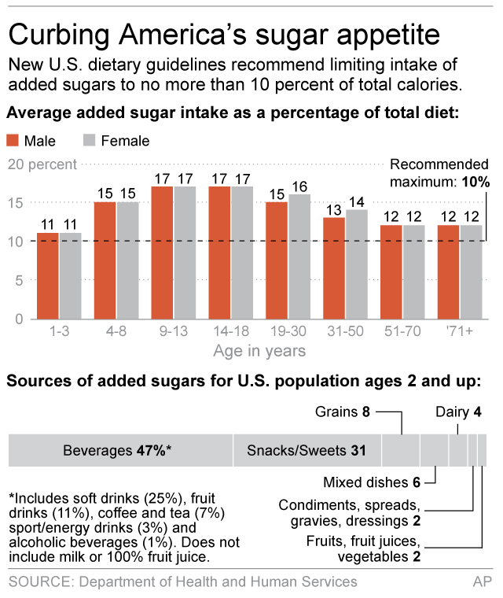
The Obama administration's new dietary guidelines, released on Jan. 7, back off from the strictest sodium rules included in the last version, while still asserting that Americans consume too much salt. The guidelines reverse previous guidance on the dangers of dietary cholesterol and add strict new advice on sugars.
After a backlash from the meat industry and Congress, the administration ignored several suggestions from a February report by an advisory committee of doctors and nutrition experts. That panel suggested calling for an environmentally friendly diet lower in red and processed meats. It also de-emphasized lean meats in its list of proteins that are part of a healthy diet.
But, as in the previous years, the government still says lean meats are part of a healthy eating pattern.

Helping Establish A Healthy Eating Style
Released every five years, the guidelines are intended to help Americans prevent disease and obesity. They cover everything from food package labels to subsidized school lunches to your doctor's advice. And the main message hasn't changed much over the years: Eat your fruits and vegetables. Whole grains and seafood, too. And keep sugar, fats and salt in moderation.
This year, one message the government wants to send is that people should figure out what type of healthy eating style works for them, while still sticking to the main recommendations. The Agriculture Department, which released the guidelines along with the Department of Health and Human Services, is also releasing a tweaked version of its healthy "My Plate" icon to include a new slogan: "My Wins."
"Small changes can add up to big differences," said Agriculture Secretary Tom Vilsack.

Added Sugars Subtract From A Healthy Diet
One new recommendation is that added sugar should be 10 percent of daily calories. That's about 200 calories a day, or about the amount in one 16-ounce sugary drink. The recommendation is part of a larger push to help consumers isolate added sugars from naturally occurring ones like those in fruit and milk. Added sugars generally add empty calories to the diet.
Sugar-sweetened beverages make up a large portion of those empty calories. According to the guidelines, sugary drinks account for 47 percent of the added sugars that Americans eat every day.
Americans also need to lower salt intake, the government says. New figures from the Centers for Disease for Disease Control and Prevention show that around 90 percent of people eat too much. The average person eats 3,400 milligrams of sodium a day, and the guidelines say everyone should lower that amount to 2,300, or about a teaspoon.

Restrictions Reduced On Sodium, Cholesterol
Lowering sodium intake was the major push of the 2010 guidelines, and that document recommended that those most at risk of heart disease, or about half the population, lower their intake to 1,500. The new guidelines eliminate that recommendation. Still, advice buried deeper in the guidelines says that those with high and borderline high blood pressure could benefit from a steeper reduction.
After years of doctors saying that Americans shouldn't eat too many eggs, recommendations for cholesterol have also shifted. The 2010 guidelines made a key recommendation that Americans consume less than 300 mg a day of dietary cholesterol, or about two eggs. That recommendation is gone, following increasing medical research showing the amount of cholesterol in your bloodstream is more complicated than once thought. Some more recent studies have shown little relationship between heart disease and how much dietary cholesterol one eats.
Still, egg lovers aren't completely off the hook. Discussion of cholesterol deeper in the document says "individuals should eat as little dietary cholesterol as possible while consuming a healthy eating pattern."

This Year's Guidelines Set Off A Political Debate
As in previous years, the report advises limiting saturated fats to 10 percent of total calories. And while lean meats are promoted, the government does suggest certain populations should reduce their meat intake and eat more vegetables. Data included in the report shows that males ages 14 to 70 consume more than recommended amounts of meat, eggs and poultry, while women are more in line with advised amounts.
While the guidelines always have been subject to intense lobbying by food industries, this year's version set off a new political debate. It was fueled by Republican claims that the Obama administration has gone too far in telling people what to eat.
Congress got involved, encouraging the administration to drop the recommendations based on environmental impact and at one point proposing to set new standards for the science the guidelines can use. That language did not become law, however. A year-end spending bill simply said the guidelines must be "based on significant scientific agreement" and "limited in scope to nutritional and dietary information."

