The Byzantine Empire

1. Introduction
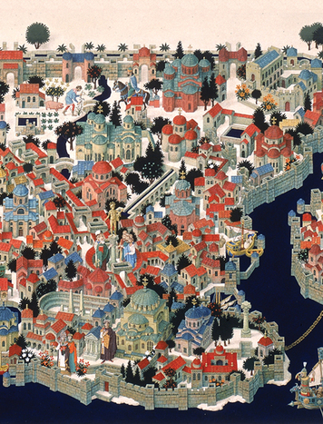
In this lesson, you will learn about the Byzantine Empire. This great empire lay in two continents, Europe and Asia. It lasted from about 500 to 1453 C.E., when it was conquered by the Ottoman Turks.
At first, the Byzantine Empire was the continuation of the Roman Empire in the east. In 330 C.E., the Roman emperor Constantine moved his capital from Rome to the city of Byzantium. This city was an old Greek trading colony on the eastern edge of Europe. Constantine called his capital New Rome, but it soon became known as Constantinople, which is Greek for “Constantine’s City.”
Later, control of the huge original empire was divided between two emperors—one based in Rome and one based in Constantinople. After the fall of Rome, the eastern empire continued for another 1,000 years. We call this the Byzantine Empire, after Byzantium, the original name of its capital city.
East and west remained connected for a time through a shared Christian faith. But the Church in the east developed in its own unique ways. It became known as the Eastern Orthodox Church. Over time, Byzantine emperors and Church officials came into conflict with the pope in Rome. The conflict eventually led to a permanent split between the Eastern Orthodox Church and the Roman Catholic Church.
In this lesson, you will learn about the Byzantine Empire, one of its greatest emperors, and its distinctive church. Let’s begin by exploring the empire’s capital—the fabulous city of Constantinople.

Themes
Cultural Interaction The Eastern Orthodox Church played a central role in daily life in the Byzantine Empire and inspired distinctive and magnificent art and architecture.
Political Structures The Byzantine state combined religion and government —the emperor also had supreme authority over the Eastern Orthodox Church and was considered God’s representative on earth.
Economic Structures The Byzantine Empire prospered through trade and Constantinople became the wealthiest city in the Mediterranean region.
Social Structures Although a small minority became fabulously wealthy through trade, most people in the Byzantine Empire lived in poverty.
Human-Environment Interaction Constantinople prospered in part due to its strategic location at the crossroads between Europe and Asia.

2. Constantinople
Constantinople [Constantinople: the city on the eastern edge of Europe, which Constantine made the capital of the Roman Empire in 330 C.E.] was more than 800 miles to the east of Rome. Why did Constantine choose this site to be the capital of the Roman Empire?
One reason was that the site was easy to defend. It was surrounded on three sides by water. The Byzantines fashioned a chain across the city’s harbor to guard against seafaring intruders. Miles of walls, fortified by watchtowers, and gates discouraged invasion by land and by sea.
Constantinople also stood at the crossroads of Europe and Asia, and the many sea and overland trade routes linking east and west. During the Byzantine Empire [Byzantine Empire: the name for the eastern Roman Empire, located at the crossroads of Europe and Asia; it lasted from about 500 to 1453 C.E.] , this special location helped to make the city, and some of its citizens, very wealthy. For more than 700 years, Constantinople was the richest and the most elegant city in the Mediterranean region. Ivory, silk, furs, perfumes, and other luxury items flowed through its markets. A French soldier who saw the city in 1204 exclaimed, “One could not believe there was so rich a city in all the world.”
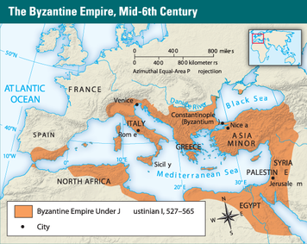
At its height, Constantinople was home to around one million people. The city’s language and culture were Greek, but traders and visitors spoke many languages. Ships crowded the city’s harbor, loaded with goods. The city streets, some narrow and twisting, some grand and broad, teemed with camel and mule trains.
Life in Constantinople was more comfortable than in Western Europe. The city boasted a sewer system, which was quite rare in medieval times. Social services were provided by hospitals, homes for the elderly, and orphanages.
Despite the luxuries enjoyed by the rich, many people lived in poverty. The emperor gave bread to those who could not find work. In exchange, the unemployed performed such tasks as sweeping the streets and weeding public gardens.
Almost everyone attended the exciting chariot races at a stadium called the Hippodrome. Two chariot teams, one wearing blue and the other green, were fierce rivals. In Constantinople and other cities, many people belonged to opposing groups called the Blues and Greens after the chariot teams. At times the rivalry between Blues and Greens erupted in deadly street fighting. But in 532, the two groups united in a rebellion that destroyed much of Constantinople. You will find out what happened in the next section.

3. The Reign of Justinian I
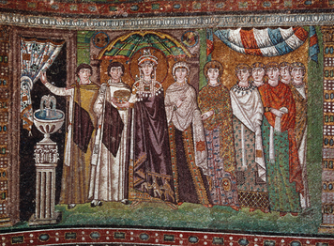
One of the greatest Byzantine emperors was Justinian I, whose long reign lasted from 527 to 565. But Justinian’s reign nearly came to an abrupt end much sooner. In January 532, the emperor and his beautiful wife, Theodora, were attending chariot races at the Hippodrome. In the past, Blues and Greens among the spectators had often fought with each other. This time, however, both groups were upset over the arrests of some of their members. To Justinian’s horror, they united in denouncing him. Fighting broke out, spilled into the streets, and escalated into a full-scale rebellion.
The rioting continued for a week while Justinian and Theodora hid in the palace. Much of the city was in flames. Justinian’s advisors wanted him to flee the city. Theodora, however, urged him to stay and fight. With her encouragement, Justinian put down the revolt. According to the official court historian, Procopius (pro-KOH-pee-us), 30,000 people were killed in the fighting. The city of Constantinople lay in ruins.
Justinian was determined to rebuild the city on a grand scale. He put huge sums of money into public works. Soon, Constantinople had new bridges, public baths, parks, roads, and hospitals. The emperor also built many grand churches, including the magnificent Hagia Sophia (AH-ee-yah SOH-fee-uh). Its name is Greek for “Holy Wisdom.” Today, this great structure is one of the most famous buildings in the world.
Besides rebuilding Constantinople, Justinian tried to reclaim some of the Roman Empire’s lost territory. He launched military campaigns that, for a time, took back parts of North Africa, Italy, and Spain.
Justinian is most famous, however, for creating a systematic body of law. Under his direction, a committee studied the thousands of laws the Byzantines had inherited from the Roman Empire. They revised outdated and confusing laws. They also made improvements, such as extending women’s property rights. The result of their work is known as Justinian’s Code. It became the basis for many legal codes in the western world.
Procopius, the court historian, wrote glowing accounts of Justinian’s achievements. But he also wrote the Secret History, in which he called the emperor “a treacherous enemy, insane for murder and plunder.” Throughout Byzantine history, distrust and divisions often plagued the imperial court. Justinian’s court was no exception.

4. The Eastern Orthodox Church
To the Byzantines, Christianity was more than a religion. It was the very foundation of their empire.
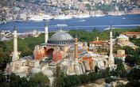
When Constantine built his new capital, he intended it to be the religious center of the empire, as well as the seat of government. Constantine himself tried to settle religious disputes by assembling a council of bishops.
Over time, the Byzantine Church separated from the Church in Rome and became known as the Eastern Orthodox Church [Eastern Orthodox Church: a Christian religion that developed out of early Christianity in the Byzantine Empire] . The word orthodox means “in agreement with right belief.” The leaders of the medieval Eastern Orthodox Church thought that their church was based on a set of beliefs that they could trace back to Jesus Christ and to the work of bishops in early Christian councils.
The Role of the Eastern Orthodox Church in the Empire Religion and government were more closely linked in the Byzantine Empire than in the west. The Byzantines viewed the emperor not just as the head of the government but as the living representative of God and Jesus Christ. This meant that church and state were combined into one all-powerful body.
The state religion also united people in a common belief. The Eastern Orthodox Church played a central role in daily life. Most people attended church regularly. Religious sacraments gave shape to every stage of the journey from birth to death. Monasteries and convents cared for the poor and the sick. These institutions were supported by wealthy people and became quite powerful. Let’s look at some of the practices of Eastern Orthodoxy.
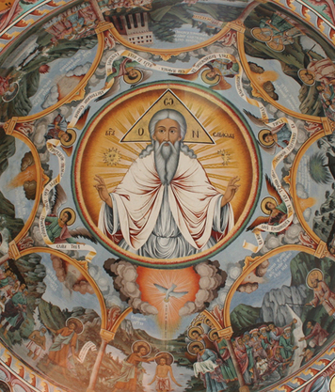
Church Hierarchy Like Roman Catholic clergy, Orthodox clergy were ranked in order of importance. In Byzantine times, the emperor had supreme authority in the Church. He selected the patriarch [patriarch: in the Eastern Orthodox Church, the bishop of an important city] of Constantinople, who ranked just below him in matters of religion.
Unlike the pope in the west, the patriarch did not claim strong authority over other patriarchs and bishops. Instead, he was “first among equals.” The patriarch of Constantinople (modern Istanbul, Turkey) still holds this honor.
Orthodox priests served under patriarchs and other bishops. Unlike Roman Catholic priests, who were not allowed to marry, many Orthodox priests were married. Bishops, however, could rise only from the ranks of unmarried clergy.
Liturgy and Prayer The Orthodox Church service corresponding to the Roman Catholic mass was the Divine Liturgy. Both the clergy and worshippers sang or chanted the liturgy, or form of public worship. The liturgy was conducted in Greek or in the local language.
Orthodox Christians also prayed to saints. Two saints were particularly important. Saint Basil promoted charity and reformed the liturgy. Saint Cyril helped create the Cyrillic (sih-RIL-ik) alphabet, which allowed scholars to translate the Bible for people in Eastern Europe.
Architecture and Art Christian faith inspired magnificent architecture and artwork in the Byzantine Empire. With its square base and high dome, the cathedral Hagia Sophia served as a model for many Orthodox churches. The architecture of the church also reflects Orthodox views. The simple base represents the earthly world. Upon it rests the “dome of heaven.” Rich decorations on the inside were meant to remind worshippers of what it would be like to enter God’s kingdom.
Building on the Greek love of art, the Orthodox Church used many images in its services and prayers. Byzantine artists created beautiful icons, which were usually painted on small wooden panels. Artists also fashioned sacred images as mosaics and painted them in murals.
An image of Christ as the Pantocrator, or ruler of all, gazed down from the domes of all Orthodox churches. Most churches also displayed an icon of Jesus’s mother, Mary (called the Theotokos, or god-bearer) and the Christ child over the altar.
Many Byzantines believed that sacred pictures brought them closer to God. But later, icons also became a source of violent disagreement.

5. Conflict Between East and West
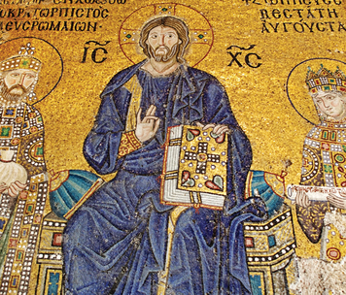
Medieval Europe and the Byzantine Empire were united in a single faith, Christianity. Over the centuries, however, cultural, political, and religious differences brought the two parts of the old Roman Empire into conflict.
The two regions had been quite different even in the days of the early Roman emperors. The eastern half of the empire had many cities, much trade, and great wealth. The western half was mostly rural and agricultural, and not nearly as wealthy.
Other differences became more pronounced after the fall of Rome. Byzantine culture was largely shaped by its Greek heritage. The west was influenced by Frankish and Germanic cultures. In the city of Constantinople, people spoke Greek. In the west, Latin was the language of scholars, diplomats, and the Church.
Perhaps most important was the conflict that developed between the churches of east and west. After the fall of Rome, popes gradually emerged as powerful figures in western Europe. The popes claimed supreme religious authority over all Christians. The emperors and patriarchs of the east did not claim that power.
Other differences added to the conflict. Let’s look at three major disagreements and how they led to a split in the Christian Church.
Iconoclasm The first major disagreement concerned religious icons. Many Christians in medieval times used images of Jesus, Mary, and the saints in worship and prayer. Some Christians in the east, however, believed that people were wrongly worshipping the icons as if they were divine. In 730 C.E., Byzantine emperor Leo III banned the use of religious images in all Christian churches and homes.
This policy of iconoclasm (“icon smashing”) led to the destruction of much religious art. Throughout Christian lands, people cried out in protest. In Rome, Roman Church leaders were angry because Leo’s order applied to parts of Italy that were under Byzantine control. Pope Gregory III even excommunicated the emperor.
The Byzantine Empire lifted its ban on icons in 843. But the dispute over iconoclasm had caused a major split between the east and west. It also helped drive popes in Rome to look for support and protection against enemies.
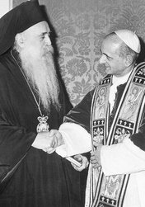
The Crowning of a Holy Roman Emperor Another major disagreement occurred in 800 C.E. At the time, Empress Irene was the ruler of the Byzantine Empire. Because she was a woman, Pope Leo III did not view her as true or strong enough to govern. He wanted the protection of a strong leader to help defend the Church in the west.
Instead, Leo decided to crown Charlemagne, the king of the Franks, as Holy Roman emperor. The pope’s action outraged the Byzantines, who felt that their empress was the rightful ruler of the remains of the Roman Empire.
The Final Break Matters between east and west came to a head in 1054. The patriarch of Constantinople, Cerularius, wanted to reassert Byzantine control of the Church. He closed all churches that worshipped with western rites. Pope Leo IX was furious. He sent Cardinal Humbert to Constantinople. The cardinal marched up to the altar of Hagia Sophia. In front of everyone, he laid down a bull (a proclamation by the pope) excommunicating Cerularius.
Cerularius responded by excommunicating the cardinal. This was only a symbolic act, for the patriarch did not have that power. But it showed that the split, or schism, between east and west was complete. Despite future attempts to heal the division, the Eastern Orthodox Church and the Roman Catholic Church were now separate churches.

Summary
In this lesson you learned about the founding of the Byzantine Empire and the Eastern Orthodox Church.
Cultural Interaction The largely Greek culture of the Byzantine Empire was influenced by the European and Asian cultures it encountered through trade. The Eastern Orthodox Church had a tremendous influence on everyday life and inspired magnificent art forms—domed churches like the Hagia Sophia, painted icons and mosaics. In the 700s, however, conflict arose with the western church over the use of icons.
Political Structures Church and state were combined in the Byzantine Empire. The emperor was also the head of the Eastern Church and was viewed as the representative of God on earth. In the 500s the emperor Justinian reformed the laws of the empire by creating a systematic body of law, known as Justinian’s Code. It became a foundation for the law of the western world.
Economic Structures Extensive trade made the Byzantine Empire wealthy. Luxury goods such as ivory, silk, furs, and perfumes were especially important. The Byzantine Empire at this time was relatively wealthy and urban compared to western Europe, which was much poorer and more rural.
Social Structures A small minority in the Byzantine Empire became fabulously wealthy from trade, but a majority remained poor. In Constantinople hospitals, homes for the elderly, and orphanages provided social services for the poor.
Human-Environment Interaction Constantinople became a wealthy and prosperous city in part due to its central location at the crossroads of trading routes between Europe and Asia.

