1. Introduction
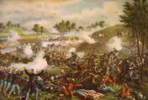
Wilmer McLean was about to sit down to lunch with a group of Confederate officers on July 18, 1861, when a cannonball ripped through his roof. It landed in the stewpot, scattering stew all over the kitchen.
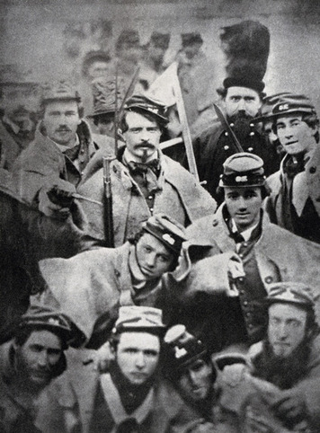
This was more than McLean had bargained for when he moved his family to a farm in the country. McLean had been a prosperous merchant in Alexandria, Virginia, just outside Washington, D.C. When he retired, he decided to move to the countryside for some peace and quiet. He bought a farm outside the small village of Manassas Junction, Virginia. The farm was comfortable and pleasant, with fields, woods, and a small stream called Bull Run. Unfortunately for McLean, Manassas was also the site of an important railroad junction. These rail lines made Manassas a strategic location in the Civil War—one that both the North and the South wanted to control.
Since the shelling of Fort Sumter in April 1861, the North and the South had been in a state of war. However, there had been no major combat since that first engagement. Then, in mid-July, the two opposing armies gathered their forces near McLean's farm.
Three days after the cannonball landed in McLean's kitchen, the First Battle of Bull Run began. The fighting raged across McLean's land for hours, but by afternoon, the Union forces were in full retreat. In the Union army, this embarrassing flight would be remembered as "the great skedaddle." A year later, another battle took place on McLean's farm. At that point, McLean decided to leave Manassas and find a safer place to live.
The McLean family relocated to the south in a small Virginian town called Appomattox Court House. McLean hoped that the town's remote location would keep the war away from his doorstep. But as you will read later in this chapter, he did not get his wish. Wilmer McLean had one more important role to play in the Civil War.

2. Four Long Years of War
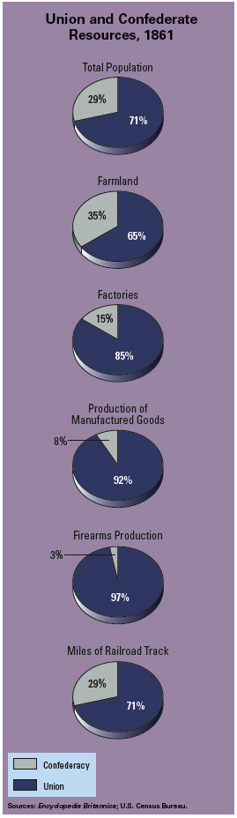
At the time of the Confederate attack on Fort Sumter in April 1861, seven states had seceded from the Union. In the months that followed, the eight slave states in the Upper South faced a difficult decision—to secede or not. Finally, four of them—Maryland, Delaware, Kentucky, and Missouri—remained in the Union, but not without serious reservations. The country, now formally divided between the Union and the Confederacy, braced for war.
The Advantages of the Union and the Confederacy As the war began, both sides were confident of a quick victory. Northerners were certain they could overwhelm the South with their superior resources. Not only did the Union have more than twice as many people than the South, but it also had a much more diverse economy. The North outstripped the South in farm production, factories, naval force, and railroad lines, which were crucial for moving troops and supplies.
Yet Southerners were optimistic. They had the advantage of fighting a defensive war on their own soil, as well as outstanding military leadership. All they had to do to win was push back invading Union forces. Before long, they believed, the Union would tire of battle and leave the Confederacy in peace.
Believing their cause was just, volunteers on both sides rushed to enlist. The 70,000 new troops that marched into battle on Wilmer McLean's farm in 1861 were certain the other side would collapse at the first whiff of gunpowder. The realities of the First Battle of Bull Run, however, destroyed such illusions. Although the South won the day, their victory did not come easily. For the North, the defeat at Bull Run was a harsh wake-up call.
The Anaconda Plan Begins to Squeeze the Confederacy After Bull Run, President Abraham Lincoln realized he had to plan for a long war. With General Winfield Scott, he devised a strategy that came to be known as the Anaconda Plan. As the name suggests, the idea was to surround the South and squeeze it to death, like an anaconda snake crushing its prey.
To accomplish this goal, the Union planned to set up a naval blockade—a line of ships stopping sea traffic in and out of Southern ports. The blockade would keep the South from trading its cotton in Europe for the war supplies it needed. Next, the Union navy would take control of the Mississippi River, separating Texas, Louisiana, and Arkansas from the rest of the South. From there, the Union army would move east to squeeze the life out of the Deep South. Finally, Union forces would invade Virginia and lop off the enemy's head, in this case the Confederate capital of Richmond.
The Union enjoyed early success with the first two steps in the plan. The navy blockaded Southern ports and stopped most trade. It also seized New Orleans and began to move up the Mississippi River. At the same time, Union forces commanded by General Ulysses S. Grant fought their way south toward the Mississippi. Along the way, Grant won decisive battles that brought much of Tennessee under Union control.
Not everything went the North's way, however. The Union navy's push up the Mississippi was blocked at Vicksburg, a key city on the river. Union armies also failed to take Richmond, despite a major offensive in the summer of 1862. The Confederate capital remained safe from Union forces for two more years.
Antietam: The Bloodiest Day of the War
After Union forces failed to capture Richmond, the South tried to turn the tables on the North. The top Confederate general, Robert E. Lee, decided to invade Union territory by crossing into Maryland. He hoped this show of strength would persuade Maryland to join the Confederacy. He also hoped that major victories on Union soil would encourage Great Britain and France to give aid to the Confederacy.
After crossing the Potomac River, Lee's army clashed with Union forces on September 17, 1862, at Antietam Creek, near Sharpsburg, Maryland. The Battle of Antietam was the bloodiest one-day battle in American history, with more than 20,000 soldiers killed or wounded. One soldier recalled, "I have never in my soldier['s] life seen such a sight. The dead and wounded covered the ground." Despite the enormous human cost, the battle ended in a stalemate, and Lee retreated back across the Potomac into Virginia.
Although the Battle of Antietam was not decisive, it was a turning point in the war. Not only had Lee's invasion of the North failed, but he had also lost a quarter of his army in the effort. European countries remained reluctant to recognize or assist the Confederacy. Furthermore, Lee's failure gave Lincoln the chance to take a step that would change the course of the war.
The Emancipation Proclamation Changes Union War Aims Although Lincoln opposed slavery, he refused at first to make abolition a war aim. "My paramount object in this struggle is to save the Union," he wrote, "and is not either to save or destroy slavery." But as the war dragged on, Lincoln decided that tying the war effort to emancipation—freeing the slaves—made sense.
Calling for the end of slavery, Lincoln knew, would link the war to a moral cause in the North. It would also win support in Europe, where opposition to slavery was strong. Freeing the slaves could also deprive the South of part of its workforce. In fact, since the start of the war, thousands of slaves had freed themselves by running away to the Union lines. News of these runaways may have influenced Lincoln's decision to call for the emancipation of all slaves.
A few days after Antietam, Lincoln issued a warning to the Confederate states: Return to the Union by January 1, 1863, or he would free their slaves. The Confederacy ignored the warning, and on January 1, Lincoln signed the Emancipation Proclamation, which declared all slaves living in states "in rebellion against the United States" to be "thenceforward, and forever free." Slaves living in areas loyal to or under Union control were not affected.
The Emancipation Proclamation had little immediate effect, because the Confederacy ignored it. Nevertheless, it gave the Union a great moral purpose and signified that a Union victory would mean the end of slavery.
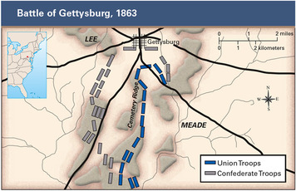
Turning the Tide: Vicksburg and Gettysburg To hasten that victory, General Grant continued to battle his way toward the Mississippi River. In May 1863, he arrived at the Confederate stronghold of Vicksburg, Mississippi, and settled in for a long siege. For six weeks, his troops shelled the city from one side, while Union gunboats battered it from the other. The Confederates dug caves into the hillsides and tried to ride it out. But eventually, they gave in. On July 4, the Confederate army at Vicksburg surrendered, and the Union finally gained control of the Mississippi.
Meanwhile, another great battle was underway in the village of Gettysburg, Pennsylvania. It began when General Lee invaded the North a second time. On July 1, 1863, his army of approximately 75,000 troops met a Union force of about 95,000 just west of the town. The Battle of Gettysburg lasted for three terrible days. At first, Lee's troops held their position, but on July 3, they suffered devastating losses and were forced to retreat. More than 50,000 soldiers were killed or wounded. Having lost a third of his army, Lee would not attack the North again but would fight a defensive war only. For the North, this victory marked a major turning point in the war.
Several months later, President Lincoln visited Gettysburg. There he gave one of the most stirring speeches in American history, the Gettysburg Address. Lincoln noted that the war was testing whether a nation "conceived in liberty, and dedicated to the proposition that 'all men are created equal' . . . can long endure." He then declared that the nation would endure and that out of war would come a "new birth of freedom."
Total War Forces the South to Surrender After the defeats at Gettysburg and Vicksburg, Southerners continued to defend their land fiercely, despite dwindling resources. To force a Confederate surrender, General Grant adopted a policy known as total war, which called for doing whatever was necessary to undermine the enemy's willingness or capacity to fight. To implement this policy, Grant adopted a two-pronged strategy. He would lead his forces into Virginia to engage Lee's army and take the Confederate capital of Richmond. Meanwhile, another Union general, William Tecumseh Sherman, would wage a campaign of destruction through Georgia and the Carolinas.
Sherman was a battle-hardened veteran who believed in total war. "We cannot change the hearts of these people of the South," he said, "but we can make war so terrible . . . and make them so sick of war that generations [will] pass away before they again appeal to it." In May 1864, he marched his troops southward from Tennessee with orders to inflict "all the damage you can."
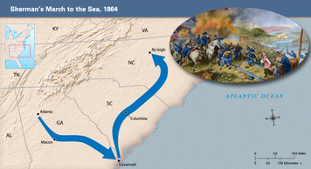

In September, Sherman captured Atlanta and burned much of it to the ground. He then continued toward the coast. During Sherman’s March to the Sea, his troops destroyed everything they found of value. They looted houses, burned fields, and killed livestock. After taking the port city of Savannah, Georgia, Sherman turned north and swept through the Carolinas.
While Sherman waged total war, Grant and Lee were locked in fierce combat in Virginia. Despite heavy losses, Grant continued on toward Richmond. On April 3, 1865, he captured the capital. With his army surrounded, Lee was finally forced to surrender.
On April 9, Lee and Grant met at the village of Appomattox Court House. Oddly enough, their meeting took place in the house of Wilmer McLean, the same man whose farm in Manassas had been the site of the first real battle of the war. As McLean later said, "The war started in my front yard and ended in my parlor." The terms of surrender Grant offered Lee were generous. Confederate officers could keep their weapons. Any officers or troops who claimed their own horses could keep them. Most important, "Each officer and man will be allowed to return to his home, not to be disturbed by the United States authorities." At long last, the Civil War was over.

3. Challenges Facing Government Leaders
While the war raged, leaders in both the Union and the Confederacy faced enormous challenges. Not only did they have to mount a huge military effort, but they also had to find ways to pay for a long war. In addition, they had to shore up public support for an increasingly unpopular struggle.
Lincoln's Balancing Act President Lincoln was elected in 1860 without getting a majority of the popular vote. Because his base of support was so thin, he faced daunting political problems as he tried to hold the Union together. His every move was criticized by political opponents and an often-hostile press.
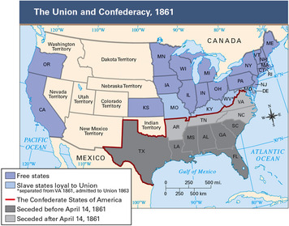
Early in the war, one of Lincoln's top priorities was to keep the border states of Maryland, Delaware, Kentucky, and Missouri in the Union. Maryland, in particular, was crucial, because it surrounded Washington, D.C., on three sides. At the start of the war, pro-secession mobs attacked a Union regiment as it passed through Baltimore. Lincoln sent in troops and suspended the constitutional right of habeas corpus—the right of a person to appear in court so a judge can determine whether the person is being imprisoned lawfully. Suspending this right allowed the Union to jail suspected opponents without charge and to hold them indefinitely. Lincoln's policy was harsh, but he saw it as necessary to keep Maryland and neighboring Delaware from seceding.
The question of emancipation posed even more challenges for Lincoln. Although abolitionists pressured him to end slavery immediately, he resisted for fear of alienating the border states or angering those in the Union who did not support abolition. After it became apparent to him that emancipation was necessary, he waited until he could make his announcement from a position of strength. Even then, he made sure that his proclamation did not cover slaves in states loyal to the Union. Although that decision upset the abolitionists, they still regarded the Emancipation Proclamation as a major step forward.
As the war dragged on, Lincoln faced other difficulties. One was finding enough men to fight. Lacking sufficient volunteers, Congress enacted a military draft in 1863. The draft law required all white men between the ages of 20 and 45 to report for military duty. However, the law had loopholes. For $300, a man who did not want to serve could buy his way out of the draft, or he could hire a replacement to serve in his place. This meant that affluent Northerners could avoid service, while the poor went off to war.
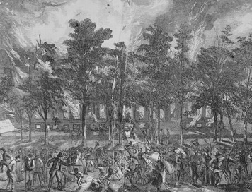
Anger over the new law triggered rioting in New York and other cities. Bitter about being drafted to free slaves, the New York City rioters directed their rage at African Americans. Estimates of casualties in the New York City draft riots ran as high as 1,000 killed and wounded.
President Lincoln also faced the challenge of leading a Union that was far from united. One wing of the Democratic Party did not believe the cost of the war—in lives, money, and civil liberties—was justified. These Democrats also did not see emancipation as a worthy war objective. Republicans nicknamed these critics Copperheads, after a poisonous snake. "Every victory of the government they lament as a defeat of their party," wrote a Philadelphia observer. "In every success of the rebels they see a party victory and hail it with triumph."
Challenges for Southern Leaders Confederate president Jefferson Davis also faced challenges in raising an army. In 1862, the South had passed America's first draft law. Like the Northern version that came later, this law included a loophole that allowed rich plantation owners to avoid military service. This issue prompted complaints of it being a "rich man's war but a poor man's fight." Some Southern states tried to evade the law, calling it an assault on states' rights.
The main challenge for Davis and other Confederate leaders, however, was figuring out how to pay for the war while keeping the Southern economy afloat. Prior to the war, the South had relied on cotton sales for most of its income. Much of that cotton was shipped to Europe, especially to Great Britain, where it played a key role in the textile industry. When the war began, the South placed an embargo on cotton exports in an attempt to force Great Britain and other European countries to recognize the Confederacy and assist it with arms and money. But Southern leaders failed to realize that Great Britain already had a surplus of cotton and was developing new sources of supply. Thus, the cotton embargo failed to prompt European action, and the South lost valuable export income.
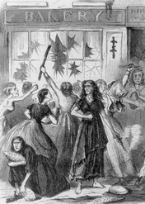
Without income from cotton sales, the South could not import the goods it needed to fight a long war. That problem was exacerbated by the Union naval blockade. Shortages of goods soon led to rising prices. Between 1860 and 1863, food prices in the South rose by more than 1,000 percent. Bacon went from 12 cents a pound to $1.50 and butter from 23 cents a pound to $3.00. With their purchasing power eroding day by day, Southerners lost faith in the Confederate currency. "An oak leaf," said a Georgian in 1863, "will be worth just as much as the promise of the Confederate treasury to pay one dollar."
As these economic problems hit home, Southerners began to show signs of discontent. They complained about high prices and a lack of food for the poor. They also accused wealthy Southerners of hoarding goods. At times, their anger erupted into violence.
In April 1863, a bread riot broke out in Richmond, Virginia. Hundreds of women rampaged through downtown, breaking windows and stealing food, shoes, and other goods. According to one account, President Davis confronted the women. "You say you are hungry and have no money," he said. "Here is all I have." He dug into his pockets and flung coins into the crowd. Then he threatened to have troops open fire if the rioters did not leave. The women went home, but other similar riots broke out in towns and cities across the South.

4. The Effect of the War on Soldiers

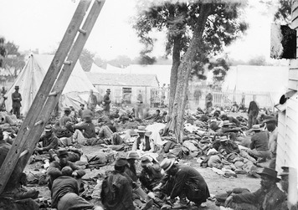
Around 3 million men fought in the Civil War. As many as a third of these soldiers died or were wounded in battle. Even for those who escaped without injury, the war exacted a tremendous cost. Soldiers had to leave their homes and families for up to four years while enduring numerous hardships.
New Weapons Make Battle More Deadly The Civil War was an extremely brutal and destructive conflict. One reason for this was the development of new and deadlier weapons, such as the rifled musket. Unlike the old smoothbore musket, this gun had grooves on the inside of the barrel that caused the bullet to spin, allowing it to travel much faster, farther, and with greater accuracy. Improved cannons with explosive shells also allowed armies to unleash a hail of artillery fire on their opponents.
These new weapons were deadly enough, but poor battlefield tactics exacerbated their effects. Instead of spreading troops out to make them difficult to target, generals massed the soldiers together for large frontal assaults on enemy lines. This tactic had worked well enough in previous wars, when guns were less accurate. But in the Civil War, snipers who were dug into defensive positions could mow down a line of charging troops with ease, even at great distances. This mismatch of new weapons with old tactics led to incredibly bloody battles, like the one at Antietam.
Civil War battles were typically chaotic, terrifying events. Fifty years later, a former soldier could still recall the awful sound of battle:
The screaming and bursting of shells, . . . the death screams of wounded animals, the groans of their human companions, wounded and dying and trampled underfoot by hurrying batteries, riderless horses and the moving lines of battle . . . a perfect hell on earth.
—Unknown Union soldier, describing the Battle of Gettysburg
Battles often took place in open fields. But sometimes, as the following soldier describes, the battles occurred in wooded areas, where the enemy was hard to spot:
No one could see the fight fifty feet from him. The lines were very near each other, and from the dense underbrush and the tops of trees came puffs of smoke, the "ping" of the bullets and the yell of the enemy. It was a blind and bloody hunt to the death, in bewildering thickets, rather than a battle.
—Unknown Union soldier, describing the Battle of the Wilderness, 1864
Although men on both sides fought with courage, it was the rare soldier who eagerly sought conflict. As one put it, "When bullets are whacking against tree trunks and solid shots are cracking skulls like egg-shells, the consuming passion in the breast of the average man is to get out of the way."
Medical Care on the Battlefield Many soldiers who were wounded in battle died where they fell. Those who were rescued often faced a grim fate in the hands of military doctors. In the 1860s, medical knowledge was quite limited. Doctors did not know how to treat many diseases, nor did they understand the causes of infection and the need for sanitary procedures in surgery.
Battlefield surgeons often worked in clothes covered with blood. They wiped their hands and surgical tools on their jackets or dipped them in dirty water between operations. One of their most common tools was the bone saw, which was used to perform amputations. Because musket balls typically shattered bones on impact, doctors had little recourse but to remove whole limbs, often without anesthesia. Piles of arms, legs, and feet would stack up outside medical tents.
Poor hygiene was another major problem in camp. Soldiers often pitched their tents near open latrines and bathed in the same water that they used for drinking. These practices encouraged the spread of disease. For every soldier who died in battle, an estimated two or three more died of disease from unsanitary conditions in camp.
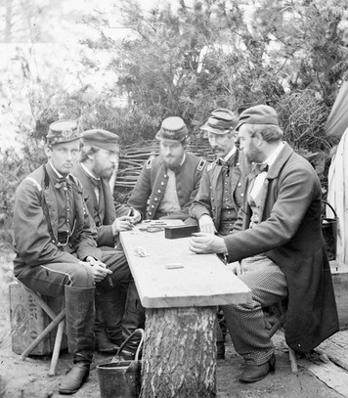
Keeping Busy Between Battles The life of soldiers was not all about the horrors of war. Most of their time was spent away from combat. On average, for every day of battle, they spent 50 days hanging around the camp. When they were not marching or drilling, the men usually had a lot of time on their hands.
To stay occupied in camp, soldiers on both sides pursued various pastimes. Reading was a common activity. Many soldiers were particularly interested in newspapers from home. Soldiers also wrote letters to their loved ones, played cards, and went swimming. Hunting and fishing were popular, as were sports like baseball and wrestling. Soldiers even performed magic shows, skits, and plays for their campmates. One Confederate production, called "Medical Board," satirized army doctors and their fondness for amputation.
Music played a special part in the lives of soldiers. To raise their spirits before battle, they sang patriotic songs like "The Battle Cry of Freedom" and "Dixie." Most of the time, however, they preferred traditional folk songs and sentimental ballads. They also made up songs about the hardships of war and the tedium of camp life. One mournful song, "Weeping Sad and Lonely," was a favorite among homesick troops on both sides.
Weeping, sad and lonely,
Hopes and fears how vain! . . .
When this cruel war is over,
Praying that we meet again.
—Henry Tucker, 1863
When Union and Confederate forces were camped near each other, as sometimes happened, troops from both armies might even join in songs together, their voices echoing across the distance between their camps.

5. The Effect of the War on African Americans
Although the war started as a conflict over states' rights and a fight to preserve the Union, at heart it was a struggle over the future of slavery. As former slave and abolitionist leader Frederick Douglass wrote,
The Negro is the key to the situation, the pivot upon which the whole rebellion turns . . . This war, disguise it as they may, is virtually nothing more or less than perpetual [everlasting] slavery against universal freedom.
—Frederick Douglass, 1861
The Promise of Freedom Stirs African Americans Although the Emancipation Proclamation did not free any slaves when it was issued, it did cause great rejoicing among African Americans in the North. Many saw emancipation as the first step toward gaining equal rights for blacks. One man described the ecstatic response he saw at a public reading of the proclamation in Washington, D.C.:
Men squealed, women fainted, dogs barked, white and colored people shook hands, songs were sung, and by this time cannons began to fire . . . and follow in the wake of the roar that had . . . been going on behind the White House . . . The President came to the window and made responsive bows, and thousands told him, if he would come out of that palace, they would hug him to death . . . It was indeed a time of times, . . . nothing like it will ever be seen again in this life.
—Henry M. Turner, The Negro in Slavery, War, and Peace, 1913
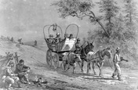
African Americans and the War Effort Even before the Emancipation Proclamation, thousands of slaves had fled to Union lines. Because there was no government policy on the fugitives, Union commanders were left to make their own decisions about what to do with them. Some tried to return fugitives to their former owners or to keep them out of Union camps. Others paid the fugitives wages for noncombat work as cooks, carpenters, guides, and drivers.
Black leaders and abolitionists had favored the idea of African American recruitment since the start of the war. But Lincoln had sidestepped offers by free blacks in the North to raise African American regiments, fearing the effect black troops might have on the border states. Widely held prejudices also played a role in his reluctance to recruit blacks. Many Northerners doubted that African Americans would make good soldiers. Frederick Douglass complained, "Colored men were good enough to fight under Washington, but they are not good enough to fight under [General George] McClellan."
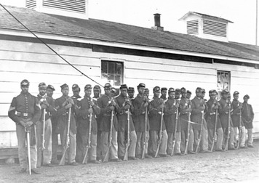
As the war wore on, public opinion began to change. Congress authorized African American recruitment in 1862. The next year, the War Department issued General Order 143, which authorized the "organization of Colored Troops." The most famous black unit was the 54th Massachusetts Regiment, which played a critical role in winning acceptance for black soldiers. On July 18, 1863, the 54th stormed the Confederate defenses at Fort Wagner, South Carolina. The assault failed, and more than 40 percent of the regiment was killed. But the troops fought valiantly and earned the praise of the nation. One newspaper wrote that without the 54th, "two hundred thousand troops for whom it was a pioneer [first experience] would never have put into the field."
Other black regiments also showed great courage under fire. Several were made up of freedmen—freed slaves—in the Confederate Army, including the 1st South Carolina Volunteers and the 1st and 3rd Louisiana regiments. After seeing the Louisiana troops in battle, one white officer wrote, "You have no idea how my prejudices with regard to negro troops have been dispelled . . . [They] behaved magnificently and fought splendidly . . . They are far superior in discipline to the white troops, and just as brave."
Racism and Discrimination Persist Despite their contributions to the war effort, African Americans still faced racism and hostility. During the New York City draft riots, dozens of African Americans were killed. In the military, black soldiers were usually assigned menial tasks, like digging ditches. They were often given poor weapons and did not receive the same training for battle as did white soldiers. As a result, they suffered higher casualty rates. In addition, black soldiers who were captured in the South faced the risk of being enslaved or executed rather than imprisoned, as white soldiers were.
African American troops were also paid as laborers, not soldiers. While white soldiers earned $13 a month, African Americans were paid just $10. Some black regiments protested by refusing to accept any pay at all. Others took a more militant approach. In November 1863, a company of black soldiers stacked their weapons and refused to pick them up again until they received equal pay. Their leader, a black sergeant named William Walker, was charged with mutiny and executed by firing squad. Finally, in June 1864, Congress agreed to equalize pay for white and black soldiers, including all back pay.

6. The Contributions of Women to the War Effort
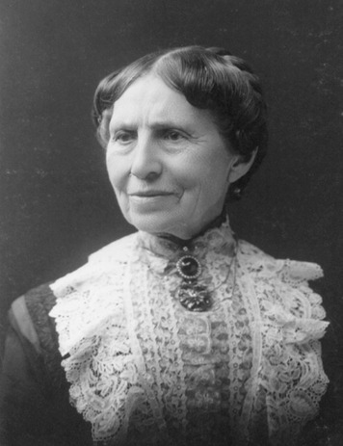
Women on both sides of the conflict played a vital role in the war effort. One of these women was Clara Barton. When the war began, Barton volunteered for war relief on the Union side. "While our soldiers stand and fight," she said, "I can stand and feed and nurse them." She began by gathering food and other supplies for the troops. Later she became a nurse and cared for hundreds of wounded soldiers. At Antietam, when the field hospital came under artillery attack, she steadied the operating table while the doctor completed his surgery. The doctor later called her "the angel of the battlefield."
Women Soldiers and Spies Though women were not allowed in the armed forces, some saw combat on the front lines. As many as 400 women disguised themselves as men and enlisted in the Union and Confederate armies. One woman, "Franklin Thompson" of Michigan, had to desert on her way to a hospital in order to keep her secret.
Other women served behind the lines in the dangerous role of spy. Women made good spies, in part because they were not suspected as quickly as men. If caught, they were also less likely to be punished severely. One of the most famous Confederate spies was Rose Greenhow. A well-connected member of Washington society, she used her contacts to learn about Union troop movements and passed this information along to the Confederate army. Her reports helped the Confederates win the First Battle of Bull Run in 1861. Eventually, Greenhow was discovered, arrested, and banished to the South.
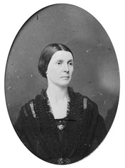
Elizabeth Van Lew, a resident of Richmond, was a successful spy for the Union. She even managed to plant one of her assistants, a former slave named Mary Elizabeth Bowser, as a maid in the home of Jefferson Davis. In that way, Bowser and Van Lew gained access to Confederate war plans. Van Lew managed to divert suspicion and avoid arrest by pretending to be mentally unbalanced. In public, she muttered to herself and looked confused. The locals called her "Crazy Bet," but when Union troops took Richmond in 1865, she dropped the act and was honored as a hero.
Women Provide Medical Care Other women, like reformer Dorothea Dix, played a crucial role by providing medical care to wounded and sick soldiers. Sojourner Truth and Harriet Tubman served as Union nurses as well, dividing their time between medical work and scouting for the Union army. In the end, more than 3,000 women served as nurses to the Union army.
Southern women also worked as nurses, and because almost all of the fighting took place on Southern soil, many turned their homes into medical shelters. After the First Battle of Bull Run, for instance, Sally Tompkins established a hospital in a private home and began caring for wounded Confederate soldiers. Altogether, she treated more than 1,300 men over the course of the war, while registering just 73 deaths. In honor of her achievements, Jefferson Davis made Tompkins a captain in the army. She was the only woman to become an officer in the Confederate army.
Women often had to overcome prejudice in order to serve. At the start of the war, many men viewed caring for wounded soldiers as "unladylike." Others believed the presence of women nurses in hospitals would distract the soldiers or that women would prove too delicate for battlefield conditions. As Confederate nurse Kate Cumming wrote, conditions were often shockingly bad, but women got used to them:
Nothing that I had ever heard or read had given me the faintest idea of the horrors witnessed here . . . I sat up all night, bathing the men's wounds, and giving them water . . . The men are lying all over the house, on their blankets, just as they were brought in from the battlefield . . . The foul air from this mass of human beings at first made me giddy and sick, but I soon got over it. We have to walk, and when we give the men anything kneel, in blood and water, but we think nothing of it.
—Kate Cumming, Kate: The Journal of a Confederate Nurse, 1959
Women doctors faced even greater obstacles. Surgeon Mary Walker tried but failed to get approval to join the Union army as a doctor. Instead, she volunteered as an assistant surgeon in a Washington hospital. Throughout the war, she worked as a battlefield doctor and later received the congressional Medal of Honor for her services.
Women Hold Down the Home Front With thousands of men fighting in the war, women—black and white—stepped in to perform crucial jobs to support their families and the war effort. They took over family farms and businesses. They also organized aid societies to raise money for war supplies and to collect and distribute food to soldiers.
Northern women had already been a part of the prewar workforce in the textile industry. As the war dragged on, rising demand for military uniforms led to more women working in textile mills and garment factories. Women in the South also made clothes, though most worked at home as private contractors.
The war also provided new job opportunities for women. For the first time, women filled a significant number of government positions. They worked in offices copying documents, for the Treasury Department minting money, and for the postal service. Women also took dangerous jobs in munitions factories, making bullets and artillery shells for the Union and the Confederate armies. Accidents in these factories were common, and many women lost their lives.

Summary
The Civil War lasted four years and cost 620,000 lives. It was by far the most destructive conflict ever waged on American soil.
Anaconda Plan Once it became clear that the war would not be quickly won, President Lincoln prepared for a long conflict with a plan to slowly crush the Confederacy.
Emancipation Proclamation By 1863, Lincoln issued a proclamation freeing all slaves in the rebellious states. However, freedom for most slaves did not come until the end of the war.
Gettysburg Address In his dedication of a cemetery for the men who died in the Battle of Gettysburg, Lincoln reminded the Union that it was fighting to preserve a nation "conceived in liberty and dedicated to the proposition that all men are created equal."
Sherman's March to the Sea The Union won the war in 1865 after General William T. Sherman waged total war across Georgia and General Ulysses S. Grant captured Richmond, Virginia.
Copperheads Both Abraham Lincoln and Jefferson Davis had to deal with opposition groups that did not support their war aims. In the North, Copperheads urged an immediate end to the war. In the South, part of Virginia seceded and joined the Union as West Virginia.
Draft riots and bread riots The leaders of the Union and the Confederacy faced challenges in managing the war effort. In the North, protesters rioted over draft laws. In the South, women protested severe shortages of food and supplies.
54th Massachusetts Regiment African Americans welcomed emancipation and the chance to fight for the Union. Although they showed great courage, blacks continued to suffer from racism and inequality.
Women's service Women made great contributions to the war effort. They collected supplies and served as soldiers, spies, medical personnel, and farm and factory workers.

