1. Introduction
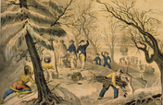
The year was 1620. A group of 102 passengers were gathered on the Mayflower, a small ship anchored off the coast of Massachusetts. They had traveled from England to join the colony already established in Virginia. However, storms had blown their ship off course, carrying them hundreds of miles north to Cape Cod. Worn out by their journey, they decided to settle in Massachusetts.
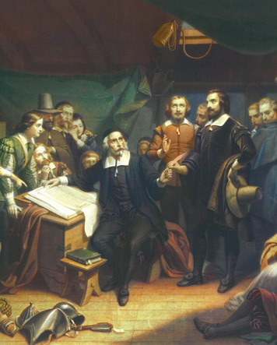
Click to read caption
About one third of the passengers were English Protestant Separatists who had come seeking religious freedom. These Separatists had broken away from the Church of England. Fearing persecution because they had formed their own church, they had fled to Holland. Later they received permission to settle in Virginia.
Other Mayflower passengers were simply seeking the opportunity to own land in America. According to Separatist leader William Bradford, some of these "strangers" became rebellious as the ship neared Cape Cod. They said no one "had the power to command them" as they were no longer bound by Virginia laws.
Fearing that a revolt could destroy the colony before it began, the Separatist leaders drew up an agreement known as the Mayflower Compact [Mayflower Compact: the first written framework for self-government in what is now the United States, made by the Mayflower passengers in 1620] . The Separatists and the other passengers agreed to live in a "Civil Body Politic." They further agreed to obey "just and equal Laws" enacted by representatives of their choosing "for the general good of the Colony." This was the first written framework for self-government in what is now the United States.
The Mayflower passengers established Plymouth Colony, the second English foothold in North America, after Jamestown. Bradford, who became Plymouth's governor, described the Separatists as pilgrims, or people on a religious journey, which is how they are known today. Over the next century and a half, thousands of people would follow them across the Atlantic. For many, though not for all, this settlement would offer liberty, opportunity, and the chance for a new life.

2. Limited Liberty, Opportunity, and Equality
The planting of colonies on the Atlantic shore triggered great changes. It brought together people from three continents—North America, Europe, and Africa—in ways that none of them were prepared for. For many, it opened up a bright new age of liberty, equality, and opportunity. For others, it brought a dark period of suffering and enslavement.
The Lure of the American Colonies: Land and Liberty The 13 colonies that eventually became the United States were founded in different ways and for different reasons. Virginia was founded by a private trading company. Some colonies, such as Pennsylvania, were founded by individual proprietors [proprietor: a person who owned a colony as a result of receiving a land grant from the king] , or owners, who received large land grants from the king. New York was originally founded by the Dutch and later captured by the British. The New England colonies were started by English Protestants called Puritans because they wanted to purify the Church of England. They wanted to create "a city upon a hill," a more perfect society based on their religious beliefs. Georgia began as a home for the poor and for criminals found guilty of not paying their debts.
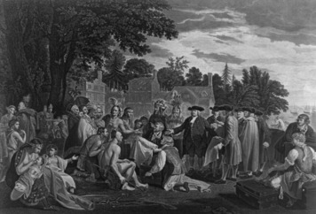
Click to read caption
Like the Jamestown settlement, almost all of the colonies faced hardships in the beginning. By 1700, however, most were thriving, although not always in ways that their founders had hoped. Most proprietors had expected to transplant the society they knew in England. In English society, a small upper class held most of the wealth and power, while the lower classes did most of the work but had few of the rights and received few of the rewards. Most colonists, however, wanted more opportunity. John Smith, a leader of the Jamestown settlement, observed that "no man will go from [England] to have less freedom" in America.
The key to a better life was the abundance of land in the colonies. Land ownership increased economic opportunity and enabled colonists to escape a life of rigid inequality. Historian Eric Foner notes, "Land, English settlers believed, was the basis of liberty. Owning land gave men control over their own labor and, in most colonies, the right to vote." The colonists' access to land, however, also meant a loss of liberty for American Indians and enslaved Africans.
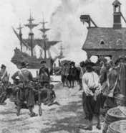
American Indians Suffer from Colonization The land that drew colonists to America was, of course, already occupied. At first, relations between native peoples and colonists were mutually beneficial. American Indians taught colonists to cultivate native crops like corn, tomatoes, potatoes, and tobacco. They introduced colonists to useful inventions like canoes and snowshoes. In return, American Indians acquired goods from the colonists, such as iron tools, metal pots, guns, and woven cloth. But the Europeans also unwittingly brought diseases that wiped out entire tribes and left others severely weakened.
In addition, settlers eventually stripped eastern tribes of most of their land through purchase, wars, and unfair treaties. A treaty is a formal agreement between two or more peoples or nations. The loss of land deprived Indians of control over resources they needed to maintain their way of life. Also, settlers rarely treated them as equals. Only a few colonial leaders, notably William Penn, founder of Pennsylvania, treated them fairly and paid them for their land.
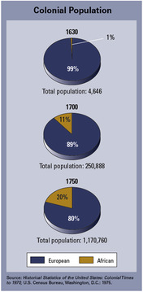
Freedom for Some, Slavery for Others Land was the main source of wealth in the American colonies. But without labor to work it, land had little value. Many colonists bought small plots of land of their own rather than working for others. Therefore, large landowners faced a severe labor shortage.
At first, some landowners met their labor needs through contracts with indentured servants [indentured servant: a settler who voluntarily gave up freedom for five to seven years in exchange for passage to America] . These were poor English settlers who voluntarily gave up their freedom for three to seven years in exchange for passage to America. At the end of their contract, they were released and given a payment known as "freedom dues." However, employers complained that these servants were disrespectful and likely to run away—behavior they blamed on a "fondness for freedom."
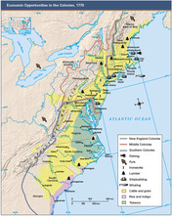
In 1619, a Dutch ship captain sold 20 captive Africans to colonists in Virginia. For the next several decades, small numbers of Africans were brought to the colonies. At first, they worked side by side with white indentured servants. A few were even treated as indentured servants, working to earn their freedom. The vast majority, however, were enslaved. Gradually landowners came to depend more and more on slaves to meet their labor needs. Eventually every colony legalized slavery, but most slaves toiled on plantations [plantation: a huge farm requiring a large labor force to grow crops for profit] in the southern colonies. These were huge farms that required a large labor force to grow cash crops—crops sold for profit.
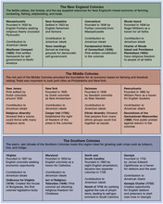
Although slavery in the colonies began for economic reasons, it became firmly rooted in racism [racism: the belief that one race of people is superior to another] . Skin color became the defining trait of a slave. As one colonial government declared, "All Negro, mulatto [of mixed black and white ancestry], and Indian slaves within this dominion … shall be held to be real estate." Laws established slavery as a lifetime condition, unless an owner granted freedom, and also defined children born of enslaved women as slaves.
Phillis Wheatley, a former slave who became one of the colonies' best-known poets, wrote of the yearning for freedom: "In every human Breast, God has implanted a Principle, which we call Love of Freedom; it is impatient of Oppression, and pants for Deliverance." Although some African Americans escaped the bonds of slavery, freedom did not bring equality. Like American Indians, blacks were viewed as inferior to whites.

3. Colonial Rights and the Growth of Self-Government
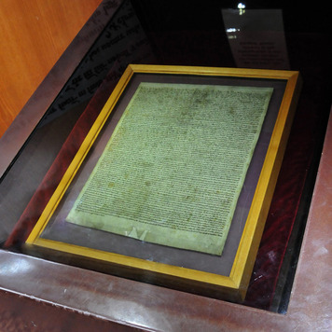
In 1744, a doctor touring the colonies wrote of dining at a tavern with
a very mixed company of different nations and religions. There were Scots, English, Dutch, Germans, and Irish; there were Roman Catholics, Churchmen, Presbyterians, Quakers, Newlightmen, Methodists, Seven Day men, Moravians, Anabaptists, and one Jew.
—Hamilton's Itinerarium: Being a Narrative of a Journey from May to September, 1744
For all the differences observed by the doctor, these people shared a deep attachment to their rights and freedoms.
The "Rights of Englishmen" For the majority of colonists, the idea that people were entitled to certain rights and freedoms was rooted in English history. They traced that idea back to the signing of the Magna Carta, or Great Charter, in 1215. This agreement between King John and his rebellious barons listed rights granted by the king to "all the freemen of our kingdom." Some of these rights established a system of justice based on due process of law. Under such a system, a government cannot deprive a person of life, liberty, or property except according to rules established by law.
Furthermore, the king agreed to make no special demands for money without the consent of his barons. This provision later led to the establishment of a legislature, a group of people chosen to make laws. This English lawmaking body was called Parliament. The Magna Carta also laid the foundation for the principle that people cannot be taxed except by their representatives in a legislature. Most importantly, the agreement made it clear that the monarch was not above the law. In contrast, rulers elsewhere typically had unlimited power over their people.
Over time, the "rights of Englishmen" were expanded, but not without conflict. One such conflict was a bitter struggle between King James II and Parliament for control of the English government. In 1688, the king was forced to flee England after a bloodless change of power called the Glorious Revolution. The throne was offered to a Dutch prince, William of Orange, husband of Princess Mary of England. Parliament then enacted the English Bill of Rights, which further limited the power of the monarch. Passed in 1689, this act confirmed that the power to tax rested only with Parliament. The act set forth individual rights, including the right to have a trial by jury and to petition the government for redress of wrongs. It also protected English citizens from "cruel and unusual punishments."
The Right to Self-Government English colonists brought these ideas about good government with them to America. Separated from England by 3,000 miles of ocean, they needed to make laws suited to life in the colonies. At New England town meetings, for example, townspeople got together to discuss local issues and solve problems by themselves. Such meetings helped lay the early foundations for self-government in the colonies.
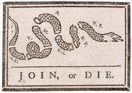
Over time, each colony elected a legislature. The first was Virginia's House of Burgesses, formed in 1619. The colonial legislatures were hardly models of democracy, for only white, male landowners could elect representatives. In many colonies, a person had to own a certain amount of property in order to vote. Nevertheless, the legislatures reflected a belief in self-government. These assemblies also affirmed the principle that the colonists could not be taxed except by their elected representatives in the legislatures.
For the colonists, self-government was local, with each colony operating independently of the others. In fact, the colonies were reluctant to work together even to face a common threat. In 1754, after war broke out in the Ohio Valley over rival French and British claims to land, Benjamin Franklin drafted the Albany Plan of Union. It proposed a confederation, or alliance, of the colonies for their own defense. The idea was as old as ancient Greece, and Franklin could also point to an alliance of six American Indian tribes known as the Iroquois League. Tribal representatives met as a Grand Council to make laws, settle disputes, and plan military strategy. However, Franklin's plan for a colonial Grand Council with the powers to tax and raise an army was quickly rejected. Parliament saw a colonial confederation as a potential threat to its authority, and the colonies were unwilling to pursue the matter.
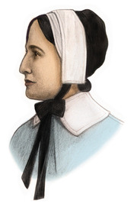
Seeking Freedom of Religion Although colonists shared a belief in their right to self-government, they were divided by religion. In the early 1600s, the governments of most countries saw religious diversity as a danger. The Puritans were not the only people who came to America to escape harassment in England for their unorthodox beliefs. Religious persecution also led to the founding of Maryland as a haven for Catholics and Pennsylvania as a refuge for Quakers. Some colonies, such as New Jersey and Pennsylvania, had more religious diversity than others.
Experience with religious persecution did not, however, lead to tolerance. Although the Puritans sought religious freedom for themselves, they refused to grant it to those who did not share their beliefs. In 1635, Puritan leaders in Massachusetts banished Roger Williams, a preacher, for holding "newe and dangerous opinions." Williams went on to found the colony of Rhode Island, where he welcomed colonists of all faiths. He firmly believed that freedom of religion, which he called "liberty of conscience," was compatible with law and order. To make his point, Williams used the example of a society aboard a ship at sea:
There goes many a ship to sea, with … Papists [Catholics] and Protestants, Jews and Turks [Muslims] … I affirm, that all the liberty of conscience, that ever I pleaded for, turns on these two hinges—that none of the Papists, Protestants, Jews, or Turks be forced to come to the ship's prayers or worship, nor compelled [kept] from their own particular prayers or worship, if they practice any. I further add that I never denied, that notwithstanding this liberty, the commander of this ship ought to command the ship's course, yea, and also command that justice, peace, and sobriety be kept and practiced, both among the seamen and all the passengers.
—Roger Williams, Letter to the Town of Providence, 1655
Elsewhere, religious prejudice was slow to fade. When Quakers came to Virginia, the House of Burgesses tried to drive them out by making it illegal to be "loving to Quakers." In 1649, the proprietor of Maryland tried to end quarreling between Catholics and Protestants by enacting the Act of Religious Toleration. This law declared that no Christian could be in any way "troubled" because of practicing his or her religion. However, it did not apply to non-Christians. Indeed, Jews suffered from prejudice in most colonies and generally did not have the right to vote or hold office. But they were usually allowed to worship and work in peace.
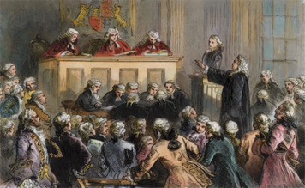
The Right to Free Expression: The Zenger Trial Governments on both sides of the Atlantic also feared freedom of expression. Even though colonies had their own legislatures, they were also subject to rule by governors appointed by the king. Following English practice for royal officials, these governors did not support freedom of expression. In the colonies, newspaper publishers who criticized governors risked being jailed. In their defense, publishers argued that "there can be … no such thing as public liberty, without freedom of speech."
In 1734, John Peter Zenger, a New York printer, was arrested for publishing "seditious libels"—rebellious statements that are false or damaging—about the governor of New York. At the trial, the judge instructed the jury to consider only whether Zenger had published the damaging remarks without regard to their truthfulness. Zenger's attorney, Andrew Hamilton, asked the jury to consider whether the remarks were true, arguing that a free people should "have a right publicly to remonstrate against the abuses of power in the strongest terms." The jury found Zenger not guilty, and he was freed. The verdict in the 1735 Zenger trial helped promote the idea that the press should have the freedom to print the truth, and that this freedom is a right that should be protected.
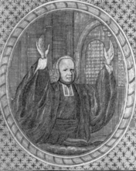
The Right to Think Freely: The Great Awakening The Zenger trial took place during a period of religious revival known as the Great Awakening. Beginning in the 1730s, traveling preachers toured the colonies, attracting huge crowds to their emotional gatherings. Critics of this revival declared that the preachers were encouraging disrespect for "the established church and her ministers." They were right. As historian Curtis Nettels observed in 1963,
The Great Awakening popularized the idea that the truth was to be found by each person in the Bible—not in man—made laws, sermons, or creeds. Authorities who violated the divine law did not merit respect… here were the seeds of revolution.
Although the Great Awakening was concerned mainly with spiritual matters, it had a broader impact, as Nettels suggests. It encouraged people to question authority and think for themselves. One revival preacher proclaimed, "The common people claim as good a right to judge and act for themselves in matters of religion as civil rulers or the learned clergy." As the colonists became more comfortable thinking freely about religious matters, they would also begin to think and speak more freely about political matters.

