The Political Development of Imperial China-Unit 7

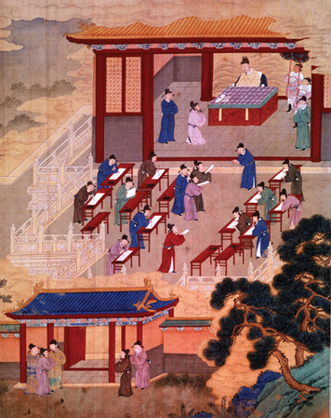
1. Introduction
Welcome to imperial China. Historians divide Chinese history into periods ruled by dynasties, or ruling families. In this lesson, you will learn about China’s political development under several dynasties from 220 to 1644 C.E.
China was first unified under an emperor in the 3rd century B.C.E. From the beginning, emperors needed help to rule. Emperor Han Wu Di, for example, once sent out this announcement:
Heroes Wanted! A Proclamation
Exceptional work demands exceptional men. . . . We therefore command the various district officials to search for men of brilliant and exceptional talents, to be our generals, our ministers, and our envoys to distant states.
Over time, Chinese emperors tried several ways of finding qualified people to administer their government. One method was to rely on the class of wealthy families. Emperors like Han Wu Di, however, preferred to choose officials for their merit, or worth. During the Han dynasty, candidates for government jobs had to prove their knowledge and ability by passing strict tests. As a result, a class of scholar-officials evolved. Under later emperors, this system developed into a rule by officials of proven merit.
In the 13th century C.E., a nomadic people called the Mongols built a great empire in Asia. Toward the end of the century, the Mongols took over China. Under Mongol emperors, government officials in China were foreigners. Some officials were Mongol friends and relatives of the emperor. Others were trusted people from other lands.
How did these approaches to government affect China? Which method won out? In this lesson, you will explore these questions.

Themes
Cultural Interaction The government and society of imperial China was strongly influenced by the philosophy of Confucianism.
Political Structures China was ruled by hereditary imperial dynasties. All dynasties ruled using large bureaucracies of government officials, although methods for choosing officials varied.
Economic Structures Because Confucian philosophy looked down on merchants, business and trade were not encouraged in imperial China.
Social Structures During some dynastic periods the aristocracy governed China while in others civil service examinations allowed for increased social mobility.

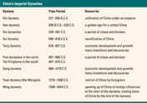
2. The Government of Imperial China
In 221 B.C.E., Prince Zheng (JUNG), the head of the state of Qin (CHIN), became the first Chinese ruler to claim the title of emperor [emperor: the political leader of a territory containing several countries or groups of people] . He took the name Qin Shihuangdi (CHIN shee-HWANG-dee), which means “First Emperor of Qin.” From that time on, China usually had an imperial [imperial: belonging or related to an emperor] form of government headed by an emperor or, sometimes, an empress.
China’s Imperial Dynasties Chinese emperors named a relative—often a son—to become emperor after their deaths. In this way they established a dynasty [dynasty: a line of rulers descended from one family] , or line of rulers from the same family.
From ancient times, Chinese rulers based their right to govern on the Mandate of Heaven. According to this idea, Heaven had chosen a particular dynasty to rule. The Chinese believed that Heaven supported the dynasty for as long as an emperor ruled well. Natural disasters such as floods, famines, plagues, and earthquakes were taken as signs that Heaven was displeased. If an emperor ruled badly and lost the Mandate of Heaven, the people could overthrow him.
The table below lists the imperial dynasties that ruled China between 221 B.C.E. and 1644 C.E. In this unit, you will focus on the dynasties that followed the Han dynasty.
China’s Breakup and Reunification The Han dynasty of ancient China held power for more than 400 years. This was a golden age of expansion and prosperity for China. In 220 C.E., however, the Han rulers lost their grip on power. A long period of disunity and conflict followed. This period ended when the Sui and Tang dynasties reunified China.
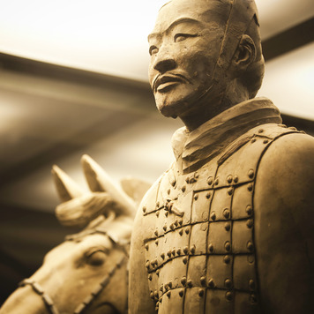
What happened to bring about the end of Han rule? Like earlier emperors, the Han governed China with the help of a large bureaucracy [bureaucracy: a highly complex body of workers with many levels of authority] of government officials. As long as the bureaucracy was skilled, honest, and hard working, China prospered. By 220, however, corrupt, or dishonest, relatives and servants of the emperor had seized control of the government.
The result was disastrous. High taxes sent many families into poverty. Workers were forced to labor for long periods of time on public projects. Bandits attacked farmers in the countryside. This led warlords [warlord: a military leader operating outside the control of the government] to oppose the emperor and fight against one another. The government grew weak and could not protect farmers.
Small farmers also suffered because they had to pay taxes and give half of everything they produced to their landlords. As they fell into debt, they had to give up their own land to large landowners and work for them, instead.
At last, the farmers rebelled. They believed that the Han dynasty had lost the Mandate of Heaven. No new dynasty took over from the Han. Instead, China broke apart into separate kingdoms, just as Europe did after the fall of Rome. Nomadic invaders ruled the north. Several short-lived dynasties ruled the south.
In 589, the northern state of Sui (SWAY) conquered the south and reunified China. The Sui dynasty created a new central government and ruled for 29 years. By 617, however, heavy taxes led to unrest and a struggle for power.
In 618, a general named Li Yuan declared himself emperor and established the Tang dynasty. Tang rulers built on the accomplishments of the Sui dynasty. They strengthened the central government and increased Tang influence over outlying areas.
Under the Tang, a unified China enjoyed a period of wealth and power that lasted nearly 300 years. Let’s look now at how Tang rulers approached problems of government.

3. Aristocracy: The Tang Dynasty
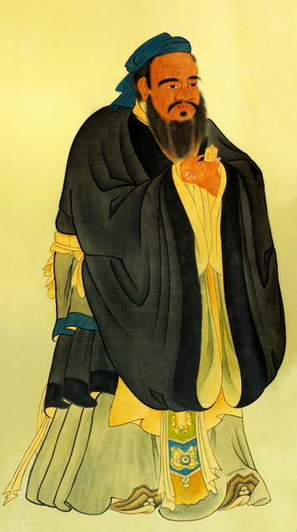
Like earlier emperors, Tang rulers relied on a large bureaucracy. Officials collected taxes and oversaw building and irrigation projects. They managed the army and enforced the laws. But how could emperors be sure that they chose the best people for these positions?
Earlier emperors answered this question in different ways. Before the Han dynasty, emperors chose members of the aristocracy [aristocracy: a ruling class of noble families] to help them govern. These people were born into noble families of wealthy and powerful landowners. But simply being wealthy did not make a person talented and knowledgeable.
To improve the bureaucracy, Han emperors created civil service examinations [civil service examination: a test given to qualify candidates for positions in the government] . Candidates took long tests to qualify for office. The tests had questions on Chinese classics, poetry, and legal and administrative issues. Mainly, they were based on the works of Confucius (kon-FEW-shus), China’s great philosopher and teacher. This began the system under which a class of scholar-officials ran the government.
Later, Tang emperors also used civil service exams to fill some government positions. Early in the dynasty, however, emperors chose aristocrats for most high-level jobs. Some officials were hired because their fathers or grandfathers had held high government rank. Some were hired because of personal recommendations. Often, aristocrats gained positions by marrying into the imperial family.
Even the civil service exams favored aristocrats. The tests were supposedly open to all except for certain groups, such as merchants, actors, and beggars. In theory, any man could attend the university where students prepared for the exams. In reality, however, only the wealthy could afford tutors, books, and time to study. As a result, aristocrats held almost all offices in the early part of the Tang dynasty.
Peasant rebellions and battles between generals ended the Tang dynasty in 907. Once again, China split apart. Five military dynasties followed one another to power in the north. The south broke up into independent kingdoms.
Beginning in 960, the Song (SOONG) dynasty rose. Gradually, Song emperors reunified the country. As you will see, they built on the civil service system to reform how government officials were chosen.

4. Meritocracy: The Song Dynasty
Under Song emperors, the idea of scholar-officials reached its height. The Song relied on civil service exams and opened them up to far more candidates. In this way, they created a meritocracy.
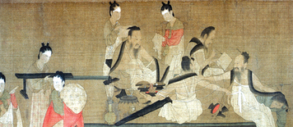
The exams were influenced by a new school of thought known as neo-Confucianism. This new teaching blended the teachings of Confucius with elements of Buddhism and Daoism (two traditional religions in China).
A Confucian scholar, Zhu Xi (JU SHEE), commented on classic Chinese writings. In 1190, his work was published as the Four Books. This work became the basis of study for all civil service exams.
Confucius taught that people must act properly in five important relationships: ruler and subject, father and son, older sibling and younger sibling, husband and wife, and friend and friend. Except for friends, one person in each relationship is above the other. Those above should be kind to those below. Those below should respect and obey those above. In particular, subjects must be loyal to their rulers. Song emperors and scholars believed that officials who had studied Confucius would be rational, moral, and able to maintain order.
Under the Song, people from lower classes gained the ability to become scholar-officials. They could attend the new state-supported schools and go on to the university. If they passed a local test, they could take the imperial exam in the capital. On those exams, they wrote essays and poems in a certain style. They answered questions about political and social problems based on Confucian ideas.
The exams were set up to prevent cheating. Candidates were locked in a small room for several days. A second person copied each paper so that the examiners wouldn’t know whose work they were reading.
Only a small proportion of candidates passed the difficult exams. Those who failed could take the tests again in the future. Those who passed had to wait a few years before their first appointment. When it came, it was for a job far from their hometown, so that they could not play favorites among family and friends. At the end of three years, officials could move up in rank.
Despite the challenges, people were happy to get such respected jobs. As government officials, they also enjoyed certain privileges, such as being excused from taxes and military service.

5. Government by Foreigners: The Period of Mongol Rule
In the 13th century, the Mongols conquered almost all of Asia. In 1276, they captured China’s imperial capital. Three years later, the last Song emperor died fleeing from the invaders.
The Mongol leader, Kublai Khan (KOOH-bly KAHN), took the title of emperor of China. He called his dynasty the Yuan dynasty. For nearly 100 years, from 1279 to 1368, China was under Mongol rule.
Under the Mongols, Chinese society was divided into four classes. The Mongols were at the top. Next came foreigners who were their friends. These people included Tibetans, Persians, Turks, and Central Asians. Many of them were Muslims. The third class was made up of the northern Chinese, who were more accustomed to the Mongols than were the southerners. The southern Chinese came last.
Kublai Khan ended the system of civil service exams. He did not believe that Confucian learning was needed for government jobs, and he did not want to rely on Chinese people to run his government. To fill important positions, he chose other Mongols whom he felt he could trust. Some of these people were his relatives.
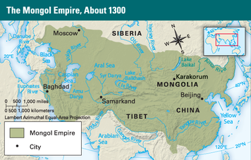
But there weren’t enough Mongols to fill every job. Besides, many were illiterate, or unable to read and write. Kublai and later Mongol emperors needed people who could handle the paperwork of a complex government. They were forced to appoint trusted foreigners to government positions, even some Europeans. Chinese scholars were appointed only as teachers and minor officials. Other Chinese worked as clerks, and some of them rose to important positions.
Without the examination system, however, there was a shortage of capable administrators. In 1315, the Mongols restored the exam system. Even then, they set limits on who could take the exam, favoring Mongol and other non-Chinese candidates.
As time went on, fighting among Mongol leaders weakened the government of China. So did the greed and corruption of officials. The Mongols had also made many enemies among the native Chinese. In the 1350s and 1360s, rebels rose up against them. In 1368, the Mongol dynasty collapsed, and the Chinese reestablished their own government under the Ming dynasty. The Ming ruled China for nearly 300 years.
6. The Revival of the Civil Service System
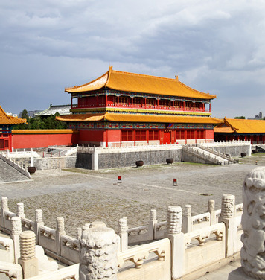
Under Ming emperors, civil service exams were again used to fill government positions. This system lasted into the 20th century.
In many ways, the exam system served China well. It provided a well-organized government. The education of its scholar-officials emphasized moral behavior, justice, kindness, loyalty to the emperor, proper conduct, and the importance of family. These values helped to unify Chinese culture.
The civil service system gave poor men who were ambitious and hard working the chance to be government officials. At the same time, it ensured that officials were trained and talented, not merely rich or related to the emperor.
Yet China’s civil service system may also have stood in the way of progress. The exams did not test understanding of science, mathematics, or engineering. People with such knowledge were therefore kept out of the government. Confucian scholars also had little respect for merchants, business, and trade. Confucians had often considered merchants to be the lowest class in society because they bought and sold things rather than producing useful items themselves. Under the Ming, this outlook dominated, and trade and business were not encouraged. In addition, the bureaucracy became set in its ways. Its inability to adapt contributed to the fall of the Ming in 1644.

Summary
In this lesson, you have learned how China was governed between 220 and 1644 C.E.
Cultural Interaction The culture of imperial China was strongly influenced by Confucianism. Confucianism emphasized respect for authority and the importance of a well-ordered society. Civil service exams chose government officials based on their knowledge of classic Confucian texts.
Political Structures China was ruled by hereditary imperial dynasties. It was believed that a dynasty’s authority came from divine favoritism, known as the Mandate of Heaven. Dynasties governed China using large bureaucracies of government officials, although different dynasties chose these officials using different methods. During the Yuan dynasty China was under foreign rule and was part of the larger Mongol Empire.
Economic Structures Confucius taught that merchants were the lowest class in society because they produced no actual goods. As a result, business and trade were looked down upon in imperial China and were not encouraged.
Social Structures During the Tang dynasty China was governed by the aristocracy. During the Song and Ming dynasties social mobility increased. The civil service exam allowed poor but ambitious men the chance to rise into the class of government officials. Under the Yuan dynasty, Mongol rulers divided society into four distinct classes, with Mongols at the top and native Chinese at the bottom.

