Toward a Global Economy

1. Introduction
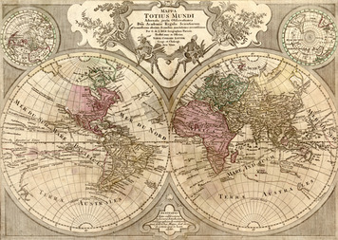
Portugal, a small European country bordering the vast Atlantic Ocean, sent sailors south in the early 1400s to explore the western coast of Africa. Part of their mission was to find West Africa’s fabled “River of Gold.” The Portuguese believed that this river was the source of the gold that trading caravans had, for centuries, carried north across the Sahara.
In the early 1400s, sailing the seas was a dangerous business. Sailors had to be tough. But even the toughest Portuguese sailor might have trembled to hear the words “Cape Bojador” (boh-juh-DOHR). This piece of land bulging out into the Atlantic presented a psychological barrier, a barrier of fear. Rumors hinted at the many hazards that lay beyond the cape. Perhaps, some sailors thought, it marked the edge of the world.
Finally, in 1434, a captain named Gil Eannes dared to sail past Cape Bojador into the unknown waters to the south. He found out why sailors feared to venture past the cape. At that point, a powerful ocean current drove ships to the south. The winds, too, blew southward. To sail north, back to Portugal, ships had to veer well out into the Atlantic to avoid the current. The knowledge and experience gained by sailing in the open ocean led to improvements in ship design and navigational tools. These advances would allow Portuguese sailors to make longer exploratory voyages.
Portuguese sailors eventually found enough gold to make their exploration a commercial success. By the end of the 1400s, they had sailed around the southern tip of Africa to India and other lands bordering the Indian Ocean. They called that region the Indies. They knew it as the source of spices and other goods prized by Europeans. Reaching the Indies marked an important stage on the road toward a global economy.

Themes
Cultural Interaction European exploration in the Americas and Asia resulted in the interchange of previously unknown goods throughout the world. Europeans spread their customs and religion, often forcibly, to the peoples they encountered.
Political Structures Europe saw the rise of sovereign nation-states and the creation of overseas empires.
Economic Structures European overseas colonies supported a mercantilist economic system and aided in the accumulation of capital.
Social Structures European settlers in Latin America created a stratified society with those born in Europe at the top.
Human-Environment Interaction Europeans colonized the Americas and forced enslaved Africans to migrate as well. They brought diseases with them that killed many Native Americans.

2. Economic and Political Changes in Europe
Portugal’s ocean voyaging came less than a century after a catastrophic event. In the mid-1300s, a disease called the Black Death swept through Europe. This killer plague sharply decreased populations and damaged economies. Although the Black Death returned periodically, by 1400 Europe had begun a healthy recovery. Two key changes marked this revival. Together, they would help Europeans dominate the first global age of world history.
Trade Connects Southern and Northern Europe The first change was economic. Trading centers in southern and northern Europe, over time, established strong ties with one another.
These two regions had separate patterns of trade. In the south, Italian city-states such as Venice and Genoa grew rich from Mediterranean trade with Muslims from the Middle East. This trade brought them luxury goods, including silk from China, ivory from East Africa, and pepper and other spices from India. In the north, a powerful association of trading cities known as the Hanseatic League developed a secure and profitable commercial network. Its products were mainly bulk goods, such as grains, wool, wood, fish, and iron. Hanseatic merchants also traded furs, beeswax, honey, and amber.
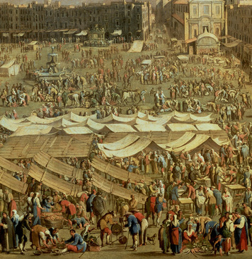
Earlier, in medieval times, merchants from south and north would have come together to trade goods mainly at fairs. Fairs were regional markets set up from time to time in a central location. As economic activity increased, Europe’s merchants sought more regular trade. By 1400, direct trade had largely replaced commercial fairs, as merchant ships carried goods back and forth between European port cities in the north and south. Direct trade helped unify Europe economically.
National States Arise The second change was political. Through the 1400s and 1500s, unified nation-states slowly emerged. In Spain, Portugal, England, the Netherlands, and France, kings secured their political authority by seizing power from local nobles and the Catholic Church. These newly formed nation-states were sovereign and territorial. That is, they were self-governing and independent, and they ruled over a specific geographical area.
All five of these states had ports on the Atlantic Ocean. That put them in a good position to take advantage of future long-distance trading opportunities. It also meant that they would compete with one another to advance their own fortunes.
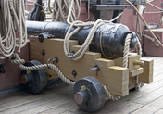
Economic competition among European nation-states gave Europe an advantage over other regions of the world. For one thing, it led to innovation. For example, each state sought to build stronger and faster sailing ships to outdo its rivals. Those rivals would quickly copy—and try to improve upon—any such innovation.
Competition also led governments to seek partnerships with businesses. States needed the resources of merchants, bankers, and investors to succeed with ventures overseas. A sovereign national state could help mobilize those resources in a number of ways. It could create a national market for the exchange of goods. It could standardize weights and measures. It could enact laws to protect private property. The state could also ensure the safety of merchants traveling within its boundaries. European states did all these things.
Competition among European states took military as well as economic form. England and France had fought off and on from the mid-1300s to the mid-1400s. After this Hundred Years’ War, they remained bitter enemies. Warfare pitted Catholic states against Protestant states during the Reformation for another 80 years, starting in the 1560s.
During this time, European states underwent a military revolution. They built up large and powerful armies and navies and supplied them with top-quality weapons. Larger cannons appeared not only on the battlefield but also on ships. This military buildup took money—lots of money. European states raised massive amounts of revenue through taxation and borrowing. To collect and distribute revenue and otherwise administer the state’s affairs, complex bureaucracies arose. Those bureaucracies also managed the voyages of exploration that several nation-states undertook. Like the revival of Europe, those explorations would have economic and military aspects.

3. Europeans Look Outward
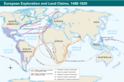
As early as the 1400s, economic competition led some European states to begin looking outward, beyond their shores. They had trade in mind. They knew that trade could bring wealth, and with wealth came power. The first of those states was Portugal.
The explorers who sailed south from Portugal along the western coast of Africa hoped to find gold, and they did. But some leaders and thinkers in Portugal, and in its neighbor, Spain, had a longer-term goal. They wanted to bypass the Muslim and Italian traders who controlled the luxury goods arriving in the Mediterranean from Asia. They wanted direct access to that Asian trade. More to the point, they wanted the profit from that trade.
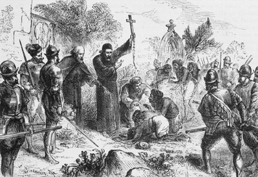
Reasons for Exploration The pursuit of profit was the main reason for all European exploration. Two related motives, competitiveness and the craving for Asian goods, also played important roles. Other factors, too, pushed European states to explore and expand. A new type of ship, the caravel, made it possible to sail against winds and currents and survive long voyages across stormy seas. Curiosity about the unknown world and an adventurous spirit also motivated Europeans.
Religion was yet another prime factor. Europeans wished to bring Christianity to non-Christians. They believed that doing so would save those people’s souls. Christians were also concerned about the growing power of another religion, Islam. They had tried, and failed, to weaken that power through the Crusades, the religious wars of the late Middle Ages. By the mid-1400s, a powerful Muslim empire led by the Ottoman Turks threatened to overrun Europe. The Ottomans would soon control all overland trade moving west into the Mediterranean Sea. By bypassing the Mediterranean gateway controlled by Muslims, Christian states in Europe could strike a blow against their enemy.
Portuguese Ships Reach India Portuguese explorers had royal support. One of the king’s sons personally sponsored the early explorations of the African coast. His name was Henrique, but he became known as Prince Henry the Navigator. He did not join any voyages of discovery. He did, however, help launch a steady stream of explorers who would eventually open a sea route to India.
After sailing past West Africa’s Cape Bojador in 1434, the Portuguese kept exploring southward. Along the coast, they traded for gold, and they also looked for slaves. At first, the Portuguese raided villages in order to capture and carry off Africans, but violent African resistance to raiding limited the practice. By 1450, the Portuguese had begun actively bartering for slaves. Muslim merchants and local African rulers would gather captives taken in raids in the interior. They would trade them to the Portuguese, usually for cloth but also for grain, silver, and horses.
Profits from the gold and slave trades financed further voyages and the establishment of trading posts and forts at regular intervals. In this way, the Portuguese worked their way slowly down the western coast of Africa. It was not until 1488 that the first Portuguese sailor, Bartolomeu Dias, sailed around southernmost Africa and into the Indian Ocean. In 1498, Portugal’s Vasco da Gama reached India, establishing what would become a well-traveled route from Europe to the riches of Asia. On a voyage to India two years later, a fleet of ships under Pedro Cabral swept far to the west while rounding Africa—and ended up in Brazil. Portugal claimed that land.
Early Exploration of the Americas Several years before Da Gama reached India, an Italian sailor named Christopher Columbus had a bold idea. He knew that the world was round. Instead of sailing east to get to the Indies, he decided to sail west, directly across the Atlantic Ocean. Based on some faulty thinking, he believed that Asia was a lot closer to Europe than it actually was. He wrote, “Between the edge of Spain and the beginning of India, the sea is short and can be crossed in a matter of a few days.” Columbus persuaded Spain’s monarchs, Isabella and Ferdinand, to fund a voyage westward. Like the Portuguese, they wanted access to the silks and spices of the Indies without having to enrich the Muslims who controlled the trade routes from Asia to the Mediterranean.
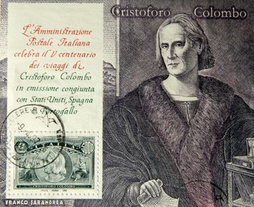
In 1492, Columbus made his first voyage to the Americas. He left Spain in August with three ships—the Niña, the Pinta, and the Santa Maria. Showing his skill as a sailor, he headed south to the Canary Islands, where he picked up the trade winds that blew westward across the Atlantic. On October 12, Columbus reached an island in the Bahamas, which he called San Salvador. He later sailed to Cuba and Hispaniola. Columbus called the native peoples Indians, because he believed that he had reached the Indies. He would maintain that belief through three additional voyages.
Spain claimed the right to trade and settle in the lands Columbus had found. The pope, who was Spanish, supported their claim. He granted them control of “all islands and mainland found and to be found . . . towards the south and west.” This vague language alarmed the Portuguese, who wanted to protect their rights in Africa and along the sea route around Africa. In 1494, the two countries negotiated the Treaty of Tordesillas (tawr-day-SEEL-yahs). This agreement drew an imaginary line from the North Pole, through the mid-Atlantic Ocean, across Brazil, to the South Pole. This “line of demarcation” gave Spain all rights to lands west of the line and gave Portugal all rights to lands east of the line.
The Italian merchant and sailor Amerigo Vespucci made two trips across the Atlantic, in 1499 for Spain and in 1501 for Portugal. After his second voyage, which took him to Brazil, he wrote a number of letters about what he saw. In them, he described the western lands as a “new world.” A mapmaker in 1507 split the lands into two continents, and he named the southern one “America” after Vespucci. The name stuck and was gradually applied to both continents.
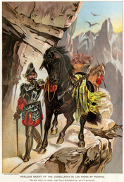
Spanish Conquests in the Americas Spain continued to send explorers to the Americas. In 1513, Juan Ponce de León landed on the shores of Florida. The same year, Vasco Núñez de Balboa crossed a narrow strip of land—the Isthmus of Panama—and came upon a vast sea. It was the Pacific Ocean.
To this point, the mission of Spanish explorers was trade and discovery. That changed with the expedition commanded by Hernán Cortés.
Cortés had conquest in mind when he landed in Mexico in 1519. He and his small army of conquistadors, or conquerors, marched inland with their crossbows, gunpowder weapons, and horses. They fought some Native American groups and forged alliances with others.
Cortés learned of the dominant Aztec Empire, centered in the city of Tenochtitlán. He set out for the city, aiming to conquer the Aztecs. After a series of negotiations, bloody battles, and retreats, the Spaniards and their Indian allies made a final assault on the city in May 1521. Three months later, they had achieved victory, at a cost of more than 100,000 Aztec lives.
A similar fate awaited another great civilization, the Incas of Peru. Weakened by civil war, the Incas fell to Spanish conquistador Francisco Pizarro. In 1532, with a small force of foot-soldiers and cavalry, Pizarro captured the Inca ruler. The Spaniards later destroyed the Inca capital at Cuzco. They looted the city and carried away huge amounts of gold and silver.
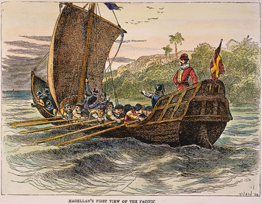
Further Voyages of Exploration Spain had a lengthy head start over its competitors in claiming territory in the Americas. But England, France, and the Netherlands all took an interest in this “new world.” Their early explorations focused on North America.
The king of England sent John Cabot, an Italian navigator, west across the ocean in 1497. In the North Atlantic off the coast of Canada, Cabot found an abundance of fish, a resource that would attract fishermen from England, Spain, Portugal, and France. But Cabot failed in his mission to find a route through the Americas to Asia—what came to be known as the Northwest Passage.
The French mariner Jacques Cartier also sought in vain for a way around the American land barrier. In 1535, he sailed up the Saint Lawrence River as far as present-day Montreal. Based on Cartier’s explorations, France would later claim Canada.
The English navigator Henry Hudson, sailing for the Netherlands in 1609, explored the Hudson River, thinking it could be the Northwest Passage. Sailing for England the next year, he searched the shores of Hudson Bay. But again he failed to find a way through the continent.
Meanwhile, the Spanish mariner Ferdinand Magellan had set out in 1519 to find a southern route around the Americas to Asia. He succeeded in sailing from the Atlantic around the southern tip of South America and into the Pacific. Magellan reached the Philippine islands in 1521, where he died in an attack by native peoples. The remaining members of his crew continued the voyage westward through the Indian Ocean, around Africa, and back to Spain, thus becoming the first to circumnavigate—sail completely around—the globe.

4. The Atlantic World
European exploration, conquest, and colonization of the Americas affected all four continents bordering the Atlantic Ocean. It resulted in a distinct Atlantic world, in which European states used the peoples and resources of the Americas and Africa to boost their economies. Throughout the Americas, native peoples and Africans suffered under the dominating Europeans.
American Colonies In the 1500s and 1600s, Spain expanded throughout what we today call Latin America. The Spanish Empire included the West Indies (the islands of the Caribbean Sea), Mexico, Central America, and South America except for Brazil. Spain focused on extracting resources from its colonies.
One important resource was silver. From the mid-1500s onward, mining—of silver and also gold—became a major industry in Mexico and in Peru. These precious metals had to be extracted from the earth by hand. For this difficult, dangerous work, the Spanish turned to the native peoples, forcing them to labor in the mines. Toiling long hours, Indian laborers dug out the metal ore and then carried heavy baskets of it to the surface.
The amount of silver that Spain took from American mines far outweighed the amount of gold. That silver brought the nation great wealth—and great power. King Philip IV of Spain declared, “In silver lies the security and strength of my monarchy.”
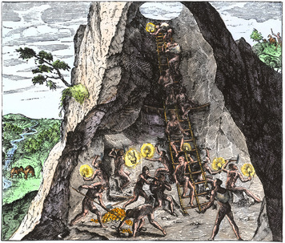
Spain used some of its enormous supply of silver to buy imported goods, such as grains from the Baltic and spices from Asia. It also shipped some to its colony in the Philippines, where it was used to buy manufactured products and Asian luxury goods. Much of the rest of Spain’s silver went to pay for the series of wars that it fought in the 1500s and 1600s.
A second key resource extracted from Spanish America was sugar. Sugarcane thrived in the soil and climate of the West Indies, and the worldwide demand for sugar kept increasing. As a result, Spanish growers established a number of sugar plantations on the islands. As in the mining industry, Indians served as forced labor—as slaves—on these plantations.
During the same period, the Portuguese colonized Brazil. They based their early economy on brazilwood, which they cut and shipped to Europe. This wood was a source of red dye (and of the colony’s name). Starting in the late 1500s, the Portuguese made far greater profits from sugar. Like the Spanish, the Portuguese in Brazil relied mainly on the native population to perform the grueling work necessary to harvest and process sugarcane. By 1600, Brazil produced more sugar than anyplace else in the world. In 1695, a huge gold strike in an inland region of Brazil boosted the colony’s economy further.
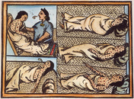
Spanish and Portuguese success did not go unnoticed by other European states. In the late 1500s, the English and the Dutch (people of the Netherlands) established a presence in the Americas. First they followed the Spanish into the Caribbean, looking for profitable ventures. There, Dutch and English pirates attacked Spanish ships and made off with silver and other precious cargo. Later they set up bases in the Caribbean islands to support their attacks on shipping. The French did the same.
In time, these three northwestern European states established sugar plantations on land that they had claimed. By the mid-1600s they were competing with Spain on two levels. They were exporting agricultural products, including sugar, to Europe, and they were also providing Spain’s American colonies with most of their manufactured goods. At the same time, the French, English, and Dutch also had colonies of their own on the mainland of North America—in coastal Canada, Virginia, New York, and New England.
Many Indians, forced to work in the mines and on the sugar plantations, died from accidents and from overwork. But many more died from disease. In fact, all over the Americas the native people were dying of diseases carried to their lands by explorers and settlers. Because they had been isolated from the rest of the world, the Indians of the Americas were never exposed to smallpox, measles, and other diseases. They had no resistance to them. In what historians call the Great Dying, these diseases killed many millions of Indians, perhaps half of all Indians in the Americas at the time of Columbus’s arrival.
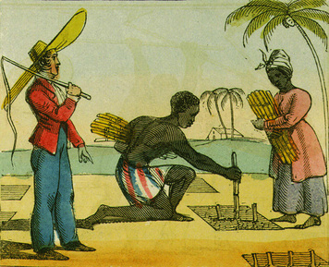
The Trans-Atlantic Slave System As a result of the Great Dying, the Europeans needed more labor for their plantations. At first the British (as they were known after England merged with Scotland in 1707) tried using indentured labor, as did the French. In the system of indentured servitude, a person agreed to work for a period of time, often four to seven years, in return for passage to the Americas, food, and a place to live.
Indentured servants from Britain found the work on West Indies sugar plantations to be brutal. Many of them died. They had a similar experience on the tobacco and rice plantations in Britain’s North American colonies.
Since 1500, the Portuguese had been shipping a limited number of enslaved Africans to the Caribbean. Africans seemed better able to survive as laborers than American Indians. They could do the exhausting and dangerous work, and they had a greater immunity to disease. For these reasons, European mine and plantation owners began to import many more enslaved Africans. Between around 1600 and 1650, more than 250,000 Africans were forced to migrate to the Spanish colonies. Another 150,000 went to Brazil.
For many years the Portuguese controlled trade along coastal Africa. Later, the English, French, and Dutch also established trading posts on the Atlantic coast. From there European merchants built relationships with African rulers willing to trade slaves. Together they set up a system for enslaving Africans and shipping them from Africa to the Americas.
The Africans and the Europeans had a fairly equal role in this trans-Atlantic slave system. Africans managed the gathering of slaves. Slavery was already widespread in African society, and trading in slaves across the Sahara had been going on for centuries. Some slaves were kidnapped in raids by African slavers. Others were made slaves by some legal judgment or to repay a debt. But most slaves were taken captive in war.
As European demand for slaves increased in the late 1600s, a few states in the interior of Africa began to focus on finding and delivering slaves. The production of slaves became their main economic activity. Coastal African states tended to serve as middlemen in the slave trade. They established trade routes from the interior to the coast and handled the exchange with European traders.
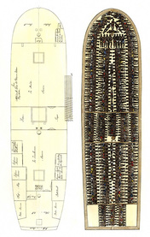
European ships carried the enslaved Africans across the Atlantic. The voyage is known as the Middle Passage. It was the middle part of the slave’s overall journey—and perhaps the most horrifying. The slave ship’s crew packed their cargo of Africans into the hold. Often they had no room to stand or stretch. To prevent revolts, male slaves were often chained in place. The food was limited and of poor quality, and conditions were unsanitary. Disease spread quickly. Many of the Africans died on the voyage, which could take from three weeks to three months.
Before 1650, Portuguese ships transported most of the enslaved Africans heading to the Americas. The majority went to mainland Spanish America. After 1650, northern European slave traders took over much of the business, and their main destination shifted to sugar plantations in Brazil and the West Indies. Later, Britain would dominate the highly profitable slave trade, transporting slaves throughout the Americas, including to plantations in their North American colonies. In the 1700s alone, some 6 million enslaved Africans were forced to migrate to the Americas.
The transport of enslaved Africans to the Americas was just the first “side” of what is known as the triangular trade. In American ports, the merchants traded their slaves for sugar, silver, tobacco, and other products of the mines and plantations. Then, the shipping of those raw materials to Europe formed the second side of the triangle. In Europe, they picked up manufactured goods such as textiles and weapons, as well as raw metal, rum, and tobacco. The third side of the triangle was the voyage to Africa to trade those goods for slaves.
The Columbian Exchange The trade between Europe and the Americas had consequences beyond just boosting European economies. It launched the Columbian Exchange, a two-way distribution of plants and animals named after Columbus. Until the arrival of Columbus, the peoples of the Americas were isolated from the rest of the world. That isolation meant that they had no immunity to European diseases. But it also meant that many of their plants and animals were unique to the Americas.
Europeans took a special interest in American food plants. These included maize (corn), potatoes, beans, squashes, pumpkins, peanuts, avocadoes, tomatoes, chili peppers, and cocoa. Merchants carried these to Europe and, from there, to Africa and Asia. Over time, these plants helped increase food production and improve the diets of people around the world.
The Columbian Exchange also brought new plants and animals into the “new world” from the “old world.” Peaches, oranges, bananas, sugarcane, coffee, oats, and wheat all became important crops in the Americas. Europeans also introduced beasts of burden and new sources of protein in the form of horses, cattle, pigs, goats, and sheep. European agriculture and the grazing needs of horses, cattle, and sheep had a great impact on the natural environment. Much land was converted from forest to farm and pasture.
Some historians include people, along with their customs and ideas, in the Columbian Exchange. Around 1.4 million Europeans and more than five times that many Africans had migrated to the Americas by 1800.
In Latin America the intermixing of Europeans, Africans, and Indians created a distinctive colonial society. That society was stratified, or formed into classes, according to place of origin, race, skin color, and other factors. At the top of the social pyramid stood those born in Europe. The lower classes included Indians, Africans, and people of mixed blood.
A different kind of class structure evolved in colonial North America. Its basis was economic, with white merchants and planters at the top of the social hierarchy. Within the colonies, Indians and Africans had little, if any, social prestige or political power.

5. Europeans in the Indies
As earlier chapters explained, the collapse of Mongol rule in Asia, starting in the 1300s, led to the rise of large, centrally governed states. In the centuries that followed, Muslim empires stretched from India across Southwest Asia and North Africa. China moved westward into Central Asia. Russia expanded eastward. These powerful states, with much to gain from trade, helped keep Asia’s overland trade routes secure.
During the same period, European states pioneered the sea route around Africa and then steadily extended oceanic trade throughout the Indian Ocean and east to China. Overland routes funneled trade goods to dozens of European trading posts planted along the coast. For the first time in history, Europe, Africa, Asia, and the Americas were directly connected by a global trading network.
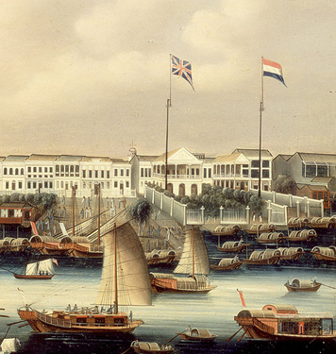
Portugal Gains Access to Asian Maritime Trade The great powers of Asia focused on expanding their land-based empires. They did take part in maritime, or sea-based, trade, but they claimed no political right of ownership over the seas. Europeans were more possessive. In 1499, Vasco da Gama laid claim to the entire Indian Ocean for Portugal. The Portuguese set about building a trading empire, based on territorial rights granted them in the Treaty of Tordesillas.
Portugal’s main goal was to sail to the Indies, trade for spices and other luxury goods, and sail back home. There was just one problem. The Asians did not need or want most European goods. Instead of exchanging products, Europeans would have to pay for Asian goods with money—mainly silver.
One option was to take part in the intra-Asian trade. Some merchants began carrying foods and other ordinary goods from one part of the Indies to another, making a profit on each trade. Over time, they built up cargoes that could be exchanged for fine spices (black pepper, ginger, cinnamon, nutmeg, mace, and cloves), Indian textiles, Chinese porcelain, and other Asian goods highly prized by Europeans.
To conduct trade, Portuguese merchants needed land bases. They often used force to get them. By the 1500s, European long-distance cargo ships came equipped with cannons. The Portuguese used those guns to attack and take control of key coastal towns. In this way, they captured Goa in India, Hormuz in the Persian Gulf, and Malacca on the Malay Peninsula. Malacca was the center of the East Indian spice trade. It also controlled the narrow Strait of Malacca. This led from the Indian Ocean to the Pacific and thus served as the eastern gateway to China and Japan.
The Portuguese used their naval advantage to dominate shipping in the Indian Ocean. They overpowered Asian merchant vessels and stole their cargoes. They blocked access to traditional shipping routes, too. One such route carried spices and other luxury goods through the Red Sea and across Egypt to the Mediterranean. The Portuguese never established a complete monopoly of the coastal trade, because Asian merchants fought back. Some armed their ships. Others changed their trade routes. Over time, however, the Portuguese gained control of a large part of the intra-Asian trade.
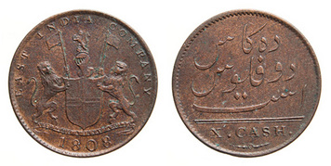
The European Model of Expansion By the mid-1500s, the Portuguese had established an effective model of expansion into Asian trade. The model had three basic parts.
1. The Portuguese relied on their superior ships, armed with gunpowder weapons, to establish land bases and achieve control of the seas.
2. At their land bases they established trading posts, called factories. These commercial centers managed Portuguese trade and finances in the region.
3. Finally, they built fortresses to protect their factories and the small colonies that arose nearby.
By 1600, the Portuguese had a string of more than 50 fortified coastal trading posts from East Africa all the way to Japan. To this time, the only other European state competing with Portugal in Asia was Spain, which controlled the Philippines. Soon, however, Portugal had a lot more company in the Indies. In the 1600s, the Dutch and the English, by applying the same model of expansion, would nearly eliminate Portugal from the Asian trade.
Competing for the Asian Trade The English, in 1600, and the Dutch, in 1602, each formed an East India Company to carry out long-distance trade with Asia. The government of England gave the English East India Company, and only that company, the right to trade in Asia. The government of the Netherlands authorized its Dutch East India Company not only to conduct trade but also to carry out political negotiations and to engage in warfare. The Dutch would fight to limit the success of the English in the Indies and to eliminate the Portuguese from the region.
Like the Portuguese, the Dutch took a military approach to creating a trading empire in the Indies. They hired experienced naval officers to help establish and maintain their outposts. Negotiations with local Asian officials went much more smoothly when a ship bristling with cannons anchored just offshore. The Dutch East India Company set up factories in India and Japan and points in between, but they focused their efforts on the East Indies.
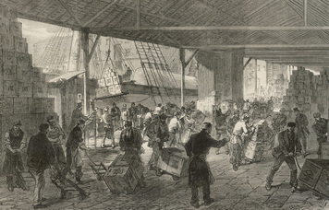
In the East Indies the Dutch hoped to monopolize the spice trade by taking control of the Spice Islands, now part of eastern Indonesia. There, most of the world’s supply of nutmeg, mace, and cloves grew. First the Dutch wrested control of the islands from the Portuguese. Then they used force and threats of force to compel local leaders to cooperate. In one group of islands, they slaughtered the native people and took over the production of their nutmeg and mace, bringing in enslaved Africans to cultivate the trees that yielded the spices. Then, in 1641, they seized Malacca from the Portuguese.
The English East India Company, at least at first, took a less violent approach to the Asian trade. Its traders sought permission before locating a factory on foreign territory. Kept out of the East Indies by the Dutch, the English focused on trade with India. There they negotiated for trading rights with the Mughal Empire and local Indian officials.
English merchants followed a fairly standard trading procedure. They used silver to buy Indian textiles and then traded the textiles in the East Indies for pepper and other spices, which they shipped to England. They also carried Indian cotton and indigo, a plant that yielded a blue dye, to Europe.
Some 200 years after the Portuguese arrived in the Indies, European merchants were still confined to coastal trading posts and various islands. In 1757, however, the British took control of the Indian territory of Bengal after Mughal power collapsed. In the years that followed, Britain would gain control of all of India and absorb it into its colonial empire.
The India trade brought the British great wealth, helping them expand into other parts of Asia. Economic power gave them military power—the ability to build ships, equip them with weapons, and engage them in warfare with their competitors. The British ousted the Portuguese from ports such as Hormuz and battled the Dutch off and on throughout the 1600s.
In the 1700s, European demand for spices fell, severely reducing the Dutch East India Company’s profits. The demand for Indian textiles, Chinese tea, and other goods rose. The British were well-positioned to profit from trading in those goods. After the French general Napoleon Bonaparte conquered the Netherlands in 1795, the British took over most Dutch outposts in the Indies. Great Britain now dominated the Asian trade.

6. Transformation of European Economies
In the first global age, the European states that engaged in long-distance trade created new economic strategies. Those strategies represented early stages in the growth of modern capitalism. The Spanish, Portuguese, Dutch, English, and French merchants who shipped goods among Europe, the Americas, Africa, and Asia were merchant capitalists. They accumulated capital, or wealth, through trade. Trade made countries wealthier, too, and stronger. For this reason, governments established merchant-friendly policies.
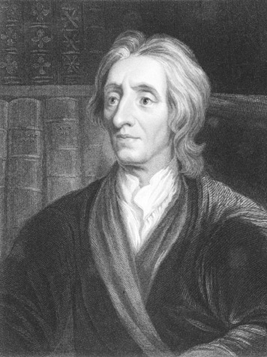
Mercantilism The philosophy behind those policies came to be known as mercantilism. Mercantilism evolved out of the intense economic competition among European states. A major focus of that competition involved trying to build stockpiles of bullion—gold and silver. English thinker John Locke offered this observation on the role of bullion:
Riches do not consist in having more Gold and Silver, but in having more in proportion, than the rest of the World, or than our Neighbours, . . . who, sharing the Gold and Silver of the World in a less proportion, want [lack] the means of Plenty and Power, and so are Poorer.
—John Locke, from Lowering of Interest, 1691
Mercantilists aimed to make their country richer and more powerful at the expense of other countries. To increase national wealth, governments allied themselves with businesses. They founded colonies to supply industries with raw materials and provide a market for finished goods—the goal being self-sufficiency. This goal also called for exporting as much as possible while importing as little as possible. Exports of goods brought gold and silver into a country. Imports sent gold and silver to other countries. To discourage imports, states placed taxes on them.
In the Atlantic world, Spain and Portugal paid huge amounts of silver and gold for manufactured goods. This trade made Dutch, English, and French mercantilists happy. Trade with Asia frustrated them, because it drained bullion out of their treasuries. From 1600 to 1800, the nations of western Europe shipped some 21,000 tons of bullion, mainly silver, to Asia.
Capitalism Mercantilism is often viewed as an early form of capitalism. Like mercantilism, it is a difficult concept to define. In its ideal form, capitalism is an economic system in which all resources are privately owned and markets determine how those resources are distributed.
During the mercantilist age, with the steady expansion of trade, several important features of capitalism appeared. One was the profit motive. European states began looking outward in hopes of making profits from foreign commerce. Another was the accumulation of capital. By applying mercantilist principles, those states built up their stocks of gold and silver. A third feature was financial innovation. The Europeans improved credit techniques, finding more efficient ways of making capital available to business.
Bank loans funded entrepreneurs, people willing to take the risks of starting and running a business. Entrepreneurs launched the East India Companies. The English and Dutch East India Companies were both founded as joint-stock companies. They raised capital by selling stock, or shares of ownership in the company. The owners held the stock jointly.
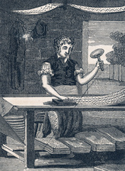
This new form of business organization was a forerunner of the modern corporation. The East India Companies were run, not by their investors, but by elected directors. They had access to the large amounts of capital needed to fund costly long-distance trading voyages. A round-trip to Asia could take three years. The East India Companies could afford to wait that long. When such a voyage was successful, all the owners profited.
Major Shift in Demand Black pepper remained a highly sought-after item of foreign trade well into the 1600s. European consumption of rare spices, indigo, and fine Chinese silks also stayed high. In the late 1600s and early 1700s, however, consumer demand shifted away from luxury goods. Europeans imported greater amounts of sugar and tobacco from the Americas, tea and textiles from Asia. The combination of imported sugar from the West Indies and tea and porcelain from China gave rise to a new tradition—the tea party.
The shift in demand may best be reflected in the flood of cotton textiles from India, including cheap calico cloth. Not all of the cotton fabric stayed in Europe. Merchants re-exported much of it to the Americas, Africa, and the Middle East. The growing worldwide demand for cotton cloth had consequences beyond boosting Asian imports. Competition for this market helped trigger a revolution in the way goods were manufactured. England’s textile industry, bolstered by the mechanization of spinning and weaving, would be the driving force in that Industrial Revolution.

Summary
In this lesson, you read about factors and events that led to Europe’s dominance in the first global age.
Cultural Interaction European colonizers imposed their customs and religion on the native peoples of the Americas and on the enslaved Africans forced to migrate to the Americas. The Columbian Exchange involved the distribution of previously unknown foods across the continents. Trade with Asia introduced European consumers to new products, such as tea.
Political Structures Sovereign nation-states rose in Europe as kings maintained power over local nobles and the Church. Through conquest and trade, several nation-states established empires.
Economic Structures Europeans followed a mercantilist philosophy, which encouraged exports and discouraged imports. A state operating under a mercantilist system obtained resources from its colonies. Those colonies also served as markets for the state’s manufactured goods. Europe’s increased profits from foreign trade led to the accumulation of capital, or wealth. The amassing of wealth was a key factor in the expansion of capitalism that took place during the first global age.
Social Structures European settlement in Latin America brought about a stratification of society. People born in Europe occupied the highest social class.
Human-Environment Interaction Europeans migrated to and colonized the Americas. The diseases that they brought with them killed a large number of the native peoples. They forced millions of enslaved Africans to cross the Atlantic to work on plantations and in mines. Europeans cut down forests in the Americas in order to cultivate crops. They greatly expanded pasture land in order to feed the cattle, horses, and other domesticated animals that were new to the Americas. Europeans also extracted resources from the land through the mining of gold and silver.

