U nit 19-World War I

1. Introduction
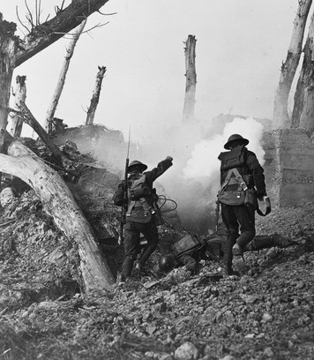
Before dawn comes the signal for yet another attack. Joined by thousands of others, the young soldier climbs out of the trench to charge the German trenches a few hundred yards away. As rockets and flares light up the no-man’s land [no-man’s land : an unoccupied area between opposing armies ] between the two armies, shells burst overhead. Pieces of jagged metal cut down the charging troops. Mines buried in the ground explode, hurling mud, iron, and men into the air. Then rifles and machine guns open up from the German trenches. The bullets fly by like raindrops in the wind. Barbed wire is everywhere. If the soldier gets caught in it, he will almost certainly be killed by the gunfire before he can free himself.
Men are falling all around him, but the soldier cannot help them. “Onward!” his officers command. Finally, the charging troops are in the enemy trenches. The German defenders surrender and are taken prisoner. This attack has been a success. But daybreak reveals the victory’s terrible cost. The ground is littered with bodies as far as the eye can see. It is a sight that the young soldier will never forget.
This scene in France in 1918 was typical of the fighting in World War I. Entrenched armies aided by aircraft, artillery, and poison gas attacked and counterattacked, again and again, trying to push each other back. Some battles lasted for months, resulting in hundreds of thousands2 of casualties, and causing battlefields to look like the surface of the moon. It is little wonder that what was called the Great War, and what we call World War I, became known to those who witnessed its horrors as “the war to end all wars.”

Themes
Political Systems Cooperation and rivalries among nations were causes of World War I and shaped the peace that followed the war.
Economic Systems The long and widespread war drained the resources of nations on both the winning and losing sides.
Human-Environment Interaction Geography and new technology helped make World War I a deadly and destructive conflict.

2. Rivalries Lead To War
In 1914, the Great Powers of Europe—Russia, Prussia, Austria, Great Britain, and France—had enjoyed that status for over a century. However, the power relationships between these nations had changed. In 1814, Prussia was the smallest of the Great Powers. By 1914, Germany, the nation Prussia created in 1871 after defeating the Austrian Empire and France in war, had become the strongest. Between 1871 and 1913, Germany surpassed Britain to become Europe’s leading industrial power. These developments dramatically altered the balance of power in Europe.
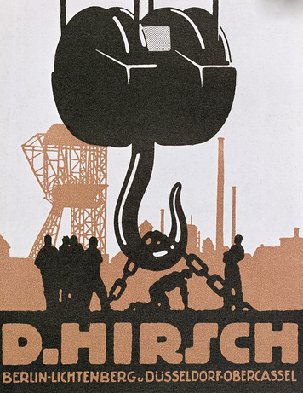
European Relations and Rivalries Following its 1871 defeat, the Austrian Empire reorganized as Austria-Hungary, and accepted Germany’s leadership in Central Europe. France’s defeat in 1871 caused it to lose status, as well as territory to the new German nation. The French resented both results. Germany was surrounded by potential enemies. Tensions with France continued, and German leaders were suspicious of Russia to the east. These concerns caused Germany to use its new industrial might to build a powerful army and navy.
In the late 1800s, however, Russia was expanding in Asia. Not until its defeat by Japan in the Russo-Japanese War of 1904–1905 did Russia refocus on European affairs. Even then, Russia was less interested in Germany than it was in the Balkan Peninsula in southeast Europe, much of which was under Turkish control as part of the Ottoman Empire.
Great Britain also was largely uninvolved in Europe in the late 1800s. Britain’s main focus was on preserving its vast, worldwide empire. As long as a balance of power existed in Europe, the British had little interest in events there. By about 1900, however, developments on the continent were arousing Britain’s concern. The British viewed Russia’s expansion in Asia as a possible threat to their control of India. Germany’s naval buildup was also serious. Britain’s naval supremacy was vital to protecting its empire in a time when communication and trade still relied mainly on the sea. Britain responded to the German buildup by increasing the size of its own navy.
France began trying to match the 600,000-man German army, even though its population was only about two-thirds of Germany’s 68 million. Russia, with a population nearly triple the size of Germany, faced no such challenge. In fact, its army of 1.3 million was of great concern to the Germans.
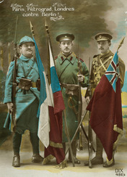
Shifting Alliances Germany was a monarchy, but its affairs were led by its first chancellor, Otto von Bismarck, until 1890. Bismarck’s foreign policy was shaped by his goal to protect Germany from the two potential enemies on its borders—France and Russia. He reduced the threat from Russia in 1881 by forming an alliance with Russia and Austria-Hungary called the Three Emperors’ Alliance. The following year, to protect Germany against France, Germany formed an alliance with Italy and Austria-Hungary. Together these countries formed the Triple Alliance. These alliances hurt France by depriving it of possible allies.
When the Three Emperors’ League dissolved due to tensions between Russia and Austria-Hungary, Bismarck kept France isolated by forming a separate German-Russian alliance called the Reinsurance Treaty. However, a new kaiser (the German title for emperor), Wilhelm II, took the throne in 1888. Kaiser Wilhelm and other German leaders were more interested in creating an overseas empire. To help achieve this goal, Germany began strengthening its navy. Bismarck was forced to resign and the Reinsurance Treaty was allowed to expire. These developments increased tensions with both Russia and Great Britain.
France took advantage of the Reinsurance Treaty’s end by forming an alliance with Russia in 1894. The French also provided money and other assistance to help Russia build railroads and modernize its army. Britain’s growing concerns about Germany prompted it to join with France and Russia in 1907 to create the Triple Entente.
The Great Powers were now aligned in two rival alliances. Should a member of either alliance become involved in a conflict, the other members were pledged to support it. In addition, fighting between any members of the Triple Alliance and Triple Entente would pull the other four nations into war. The alliance system made it possible for a minor dispute to produce war throughout Europe. In 1914, in the Balkans, this possibility became reality.
Unrest in the Balkans The growing tension between Germany and Russia mainly resulted from Germany’s support of Austria-Hungary in its rivalry with Russia for control of the Balkan Peninsula. Balkan peoples sought their freedom as Ottoman power declined. The Great Powers recognized the independence of Serbia in 1878 and put Austria-Hungary in charge of Bosnia-Herzegovina—a multi-ethnic region of Croats, Turks, and Serbs on Serbia’s border. Russia quickly formed close ties with Serbia and took on the role of Serbia’s protector.
Many Serbs believed that Bosnia-Herzegovina should be part of Serbia. Russia supported this goal, hoping to weaken Austria-Hungary and increase its own influence in the Balkans. Russia also supported Serbia in two short Balkan Wars in 1912 and 1913. The first war ended Ottoman rule on the peninsula, and the second war divided the former Ottoman lands among the Balkan nations. Serbia doubled in size as a result.
This development heightened tensions with Austria-Hungary, which feared that Serbian expansion would stir nationalism and unrest among the empire’s ethnic minority groups. In fact, organizations in Serbia, supported by leaders in Serbia’s government, had been doing just that since Austria-Hungary officially annexed Bosnia-Herzegovina in 1908. In June 1914, an act of Serbian nationalism led to the murder of the heir to the Austro-Hungarian throne. Gavrilo Princip, a Bosnian Serb who had been trained by a Serbian secret terrorist organization called the Black Hand, shot and killed Archduke Franz Ferdinand in the Bosnian city of Sarajevo.
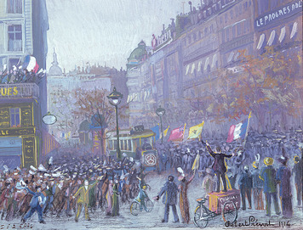
The Rush to War Austria-Hungary saw Franz Ferdinand’s assassination as a chance to crush Serbian nationalism. After making sure it had Germany’s support, it made a series of harsh demands on Serbia. Austrian leaders expected Serbia to reject these demands, which would give Austria-Hungary an excuse for war. When Serbia agreed to most of them, Austria-Hungary declared war on Serbia anyway on July 28, 1914.
Russia, which was pledged to protect Serbia, began to mobilize, or ready its army and other resources, for war. On July 31, Germany gave Russia 24 hours to halt its mobilization. The Germans also demanded that France pledge neutrality in the event of war between Germany and Russia. When these demands were ignored, Germany declared war on Russia on August 1, and two days later declared war on France. Because of the alliance systems, nearly all of Europe was at war within two weeks.
Many Europeans greeted the outbreak of war in August 1914 with a wave of patriotic confidence and celebration. They believed that their side would be victorious in just a few months. Few could have predicted or imagined just how long and terrible this war would be.

3. Fighting the Great War
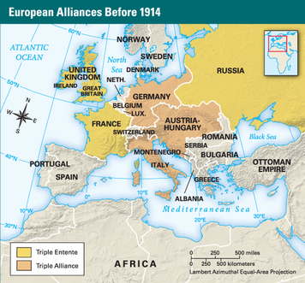
When the fighting began in 1914, German leaders had been planning for such a war for more than a decade. The Schlieffen Plan called for Germany to defeat France in the west, knocking it out of the war before Russia could mobilize its huge army in the east. However, in the late 1800s, France had heavily fortified its border with Germany. A quick victory required bypassing these defenses by invading France from the north, through neutral Belgium, with an overwhelming force. When Belgium refused to let German troops enter its territory, Germany attacked it on August 4. Outraged by this violation of Belgium’s neutrality, Great Britain declared war on Germany later that day.
Britain’s declaration of war against Germany meant that the entire British empire was at war. Britain’s action made the conflict a true “world war.” Hoping to gain Germany’s colonies in Asia, Japan declared war on Germany on August 23, 1914. In November, the Ottoman Empire officially entered the war on the side of Germany and Austria-Hungary to form what became known as the Central Powers. They were joined by Serbia’s Balkan rival Bulgaria in 1915. Britain, France, Russia, and their partners were known as the Allied Powers, or simply the Allies. Italy, which remained neutral when war broke out, joined the Allies in 1915.
Stalemate on the Western Front The Schlieffen Plan might have worked if German leaders had not decided to transfer some forces back to Germany. However, they worried that Russia might mobilize its army faster than expected and attack Germany from the east. So a large number of troops returned to Germany to protect it. This allowed French and British forces to stop the German advance from Belgium at the Marne River, just short of Paris, in early September.
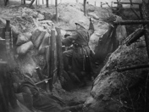
The Battle of the Marne denied Germany its goal of quickly knocking France out of the war. However, the invasion gave Germany control of part of France. The German army dug in and prepared to defend the territory it had captured. Unable to drive the Germans out, the British and French also dug trenches to defend against further attacks. Over time, each side extended its trenches, trying to get a geographic advantage over the other. By November, a network of trenches stretched 400 miles, from the English Channel to Switzerland. This area of the fighting became known as the Western Front.
For the next three years, the Western Front was a brutal killing field as each side tried, with little success, to push the other back. For example, repeated Allied attacks on German trenches in one region of France in February and March 1915 gained only 500 yards of ground, and cost the lives of 50,000 men. In February 1916, German troops tried to break the stalemate by smashing through the French defenses at the town of Verdun. In June, Allied forces launched a similar assault on German lines along the Somme River. The Battle of Verdun and the Battle of the Somme each lasted for months. Nearly 2 million men were killed or wounded. Neither attack succeeded.
A New Kind of War The terrible slaughter on the Western Front and elsewhere in World War I resulted from mixing of new technology with old tactics. By the early 1900s, all European armies had rifles that could hit a target with deadly accuracy from over a quarter-mile away. The machine gun, perfected in the late 1800s, could fire 600 bullets a minute to a range of more than a half-mile. The range and accuracy of artillery was also much improved. The biggest guns could hurl an explosive shell 25 miles. Advancing troops could come under fire long before they could even see their enemy.
Such weaponry, when combined with trenches protected by entanglements of barbed wire (invented in the 1870s), gave defenders a major advantage. However, many military leaders viewed war as a test of courage and will. For example, the main offensive tactic of the French army was the infantry charge. Commanders on both sides believed that such methods could succeed if enough men were willing to die. One 1917 battle, in which the French army lost 130,000 men in 10 days, ended when troops refused to make yet another attack.
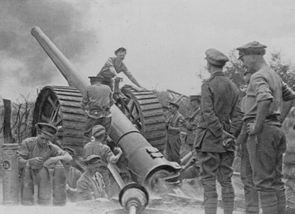
Other weapons were new to World War I, not just improvements of earlier versions. Tanks, which first appeared at the Battle of the Somme, could help troops move forward by tearing through barbed wire defenses and rolling over enemy trenches. In 1915 Germany began using poison gas. Its first use drove panicked troops from their defenses as the clouds of gas settled in their trenches. Armies on both sides were soon lobbing gas at each other in artillery shells. The airplane was another new weapon in World War I. The first planes were used to spy on the enemy. By 1917 they were directing artillery fire and dropping bombs on military and civilian targets.
The Eastern Front Trench warfare was less widespread on the Eastern Front—the name given to the battle zones of Eastern Europe. However, the fighting there was just as bloody. In August 1914 the French begged Russia to take pressure off the Western Front by invading Germany. The Russian army was not ready to fight, but in late August it attacked anyway. A large Russian force was almost completely destroyed at the city of Tannenberg, just inside Germany’s eastern border. Of 150,000 Russian troops, some 130,000 were killed, wounded, or taken prisoner.
Despite its size, the Russian army proved no match for the better equipped Germans. While the Austrians were conquering Serbia (1915) and Romania (1916), German forces advanced deep into Russia. In 1917, the huge number of lives and resources lost caused Russia’s government to collapse. Months of unrest followed until, in December, a new government signed a peace agreement with the Central Powers, and pulled Russia out of the war.
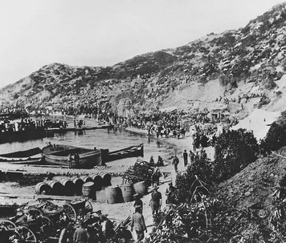
The Fighting Elsewhere In early 1915, a naval force landed French, British, and colonial troops at Gallipoli, a peninsula in the European part of present-day Turkey. The goal was to capture Constantinople, the Ottoman Empire’s capital, and gain access to the Black Sea. This would provide a sea route to Russia to provide supplies that it desperately needed. However, the invaders met strong Turkish defenses. A stalemate quickly developed. In December, after suffering more than 200,000 casualties, the Allies withdrew in defeat from Gallipoli. Turkish losses were even greater, a total of about 250,000.
The Allies had little early success invading other parts of the Ottoman Empire. In April 1916, the Turks defeated a force of British colonial troops from India. However, that summer an Arab uprising against Turkish rule drove the Ottomans out of much of the Arabian Peninsula. In December 1917, the British captured Jerusalem.
The Turks’ war effort was also troubled by other unrest. Russia had long been stirring up nationalism among the nearly 2 million Armenians living in Anatolia (a part of present-day Turkey). Ethnic tensions already were high when Armenian volunteers from the Russian Empire joined Russian troops in invading the Ottoman Empire in early 1915. Fearing disloyalty in their own Armenian population, Ottoman leaders ordered that nearly all the empire’s Armenians be rounded up and forced into prison camps in Syria. As many as 600,000 people starved to death or were killed by Turkish troops and police in what is known as the Armenian genocide.
Other fighting in World War I occurred elsewhere, on both land and sea. Japan and Britain seized German-held islands in the Pacific. In Africa, some 12,000 African soldiers defended German East Africa against 130,000 Allied troops for three years until finally being forced to surrender in November 1918. But the fighting in these and other places had little effect on the war’s outcome. By 1917, it was clear that the victory in the Great War would be decided on Europe’s Western Front.
The War at Home The unexpected and long war in 1914 severely strained the resources of nations on both sides. When the fighting began, Austria-Hungary had enough cash reserves to pay for only three weeks of fighting. Other nations’ circumstances were not much better. Nearly half of Britain’s economy—and more than one-third of Germany’s—depended on foreign trade, much of it with the other nations of Europe. But trade was difficult in the midst of such a war. This was especially true for Britain and Germany when each began a naval blockade of the other. Warships on each side also captured or sank their enemies’ merchant ships on the high seas.
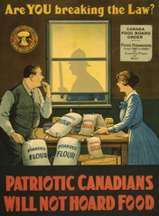
As the war continued and nations had difficulty paying its costs, many just printed more paper money. This led to inflation, which created hardships at home, especially for the poor. In Italy, for example, prices increased 700 percent during the war.
Shortages of food, fuel, and raw materials also developed. The German and British governments took greater control over industry and began rationing food and other goods. The governments of Russia and Austria-Hungary were less efficient, however, and shortages there soon became severe. German scientists developed artificial substitutes for some needed goods, such as sugar, rubber, and textiles. But even in Germany, clothing was scarce by 1916, and in cities, people simply did not have enough to eat. By 1917, food riots and strikes happened with increasing frequency.
Even before the war, all the Great Powers, except Britain, required young men to serve in the army as active-duty troops and then as reserves afterward. Heavy battlefield losses led Britain to begin requiring military service from men age 18 to 41 in 1916, while Germany made men of all ages eligible to be called. The high loss of life, combined with the wartime shortages, caused growing unrest in nations on both sides. Britain and Germany, in particular, used propaganda to boost morale and keep the public behind the war. However, by 1917, peace movements existed in every Great Power—including France, where German forces remained entrenched on the Western Front.

4. The Tide Turns
Within weeks of going to war in 1914, the British began a naval blockade of Germany to cut off its overseas trade. Great Britain declared the entire North Sea a war zone where British warships could stop merchant ships and seize any cargoes bound for Germany. In February 1915 Germany responded by establishing a blockade of Britain. The German navy was still no match for the British navy. So Germany turned to a new technology—the submarine, or U-boat (from the German word Unterseeboot, meaning “undersea boat”).
Unlike warships that operate on the surface, submarines are not equipped to capture ships or seize their cargoes. Instead, Germany enforced its blockade by announcing that its U-boats would, without warning, torpedo and sink Allied and other merchant ships approaching Great Britain. This policy eventually brought the United States into the war.
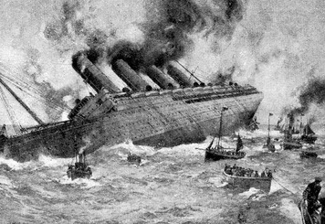
The United States and World War I When war broke out in Europe, the United States remained neutral. Although the nation had close historical and cultural ties with Great Britain, it had a large German-American population too. In addition, most Americans were not eager to get involved in what they viewed as a European dispute. Many American companies also saw the war as an opportunity to sell supplies to both sides.
Tensions with Britain increased when British warships seized American goods bound for Germany. However, the German blockade of Britain had more serious consequences. In May 1915, a U-boat sank the British passenger ship Lusitania, which was also carrying 173 tons of ammunition from New York to London. More than a thousand passengers, including 128 Americans, lost their lives. Public outrage, combined with the sinking of two more passenger ships later that year, brought U.S.-German relations to the breaking point. To avoid war, Germany promised that its U-boats would warn merchant ships before sinking them, to give those on board time to launch lifeboats.
By late 1916, however, German leaders had become concerned about how much longer Germany could continue to fight. They decided to tighten their blockade, gambling that this would force Britain to surrender before the United States could enter the war. In February 1917, Germany resumed its previous policy of unrestricted submarine warfare. Furthermore, Germany made an offer of an alliance with Mexico. It promised that if Mexico went to war against the United States, Germany would reward Mexico with lands in New Mexico, Texas, and Arizona. These actions led the United States to declare war on Germany in April 1917.
The United States’ entry into World War I was the turning point of the war. Like Germany and Austria-Hungary, Britain and France were nearly exhausted by 1917. It took nearly a year for the United States to raise and train troops and to fight in Europe. But the flow of arms, food, and other supplies to Britain and France greatly increased immediately. By July 1917, U.S. warships were helping the British navy combat the German U-boat blockade.
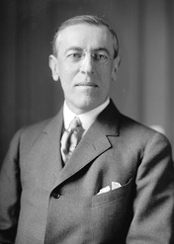
The Fourteen Points The United States also took the lead in trying to bring the war to an early end. In January 1918, President Woodrow Wilson issued a statement of war goals called the Fourteen Points. The first five points addressed general world concerns—an end to secret agreements between nations, freedom of the seas, the removal of trade barriers, arms reduction, and a fair settlement of colonial disputes. The next eight points dealt with specific territorial issues in Europe and the Ottoman Empire. They were based on the principal of self-determination—the right of nations and peoples to control their own fate and to decide what form of government they will have. The fourteenth point called for “a general association of nations” to be formed, whose members would work together to protect all nations.
Wilson’s Fourteen Points were not embraced by other Allied leaders. However, they kept their feelings private while the war continued because they needed the Americans’ help. The Fourteen Points also strengthened the peace movements in Germany and Austria-Hungary, an effect Wilson had hoped for. The Fourteen Points contributed to Germany’s decision to surrender in November 1918.
The War Comes to a Close Russia’s withdrawal from the war at the end of 1917 allowed Germany to move troops from the Eastern to the Western Front. With more than 500,000 more soldiers now on the Western Front, German commanders hoped to defeat the British and French forces there and end the war before a large number of American troops could arrive.
In late March 1918, the Germans launched a massive attack on the British at the Second Battle of the Somme. For the next two months, they slowly pushed the British and French forces back in heavy fighting. By June, the German army was again within artillery range of Paris. Casualties on both sides were massive. The Germans lost nearly 500,000 men. British and French losses were only slightly fewer. The German army was exhausted. But the Allies were reinforced by 300,000 American troops arriving on the Western Front each month by late spring. In June some of these troops helped French forces stop the German advance at Château-Thierry.
In July, after stopping yet another German attack at the Second Battle of the Marne, the Allies counterattacked. Fighting separately for the first time, the American army defeated German forces at Saint Mihiel in September 1918. Then the Americans joined British and French forces to defeat the Germans in the month-long Battle of the Argonne Forest. These defeats pushed the German army back to the border of Germany.
The other Central Powers were also collapsing. An army of Serbian, Italian, Greek, French, and British forces overwhelmed Bulgarian troops in the Balkans. Viewing the situation as hopeless, Bulgaria surrendered on September 30. Meanwhile, British and Arab forces were rapidly advancing from the east and south in the Ottoman Empire. Bulgaria’s defeat exposed the empire to attack from the west as well. On October 30, the Turks surrendered. Meanwhile, Austria-Hungary, destroyed by the collapse of its army and independence movements within its own empire, also asked for peace.
By 1918, the German people were enduring terrible hardships. By late October, those hardships became unbearable as Germans lost confidence that they would be victorious in the end. Mutinies in both the army and navy led to revolts in every major German city. On November 9 the Kaiser abdicated and then fled to the Netherlands. In Berlin, the monarchy came to an end. Civilian political leaders took control and declared Germany to be a republic.
With Germany on the verge of revolution and Allied armies poised to invade, German leaders knew that only surrender could save their nation. On November 11, 1918, they signed an armistice, an agreement to stop fighting. The Allies’ terms for the armistice were stiff. Germany had to turn over much of its military equipment to the Allies and return all of its troops to German soil. The Allies prevented Germany from being able to continue the fight, but they would not occupy Germany itself. At 11:00 a.m. on November 11, the “war to end all wars” was finally over.
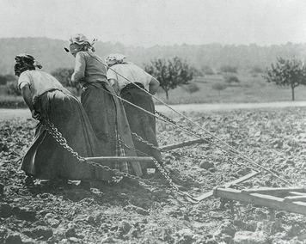
\The War’s Costs The costs to both sides in World War I were staggering. Of the 65 million men who fought in the war, some 8.5 million were killed and another 21 million wounded—many of them crippled for life. Germany and Russia each lost 1.7 million soldiers, followed by Austria-Hungary and France with more than 1.2 million dead. Great Britain and its empire suffered some 900,000 dead.
The war’s civilian casualties are impossible to determine. However, the fighting left large parts of France, Belgium, and other places in Europe in ruins. The cost of this destruction has been estimated at $37 billion. To this must be added the $200 billion cost of fighting the war. Both figures were huge sums for the time. The social and economic effects of the loss of millions of lives cannot be calculated. However, in a number of European nations, an entire generation of young men had been nearly wiped out.

5. Peace and Its Aftermath
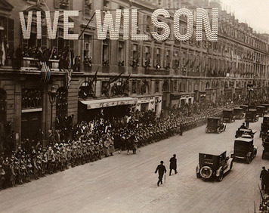
World War I had an enormous impact on the rest of the twentieth century. The centuries-old Austrian and Ottoman empires were gone. Germany, Austria-Hungary, and Russia were no longer major powers, and France was determined to ensure that Germany would never be one again. Their place in the world order was taken by the United States and a rising power in the Pacific—Japan.
The Paris Peace Conference In January 1919, an international conference began at Paris, France, to set the terms of the peace. Twenty-seven nations were represented. However, the conference was dominated by the leaders of the most powerful Allies. Called the “Big Four,” they were Prime Minister David Lloyd George of Great Britain, French premier Georges Clemenceau (kle-mahn-SOH), Italy’s premier Vittorio Orlando, and President Woodrow Wilson of the United States.
The defeated Central Powers had no part in the peace negotiations, nor did Russia. Although Russia had been an Allied Power, the Big Four distrusted its new communist government. Over the next 20 months, treaties with Germany (June 1919), Austria (September 1919), Bulgaria (November 1919), Hungary (June 1920), and Turkey (August 1920) were concluded at locations around Paris.
The Treaty of Versailles The treaty with Germany was called the Treaty of Versailles. Its contents were determined by negotiations between Wilson, Clemenceau, and Lloyd George. The negotiations were often tense. Wilson’s Fourteen Points had made him a hero among Europeans who were tired of war. However, the other Allies had made secret agreements that were at odds with Wilson’s goals for the peace. “Mr. Wilson bores me with his Fourteen Points,” Clemenceau declared. “Why, God Almighty has only Ten!”
Clemenceau, whose nickname was “the tiger,” wanted Germany crushed so that it would never again be a threat in Europe. He demanded German territory for France and that Germany pay reparations—compensation for the wrongs and damage it had done. Britain’s Lloyd George had more moderate views. He did not want Germany so weak that it could not trade with Britain. However, he also hoped to divide up Germany’s colonies and wanted Germany to pay reparations.
Expecting a treaty based on Wilson’s vision of a just peace, German leaders were shocked by what they were forced to sign. The Treaty of Versailles reduced Germany’s size and population by about 10 percent. The Alsace-Lorraine region, which Germany had taken from the French in 1871, was returned to France. In the east, land was stripped away to give the Poles their own nation again. In addition, East Prussia was separated from the rest of Germany by a corridor of land given to Poland so that Poland would have access to the Baltic Sea.
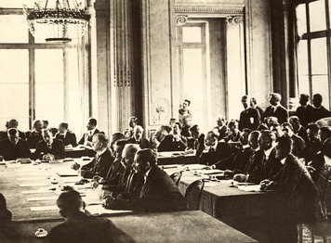
The Treaty of Versailles also limited Germany’s armed forces to a small navy and a 100,000-man army with no offensive weapons. German troops were banned from the Rhineland, an industrial area of Germany along its new border with France. The treaty put Rhineland’s resource-rich Saar region under international control for 15 years and gave France control of the Saar’s coal mines. In addition, Germany lost all of its overseas colonies.
Finally, the treaty required Germany to accept responsibility for starting the war and to pay the Allies for the damage and losses they had suffered. The amount of these reparations was later set at $33 billion (about $402 billion today). The reparations payments put even greater strains on a German economy that had been nearly destroyed by the war. The German people were especially outraged by this part of the treaty.
The Other Central Powers and Russia Austria-Hungary fared badly too. The Allies broke up its empire along ethnic lines. A northern region largely populated by Czechs was linked with the Slovaks in the east to form Czechoslovakia. The empire’s Slovene, Serb, and Croat peoples were joined with Serbia to form the new nation of Yugoslavia. Romania and Italy also gained territory, although the Italians felt that their gains were not nearly enough. The land that remained became the separate nations of Austria and Hungary. Bulgaria, another Central Power, lost territory to Yugoslavia and Greece. The Austrian army was limited to 30,000 men, while Hungary’s army was limited to 35,000 men. The treaty with Bulgaria allowed it an army of 20,000.
The Allies also dissolved the Ottoman Empire. Perhaps more than anywhere else, secret wartime agreements among the Allies shaped the peace with the Ottomans. Britain and France took over most of the Arab areas of the Ottoman Empire and created borders that shaped the modern map of Southwest Asia. Greece and Italy received parts Turkey itself, while other parts came under British and French control.
This settlement led to revolution in Turkey. Enraged Turkish nationalists rejected the treaty and their government for signing it. They overthrew the Ottoman ruler, forced the Italians and French out of Turkey, and defeated a Greek army sent to enforce the treaty. A new treaty with the Allies restored the peace in 1923. It also recognized Turkey’s new government and independence.
Russia was the only Allied Power to lose territory from World War I, and of all the Great Powers, its losses were the greatest. Following its revolution and withdrawal from the war in 1917, Russia was too weak to hold on to parts of its empire. When Finland and the Baltic states of Estonia, Latvia, and Lithuania revolted, the other Allies recognized their independence. However, Russia’s greatest loss of territory was to Poland, one of the nations the Allies created at the Paris Peace Conference. The Big Four also gave Romania a small amount of Russian territory.
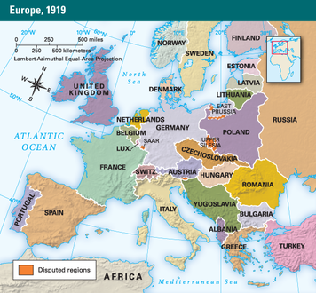
The League of Nations The Paris Peace Conference entrusted its greatest hopes for peace to the international organization Wilson had called for in his Fourteen Points. Established in the Treaty of Versailles, it was called the League of Nations. It consisted of three bodies: an assembly of representatives of all member nations, a council of representatives from the main Allied Powers (plus other nations on a rotating basis), and an executive office headed by a secretary general. The League would work closely with another new organization, the Permanent Court of International Justice (also called the “world court”), to settle disputes between nations. In addition, the League relied on collective security—joint action by member nations against an aggressor—to keep the peace.
The League of Nations also gave the Allies a way to take over German and Ottoman possessions in Africa and the Middle East without formally annexing them. Instead, these territories became mandates under League supervision. The League then assigned a member nation to govern each mandate with the goal of leading it to independence. This system allowed the Allies to control these lands despite their pledge that gaining colonies was not a goal in the peace settlement.
The Postwar Era The death, destruction, and disillusionment brought by World War I shook western society to its core. The war caused many people to reject the long-held belief in human progress first expressed by the Enlightenment. Much of the art and literature of the 1920s reflected this change in attitude. American writers Gertrude Stein and Ernest Hemingway referred to the young men and women who came of age after the war as the “lost generation.” Hemingway captured their attitudes in his 1926 novel The Sun Also Rises. Another Hemingway novel, A Farewell to Arms (1929), expressed dissatisfaction with life that was common in the 1920s.
The horrors of the war inspired an abstract art movement in Europe called Surrealism. Artists, like Spanish painter Salvador Dali, mixed images in ways that present the viewer with a world that makes no sense. Human forms painted by Pablo Picasso, another Spanish artist, were so distorted that they looked like monsters.
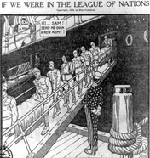
The “war to end all wars” created a public attitude, especially in Great Britain and the United States, that in the future, war must be avoided at all costs. The United States Senate expressed this attitude when it refused to approve the Treaty of Versailles and rejected U.S. membership in the League of Nations. U.S. Senators feared that the collective security requirements of the League of Nations would draw the United States into other wars. But Americans sought to preserve the peace in other ways. For example, the Washington Naval Conference in 1921 resulted in an agreement by the major powers to reduce the size of their navies. In 1928 U.S. and French officials drew up an agreement that outlawed war as an instrument of foreign policy. The Kellogg-Briand Pact was signed by more than 60 nations.
The absence of the United States from the League of Nations seriously weakened the organization’s influence and prestige. More significant was the lack of power that the League of Nations had to enforce its will. Its real power lay in the hands of its member states, who had to decide if and when to take action to secure the peace.
This lack of power would have serious consequences in the near future. The peace settlement had left nations on both sides of the war dissatisfied. Germany felt betrayed and desired revenge. Japan and Italy had territorial ambitions that remained unfulfilled. All three nations would soon be engaged in changing their situation. The League of Nations would prove powerless to keep the world at peace.

Summary
In this lesson, you learned about World War I, which was fought from August 1914 to November 1918. The war and its outcome changed the world in many ways.
Political Systems Germany felt surrounded by potential enemies, so it entered into alliances with other nations to protect itself. Germany’s rivals entered into alliances as well. This network of opposing alliances turned a regional dispute into a major war. After the war, a defeated Germany was harshly punished and the empires of its allies were destroyed.
Economic Systems Neither side was prepared for a long war. Germany and Britain blockaded each other to cut off imports of supplies. Nations rationed goods, but the fighting eventually depleted their resources. Hardships at home caused unrest and peace movements to develop, especially in Germany and Austria-Hungary. The United States’ entry into the war in 1917 provided the resources that the Allies needed for victory.
Human-Environment Interaction The fighting in World War I took place in Europe, the Middle East, and Africa. On Europe’s Western Front entrenched armies battled for years, unsuccessfully trying to push each other back. There, and on the war’s other fronts, modern weapons combined with traditional battlefield tactics to produce a tremendous loss of human life.

