Unit 11- Expanding Empires Outside of Europe

1. Introduction
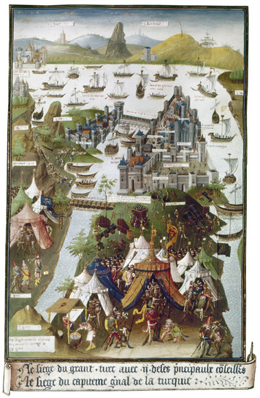
On April 6, 1453, the Ottoman Turks began their attack on the city of Constantinople. They bombarded the Byzantine capital with artillery, blasting away at the city’s walls. Yet for weeks the Byzantine defenders held on.
Constantinople’s defenses were the strongest in the world. An extensive system of moats, walls, and towers repelled enemy forces. Over the centuries, many attacking armies—including the Ottomans—had tried but failed to capture the city.
This time, however, things were different. The Byzantine Empire was near collapse. It controlled only Constantinople and a few nearby ports and islands. The Ottomans, in contrast, were on the rise. They had conquered the lands of Anatolia to the south and the Balkans to the north. They had the Byzantines surrounded. They also had them outnumbered. A Byzantine force of just 7,000 troops faced an Ottoman army of 100,000. Furthermore, Constantinople’s walls had not been built to withstand cannon fire.
After nearly two months of siege, the end came suddenly. On the morning of May 29, the Ottomans broke through the walls and captured the city. Constantinople was in Islamic hands.
The fall of Constantinople had a major effect on Europe and Asia. The city had once halted the Muslim advance into Europe. Now that obstacle was gone. A new, Muslim empire controlled the Eastern Mediterranean and its trade routes to Asia. The Ottoman rise also underscored the growing importance of gunpowder weapons in the formation of powerful states and empires.
In this lesson, you will read about five great empires of Eurasia, beginning with the Ottoman Empire. You will learn how they rose to power and why they eventually declined.

Themes
Cultural Interaction Large empires brought together diverse peoples across Eurasia. Some cultures adapted, while others resisted change.
Political Structures Rulers built strong, centralized states to maintain control over large territories.
Economic Structures Trade and commerce brought increased wealth, but agriculture remained the chief economic activity.
Social Structures Class systems brought order to societies but also imposed rigid social differences.

2. The Ottoman Empire
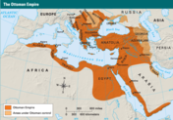
After the capture of Constantinople, the Ottomans went on to build one of the largest empires in history. At its height in the 1600s, the Ottoman Empire controlled Southwest Asia, coastal North Africa, and large parts of Europe.
Origins and Expansion The Ottomans were a Muslim tribal group that emerged in northwestern Anatolia in the late 1200s. They traced their origins to Turkish nomads who had migrated from Central Asia centuries before. They took their name from Osman, a powerful warrior chief who united various tribes and began a campaign of conquest in 1299.
By the early 1300s, the Ottomans were expanding into Byzantine territory. They took the towns and cities south of Constantinople, then crossed into Europe. By 1400, they had captured much of the Balkan Peninsula. They suffered a setback when Timur Lang, the last of the Mongol conquerors, seized a large part of Anatolia in 1402. But they rebounded, and in 1453 took Constantinople. They renamed it Istanbul and made it their capital.
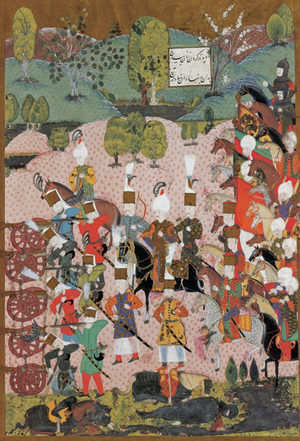
The Ottoman sultan, or ruler, who captured Constantinople was Mehmet II, also known as the Conqueror. Under Mehmet and his successors, the Ottomans continued to expand the empire. They took the rest of the Balkans, including Greece, and the lands around the Black Sea. They occupied Mesopotamia and portions of Arabia, Palestine and Syria, Egypt, and North Africa. They seized Hungary in 1526 and almost captured Vienna. Many of these conquests took place under their greatest sultan, Suleyman I. Known as Suleyman the Magnificent, he ruled from 1520 to 1566.
By the mid-1600s, the Ottomans ruled an empire nearly the size of ancient Rome. They controlled rich agricultural lands and prosperous trading cities, which brought great wealth to the empire. They also occupied the holy cities of Mecca and Medina, giving them claim to leadership of the Muslim world. They had achieved their conquests by building a powerful military, which made effective use of field cannons and armed infantry. And they maintained their empire by creating a strong, efficient government.
Organization of the Empire The Ottoman state was highly centralized. All power flowed from the sultan, who governed as an absolute ruler. For six centuries, the royal family of Osman kept the throne, passing it down through male members of the family. There was no clear line of succession, however. The sultan’s heirs had to fight for power. So when one of them gained the throne, he typically had his brothers and other male relatives killed or imprisoned to prevent challenges to his rule.
The sultan sat at the top of a large political structure. Directly beneath him was the grand vizier, the chief minister in charge of the government. The grand vizier met with other ministers and military leaders in a governing council called the divan. Beneath these high officials lay a large bureaucracy of lesser officials who served the government at all levels. A network of provincial governors managed the conquered territories and linked them to the central government in Istanbul.
The Ottoman bureaucracy was a merit-based system. Most officials gained office based on their abilities, not their social position. Such a system is called a meritocracy. Other states, notably China, developed similar systems. In the Ottoman state, however, many of the top officials were captives. These captives, most of them Christians, were taken from conquered lands in Anatolia and the Balkans. They were brought to Istanbul, where they were converted to Islam and trained for a life in government service.
To ensure a steady supply of captives for government service, the Ottomans levied a tax called the devshirme. This tax required conquered regions to provide a regular allotment of children to serve the sultan. Many of the boys were trained for military service. They became part of an elite fighting force called the janissaries. Because of their training and allegiance to the state, the janissaries were renowned as the best soldiers in the world.
The brightest and most capable captives, however, were groomed for government office. The most successful became ministers, judges, and governors. One famous example was Ibrahim Pasha, the son of a Greek fisherman who was sold into slavery and entered the household of Suleyman the Magnificent. He later married the sultan’s sister and became the grand vizier, second in power only to the sultan.
The Ottomans divided society into two broad classes: the rulers and the ruled. The rulers were members of the military and governing class, which included both Muslims and non-Muslims. They did not pay taxes. The people being ruled included taxpaying commoners, such as farmers, artisans, and merchants.
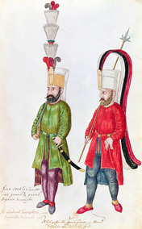
A Diverse Society Ottoman society was ethnically diverse, with large numbers of Greeks, Serbs, Bulgarians, Romanians, Armenians, Turks, and Arabs. The Ottomans were generally tolerant of different cultures and religions. They allowed Orthodox Christians and Jews to practice their faith, subject to certain restrictions and special taxes. Although second-class citizens, non-Muslim groups were organized in separate communities that were given the right to manage their own religious affairs.
The Ottomans were less tolerant of Shi’a Muslims. As Sunnis, they saw the Shi’a as a challenge to their authority and often persecuted them. They also waged long and vicious wars with the Safavid Empire of Persia. The Safavids were a Shi’a state that bordered the Ottomans to the east.
Under Suleyman, the Ottomans developed a strong legal code. This code was based on Shari’a, or Islamic law. But the code also included non-Islamic provisions for situations that were not covered by Shari’a. Suleyman’s law code provided a uniform legal system regardless of people’s social and religious origins. For that reason, he was also known as the Lawgiver.
A Gradual Decline Suleyman’s reign was the high point of the Ottoman Empire. After his death in 1566, Ottoman power gradually declined.
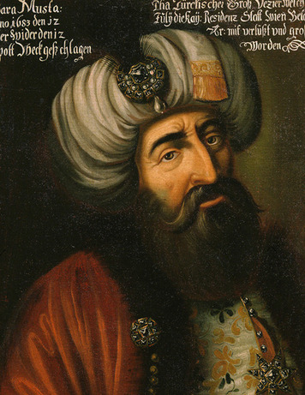
One early blow occurred in 1571 at the Battle of Lepanto. This naval battle off the coast of Greece pitted the Ottoman navy against a combined European fleet. The Europeans dealt the Ottomans a stinging defeat, their first major loss in battle. The Ottomans recovered and even conquered more lands. But they were dealt another harsh blow in 1683, when they again failed to take Vienna, the capital of Austria’s Hapsburg Empire. By this time, the Ottoman’s image of invincibility had been shattered.
In addition, a series of increasingly weak and corrupt sultans led the Ottoman Empire in its final centuries. One reason for this weakness may have been the Ottoman policy of imprisoning possible heirs to the throne, which included the sons of the reigning sultan. As prisoners, these contenders to the throne did not receive the education or training they needed to rule the empire. Those who eventually rose to power mismanaged the empire, and the central government lost power and authority.
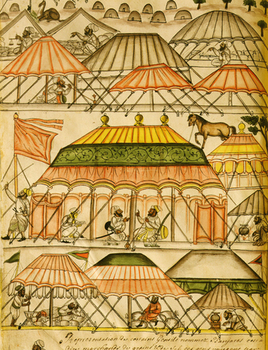
The Ottomans also suffered from economic problems. By the 1600s, European countries had developed new sea trade routes to Asia that bypassed the traditional land routes across Ottoman territory. This reduced the amount of revenue the Ottomans could earn from trade. An influx of silver from the new American colonies also lowered the value of the Ottoman currency and caused inflation.
The Ottoman rulers took steps to modernize in the late 1700s. The sultans and their ministers adopted reforms in an effort to strengthen the economy and government. But by this time the empire was shrinking. At the same time, Europe was growing more powerful. The Ottoman Empire survived until the early 1900s, but was finally dissolved in 1923, after World War I.

3. Mughal India
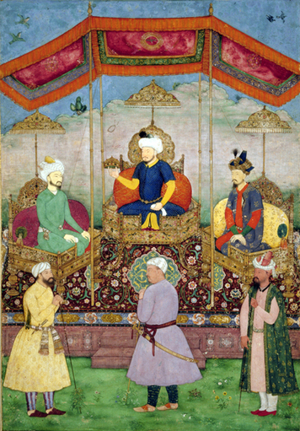
Click to read caption
In the 1500s, a new empire arose in India under the Mughal dynasty. Like the Ottomans, the Mughals were Muslim Turks with ethnic roots in Central Asia. They, too, built a large empire with the aid of gunpowder weapons and an efficient, centralized government.
Founding the Empire The founder of the Mughal dynasty was Babur, a descendant of the Mongol leaders Timur and Genghis Khan. Mughal was the Persian word for “Mongol.” As a young man, Babur moved south from Central Asia to conquer Afghanistan. But he had his eyes set on India.
For three hundred years, a group of Muslim states known as the Delhi Sultanate had ruled most of northern India. In 1526, Babur invaded India. Near Delhi, he confronted the army of Sultan Ibrahim. The sultan had 100,000 troops against Babur’s 12,000. But Babur’s soldiers were well trained and equipped with artillery and muskets. Babur later wrote:
I put my foot in the stirrup of resolution and my hands on the reins of confidence in God, and marched against Sultan Ibrahim. . . . The sun had mounted spear-high when the onset began, and the battle lasted until midday, when the enemy was completely broken and routed.
—Babur, Memoirs
Babur went on to conquer most of northern India. In 1530 he died, leaving the throne to his son Humayun. His son was a poor ruler, however, and lost most of the empire. When Humayun died in 1556, he left only a small kingdom around Delhi to his son Akbar.
A Golden Age Akbar was just 13 years old when he took power. He was a brilliant leader who soon revived the Mughal Empire. Akbar ushered in a golden age of Indian civilization that lasted for more than two centuries.
Akbar continued to expand the empire. Over his 40-year reign, he conquered more than half the Indian subcontinent. But his greater skill was in governing. He divided India into provinces and districts and established an efficient system of administration. He also reformed the tax system to reduce taxes on peasant farmers.
Akbar ruled as an Indian, not as a foreign conqueror. He knew that his rule could only succeed with the support of India’s diverse population. He promoted tolerance by allowing his subjects—whether Sunni or Shi’a Muslims, Hindus, or Sikhs—to worship as they pleased. He eliminated unfair taxes on Hindus and appointed Hindu leaders to high positions in government. He invited Hindu, Muslim, and Christian scholars to his court and even hired a Jesuit tutor for his son. Despite his tolerance, however, he was ruthless in putting down opposition. When a Hindu prince defied his authority in 1568, he sacked the prince’s city and massacred its defenders.
Art and culture flourished under Akbar’s rule. The Mughal Empire brought together cultural traditions from the Indian, Persian, and Arab worlds. Persian was the official court language. It blended with local tongues to form Hindi, the main language of modern India, and Urdu, the official language of Pakistan.
Akbar valued learning and promoted the arts. Poetry and painting, particularly miniature painting, flourished in Mughal India. Mughal architects mixed Islamic and Indian styles to create buildings with great domes, arches, and minarets. These buildings were beautifully decorated with carvings, mosaics, and other intricate designs.
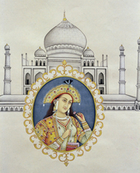
Akbar died in 1605, leaving behind a strong and orderly empire. The rulers that followed over the next century maintained the empire, though with less skill.
Shah Jahan ruled for three decades, from 1628 to 1658. He is best known for his lavish court life and the construction of the Taj Mahal. Built in memory of his wife, this building—with its marble dome and splendid gardens—is one of the world’s architectural treasures.
The next ruler, Aurangzeb (AWR-uhng-zehb), held power for five decades, until 1707. He was a fervent Muslim who abandoned Akbar’s policy of tolerance toward Hindus. He removed Hindu officials from government and reinstated the much-hated taxes on Hindus. At the same time, he carried out a long and bloody military campaign that brought most of southern India into the Mughal Empire. Under his rule, the empire reached its greatest size.
Trade and Interaction The success of Mughal rule depended on the vast wealth and resources of the Indian subcontinent. During the Mughal era, India’s economy was larger than that of any European nation. It supported a population of some 150 million people, much larger than Europe’s. Abundant farmlands, particularly in the Ganges River plain of northern India, produced large harvests of rice, sugar, and other crops. Industries made a wide range of goods, from cotton cloth to gold jewelry.

Click to read caption
Trade and commerce were critical to the Indian economy. For centuries, India’s position on sea routes across the Indian Ocean had spurred the growth of trade. These trade routes connected India with China and the Spice Islands to the east, and with Southwest Asia, Africa, and Europe to the west. This maritime trade brought great wealth to India.
Along these trade routes, Mughal merchants and Sufi missionaries also spread Indo-Muslim culture and the Islamic faith. During the Mughal era, many people in Southeast Asia—particularly Indonesia—converted to Islam. Indonesia is a largely Muslim country today as a result of this exchange.
During this era, European traders also came to India, drawn by its many riches. The Portuguese had arrived in the early 1500s. By the 1600s, the French, Dutch, British, and Danish had also established trading stations on Indian shores. They exchanged silver from the Americas for cotton cloth, spices, and other Indian trade goods.
The Mughal Decline By the 1700s, European influence in India was growing. Meanwhile, Mughal power was in decline. Aurangzeb’s focus on conquest had distracted attention from other critical needs and depleted the royal treasury. His harsh policies toward Hindus had also turned many Indians against Mughal rule. “Your subjects are trampled underfoot,” one Indian wrote. “Every province of your empire is impoverished.” Rebellions broke out, and various regions separated from the Mughal state. The empire began to unravel.
A series of weak Mughal rulers was unable to reverse the decline. By the late 1700s, Britain had taken advantage of this weakness and gained effective control over large parts of India. The Mughal ruler became a figurehead, with no real power. Mughal rule officially lasted until 1857. But by the early 1800s, India was essentially a British colony.

4. China Under the Ming and Qing
During the era of Ottoman and Mughal rule, two dynasties governed China, the Ming and the Qing (ching). Both dynasties took power during times of upheaval. To restore order, they established strong, centralized rule and revived traditional Chinese values, including Confucian ideals.
The Ming Revival In the mid-1300s, China was in turmoil. The Mongol Yuan dynasty was still in power, but disease and natural disasters had weakened the Mongol grip. Bandits and rebels roamed the countryside. In 1368, a Chinese rebel army overthrew the Mongols. The rebel leader, Zhu Yuanzhang (JOO yuwen-JAHNG), took power and established the Ming dynasty. In Chinese, the word Ming means “brilliant.”
The new Ming emperor set out to restore traditional Chinese rule. He revived the state examination system, used to select officials for the civil service. This system of tests was based on the Chinese classics, especially the works of the philosopher Confucius. Under Ming rule, Confucian scholars were again elevated in Chinese society. Classical art and literature were held up as models for artistic expression.
The emperor also reformed the tax system and distributed land to Chinese peasants. Under the Ming, agriculture prospered. New crops such as potatoes and corn, brought from the Americas in the 1500s, increased the food supply. As a result, the Chinese population doubled during the first two centuries of Ming rule. Trade and commerce also increased, though Ming rulers—in traditional Confucian style—favored agriculture over business.
During his 30-year reign, Zhu Yuanzhang brought peace and stability to China. But he was also a despot who ruled with an iron hand. Fearing threats to his power, he had thousands of officials executed for suspected wrongdoing. He described his actions this way: “In the morning I punish a few; by evening others commit the same crime. . . . Day and night I cannot rest. . . . To be a ruler is indeed difficult.”
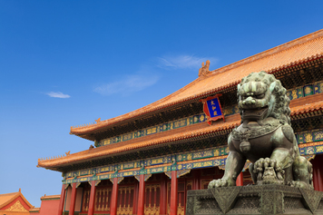
Ming Expansion In 1403, the emperor’s son, Yong Le (yoong LAW), took power. He continued to strengthen the Chinese state. He rebuilt the Great Wall, an ancient defense against nomadic invaders from the north. He also built a new capital at Beijing. The city was enclosed by high walls and featured a great palace—called the Forbidden City—at its heart. In its grand design, the new capital symbolized the power of the Chinese empire.
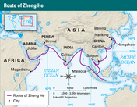
Yong Le also expanded China’s influence overseas. He sponsored a series of great ocean voyages under the command of Admiral Zheng He (JEHNG HUH). Between 1405 and 1433, Zheng He led a large fleet on seven voyages to Southeast Asia, India, Arabia, and Africa. He met with foreign rulers and brought back exotic goods, including zebras and giraffes. The main purpose of the voyages was to increase the flow of tribute to China. For the Ming, the tribute system demonstrated Chinese power. It bolstered their age-old belief that China, which they called the “Middle Kingdom,” was the center of the world.
Although the Ming voyages were a great success, the government ended sea travel in the 1430s. The expeditions were expensive, and China decided to focus attention on the defense of its northern border. The decision also reflected the conservative Chinese view that other cultures were inferior and had little to offer China. Increasingly, the Ming rulers looked inward and isolated China from the rest of the world.
The Qing Dynasty Ming rule lasted for nearly three centuries. By the early 1600s, however, the Ming dynasty had grown weak and corrupt. Famine and rebellions ravaged the country. In Chinese terms, the Ming had lost the Mandate of Heaven, the traditional right to govern. In 1644, Manchu invaders from the north stormed into China and seized power with the aid of gunpowder weapons. They formed a new dynasty, the Qing (ching), which means “pure.”
The Manchus came from Manchuria, a region just north of Korea. Although the Chinese saw them as foreign barbarians, the Manchus had long been influenced by Chinese culture and had adopted many Chinese customs. At first they met strong resistance to their rule. Over the next few decades, however, they brought all of China under their control.
To remain in power, the Manchus adopted policies that were both tough and generous. On the one hand, they forced Chinese men to submit to their rule by wearing their hair in the Manchu style, with a shaved forehead and pigtail in the back. They also kept control of the military by reserving the top positions for Manchus.
At the same time, the Manchus showed respect for Chinese traditions. They preserved the structure of Ming government and ruled according to Confucian principles. They supported the state exam system and allowed Chinese officials to hold high positions in government. They upheld the values of classical Chinese culture. In this way, the Manchus gradually won acceptance from the Chinese people.
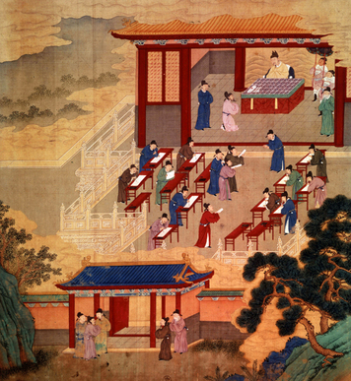
The Qing dynasty also benefited from having two outstanding emperors. The first, Kangxi (kahng-shee), ruled from 1661 to 1722. His grandson, Qianlong (chyahn-lung), gained the throne in 1735 and held power just as long. Both men were wise and capable rulers. They expanded the boundaries of the empire and brought peace and prosperity to China. Qing China became the largest and richest empire in the world.
Isolation and Decline As in the past, most of China’s wealth came from agriculture. But trade and commerce also played an important role. Like good Confucian rulers, the Qing officially discouraged trade, while allowing it in limited form. They restricted European traders to the port of Canton, in southern China, and showed little interest in European goods. In 1793, Emperor Qianlong wrote to King George III of England: “Our Celestial Empire possesses all things in abundance. We have no need for barbarian products.” Nevertheless, the Qing agreed to exchange Chinese goods—including silk and tea—for silver from the Americas.
As a result, China’s economy continued to grow, and so did its population. Between 1650 and 1800, the population rose from 140 million to 350 million, more than a third of humanity. China could not sustain such growth forever, though. In the 1800s, it began to experience food shortages and famine. Once again, rebellions broke out and the dynasty faltered.
In some ways, China’s success under Qing rule also contained the seeds of its decline. For centuries, China had relied on its traditions to ensure stability, prosperity, and power. But as global interaction increased and the world began to change, this conservative approach hindered progress. China rejected new ideas in science, technology, and economics that might have brought increased productivity and wealth. Instead, it fell back on its old ways. This reluctance to change left China vulnerable to the growing power of Europe. The Qing dynasty lasted until 1911, but as a result of its policies by the late 1800s it was increasingly dominated by Western powers.

5. Tokugawa Japan
While the Ming dynasty ruled China, another strong dynasty—the Tokugawa—took power in Japan. In the 1600s, the Tokugawa (toh-koo-GAH-wah) unified Japan and brought a long period of peace and stability to the country.
A Feudal System For centuries, Japan had been a feudal society, much like medieval Europe. Local lords, known as daimyo (DIE-mee), controlled large landed estates. They relied on armies of samurai warriors to defend their land and settle disputes with other lords.
At the top of this feudal structure was the emperor, who claimed descent from a mythical sun goddess. But real power rested in the hands of the shogun, a military leader who ruled on behalf of the emperor and demanded the allegiance of the daimyo. In theory, the daimyo respected the shogun’s authority, but the system was unstable. Because power was decentralized and allegiance based on military strength, a lord who grew strong enough might challenge the shogun and seize power himself.
In the late 1400s, civil war broke out when a series of weak shoguns lost control of the state. For the next century, the daimyo, backed by their samurai armies, battled each other for power. This period of warfare was known as the Age of the Warring States.
Finally, in the late 1500s, two powerful daimyo gained the upper hand. Using muskets and field artillery, they defeated their rivals and took power. But it was a third lord, Tokugawa Ieyasu (toh-koo-GAH-wah ee-yeh-YAH-soo), who finally ended the wars and united Japan. In 1603, he became shogun. He created a dynasty and a government that ruled Japan for the next 250 years.
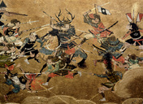
Tokugawa Rule To ensure stability, the Tokugawa rulers formed a strong, centralized government. They established controls on the daimyo and on Japanese society that allowed them to govern effectively. Scholars have referred to the Tokugawa system as centralized feudalism.
To curb the power of the daimyo, the Tokugawa rulers created a secret police force to root out opposition. They banned the use of firearms and the construction of new castles. They also restricted the movement of samurai and forced the daimyo and their families to live as virtual hostages in Edo, the capital city now known as Tokyo. This arrangement placed a great financial burden on the daimyo while curbing their power and helped ensure their loyalty.
The Tokugawa also established a rigid social structure, consisting of four social classes. At the top was the warrior class of lords and samurai, which made up around 5 percent of the population. Next came farmers, considered the most productive part of society. Artisans made up the third social class. At the bottom were merchants. An elaborate code of etiquette laid out rules for the dress and behavior of each class.
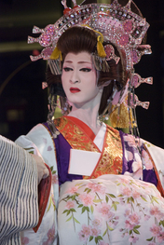
In principle, social mobility was rare in Japan. This rigid structure was designed to ensure social order and respect for authority. In this way, it helped reinforce Tokugawa rule.
Chinese Influence The social system of Japan reflected Confucian values from China. As an island nation, Japan had never been conquered by China. But it was still heavily influenced by Chinese civilization.
As early as 500 C.E., Chinese culture was making its mark on Japan. Along with Confucian thought, the Japanese borrowed their writing system and early political structures from China. They absorbed Chinese influences in art and literature. They also adopted Buddhism from China. Over time, however, the Japanese blended Chinese customs with their own traditions to form a unique Japanese culture.
During the Tokugawa era, various art forms flourished in Japan. Kabuki is a form of theater that combines elaborate costumes, music, and dance. It became popular in Japanese cities. Visual artists created beautiful woodblock prints showing scenes from urban and rural life. Writers and poets explored new forms of literature, including short verse called haiku (HI-koo).
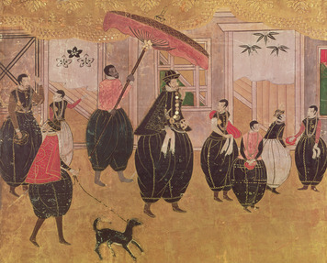

A Policy of Isolation Not long before the Tokugawa took power, European traders and missionaries had arrived in Japan. At first, the Tokugawa rulers remained open to foreign influence. They took an interest in Western goods and welcomed new ideas in science, mapmaking, and shipbuilding. They even allowed Catholics to set up missions. They became alarmed, however, when Japanese began to convert to Catholicism. Religious intolerance spread in the form of expelling the missionaries and cracking down on Christian converts.
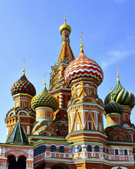
This xenophobia, or fear of foreigners, started to affect commercial exchange when the government also began to restrict trade. By 1638, it had expelled most European traders, limiting trade to just one port. Only the Dutch were allowed to visit, once or twice a year. The government also prohibited Japanese from traveling abroad and outlawed the building of large ships.
For the next two centuries, Japan was effectively isolated from the rest of the world. This policy of isolation was beneficial in that it helped the Tokugawa rulers preserve Japanese traditions and maintain control. But the negative impact was that it also prevented Japan from gaining useful knowledge from abroad. Like China under the Qing, Japan did not benefit from developing ideas in science, technology, and other fields that would have helped the country develop.
Ultimately, this lack of progress left Japan vulnerable to foreign powers. In the mid-1800s, American warships forced Japan to open up to foreign trade. Not long after, the Tokugawa government came to an end. Japan had entered a new era.

6. The Russian Empire
In the 1500s, Russia formed a powerful state and began to expand its territory. Over the next few centuries, it built a great empire that stretched across Eurasia. Unlike China or Japan, however, Russia made efforts to modernize by adopting Western ideas.
The Rise of Russia The origins of the Russian state go back to the late 1400s and the rise of Prince Ivan III of Moscow. At the time, the Mongols still controlled Russia, but they were divided and their power was waning. They allowed Russian princes to govern their own cities in return for tribute payments. They also allowed Russians to practice their Orthodox Christian faith, which helped bolster Russian identity under Mongol rule.
Ivan III—also known as Ivan the Great—came to power in 1462. Seeing that the Mongols were in decline, he began to conquer lands around Moscow and build up his strength. By 1480, he had thrown off Mongol control. He continued his conquests over the next two decades, tripling the size of Moscow’s territory and making it the dominant power in Russia. He began to call himself czar, the Russian form of “caesar.” He saw Russia as the “Third Rome”: the heir to the Roman and Byzantine empires and the defender of Christianity.

Ivan the Great’s successors continued to expand the Russian state. The most powerful of the early czars was his grandson, Ivan IV, who gained the throne as a child in 1533. During his reign of nearly 50 years, Ivan IV took three steps to strengthen the central government and modernize Russia. First, he conquered Mongol lands to the south and east, incorporating them into Russian territory. Second, he instituted reforms, including a uniform code of laws, to make the state more efficient. Third, he fought feudalism and took steps to curb the power of the boyars, Russia’s landed nobility.
Ivan is best remembered, however, as a cruel tyrant who terrorized Russian society. Mid-way through his reign, he became obsessed with threats to his rule. He persecuted the boyars by attacking them and seizing their lands. He created a secret police force and had thousands of people arrested, tortured, and killed. These actions earned him the nickname Ivan the Terrible.
Rule of the Romanovs After Ivan’s death in 1584, his son Fyodor became czar. Fyodor was a weak ruler, however, who failed to mend the divisions caused by his father. In the early 1600s, after Fyodor’s death, Russia was engulfed in a 15-year period of civil war known as the Time of Troubles.
In 1613, however, a new czar, Michael Romanov, came to power. Gradually, Russia began to recover from the social divisions Ivan had created. The Romanov family would rule Russia for the next 300 years.
Under the Romanovs, Russia continued to expand its empire. It moved east, taking in the lands of Siberia—a huge portion of the Asian continent—and extending Russia’s borders to the Pacific Ocean. Siberia was rich in resources, including furs. During the 1600s, Russian colonizers settled in Siberia and established a lucrative fur trade.
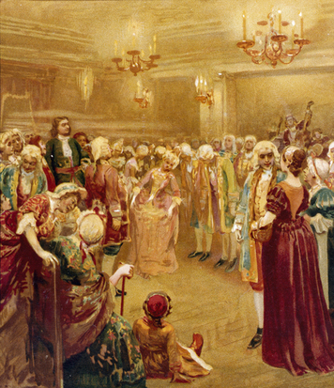
Click to read caption
The Modernizing Czars The Romanovs continued to reform and modernize the Russian state. The leaders in this effort were Peter I, also known as Peter the Great, and Catherine the Great who mark the golden age of Russia’s enlightenment.
When Peter took power in 1682, Russia was still largely isolated from Europe. But Peter was determined to open Russia up to the West. He took a long journey through England and France to absorb new ideas. He visited factories, hospitals, and museums, and even worked for a time in a shipyard. He returned home with plans to transform Russia into a modern nation.
Peter sought to gain access to a coastline on the Baltic Sea, which he successfully acquired via war with Sweden. The territory gained from Sweden would become “Russia’s window into the West.” There he built a modern new capital named after himself—St. Petersburg—based on European designs. He brought in European advisers and specialists, set up schools to teach technical subjects, and established an academy of sciences to promote new learning. Under his rule, Russia built factories and roads and established a professional army and civil service on the European model. The government required officials to dress in the Western style and to shave off their beards.
Russia’s modernizing efforts continued under another emperor, Catherine II, who ruled from 1762 to 1796. She was also known as Catherine the Great. Like Peter the Great, Catherine also founded schools and supported the arts and sciences. She promoted Enlightenment principles of justice and good government. But like her predecessors, she was an absolute ruler who governed with an iron fist, allowing few freedoms and forcing Jews into a limited area called the Pale of Settlement.
The End of Monarchy By the time of Catherine’s reign, Russia faced a looming crisis that would eventually bring down the czars. For more than a century, Russia’s serf population had been growing. In 1800, around half of all Russian peasants—around 20 million people—were tied to the soil like peasants in western Europe had been prior to the 14th century. They had no rights and lived in terrible poverty. When they revolted, as they sometimes did, their uprisings were brutally repressed.
Thus, while Russia was taking steps to modernize, its social system was still mired in the past. Russia was the last European country to outlaw serfdom, in 1861, and by then it was too late. In 1917, a revolution erupted and brought an end to the Russian monarchy as a result. The Romanov attempt to modernize Russia had been too concentrated on science and technological developments and ignored socio-political developments. This unbalance brought about the last of the European revolutions.

Summary
In this lesson, you learned about five powerful empires that ruled in Eurasia during the period from 1400 to 1800. These empires gained power with the aid of gunpowder weapons and maintained control over large territories.
Cultural Interaction The Eurasian empires incorporated many different peoples and cultures. Some, like the Ottomans and Mughals, reflected diverse cultural influences. Others, like the Chinese and Japanese, held fast to their own traditions and resisted cultural change. The Russians modernized by opening up to the West.
Political Structures All five empires built strong, centralized states to govern their territory. They created official bureaucracies and codes of law to make government more effective. Nevertheless, most rulers—such as the Ottoman sultans and the Russian czars—held absolute power.
Economic Structures Trade and commerce became increasingly important across Eurasia, especially in the Ottoman and Mughal empires. Trade grew in China, too, though without official support. In the Confucian style, both China and Japan favored agriculture over commerce.
Social Structures Eurasian states imposed class structures designed to maintain social and political order. But rigid social systems, such as those in Japan and Russia, left empires unprepared for change.

