Name____________________________Date_____
Unit 11 Reconstruction

1. Introduction
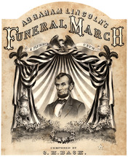
How could a nation torn apart by civil war put itself back together? That was the question facing all Americans in 1865. In his second inaugural address, Abraham Lincoln spoke of healing the wounds on both sides of the conflict:
With malice [hatred] toward none; with charity for all; with firmness in the right, as God gives us to see the right, let us strive on to finish the work we are in; to bind up the nation's wounds; to care for him who shall have borne the battle, and for his widow and his orphan; to do all which may achieve and cherish a just and lasting peace among ourselves and with all nations.
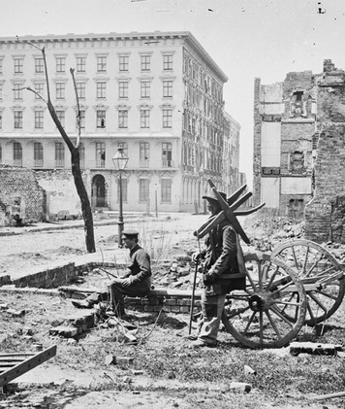
—Abraham Lincoln, Second Inaugural Address, March 1865
But Lincoln would not have the chance to put his plan into action. A little more than a month after his inauguration, he was assassinated while attending a play at Ford's Theater in Washington, D.C. Northerners were deeply grieved by his murder. Young Caroline Cowles Richards wrote in her diary, "I have felt sick over it all day and so has every one that I have seen. All seem to feel as though they had lost a personal friend, and tears flow plenteously."
Lincoln's assassin, an actor named John Wilkes Booth, believed he was saving the Confederacy by murdering the president. Although few Southerners rejoiced at Lincoln's death, many Northerners blamed the South for his murder, as well as for the war. They wanted the South punished.
With Lincoln gone, the task of bringing these two sides together fell to his vice president, Andrew Johnson. A large part of healing the nation's wounds would be to rebuild the devastated South. This undertaking, called Reconstruction, was an enormous task. But it was also an enormous opportunity to extend the ideals of liberty, equality, and opportunity to the almost 4 million African Americans who had just been freed from slavery.

2. Andrew Johnson Begins Presidential Reconstruction
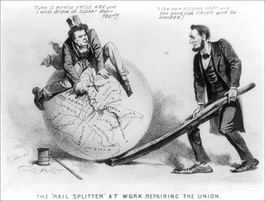
"The queerest character that ever occupied the White House"—that is how one observer described Andrew Johnson. Certainly, Johnson's path to the presidency was unusual. When the war broke out, Johnson was a senator from Tennessee. Even though his state seceded, he kept his senate seat—the only senator from a Southern state to do so. A lifelong Democrat, Johnson was nonetheless nominated by Republicans to run for vice president in 1864. True to his party roots, Johnson saw himself as a champion of the common man. But though he condemned former slaveholders as a "pampered, bloated, corrupted aristocracy," he had little concern for former slaves. They would have no role in his plans for reconstructing the South.
Johnson's Reconstruction Plan: A Smooth Return for Southern States Fewer than two months after taking office, Johnson announced his Reconstruction plan. A former Confederate state could rejoin the Union once it had written a new state constitution, elected a new state government, repealed its act of secession, canceled its war debts, and ratified the Thirteenth Amendment to the Constitution. The first of three Reconstruction-era amendments, the Thirteenth Amendment abolished slavery. Republicans in Congress urged Johnson to add a requirement that Southern states must grant freedmen the right to vote. Johnson, however, resisted their pleas. "White men alone," he insisted, "must manage the South."
Former Slaves Test Their New Freedom As Presidential Reconstruction got underway, former slaves were testing the meaning of freedom. For many, it meant freedom to travel. Before emancipation, slaves could not leave their homes without a travel pass from their masters. Now they took to the road, often in search of loved ones who had been sold in slavery times. For others, freedom meant the right to wed, knowing that the marriage was not only legal but could also last "until death do us part." "Weddings, just now, are very popular and abundant among the colored people," wrote an army chaplain. "I have married during the month twenty-five couples, mostly those who have families, and have been living together for years."
Freedom also meant the right to pursue something else long denied to slaves—an education. Freedmen flocked to schools set up by various groups. Booker T. Washington, a freedman who became a leading educator, observed,
It was a whole race trying to go to school. Few were too young, and none too old, to make the attempt to learn. As fast as any kind of teachers could be secured, not only were day-schools filled, but night-schools as well. The great ambition of the older people was to try to learn to read the Bible before they died.
—Booker T. Washington, Up from Slavery: An Autobiography, 1901
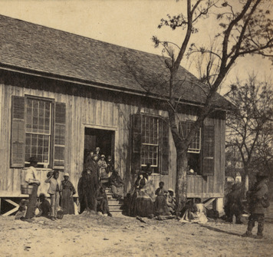
Along with education, freedmen were desperate to acquire land to farm. During the war, Congressman Thaddeus Stevens had advocated breaking up Southern plantations to give freed slaves "forty acres and a mule" in return for their years of unpaid labor. "We have turned, or are about to turn, loose four million slaves without a hut to shelter them or a cent in their pockets," he argued. "If we do not furnish them with homesteads . . . we had better have left them in bondage." Congress, however, refused to implement Stevens's plan, arguing that to take planters' land without payment would violate their property rights.
Before the end of the war, the Union government had established the Freedmen’s Bureau to assist former slaves and poor whites living in the South. The bureau provided food, clothing, education, and medical care. It also gave legal assistance to former slaves and acted as a court of law in some situations. But its attempts to solve the problem of farmland for freedmen were thwarted by Johnson, who pardoned former Confederates and returned the land to them.
Black Codes Restrict the Freedom of Former Slaves As new Southern governments were formed, Johnson withdrew Union troops from the South. Many Northerners did not share Johnson's willingness to let the South reconstruct itself. Congressman Benjamin Flanders warned of former Confederate leaders: "Their whole thought and time will be given to plans for getting things back as near to slavery as possible."
Sadly, Flanders was right. Across the South, state legislatures passed black codes—laws intended to restrict the freedom and opportunities of African Americans. The black codes served three purposes. The first was to spell out the rights of African Americans. They could own property, work for wages, marry, and file lawsuits. But other civil rights, or rights of citizenship, such as the right to vote or to serve on juries, were denied them. The second purpose was to ensure a workforce for planters who had lost their slaves. The codes required freedmen to sign yearly labor contracts each January. Those who did not could be arrested and sent to work for a planter.
The final purpose of the black codes was to maintain a social order in the South that limited the upward mobility of African Americans. The codes barred blacks from any jobs but farm work and unskilled labor, making it impossible for them to rise economically or to start their own businesses. Such restrictions led a Northern journalist touring the South to write,
The whites seem wholly unable to comprehend that freedom for the negro means the same thing as freedom for them. They readily enough admit that the Government has made him free, but appear to believe that they still have the right to exercise over him the same old control.
—Sidney Andrews, Atlantic Monthly, 1866

3. Congress Takes Control of Reconstruction
By the end of 1865, every Southern state had formed a new government. The Thirteenth Amendment had been added to the Constitution. In President Andrew Johnson's view, Reconstruction was over. After looking at the black codes enacted across the South, many in the North disagreed with Johnson. One Republican newspaper wrote,
We tell the white men of Mississippi that the men of the North will convert the state of Mississippi into a frog pond before they will allow such laws to disgrace one foot of soil in which the bones of our soldiers sleep and over which the flag of freedom waves.
—Chicago Tribune, December 1865
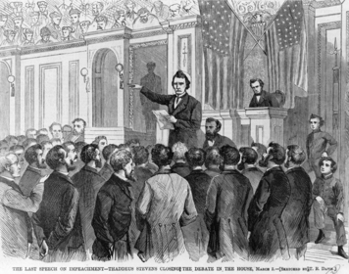
Radical Republicans Challenge Johnson's Reconstruction When Congress met in December 1865, many lawmakers were of the opinion that Reconstruction had hardly begun. A group of Radical Republicans, led by Thaddeus Stevens and Charles Sumner, were especially critical of Johnson's plan. The Radicals had been abolitionists before the war. Now they were determined to reconstruct the nation on the basis of equal rights for all. Their commitment to racial equality put them on a collision course with the president.
Early in 1866, the Radical Republicans joined with more moderate lawmakers to enact two bills designed to help former slaves. The first extended the life of the Freedmen's Bureau beyond its original one-year charter and gave the bureau greater powers. The second, the Civil Rights Act of 1866, took direct aim at the black codes. It declared that African Americans were entitled to "equal benefit of all laws . . . enjoyed by white citizens."
To Congress's surprise, President Johnson vetoed both bills. The continuation of the Freedmen's Bureau, he argued, was too costly and would encourage freedmen to lead a "life of indolence [laziness]." He rejected the Civil Rights Act as a violation of states' rights. In one of his veto messages, Johnson claimed to be representing the will of the people. "This [claim] is modest," quipped one Republican, "for a man made president by an assassin."
Republicans gathered the two-thirds majority in each house needed to override Johnson's veto of the Civil Rights Act. This was the first time in American history that a major piece of legislation became law over a president's veto. Next, they enacted a new Freedmen's Bureau bill. When Johnson vetoed it, Congress overrode his action once again.
To further protect the rights of freedmen, Congress passed the Fourteenth Amendment to the Constitution. The basic principle underlying this amendment, Stevens said, was that state laws "shall operate equally upon all." The amendment reversed the Dred Scott decision by defining "all persons born or naturalized in the United States" as citizens. It further prohibited any state from denying its citizens "due process" or "the equal protection of the laws."
The Fourteenth Amendment became a major issue in the election of 1866. President Johnson toured the North, making fiery speeches against the amendment and its Republican supporters. His tour did the president more harm than good. Republicans won a veto-proof, two-thirds majority in both houses of Congress. From that point on, Congress would control Reconstruction.
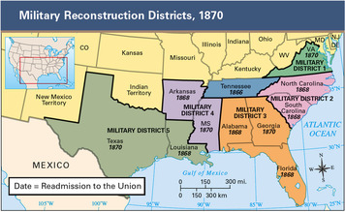
Congress Puts the South Under Military Rule In 1867, Congress laid out its plan for Reconstruction in a series of laws known as the Reconstruction Acts. These acts outlined a process for admitting Southern states back into the Union. The South was to be divided into five districts, each controlled by federal troops. Election boards in each state would register male voters—both black and white—who were loyal to the Union. Southerners who had actively supported the Confederacy would not be allowed to vote. The voters would elect conventions to write new state constitutions. The constitutions had to grant African Americans the right to vote. The voters would then elect state legislatures, which were required to ratify the Fourteenth Amendment.
In addition, Congress enacted two laws designed to keep Johnson from interfering with its Reconstruction plan. The Command of the Army Act limited the president's power as commander in chief of the army. The Tenure of Office Act barred the president from firing certain federal officials without the "advice and consent" of the Senate.
President Johnson Faces Impeachment President Johnson blasted both of these laws as unconstitutional restrictions on his power. To prove his point, he fired Secretary of War Edwin Stanton, a Radical Republican appointed to office by President Lincoln. Two days later, the House of Representatives voted to impeach Johnson for violating the Tenure of Office Act. The House further charged that "Andrew Johnson had brought the high office of the President of the United States into contempt, ridicule, and disgrace, to the great scandal of all good citizens." Johnson then faced trial in the Senate. If two thirds of the senators found him guilty of any charge, he would be removed from office.
During his Senate trial, the president's lawyers argued that Johnson's only "crime" had been to oppose Congress. Were he to be removed for that reason, "no future President will be safe who happens to differ with a majority of the House and . . . Senate." They also quietly spread the word that if acquitted, Johnson would no longer oppose Congressional Reconstruction. When the votes were cast, Johnson escaped removal by a vote of 36 to 25, just one vote short of the two-thirds majority required.

4. Living Under Congressional Reconstruction
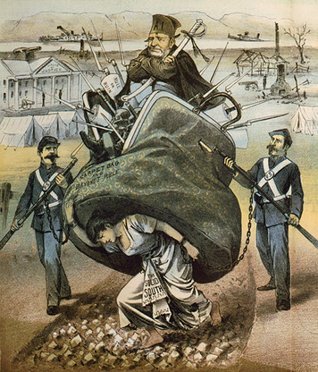
White Southerners were shocked by the return of federal troops to the South under the Reconstruction Acts. Having complied with Johnson's plan, they believed that Reconstruction was over. Black Southerners, however, were elated. For months, freedmen had been organizing to fight discrimination. "We simply ask," one group declared in a petition to Congress, "that the same laws that govern white men shall govern black men." As election boards began registering voters across the South in 1867, it seemed their pleas had been heard.
The South's New Voters: Freedmen, Scalawags, and Carpetbaggers With former Confederates barred from registering, the right to vote was limited to three groups. The largest was freedmen, who had never voted before. Most of them joined the Republican Party, which they saw as the party of Lincoln and emancipation.
The next largest group consisted of white Southerners who had opposed secession. Many were poor farmers who also had never voted before. Because they viewed the Democratic Party as the party of secession, they, too, registered as Republicans. Southern Democrats, who viewed these new Republicans as traitors to the South, scorned them as "scalawags," or worthless scoundrels. The last group of voters was made up of Northerners, most of them former soldiers, who were attracted to the South after the war. Yankee-hating Southerners called them "carpetbaggers," a term for a piece of luggage travelers often carried. They despised carpetbaggers as fortune hunters who invaded the South to profit from the misfortunes of Southerners.
The newly registered voters cast their first ballots in the 1868 presidential election. The Republican candidate for president was the Union war hero Ulysses S. Grant. He supported Congressional Reconstruction and promised to protect the rights of freedmen in the South. His democratic opponent, Horatio Seymour, promised to end Reconstruction and return the South to its traditional leaders—white Democrats.
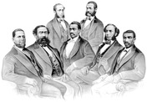
The election was marred by violence in several Southern states. A white Republican in Georgia wrote, "We cannot vote without all sorts of threats and intimidations. Freedmen are shot with impunity [no punishment]." Even so, the Republican Party swept every Southern state except for Louisiana and Georgia, where attacks on Republicans had made campaigning impossible. Nationwide, Seymour won a majority of white votes. Grant, however, won the popular vote with the help of half a million black voters. For Republicans, the lesson of the election was clear: Their party needed the black vote in order to remain in power.
Grant's victory helped persuade Congress to pass the last of the Reconstruction amendments. The Fifteenth Amendment states that "the right of citizens . . . to vote shall not be denied or abridged [limited] by the United States or by any State on account of race, color, or previous condition of servitude." "Nothing in all history," wrote abolitionist William Lloyd Garrison, equaled "this wonderful, quiet, sudden transformation of four millions of human beings from . . . the auction-block to the ballot box."
New State Governments Begin to Rebuild the South Across the South, voters chose delegates—about one fourth of them African Americans—to state constitutional conventions. These delegates wrote constitutions that not only banned racial discrimination but also guaranteed blacks the right to vote and to hold public office. Elections were then held to form governments. To the dismay of white Democrats, a majority of those elected were Republicans and about a fifth of them freedmen. The new governments quickly ratified the Fourteenth and Fifteenth amendments, the last step of the Reconstruction process. By 1870, every Southern state had been readmitted to the Union.
The most enduring accomplishment of these Reconstruction governments was the creation of the South's first public, tax-supported school systems. At first, whites stayed away rather than mix with blacks. To attract white students, most states segregated their schools by race, even where doing so was prohibited by law. Segregation—the forced separation of races in public places—was not the rule in other areas of life. In fact, several of the Reconstruction governments outlawed segregation in transportation, places of entertainment, and other businesses. But these laws were hard to enforce.
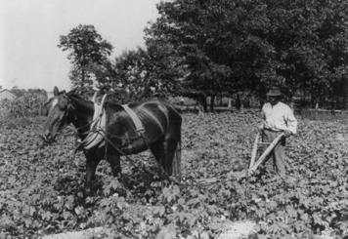
The South's Economic Recovery Remains Slow The new state governments undertook ambitious programs to strengthen the Southern economy. They hoped economic growth would alleviate poverty and racial tensions. Unfortunately, money intended to rebuild roads and bridges and to expand railroads often fell into the hands of corrupt government officials. Although industry and trade led to the rebirth of some Southern cities, most of the South remained dependent on agriculture.
The plight of Southern farmers became increasingly desperate. The South was still suffering the staggering costs of the war. During the conflict, many whites had lost all they had—their homes, farms, and businesses. Taxes and debts led some to sell their land. Even once-wealthy planters were struggling. They had land but no money to hire workers to produce crops. Many planters divided their land into small plots that they rented to workers who would grow crops, a system known as tenant farming. In some cases, tenant farmers would pay a share of their crop as rent instead of cash.
At first, sharecropping looked promising to both black and white landless farmers. They hoped that in time they would earn enough money to buy land for themselves. In reality, these farmers often experienced a new form of bondage: debt. Most sharecroppers had to borrow money from planters to buy the food, tools, and supplies they needed. Few ever earned enough from the sale of their crops to repay these debts. As a result, sharecropping usually led to a life of debt peonage rather than one of economic independence. Under this system, debtors were forced to work for the person they owed money to until they paid off their debts. "We make as much cotton and sugar as we did when we were slaves," noted one Texas sharecropper, "and it does us as little good now as it did then."

Summary
The Reconstruction era lasted from 1865 to 1877. During these years, biracial governments were established across the South. These governments expanded the rights and opportunities of former slaves. But when Reconstruction ended, the South returned to "white man's rule."
Reconstruction amendments During Reconstruction, three amendments were added to the Constitution. The Thirteenth Amendment outlawed slavery, the Fourteenth Amendment made former slaves citizens, and the Fifteenth Amendment gave African American men the right to vote.
Presidential Reconstruction In 1865, President Johnson allowed the Southern states to reconstruct themselves. Most enacted black codes that severely restricted the rights of former slaves.
Congressional Reconstruction Congress took control of Reconstruction in 1867. Federal troops were sent to the South to oversee the establishment of state governments that were more democratic.
Reconstruction governments The South's first biracial state governments established a public school system and outlawed racial segregation. But these governments were bitterly opposed by white terrorist groups like the Ku Klux Klan.
Jim Crow laws Reconstruction ended as part of the Compromise of 1877. Once Democrats regained control of the state governments in the South, they passed Jim Crow laws that segregated blacks from whites in public life. In 1896, the Supreme Court ruled in Plessy vs Ferguson that segregation was constitutional under the doctrine of "separate but equal."

