Unit 12 Change and Conflict in the America

Section 1 - Introduction
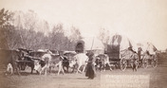
By the mid-1800s, many Americans felt the need for a change, for a fresh start. Like the early settlers who crossed the Appalachians, they migrated westward in search of opportunity.
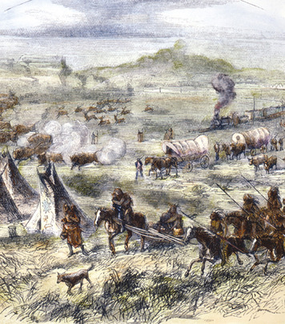
Entire families packed their belongings into covered wagons and hit the westward trail. Sooner or later, they crossed the Mississippi River. From their perspective, this mighty river was the frontier, or boundary, marking the beginning of wilderness. "I do remember my emotions after we were all landed on the [other] side of the river," one traveler recalled. "I felt as if we had left all civilization behind us."
In many ways, they had. Overland travelers would spend weeks or months on what amounted to a long and challenging expedition. They would have to adapt themselves to the demands of living on the trail, such as repairing wagons and handling oxen and other livestock. They also had to learn to cook and clean under tough circumstances.
The travelers had to survive with limited resources. Water and wood were scarce on the plains, and food was also difficult to find. They brought very little to eat besides flour, bacon, beans, salt, and coffee. One woman wrote in her journal, "About the only change we have from bread and bacon is bacon and bread."
Many of the new migrants were farmers, but other people also sought opportunity in the West. Miners searched for gold, silver, and other minerals in the hills and mountains. On the grassy plains, ranchers hired cowboys to herd their cattle. Immigrant workers found jobs laying rail lines, and railroad owners made profits shipping western goods to market. However, this rising tide of migration brought further conflict with American Indians. The tribes of the Great Plains, in particular, would fight long and hard against the massive invasion of their lands and destruction of their way of life.

Section 2 - Mining and Ranching Opportunities in the West
The first settlers heading west from the Mississippi Valley had a distant objective. They wanted to reach the rich farmlands of the Far West. They moved as fast as they could across the Great Plains. Then they struggled to get over the Rocky Mountains. Most of them stopped for good only when they reached the fertile fields and valleys of Oregon and California. By 1848, 14,000 people had made this journey. This trickle of migration changed quickly in the mid-1800s, however, after settlers found gold in California.
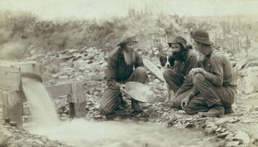
Miners: In Search of the Big Strike In 1848, a landowner named John Sutter was building a sawmill on the American River, in California's Central Valley. This river flowed down from the Sierra Nevada range to the east. In January of that year, Sutter's workers found gold near the mill. Sutter tried to keep the gold a secret, but eventually word got out. Up and down the Pacific Coast, men deserted their work to head for Sutter's Mill. By the year's end, gold fever gripped the whole nation and even spread abroad. The California gold rush was on.
In the spring of 1849, some 40,000 migrants from the East headed overland to California. That same year, about 40,000 more people boarded steamships bound for San Francisco. Soon California swarmed with "forty-niners," as these miners were called. About nine out of ten were men, most of them young. Many came from Mexico, and thousands more arrived from as far away as Europe and China. All of them were motivated by one great hope—to strike it rich.
Few of these prospectors and treasure hunters knew anything about mining. Luckily, much of California's gold was not locked up in solid rock. Over time, water erosion had dislodged much of the gold and washed it down into streambeds. Miners called this placer gold, which they could mine using simple tools, such as pans and shovels. Other prospectors looked for veins of gold and silver in solid rock. Often working in groups, they used hand tools and weak explosives to extract the metal. Miners called a thick vein a lode. Every prospector's dream was to find the "mother lode" that would produce untold riches.
Between 1850 and 1860, California's population jumped from about 93,000 to over 380,000. Prospectors set up tent camps near their claims. Merchants of all kinds followed close on their heels. As stores, banks, saloons, and restaurants opened up, some camps swelled into towns. When a site no longer produced much metal, most prospectors moved on.
For three decades after the California gold rush, hordes of miners chased their dream of riches from Mexico to Alaska and east as far as the Black Hills of Dakota. They endured backbreaking work and conditions that were dismal and sometimes dangerous. However, very few prospectors ever struck it rich. After years of searching, most would have agreed with the familiar saying, "Gold is where I ain't!"
By the early 1850s, most of the ore that could be easily mined in California had been found. Individual prospectors eventually gave way to large mining companies that used hydraulic machines to wash away whole hillsides in search of gold. In the process, they damaged the environment, destroying habitat, polluting rivers, and leaving behind large piles of debris on which nothing could grow.
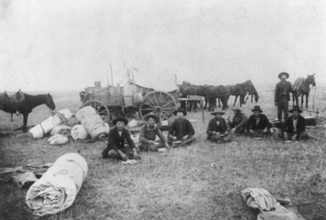
Click to read caption
Ranchers and Cowboys Find a Home on the Range While miners uncovered the West's valuable stores of gold, silver, and other minerals, cattle ranchers found opportunity in a different kind of natural resource: grass. Their beef cattle thrived on the abundant grasses and open range of the Great Plains.
Plains cattle ranching had started in Texas before the Civil War. The region had a long tradition of ranching going back to the first Spanish settlers. Mexican vaqueros started many cowboy customs. They rode horses and wore boots with pointed toes and wide-brimmed hats. They rounded up cattle and branded them.
Many Texas ranchers went off to fight in the Civil War and never returned. Untended, their cattle multiplied. By the mid-1860s, several million tough longhorn cattle roamed wild on the open plains. Many lacked the brands that showed ownership. Some Texans began to round up unbranded cattle with an eye toward driving, or herding, them north to market.
Their timing was good. The growing populations of eastern cities had raised the demand for beef. In the East, ranchers could get $40 a head for cattle that sold for $5 or less back in Texas. Also, railroad companies had begun extending rail lines west from Missouri into Kansas. Cowhands could drive their herds to "cow towns" that sprang up along the rail lines. The potential for large profits made a long cattle drive to one of these cow towns seem well worth the effort.
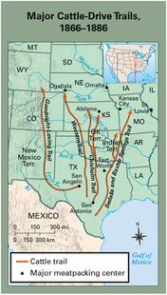
The era of the long drive began in 1867, when cowboys following the Chisholm Trail drove longhorns north from San Antonio, Texas, to Abilene, Kansas. From Abilene and other cow towns, live cattle were shipped in rail cars to meatpacking centers like Chicago. Working as a team, a dozen cowboys could drive more than a thousand cattle at a time along the trail. African Americans and Mexican Americans made up at least a quarter of all cowboys on the long drives.
Cowboys led rough lives, working outdoors and sleeping on the ground in all types of weather. They had to be prepared to defend the herd against people who wanted to steal the cattle, as well as against Indian attacks. There was also the constant threat of a stampede.
The long drives ended once rail lines reached into cattle country during the 1880s. The new lines not only transported cattle to market but also brought farmers to the plains. The newcomers sparked conflict with the cattle ranchers by fencing off their farms with barbed wire, effectively closing the open range. Nature dealt cattle ranching an even harsher blow when the blizzards of 1886 and 1887 killed thousands of cattle, forcing many ranchers into bankruptcy. Those who survived decided to fence in their ranches and raise only as many cattle as their land could support.

Section 3 - Railroads Open the West to Rapid Settlement
An easterner bound for the California goldfields in 1849 could not have made it halfway to the Mississippi River by train alone. Before the 1850s, most railroads were short lines, connecting cities and towns in just one region. A flurry of rail building in the 1850s changed that. By 1860, rail lines extended from the Atlantic Coast across the Mississippi. This expansion set the stage for opening up western lands to settlement and for linking the East and West coasts by rail.
The gold rush had produced a population explosion in the Far West. Yet this growing region remained in isolation, essentially separated from the rest of the nation. During the 1850s, many people pointed out the need for better transportation and communication between East and West. In particular, merchants demanded a faster way to transport goods across the Great Plains and the Rockies. They wanted a transcontinental railroad, one that spanned the continent. This need presented a great opportunity to railroad builders.
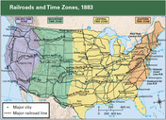
The First Transcontinental Railroad Creates Huge Challenges In 1861, four wealthy merchants in Sacramento, California, founded the Central Pacific Railroad Company. Known as the "Big Four," they sought government support for a transcontinental railroad. One of them, C. P. Huntington, went to Washington to act as a lobbyist to push for a railroad bill. Lobbyists try to persuade legislators to pass laws favorable to groups they represent.
Plans for a transcontinental railroad had been stalled by debate in Congress over whether to follow a northern or southern route. However, the South's secession and the onset of the Civil War led Congress to approve a northern route that would unite California and Oregon with the rest of the Union. The Pacific Railway Act, passed in 1862, directed the Central Pacific and the newly created Union Pacific Railroad Company to construct railway and telegraph lines from the Missouri River to the Pacific Ocean. The Union Pacific would start in Omaha, Nebraska, and work its way west. The Central Pacific would start in Sacramento and head east.
Building the first transcontinental railroad posed tremendous challenges. One problem was raising enough funds. Under the Pacific Railway Act, the government pledged to help each company by granting it 6,400 acres of land and up to $48,000 in loans for each mile of track laid. Once the laying of rails began, the owners could sell the land to settlers to help pay for construction costs. But they needed startup money. The Union Pacific had trouble raising funds and did not lay its first rails until 1865.
The Union Pacific also faced conflicts with some of the tribes that lived on the Great Plains. Its route followed the Platte River through territory controlled by the Cheyenne, Arapaho, and Lakota Sioux. All three tribes had been battling the U.S. Army for years, and their attacks on railroad workers sometimes stopped construction.
For the Central Pacific, rough terrain was a major challenge. Crossing the Sierra Nevada was an epic engineering feat. The rail line had to pass over, and sometimes through, high mountain passes. It also had to bridge deep canyons. On some days, progress was measured in inches. Beyond the Sierra Nevada lay the Great Basin, a vast, dry region where summers are blistering hot.

Working on the Railroad: Jobs and Hardships for Immigrants
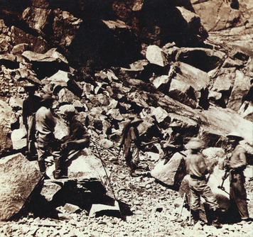
In meeting these construction challenges, the two railroad companies owed much of their success to immigrant labor. At first, both companies faced a severe labor shortage. They needed thousands of workers, but the Civil War and the gold rush had siphoned off a large part of the labor pool.
The end of the Civil War in 1865 solved part of the Union Pacific's labor problem. Ex-soldiers and former slaves eagerly joined company crews. So did immigrants from Europe. In fact, the bulk of its 12,000-man workforce was made up of Irish immigrants. Large numbers of Irish began immigrating to the United States after a potato disease brought famine to Ireland in 1845. Many first settled in eastern cities, where they were looked down on for being Catholic and poor. In the face of such discrimination, railroad jobs seemed like an attractive opportunity.
When the Central Pacific began construction in 1865, it also faced a shortage of workers. In desperation, it decided to hire workers from China, despite widespread prejudice against the Chinese. The company advertised in China, promising impoverished workers good pay. By 1868, the Central Pacific was employing about 10,000 Chinese workers, who made up four fifths of its labor force. Chinese workers were paid lower wages than white workers and were targets of racism.
Working on the railroad was both strenuous and dangerous. Some workers were killed in Indian attacks. The use of dynamite to blast tunnels through the Sierra Nevada also resulted in injuries and deaths. Extreme cold in winter left many workers with frostbite, and snow avalanches killed others. Yet the workers who survived had money in their pockets.
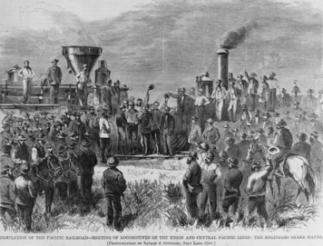
Railroads Become Lifelines in the West Both companies overcame all obstacles, and on May 10, 1869, their lines met at Promontory Point, Utah. That day marked a turning point in the history of the West. With the completion of the railroad, travel time between the Pacific and Atlantic coasts shrank from 4 months to 10 days. To mark the occasion, two officials, one from each company, drove ceremonial spikes of gold and silver into the railroad ties.
Once the first transcontinental railroad had been completed, railroad construction continued elsewhere with a fury. This rapid expansion made many "railroad barons," like the Big Four, very rich. It also encouraged settlement by making land available to farm families. Towns sprang up along the routes. In addition, railroads served the transportation needs of new industries, such as mining and lumbering. Perhaps most importantly, they united East and West.
For many people in the West, the railroads became lifelines. But because farmers depended on them, the railroads could charge excessive rates to ship their crops to market. Such policies led to growing demands for some government control over the railroad companies.

Section 4 - Indian Wars Shatter Tribal Cultures
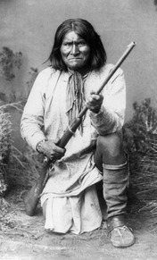
To many people, the railroad represented progress. But for the Indians on the Great Plains, it was a threat to their very existence. The railroad cut through their hunting grounds, disturbing the buffalo, their main source of food, clothing, and shelter. It also brought ranchers, farmers, and soldiers to the hunting grounds. In response, many tribes fought the railroad, waging war to stop the rush of settlement that jeopardized their ways of life. Their battle for survival represented the latest round of what are known as the Indian Wars.
Cultures Clash on the Great Plains From the perspective of a nation bent on expanding westward, the many Indian tribes in the West presented a problem. They refused to change their customs to conform to the settlers' culture. For example, they believed that tribes or villages had rights to areas of land. However, they did not believe that land could be owned, bought, or sold.
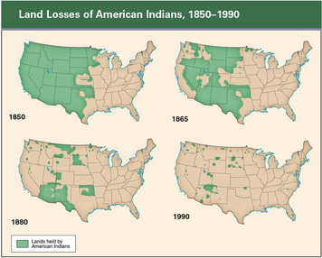
Differences between Indians and settlers over land had led to conflict early in the nation's history. Conflicts continued as settlers crossed the Appalachians and laid claim to tribal lands in the Ohio and Mississippi river valleys. To end such conflicts, the Indian Removal Act of 1830 had forced the largest tribes living east of the Mississippi to move west to Oklahoma Territory on the Great Plains. When settlers began to populate the West after the Civil War, they again clashed with native peoples. The Indians were once more viewed as "an obstacle to the progress of settlement and industry," as one government official put it.
A complex clash of cultures occurred on the Great Plains. Nomadic tribes had roamed the plains freely for centuries in pursuit of buffalo. They had little in common with eastern tribes, who had been conquered and "removed" to the plains in the 1830s. These differences led to conflict between nomadic tribes that wanted more open land and settled tribes that wanted to protect their farmland.
Larger conflicts arose with the advance of white civilization. As settlers moved westward, they slaughtered millions of buffalo, endangering a vital element of tribal cultures. Many tribes refused to give up their homelands and ways of life without a fight. Their warriors began attacking settlers.
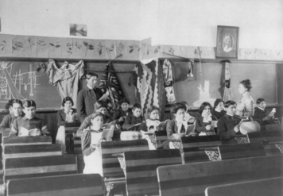
The U.S. Army responded with attacks on the plains tribes. In 1864, troops raided a party of Cheyennes and Arapahos who had camped at Sand Creek, Colorado, with permission from the commander of a nearby fort. More than 150 people, many of them women and children, were killed. The Sand Creek Massacre sparked a general uprising among the plains tribes.
In an effort to end conflict and open up land for settlers, the federal government tried to confine most western tribes to reservations. A reservation is an area of federal land reserved for an Indian tribe. Federal officials promised to protect these tribes. However, instead of protecting Indians, the government far too often helped prospectors and settlers who invaded a reservation. For example, a gold strike in the Black Hills of the Dakota Territory brought hordes of miners onto the Sioux reservation in the 1870s. The government ignored the invasion, even though the Treaty of Fort Laramie, signed in 1868, guaranteed the Sioux exclusive rights to the land.
Many tribes, from the Apaches and Comanches in the south to the Sioux, Cheyennes, and Arapahos in the north, refused to stay on reservations. Bands of raiders moved out onto the plains, where they fought to stop the expansion of settlements. In 1876, Sioux and Cheyennes who were camped near the Little Bighorn River in Montana came under attack by U.S. Cavalry troops under George Armstrong Custer. The much larger Indian force, led by Sioux chiefs Sitting Bull and Crazy Horse, wiped out Custer's troops.
After the Battle of the Little Bighorn, also known as "Custer's Last Stand," federal forces hunted down and captured about 3,000 Sioux warriors. Over the next few years, the army subdued the other major tribes of the Great Plains.
Adaptation and Efforts to Assimilate American Indians The settlement of the West was disastrous for large numbers of American Indians. Many died as a result of violence, disease, and poverty. Others clung to a miserable existence on reservations.
The survivors struggled to adapt to their changed circumstances. Some Indians tried agriculture. The eastern tribes that had been removed to Oklahoma became successful farmers. Many tribes established their own government and schools.
At the same time, the U.S. government adopted policies aimed at speeding the assimilation, or absorption, of Indians into the dominant culture. Federal officials set up about two dozen boarding schools to educate American Indians in "white men's ways." Congress furthered the assimilation push by enacting the Dawes Act of 1887. Under this law, a tribe could no longer own reservation lands as a group. Instead, the government began distributing land to individuals within a tribe. Each family was granted its own plot of land, which it could hold or sell. This change eroded a cornerstone of American Indian cultures—the belief that land could not be bought or sold. Land sales, both free and forced, greatly decreased the amount of Indian-owned land.

Section 5 - Settling the Great Plains
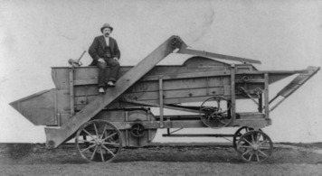
Despite resistance from tribes of the Great Plains, settlers continued to migrate there during the second half of the 19th century. They ventured on foot, on horseback, and in ox-drawn wagons. Later they came by rail. Most had one goal: the opportunity to turn a plot of grassland into a farm.
Opportunities and Challenges on the Great Plains Several factors transformed the Great Plains from a place to pass through on route to the West Coast into a land of opportunity. Perhaps the most important was the steady expansion of the railroads. The railroads carried settlers onto the plains, and the railroad companies sold settlers land that the companies had been granted by the government. Another factor was that families felt much safer migrating to the West because the army had reduced the threat of attack by plains tribes. A third factor was the passage in 1862 of two federal laws that encouraged settlement.
The two new laws were the Homestead Act and the Morrill Land-Grant Act. The Homestead Act was designed to provide tracts of land called homesteads to settlers in the West. The act offered 160 acres of public land for a small fee to anyone who agreed to work the land and live on it for five years. This law attracted about 600,000 farmers who claimed more than 80 million acres of land by the end of the 19th century. The Morrill Land-Grant Act gave each state large tracts of public land to help finance the establishment of agricultural colleges. To raise funds to build colleges, states sold homesteads to settlers.
The plains offered settlers a fresh start. The settlers knew by the look and smell of the rich soil that crops would thrive in this land. To be successful, however, they had to overcome some difficult challenges. The first was building houses on the largely treeless plains. Lacking lumber, some homesteaders simply dug a hole in the side of a hill as a shelter. Other settlers fashioned houses out of the tough plains turf, or sod. They called these houses "soddies." Sod blocks, cut out of the ground with a shovel or an ax, formed the walls. Most roofs were made of sod as well. Once farmers could afford lumber delivered by train, they replaced their dugouts and soddies with wood-frame houses.
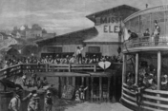
Another challenge was the environment. The Great Plains region typically has an arid climate. The settlers who flocked there in the 1870s and 1880s arrived during an abnormally wet period. The unusual amounts of rain helped crops flourish. Still, farmers had to deal with winter's deep cold, piercing winds, and blizzard snows. By the early 1890s, drought conditions had returned, especially in Kansas, Nebraska, Colorado, and the Dakotas. As the soil dried up, wheat, corn, and other crops failed. Farmers also had to contend with grasshoppers. Great clouds of these pests, thick enough to darken the sky, descended on fields with little warning. They chewed for days on everything edible, destroying entire crops.
In the face of these hardships, many farmers left the plains. The sides of their covered wagons bore the words "In God We Trusted, In Kansas We Busted." Others worked to overcome the harsh conditions by using dry-farming techniques. To conserve soil moisture, they plowed and planted a field one year and left it uncultivated the next. Also, tools had made farm life easier. The steel plow, invented in 1837, had made it easier to cut through the thick prairie sod and prepare it for planting. The mechanical reaper neatly cut and bound sheaves of grain at harvesttime. Windmills pumped water from deep wells for household use and irrigation.
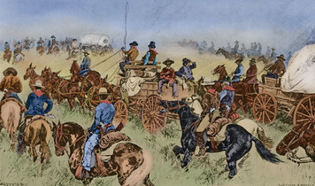
African Americans See the Plains as the "Promised Land" The women and men who settled the West represented a broad range of Americans. Many were native-born white farm families from the Midwest. Some had moved at least once before. Other settlers were immigrants from Europe. Often they were lured by the claims of railroad agents skilled at stretching the truth. Still others were former slaves searching for the opportunity to own their own land.
After the Civil War, many African Americans fled the South in search of better lives elsewhere. Thousands joined the westward movement. Freedmen worked as cowboys in Texas. They also joined the army, helping to protect settlers. However, most African Americans who headed west became farmers.
Former slaves such as Henry Adams and Benjamin "Pap" Singleton encouraged African Americans to build farm communities on the Great Plains. These leaders helped organize a postwar migration to Kansas and beyond. The migrants became known as Exodusters, a reference to Exodus, the second book of the Bible, which recounts the Israelites' escape from slavery in Egypt, the beginning of their journey to the "Promised Land."
Offered the opportunity to succeed or fail on their own terms, as independent farmers, thousands of African Americans made the trek to Kansas. Some bought farmland and formed new communities, such as Nicodemus, a town of about 700 black settlers from Kentucky. Others found work in towns and on farms in Texas, Oklahoma, and other plains states.
Despite their rising numbers and the independence that came with owning land, African Americans in the West still faced racism. For example, when a group of black migrants from Mississippi tried to settle in Lincoln, Nebraska, white townspeople drove them away. The migrants persisted, however, and Lincoln eventually accepted black residents into the community.

Section 6 - Farmers Rise Up in Protest
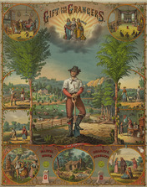
Farmers transformed the grasslands of the Great Plains into bountiful croplands. Their hard work, aided by improved farm machinery, greatly increased agricultural productivity. Yet many of them failed to prosper. To buy costly new machinery, many had taken out bank loans, often at high interest rates. They also owed money to merchants for the seeds they bought on credit every year, and to railroads, which kept raising shipping rates. Crop prices, however, dropped as supply outstripped demand at home and in the world market. With their incomes reduced, farmers found it difficult to pay their debts. As their debts mounted, so did their anger.
Farmers' Frustrations Give Rise to Populism In 1867, Oliver Hudson Kelley started an educational and social organization to help farmers in Minnesota. Known as the National Grange, it soon spread throughout the country. The Grange helped farmers find their political voice. They channeled their anger into a protest movement based on populism, a political philosophy that favors the common person's interests over those of wealthy people or business interests.
In the early 1870s, several states passed "Granger laws" to regulate railroad rates. In 1886, the Supreme Court ruled in the case Wabash, St. Louis and Pacific R.R. v. Illinois that only the federal government has the right to regulate interstate commerce. In response, Congress passed the Interstate Commerce Act in 1887. This law established the Interstate Commerce Commission to ensure that railroads set "reasonable and just" rates.
Farmers also took action through other organizations. One of these groups, the Greenback Party, was formed in the mid-1870s with a plan to raise crop prices and relieve farmers' debts. The Greenbackers' goal was to increase the amount of greenbacks, or paper money, in circulation by changing the monetary policy of the government. Monetary policy is aimed at controlling the supply and value of a country's currency.
At that time, the amount of money flowing through the U.S. economy was controlled by a monetary policy known as the gold standard. According to this policy, every paper dollar in circulation had to be backed by a dollar's worth of gold in the U.S. Treasury. The gold standard ensured the value of U.S. currency but limited the amount of money the government could print.
The Greenbackers wanted the government to increase the money supply by issuing greenbacks backed by both gold and silver. By increasing the money supply, Greenbackers hoped to fuel inflation, or a general rise in prices, including crop prices. Higher crop prices would give farmers more income with which to pay off their debts. The Greenback Party failed to achieve its main goal, but it did open many Americans' eyes to the farmer's plight.
In the 1880s, farmers in the South and Midwest formed local organizations called Farmers' Alliances. These groups later led protests against railroads, banks, and other powerful interests centered in the East. In the 1890 election, many Democratic and Republican candidates claiming to support policies proposed by Farmers' Alliances won elections at the state level and seats in Congress. Yet they enacted only a few Alliance proposals into law. In response, disappointed Alliance members vowed to create their own national political party.
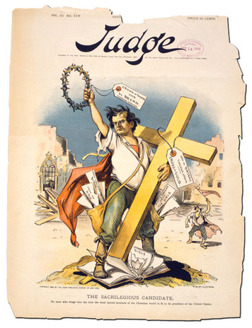
The Rise and Fall of the Populist Party By 1892, populism had broadened its appeal beyond farmers to include industrial workers. That year, farm and labor leaders met in Omaha, Nebraska, to launch the People's Party, also known as the Populist Party. Populist candidate James B. Weaver ran for president that year on a platform that called for government ownership of railroads, the coinage of silver to increase the money supply, and other reforms designed to help working people. More than a million Americans voted for Weaver, about 8.5 percent of the total vote.
The money supply remained a major issue during the 1890s. The opposing sides of the debate became known as "silverites" and "gold bugs." The Republicans generally favored the gold standard. The Democrats were deeply divided, but the silverites prevailed as the election of 1896 approached. William Jennings Bryan won the Democratic presidential nomination with a moving speech that condemned the gold standard. In a booming voice he declared, "You shall not crucify mankind upon a cross of gold."
Instead of running their own candidate, the populists endorsed Bryan. The Democrats lost the election, and the Populist Party soon faded from the political scene. But the anger and idealism that had given rise to populism did not fade with it. During the party's short life, many Americans had begun to rethink what government could and should do to promote opportunity for all. "The power of government—in other words the power of the people—should be expanded," declared the populists' Omaha Platform, to end "oppression, injustice, and poverty." This vision would soon inspire a new generation of reformers.

Summary
Settlement of the West in the mid- and late 1800s brought opportunities for many Americans. This migration also sparked conflict as settlers invaded Indian homelands.
Mining Gold-rush fever sparked a rush of prospectors to the West. Though few fortunes were made, this migration helped populate California and other western regions.
Ranching Riding along the Chisholm Trail and other routes, cowboys herded cattle north to be shipped to meatpacking plants.
Transcontinental railroad Building the first rail line to California was a huge undertaking that relied on government support and immigrant labor. The spread of railroads across the West brought wealth to railroad barons and opened the region to settlement.
Indian wars The tribes on the Great Plains fought to preserve their way of life. To prevent conflict and open lands for settlement, the government moved tribes onto reservations. Through the Dawes Act, it tried to assimilate Indians into white culture.
Homestead Act The Homestead Act brought more farmers to the Great Plains, including African Americans who called themselves Exodusters. Farmers faced such challenges as crop-eating insects and drought.
Protests by farmers Burdened by falling crop prices and large debts, farmers formed political organizations such as the Grange. Their protest movements gave rise to the Populist Party.

