Transformations in Europe

1. Introduction
In 1455, the German metalworker Johannes Gutenberg launched a revolution in ideas. Using a printing press, he published Europe’s first printed book—the Gutenberg Bible. Previously, books in Europe had been copied by hand, a laborious task that made them expensive and relatively rare. After Gutenberg, books could be produced cheaply and in great quantities. The printing press brought dramatic changes to Europe, and later to the world.
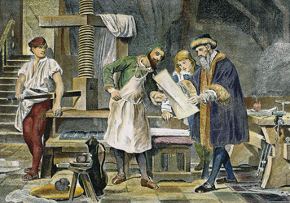
Click to read caption
Gutenberg did not invent printing. By 700 C.E., the Chinese were using carved wooden blocks to print books on paper. From there, the technology spread to Korea, Japan, and the Muslim world. The Chinese later invented movable type, using a separate clay block for each character, but this process was not efficient for the thousands of characters in Chinese writing. The Koreans produced moveable metal type in the 1200s, but faced similar problems as the Chinese. Gutenberg’s innovation was to make durable metal type for the much smaller European alphabet and combine it with an effective printing press of his own design. The combination worked brilliantly.
Gutenberg’s press caused an explosion in book publishing. By 1500, hundreds of printing houses across Europe had produced some 30,000 titles—around 20 million books in all—in more than a dozen languages. This print revolution helped spread ideas and knowledge across Europe. It promoted literacy and education. It also helped energize four important cultural and intellectual movements of early modern Europe: the Renaissance, Reformation, Scientific Revolution, and Enlightenment.

Themes
Cultural Interaction New ideas and religious beliefs spread across Europe with the aid of the printing press. Artists, scientists, and thinkers shared knowledge and advanced learning.
Political Structures Political conditions helped give rise to cultural movements. Those movements, in turn, influenced political structures.
Economic Structures Wealth and prosperity in Europe nurtured the Renaissance. Ideas generated during the Scientific Revolution and Enlightenment had important economic effects.
Social Structures The ideas of the Renaissance, Reformation, and Enlightenment helped transform European society.

2. The Renaissance
In 1550, the Italian artist Giorgio Vasari wrote a book, The Lives of the Artists. In it, he praised the revival of classical Greek and Roman culture occurring in Italy at the time. Vasari contrasted this cultural flowering with the “darkness” of the Middle Ages after the fall of Rome. Historians would later refer to this age of cultural revival as the Renaissance, a French word meaning “rebirth.”
Roots of the Renaissance Historians generally date the Renaissance to the period from 1300 to 1600. In fact, the Renaissance did not start or end at a particular time. Nor did it represent a clear break with the past. Many of the changes that took place during this period had their roots in the late Middle Ages.
By 1300, Europe was moving out of the feudal age. Increased trade and commerce were generating new wealth, prosperity, and urban growth. Universities in Paris, Oxford, and other cities had emerged as centers of higher learning. National monarchies and city-states were gaining more power. The Catholic Church was still a dominant force, but it was losing some of its control over cultural and political life.
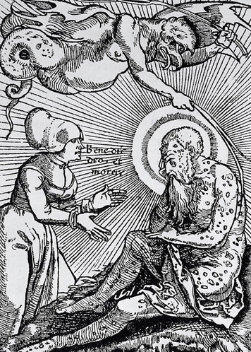
Click to read caption
During the 1300s, wars and the bubonic plague—the Black Death—caused great turmoil in Europe. These events devastated whole regions and populations and shrank the labor force. But they also helped destroy feudalism and create new possibilities for change. One of those changes was the growth of urban workshops that made use of new, laborsaving devices. The skilled artisans who worked in these small industries produced a wide range of luxury goods and machinery. From this artisan class came many of the craft workers, artists, architects, and other creative individuals who powered the Renaissance.
Italian Origins The Renaissance began in Italy, where conditions were ideal for a cultural resurgence. In 1300, much of Italy was controlled by city-states, such as Rome, Venice, Florence, and Milan. These city-states had grown rich from trade and commerce. Wealthy Italian merchants and bankers had money to spend on luxuries and works of art.
City-state rulers also sought to compete with their rivals by bringing artistic glory to their cities. Rich patrons of the arts, such as the ruling Medici (MED-ih-chee) family of Florence, offered financial support to writers and artists. Education also became more important, as the demands of business and government called for more literate people versed in accounting and law.
Other factors played a part, too. Italy had long been engaged in trade across the Mediterranean. This foreign contact gave Italians a greater awareness of the world. The Italian people were also surrounded by the remains of classical Rome. This heritage helped stimulate interest in the past. This interest was enhanced by contacts with the Byzantine Empire, where much classical scholarship was preserved. During the 1300s and 1400s, many Byzantine scholars moved to Italy to escape the growing threat of the Ottoman Empire. They brought a large body of knowledge with them.
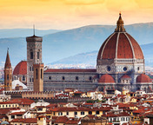
Although Renaissance thinkers sought to revive classical culture, this culture had never really disappeared in Europe. The Catholic Church had preserved the works of Plato, Aristotle, and other ancient philosophers, but it interpreted their work from a Christian perspective. What the Renaissance thinkers did was return to the original sources and read them in a new, non-religious light.
In reviving classical thought, the artists and writers of the Renaissance were guided by humanism. This philosophy balanced religious faith with a secular point of view. It emphasized the dignity and worth of the individual. As humanists, the Renaissance thinkers studied classical art and literature for their insights into human life, rather than spiritual matters.
Renaissance Writers The first great writer of the Italian Renaissance was Dante Alighieri (ahl-ee-GARE-ee). His greatest work, The Divine Comedy, is an epic poem that describes the author’s imaginary journey through the afterlife. Dante was the first well-known author to write in both classical Latin and the Italian vernacular, or native language. He promoted the use of Italian to make learning more available to a wider audience.
Two great humanists followed in Dante’s footsteps. Francesco Petrarca—known as Petrarch—wrote lyrical poetry, also in Italian. He scoured libraries across Europe for classical works and brought them to wider attention. A second great writer was Giovanni Boccaccio (boh-KAH-chee-oh). His most famous work, The Decameron, tells the story of ten young people who flee Florence to escape the plague. While away, they tell stories to pass the time. The book appealed to many Italian readers, though the church did not like its liberal approach to the younger generation.
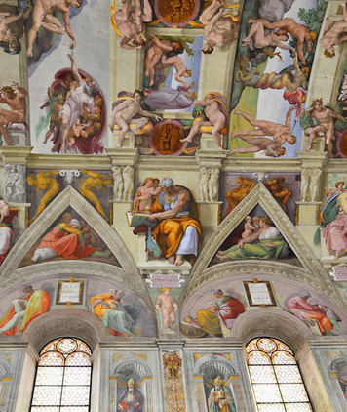
Another writer, Niccolò Machiavelli (mahk-ee-uh-VEL-ee), wrote books with political themes. His best-known work, The Prince, offered highly practical advice to rulers. For example, he wrote that a ruler should always be ready for war. “Once princes have given more thought to personal pleasures than to arms,” he wrote, “they have lost their domain.” He also wrote that it is more important for a ruler to be feared than to be loved. Although Machiavelli’s advice may seem harsh for a Renaissance humanist, his realistic approach matched the secular spirit of the time.
Renaissance Art The Italian Renaissance also produced an extraordinary outpouring of art. Renaissance painters mastered the art of perspective, giving visual depth to their work. Sculptors working in stone revived the realism of classical Greek sculpture. Three of the greatest Italian artists were Leonardo da Vinci (duh VIN-chee), Michelangelo (MY-kul-AN-juh-loh), and Raphael (RAF-ee-ul).
Leonardo was a true “Renaissance man,” a person who is skilled at many different things. He was a painter, sculptor, architect, and engineer. He is perhaps most famous for his painting the Mona Lisa, a portrait of a woman with a mysterious smile. But he also made thousands of drawings of human anatomy, plants and animals, mechanical devices, and weapons. He even designed a flying machine, centuries before airplanes were invented.
Michelangelo was a brilliant artist who depicted the human body in astonishing detail. His greatest masterpiece is the painting on the ceiling of the Sistine Chapel in Rome, which shows scenes from the Bible. His stone sculptures La Pietà and David are also remarkable for their realism.
Raphael emphasized balance and composition in his paintings. One of his greatest works, the School of Athens, shows philosophers from ancient Greece alongside artists and thinkers of the Renaissance. It reflects the humanist devotion to classical ideals.
The Northern Renaissance By the mid-1400s, the Renaissance was spreading to other parts of Europe, particularly northern Europe. Cities in Germany, France, Great Britain, Holland, and Flanders (modern-day Belgium) were beginning to grow and prosper after decades of disease and warfare. These cities became fertile ground for Renaissance ideas, spread through the new medium of the printing press. Northern writers and artists also traveled to Italy to study, and Italians came north. As a result, Renaissance art and humanism took hold in northern Europe.
Northern humanists maintained their Christian faith, but they also wrote works critical of the church and society. The greatest of the Christian humanists was the Dutch writer Desiderius Erasmus. In his most famous work, The Praise of Folly, written in 1509, Erasmus criticized corruption and abuses in the Catholic Church.
A few years later, in 1516, the Englishman Sir Thomas More published his famous book Utopia. This visionary work describes an ideal society governed by reason, rather than the power of kings or popes, where all property is shared and people enjoy equal rights.
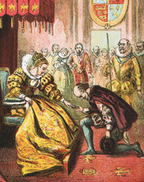

The greatest writer of the Northern Renaissance was William Shakespeare, who lived from 1564 to 1616. The themes of classical culture and humanism are evident in many of his plays, including Julius Caesar. Shakespeare’s interest in the ways of the world and his love of vernacular English mark him as a true Renaissance man.
Great artists of the period included Albrecht Dürer (DYUR-ur), Jan van Eyck (yahn van YK), and Pieter Bruegel (BROY-guhl). Dürer was a German artist who studied in Italy and mastered the use of perspective. Van Eyck and Bruegel were both Flemish painters. Van Eyck advanced the Flemish technique of oil painting, which gave his work a rich, luminous quality. Bruegel is famous for his scenes of Flemish peasant life.
The Renaissance and Religion At times, the values expressed in Renaissance art and literature provoked tensions with the Catholic Church. The church had long regarded itself as the guardian and interpreter of knowledge and culture. But that position was challenged by the secular philosophy of humanism, which advanced the classical Greek idea that “man is the measure of all things.” Humanist philosophy suggested that individuals could understand the world for themselves and even question church teachings. It implied that individuals were free to make their own moral and ethical choices. These ideas undermined church authority.
Nevertheless, most Renaissance thinkers remained faithful Christians. Although they might embrace humanism and criticize church practices, they did not question the basic tenets of Christian religion. In fact, humanist thinkers like Erasmus promoted the search for a deeper spiritual experience. This quest for a more meaningful faith would lead to a major transformation of Christianity during the 1500s.

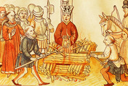
3. The Reformation
In October 1517, a Catholic scholar in Germany named Martin Luther wrote a letter to the archbishop of Mainz. In the letter, he criticized church corruption and called for reforms. Luther’s views were spread in printed pamphlets and soon sparked a religious revolt. Many protesters left the Catholic Church and formed new Christian religious movements. This became known as the Reformation.
Problems in the Church For centuries, the Catholic Church had commanded the loyalty and faith of most Europeans. But over time, problems had arisen within the church. Although priests took a vow of poverty, the pope and other high officials lived in wealth and luxury. Some Catholic clergy had wives and children, despite their vows of celibacy. Local priests were often poorly educated. Many were illiterate and barely understood the Bible. The church also engaged in corrupt practices, including selling church positions and charging for services. The church even sold pardons, known as indulgences, which released sinners from punishment.
Critics had called attention to these problems in the past. In the late 1300s, Oxford professor John Wycliffe criticized the wealth and immorality of church officials. Another critic, the Czech preacher Jan Hus, called for an end to church corruption. In 1415, Hus was burned at the stake for heresy. Christian humanists like Erasmus and More had also mocked superstitions and false doctrines taught by the church.
Luther echoed these concerns, but he did not mean to start a revolt. Instead, he hoped to prompt a debate within the church. His initial complaint was over the selling of indulgences. But his real aim was to restore purity to the church. He believed that rituals like confession and praying to the saints did not bring salvation, as the church claimed. He argued that salvation came from faith alone, and that the Bible was the only source of religious truth. “One thing, and only one thing, is necessary for Christian life,” he wrote. “That one thing is the holy Word of God.” Luther argued that believers did not need priests to show them the truth. He said that any Christian could read the Bible and understand God’s message.
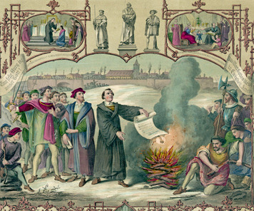
A Protestant Revolution Luther’s ideas did not sit well with church leaders. They regarded his views as heresy and a threat to church authority. In 1520, Pope Leo X demanded that Luther retract his teachings, on pain of excommunication. Luther refused and was expelled from the church. He soon went into hiding to avoid punishment. But he continued to write and publish his work, which was printed and circulated throughout Europe.
Luther and his followers formed the Lutheran Church, a new branch of Christianity. Lutheran ministers simplified church services and rituals and preached in German rather than Latin. Many Germans abandoned Catholicism in favor of the new Lutheran faith.
At the time, Germany was part of the Holy Roman Empire, a state that also included parts of France, Italy, and central Europe. The German territories enjoyed considerable self-rule within the empire, however. Some of their ruling princes defied the emperor, Charles V, and sided with Luther. They became known as Protestants for their protests against the Catholic Church.
Meanwhile, other Protestant groups arose in different parts of Europe. Switzerland was a major focus of reform activity. In Zurich, Huldrych Zwingli (HUL-drick ZVING-lee), a Catholic priest inspired by Luther’s ideas, founded a new religious denomination. His Reformed Church emphasized Bible study and banned all images and music from church services.
In Geneva, the reformer John Calvin founded an even stricter denomination. Calvin emphasized the values of thrift, hard work, and the rejection of worldly pleasures. Members who did not uphold these values were excommunicated. Calvin also stressed the notion of predestination. This is the idea that some people are chosen by God for salvation. Calvin’s church gained followers throughout Europe—in France, the Netherlands, Germany, and England. His ideas later had a major impact on religion in British North America.
England also underwent its own Reformation. In 1534, King Henry VIII formed the Church of England, also called the Anglican Church. Henry broke with the Catholic Church because it refused to grant him a divorce from his wife, but also because he wanted to claim power over the church—and its wealth—in England.
The spread of Protestant religion provoked conflicts across Europe. In Germany, Protestant and Catholic states fought a series of bitter wars that lasted for a century, until the mid-1600s. Religious wars and persecutions also ravaged France, the Netherlands, and other countries. Only Italy, Spain, and Portugal remained outside Protestant influence. Eventually, it became custom that the ruler of each state would choose the religion of his people. This led to the migrations of many believers to more hospitable lands.
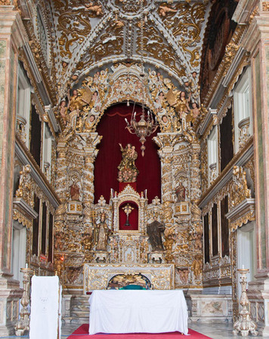
The Catholic Response To meet the challenges of the Reformation, the Catholic Church began its own campaign of reform and renewal. This movement is known as the Counter-Reformation.
The church took a number of steps to defend Catholicism. In 1545, it began a series of meetings known as the Council of Trent. This council defined Catholic doctrine and called for needed reforms. One reform was to end the sale of indulgences. Another was to improve education for priests. The council also imposed more rigid discipline on Catholics, making church attendance mandatory and banning certain books. These and other changes helped establish more order and unity in the church.
The church also sought to increase its membership through renewed missionary activity and a more personal style of worship. It founded a new religious order, the Jesuits, to win Catholic converts in Europe and overseas. It also built lavish new churches, filled with magnificent art to inspire the faithful. This splendid style was designed to appeal to the emotions. It offered a stark contrast to the simple, severe quality of Protestant religion.
The Counter-Reformation helped revive the Catholic Church. Nevertheless, by the 1600s the Reformation had changed the face of Europe. The continent was no longer united around the Catholic religion. Rulers claimed more freedom from religious authority. Europeans were also more educated and literate, thanks to the Protestant emphasis on Bible study and the effects of the printing press. Although Europe remained highly religious, these changes encouraged secular trends in European society.

4. The Scientific Revolution
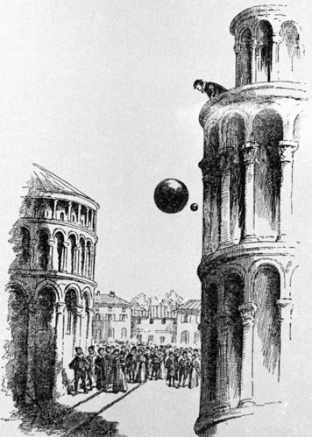
The changes that took place in European society during the Renaissance and Reformation also helped prompt new ways of looking at the natural world. Beginning in the 1500s, scientists—then called natural philosophers—used their powers of reasoning and observation to understand the laws of nature. This movement became known as the Scientific Revolution. It would transform life in Europe, and eventually around the world.
The Origins of Modern Science Before 1500, most Europeans relied on two main sources of knowledge about the natural world. One was the Bible and religious teachings. The other was the work of classical philosophers such as Aristotle. But the Renaissance and Reformation undermined traditional authority and encouraged independent thought. Some people began to look beyond religion and the classics for answers to questions about nature and the universe. This questioning spirit encouraged the growth of science.
Other factors also played a part. Universities gave scholars the opportunity to pursue studies in science and math. Overseas trade and exploration brought new knowledge from China, India, and the Muslim world. The discovery of the Americas exploded old notions of world geography and exposed Europeans to new peoples, plants, and animals. Sea voyages also sparked interest in astronomy, navigation, and mapmaking. European states increasingly supported research and technology in these fields. All these developments were aided by the printing press, which helped spread information and promote new learning.
The Scientific Revolution did not happen suddenly or bring change overnight. It was a gradual process with roots in the Middle Ages and the Renaissance. It really began to take off during the period from the mid-1500s to the late 1700s. In many ways, the revolution still continues today.
Understanding the Universe The first major breakthroughs in science came in the field of astronomy. Since the days of ancient Greece, most people had believed that Earth was the center of the universe. This view is known as the geocentric theory. According to Aristotle, the sun, planets, and stars all revolved around Earth in circular orbits. The Greek astronomer Ptolemy expanded on this theory in the 2nd century C.E. The church also supported the idea of an Earth-centered universe.
In 1543, however, the Polish astronomer Nicolaus Copernicus offered another theory. He determined that Earth and the other planets revolve around the sun. His heliocentric theory described the solar system more accurately. But his work was largely ignored at the time.
Nevertheless, by the early 1600s other scientists were building on the work of Copernicus. The German astronomer Johannes Kepler used math to calculate the movement of the planets. He determined that they travel in elliptical orbits, rather than circles. The Italian scientist Galileo Galilei (gal-uh-LEE-oh gal-uh-LAY) observed the sky directly with a new invention, the telescope. His observations supported the heliocentric theory. In response, the Catholic Church charged Galileo with heresy and forced him to retract his views. But his ideas continued to spread.
The next major advance in understanding the universe came from the English physicist Isaac Newton. In 1687, Newton published the Principia, or Principles, a book that explained the laws of gravity and motion. Newton’s work had an enormous impact. People began to see the universe as a well-designed machine, much like a clock, that works on mechanical principles. Although the mechanical universe contradicted church teachings, most early scientists, including Newton, were not opposed to religion. In fact, many regarded the laws of nature as another example of the miracle of creation.
The Scientific Method A key outcome of the Scientific Revolution was the development of the scientific method. This method is based on careful observation and testing of data. It forms the basis of scientific investigation.
The method involves several steps. It begins with a problem or question based on observation. The scientist then forms a hypothesis, or assumption, to answer the question. The hypothesis is tested in an experiment, and the results are recorded. The scientist then analyzes the results to determine whether the hypothesis is correct or not.
Two early scientists had a critical influence on the development of the scientific method. One was René Descartes (reh-NAY dey-KAHRT), a French philosopher skilled at mathematics and logic. Descartes believed that human reason could be used to solve complex problems. The other figure was Francis Bacon, an Englishman who emphasized the value of experimentation. Bacon also believed that science should have practical benefits. “The true and lawful end of the sciences,” he wrote, “is that human life be enriched by new discoveries and powers.” This idea would promote the growth of technology, with all its economic and environmental effects.
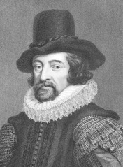
The Expanding Sciences As the Scientific Revolution continued, other scientists made key discoveries in various fields. In many cases, they took advantage of new inventions, such as the microscope and thermometer, to aid their discoveries.
Some of the most important advances occurred in the fields of biology, medicine, and chemistry. The Swedish biologist Carl Linnaeus developed a system for classifying plants and animals by scientific type. The English physician William Harvey discovered how blood circulates through the body. The French chemist Antoine Lavoisier explained the chemical process that creates fire.
These pioneering scientists helped establish the foundations of modern science. Their work provided the basis for other scientific advances and new technologies that would transform the world. At the same time, the ideas of science also inspired new ways of thinking about human society, based on the principles of reason and progress.

5. The Enlightenment
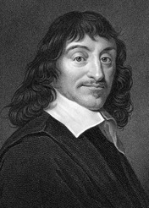
In the mid-1600s, European thinkers began to apply scientific principles to the study of society and government. They believed that reason was the key to human progress and that scientific methods could be used to solve social problems. This intellectual movement, which reached its peak in the 1700s, was called the Enlightenment.
Sources of Enlightenment Thought The Enlightenment was a direct outgrowth of the Scientific Revolution. Enlightenment thinkers were inspired by science and its goal of understanding the laws of nature. They believed that human society also functioned under natural laws. They hoped to use the power of reason to understand and improve society. As a result, this period is sometimes called the Age of Reason.
The Renaissance and Reformation also influenced the Enlightenment. Enlightenment thinkers adopted the Renaissance ideas of individualism and secular thought. From the Reformation, they took the habit of questioning authority. They were skeptical of received knowledge and insisted on discovering truth for themselves. They followed the example of Descartes, who wrote, “The first rule was that I would not accept anything as true which I did not clearly know to be true.”
From classical Greece and Rome, Enlightenment thinkers also got the idea that people should have a say in their government. Those who supported this idea took inspiration from the democracy of ancient Athens and the republic of ancient Rome.
Thinkers across Europe embraced Enlightenment ideals, especially in Britain and France. Although these thinkers generally shared a devotion to the ideas of reason and progress, they did not always agree. The Enlightenment was a diverse movement, with many points of view.
The British Enlightenment The first major thinkers of the Enlightenment were from Great Britain. Two of the most important were Thomas Hobbes and John Locke. Hobbes wrote his most important book, Leviathan, in 1651. In it, he argued that people were naturally selfish and needed strong rulers to keep order. He believed that absolute monarchy was the best form of government.
John Locke held very different views from Hobbes. He favored constitutional monarchy, a form of government in which laws limit a monarch’s power. Locke argued that the basis of government was a social contract in which people agree to be ruled in return for protection of their natural rights. These rights include the right to life, liberty, and property. If a government failed to protect natural rights, Locke said, the people had a right to overthrow it. Locke’s ideas had a major impact on political thought, especially in France and in England’s North American colonies.
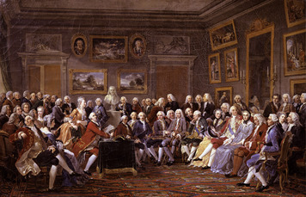
Another key figure in the British Enlightenment was the Scottish philosopher Adam Smith. His book The Wealth of Nations laid the foundations for modern economics. Smith believed that a free market, based on competition and self-interest, would benefit society as a whole. But he also argued that a successful economic system must help the poor. As he wrote: “No society can surely be flourishing and happy, of which the far greater part of the members are poor and miserable.”
Some Enlightenment thinkers also addressed the rights of women and children. For example, in 1792 the English author Mary Wollstonecraft voiced early feminist ideas in her book Vindication of the Rights of Women.
French Philosophers In the 1700s, the center of the Enlightenment shifted to France. In Paris, the philosophes—a French word for Enlightenment thinkers—gathered for lively discussions in private homes, called salons.
Among the most famous philosophes were the Baron de Montesquieu (MON-tuh-skyoo), Voltaire, and Jean-Jacques Rousseau (roo-SO). All three had an important influence on the founding ideals of the United States.
Montesquieu’s most famous book was The Spirit of the Laws. In it, he made the case for a three-part system of government, with a separation of powers among executive, legislative, and judicial branches.
Voltaire—whose given name was Francois-Marie Arouet—was a brilliant writer and thinker who advocated religious tolerance. He criticized religious persecution and supported freedom of speech.
Rousseau believed that people are corrupted by society and that they can find a purer life in harmony with nature. But he also recognized that government was necessary and argued for a political system based on the will of the people. He wrote: “The people, being subject to the laws, ought to be their author; the conditions of society ought to be regulated solely by those who come together to form it.”
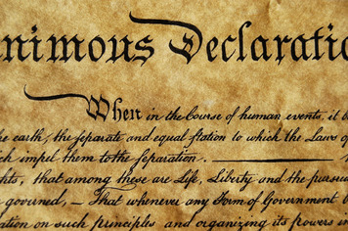
The Impact of the Enlightenment The Enlightenment had various effects. One was to encourage new ways of thinking among some political leaders. Monarchs like Russia’s Catherine the Great embraced reform ideas in education and social welfare. They became known as enlightened monarchs, though their reforms were often half-hearted.
More importantly, the Enlightenment gave rise to new political ideals. The ideas of liberty, natural rights, and republican government spread throughout Europe and the Americas. They encouraged the American and French revolutions of the late 1700s. They also helped spark independence movements in Latin America in the early 1800s.
The Enlightenment also promoted an optimistic faith in the future. Enlightenment thinkers believed that society could be understood and improved. Many thought that social and political progress were inevitable. These ideas carried forward into the modern era.
This period also encouraged the trend toward secular attitudes in society. It emphasized reason over religion in the search for knowledge. It also promoted the principles of religious toleration and respect for the individual. These too were key legacies of the Enlightenment.

Summary
In this lesson, you read about four key movements in Europe: the Renaissance, Reformation, Scientific Revolution, and Enlightenment. Together, they helped transform European society in the early modern era.
Cultural Interaction Each movement spread new ideas and beliefs. The Renaissance revived classical learning and promoted secular attitudes. New styles of art and literature emerged. The Reformation challenged Catholic beliefs and produced new Christian faiths. The Scientific Revolution used the power of reason to discover natural laws. In the process, it altered views of nature and the universe. The Enlightenment applied scientific principles to the study of society. It encouraged belief in human progress.
Political Structures City-state politics in Italy helped give birth to the Renaissance. The Reformation sparked religious wars and reduced the power of the Catholic Church. The Enlightenment promoted new political ideals that sparked reform and revolution in Europe and the Americas.
Economic Structures Growing prosperity provided the economic foundations for the Renaissance. The methods and discoveries of the Scientific Revolution led to the growth of technology. Enlightenment ideas gave rise to the modern science of economics.
Social Structures The Renaissance, Reformation, and Enlightenment all had effects on European society. The emphasis on individual worth and secular thought helped loosen social restrictions. The challenge to the authority of the Catholic Church also shook up society.

