Name_____________________________________Date______

Unit 15:Political Revolutions and Their Legacies

1. Introduction
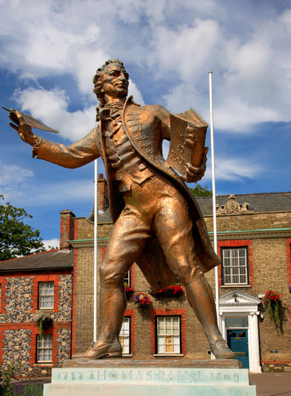
As the year 1775 came to a close, British colonists in North America faced a crucial question. Should they work out their differences with Great Britain, or should they declare their independence?
In January 1776, a publication appeared that helped Americans answer that question. The 50-page pamphlet, titled Common Sense, made a strong case for independence: “Every thing that is right or natural pleads for separation. The blood of the slain, the weeping voice of nature cries, ’TIS TIME TO PART.”
Thomas Paine, the pamphlet’s author, grew up a student of the Enlightenment. Political thinkers of the Enlightenment used reason to identify people’s rights and freedoms. One thinker, John Locke, wrote that it was proper to overthrow a government that violated people’s natural rights. This was a radical idea—one that Paine believed firmly and expressed persuasively. Six months after Common Sense came out, the Americans declared independence. Their political revolution had officially begun.
Paine’s writings influenced other revolutions as well. He strongly defended the French Revolution in his book Rights of Man. It helped make Paine a hero to the French, who elected him to their National Assembly. Revolutionaries in Latin America, too, admired Paine. At least one of them, Francisco de Miranda, met with Paine well before Spain’s colonies rebelled.
The influence of Paine’s work played a part in the political revolutions of the 1700s and 1800s. But major events in history have many causes. At the root of this era’s political upheavals lay a set of Enlightenment ideas. Though radical, these ideas, which were spread via the writings and actions of Paine and others, made sense to people across the globe. They helped generate an era of democratic revolution whose impact can still be felt today.

Themes
Cultural Interaction Enlightenment ideas circulated around the world, helping support political uprisings in the Americas, Europe, and Asia.
Political Structures Revolutions of the late 1700s replaced monarchies with representative political systems. Democratic movements inspired similar changes in political structures elsewhere in the world.
Economic Structures The spread of liberalism encouraged economic freedom and the protection of private property.
Social Structures Tensions among social classes helped trigger some political revolutions.

2. The American Revolution
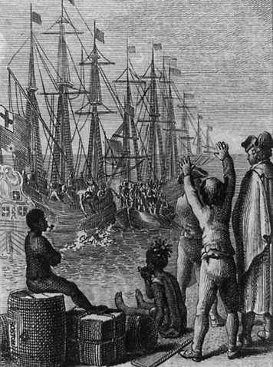
The American Revolution began with musket shots exchanged between British army regulars and a colonial militia at the Battles of Lexington and Concord in April 1775. By war’s end, some 4,400 Americans had been killed in battle. Another 18,000 or more had died off the battlefield, mainly from disease. The British death toll was about the same.
The Path to War The trouble started right after the French and Indian War, a nine-year struggle that ended in 1763. The British defeated the French and their Native American allies, but at great cost. The victory ended the French threat in North America. But the Indian threat remained. Americans, especially pioneers on the western frontier, demanded protection from Indian attacks. The British expected their colonies to help pay for their own defense.
To raise revenue, the British passed the Stamp Act in 1765. It required colonists to pay a tax, represented by a stamp, on everyday goods such as newspapers and playing cards. The tax outraged colonists. A secret organization known as the Sons of Liberty arose in several cities to organize protests against the Stamp Act. Before this time the colonies acted, for the most part, as distinct and separate units. Opposition to the Stamp Act was beginning to unite the colonies.
The violence of some protests, including threats against tax collectors, led Parliament to repeal the Stamp Act in 1766. But other new taxes followed. Colonists again reacted with demonstrations. They boycotted, or refused to buy, goods that carried a tax. In one protest in December 1773, colonists dressed as Indians dumped a load of tea from a British ship into Boston Harbor rather than pay the tax on it. Britain denounced this Boston Tea Party and took steps to punish the colony. The Coercive Acts, known in the colonies as the “Intolerable Acts,” closed the port of Boston. They also increased the power of the royal governor at the expense of local leaders.
As the Intolerable Acts showed, the British had more in mind than just raising tax revenue. They also wanted to exert more control over their colonies. Almost from the beginning, the English settlers had enjoyed a modest level of political freedom Elected representatives served in colonial assemblies. The assemblies had key lawmaking powers. Nonetheless, most colonies also had royal governors appointed by the British monarch. In theory those governors had the power to say when the assemblies would meet, veto laws passed by the assemblies, and choose key officials. But in reality the colonies largely governed themselves.
After passage of the Intolerable Acts, those political freedoms now seemed in jeopardy. Colonists feared that Britain would tighten its control of all the colonies. Their alarm increased when Parliament passed the Quebec Act. This act expanded the province of Quebec southward to the Ohio River. Colonists would be kept from settling in this fertile region.
Colonial leaders decided to join together to form a single governing body to present their complaints to the British. By forming a united front, they hoped to have more power to negotiate. From September to October 1774, the First Continental Congress met in Philadelphia. The Congress consisted of a mix of moderates and radicals. The moderates wanted to compromise with the British to avoid a showdown. The radicals hoped to persuade the British to restore the freedoms that they had come to cherish. If not, they were ready to separate completely from Britain.
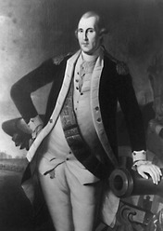
The Fight for Independence Weeks before the Second Continental Congress convened in May 1775, the Battles of Lexington and Concord took place. The American Revolution had begun. Soon the radicals took charge, insisting on breaking free from Britain.
With the help of persuasive writings such as Paine’s Common Sense and Thomas Jefferson’s Summary View of the Rights of British America, the movement for independence swept up many colonists—although not all. A significant number of Loyalists, especially in parts of New York, New Jersey, and the Carolinas, opposed the Patriots. They would continue to support Britain throughout the Revolutionary War.
The members of Congress chose George Washington to command the Continental Army. Washington had earned their respect by his leadership of British troops during the French and Indian War. From the fall of 1775 to the spring of 1776, Patriot forces took the offensive. They invaded and later retreated from Canada. They pushed the British out of Boston.
In June 1776, the Continental Congress appointed a committee to prepare a document declaring the colonies’ independence. Jefferson wrote the first draft. After some debate and revisions, the members of Congress signed the Declaration of Independence on July 4, 1776. Benjamin Franklin knew that this document was also a declaration of war. As he signed it he noted, “We must all hang together or assuredly we will all hang separately.”
It did not take long for the British to respond. By September, armed with about 32,000 troops and a huge fleet of warships, they had taken New York City. Washington and his army fled. The British followed, chasing them into New Jersey. To escape, the Continental Army had to cross the Delaware River into Pennsylvania.
Just when the Patriot cause looked bleakest, Washington pulled off a daring move. On Christmas night, 1776, he led his army back across the ice-choked river to attack the British at Trenton, New Jersey. Before they left, he boosted his troops’ spirits with words recently written by Thomas Paine:
These are the times that try men’s souls. The summer soldier and the sunshine patriot will, in this crisis, shrink from the service of their country; but he that stands it now, deserves the love and thanks of man and woman.
—Thomas Paine, The American Crisis, No. 1, December 23, 1776
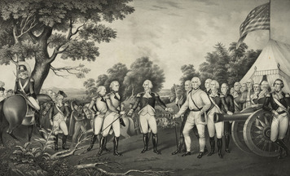
Washington’s men decisively defeated the British force at Trenton. Ten days later, they won another victory at Princeton. Washington showed that he was a superb strategist. But he knew that he owed much of his success to foreign powers. France, along with two other British enemies, Spain and Holland, had been secretly sending vital supplies to the Continental Army.
The French were willing to do more, but they needed proof that the Americans could indeed win the war. That proof came with the Battle of Saratoga, in upstate New York. By winning there, the Americans stopped the British from taking control of the Hudson River Valley, which would have isolated New England from the rest of the country. After that victory, France started to take an active role in the war. Thus Saratoga was a turning point in the revolution.
Many bloody battles followed. The war shifted away from the northern colonies as the British took control of much of the South. Eventually, with the help of French troops and ships, the Continental Army trapped the main British army at Yorktown, in Virginia. The surrender of that army in October 1781 marked the end of major hostilities. The Americans had won their independence.
Treaty of Paris The official end of the Revolutionary War came in 1783 when American and British delegates signed the Treaty of Paris. In the peace treaty, Great Britain acknowledged the independence of the United States. It also accepted the expansion of the new nation from the Great Lakes south to Florida and westward to the Mississippi River. For its part, the United States agreed to recommend that states restore to Loyalists their rights and liberties and any property that might have been taken away during the war.
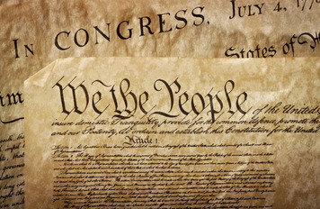
Constitution and Bill of Rights Thomas Paine had come up with the name for the new country—the United States of America. Just how “united” those states would be, however, was unclear. But its first constitution offered some clues.
In 1781, the states had ratified, or approved, the Articles of Confederation. This written constitution spelled out the role of the central government and its relationship to the states. After their experience with British tyranny, Americans were in no mood to invest much power in a central government. The Articles did give Congress certain powers. But to carry out those powers, it needed support and money from the states, and the states did not willingly provide either.
Basically, the states were to be considered sovereign. Each had the ability to create laws, resolve disputes, and otherwise make and carry out policies without interference by other states or the central government.
In general, the Articles of Confederation proved to be a failure. It left the central government too weak to resolve nationwide economic problems or maintain order. A number of leaders called for a convention to fix the Articles. The Constitutional Convention met in Philadelphia in May 1787. The 55 delegates decided quickly that instead of trying to fix the Articles of Confederation, they would replace it. By the end of that long, hot summer, the people of the United States had a brand new Constitution, one that has continued to serve the country to this day.
The process of creating the Constitution involved a great deal of debate and compromise. One major issue concerned competition between large and small states. The large states wanted representation in Congress to be based on population. The small states wanted each state to have an equal number of representatives both in the House of Representatives and the Senate. This issue was finally settled through the Great Compromise. A state’s representation in the House would be based on its population. Each state would have an equal number of senators.
A related issue involved the counting of slaves in determining a state’s population—and thus the number of its representatives in the House. Southern states wanted each slave to be counted. Northern states objected. The compromise was to count each slave as three-fifths of a person.
The Constitution laid out a plan of government based on the separation of powers. It allotted powers to three branches—the executive, legislative, and judicial. Each branch could check, or restrain, the power of the other two. The Constitution also served as the supreme law of the land. It helped ensure that the rule of law would prevail. Rule of law means that the law applies to everyone. Nobody—not even the president, the highest official in the land—is above the law.
The states ratified the Constitution in 1788. Three years later, they approved a Bill of Rights, intended to protect individuals’ civil liberties. In this way, the Constitution completed the American political revolution. It replaced the monarchical political system with a totally new structure of government—a representative democracy.

3. Revolutions in France, Italy, and Germany
The American Revolution changed the political system, but it did not really alter people’s day-to-day lives. The French Revolution, on the other hand, led to a major social upheaval. A radical assault on France’s traditional institutions—the monarchy, the Church, feudalism—the revolution thoroughly transformed French society.
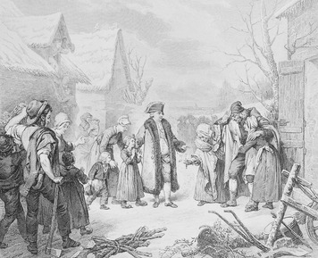
Social Divisions and Financial Problems The French people in the 1700s were sharply divided socially. The nobles and the clergy, or officials of the Roman Catholic Church, represented the top two estates, or legal categories. To be a noble or a member of the clergy, a person had to meet specific legal requirements. Everyone else, from merchants to peasants, belonged to the Third Estate. This commoner class made up some 95 percent of the population.
The commoners, for the most part, accepted the three-tiered society. However, many of them resented certain feudal privileges granted to the landowning nobles and clergy. Noble landlords had an exclusive right to carry weapons, hunt, and demand work from the peasants. They could levy taxes but were themselves exempt from most taxes. Of the third estate, merchants and government officials paid a limited amount in taxes. The tax burden fell largely on the peasants, most of whom were poor.
For France, the 1700s was a century of continual warfare. To pay for their military ventures, including support of the colonists in the American Revolution, French kings had to borrow more and more money. By 1788, King Louis XVI faced severe financial problems. In fact, France hovered on the verge of bankruptcy.
Louis considered a set of reforms for resolving the economic crisis. They included raising taxes. The peasants, however, could not afford to pay any more than they already did. Meager harvests, rising consumer prices, and high unemployment had already taken a terrible toll on the poor. Yet the rich were protected from new taxes by their exemptions and traditional rights.
To move forward with reforms, the king decided that he needed the approval of the Estates-General. This assembly of representatives from all three estates had not met since 1614. However, the king’s decision to summon the Estates-General proved disastrous. It gave the commoners access to power. They used that power in ways that led, through a complex series of events, to a political revolution.
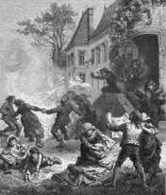
A Radical Revolution On May 5, 1789, the Estates-General met at Versailles, the king’s palace, some 10 miles outside Paris. Delegates to the meeting brought lists of grievances to discuss with the group. Many also brought their Enlightenment ideas about liberty and about government based on natural laws. Most representatives of the Third Estate had legal backgrounds. On June 17, they declared themselves to be a National Assembly, with the power to govern France. They started designing a constitution.
The king took steps to stop the Assembly from meeting, which roused the people of Paris. On July 14, a mob destroyed the Bastille, a fortress and prison that symbolized royal power. The revolution had moved into the streets. In the weeks that followed, it also spread to the countryside. Most peasants, out of fear, remained on the sidelines. But some took this opportunity to destroy their landlords’ property, especially documents that showed how much they owed their masters in feudal dues.
As these outbursts of violence suggest, the French Revolution had no sharply defined goal, such as independence. Instead, it was a broad-based war on privilege, powered by Enlightenment ideas. The course of the revolution resembled a roller-coaster ride. It had several stages, as dominant groups came and went.
The National Assembly kept control only for a few years. But by 1791, it had transformed France. It had adopted the Declaration of the Rights of Man and Citizen, a document that defined the individual and collective rights of all three estates as equal and universal. It had turned the country into a constitutional monarchy. It had forced the French Catholic Church to cut its ties with Rome. It had abolished feudalism, the system of privileges held by the nobles and clergy. All French citizens were now equal under the law. As the Declaration of the Rights of Man and of the Citizen—the preamble to the constitution—stated, “Men are born free and remain equal in rights.”
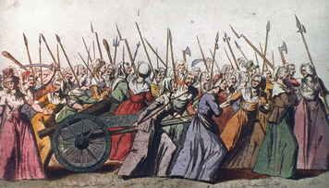
As for women, they were largely left out of the revolution. The men “reasoned” that women were, “by nature,” unfit to take a political role. The feminist Olympia de Gouge reacted by drafting a Declaration of the Rights of Woman and of the Citizen. There she wrote, “Woman is born free and lives equal to man in her rights.”
Some women did join the French Revolution. They took part in protests and joined political clubs. Others actively opposed the revolution. Many of these defended priests, who were often mistreated, and tried to ward off attacks on the Catholic Church.
After 1791, the French Revolution took a turn toward violence. Fearing a foreign plot to undermine its progress, France declared war on Austria and Prussia in 1792. It also replaced the National Assembly with a body known as the Convention, which would govern until 1796.
Extremist politicians gained control of this new assembly. They encouraged a thirst for blood among the people, and their rule became a Reign of Terror. In 1793, they beheaded King Louis XVI and his wife Marie Antoinette and replaced the monarchy with a republic. Their quest for absolute unity and loyalty led to the deaths of tens of thousands more citizens in the next year and a half. Many were executed, as the king had been, by guillotine. Many more were killed in clashes with opponents of the revolution throughout the country.
Moderates in the Convention took charge in 1794. They executed the main agent of the Terror, Maximilien Robespierre. If this did not mark the end of the French Revolution, it came five years later with the rise to power of a shrewd and power-hungry French general, Napoleon Bonaparte.
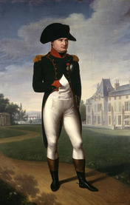
Napoleon Takes Control In 1799 Napoleon, a skilled army commander, seized control of France in a coup d’état, bringing an end to representative government. Napoleon ruled as a dictator. Yet he also retained—in theory if not always in practice—many of the gains of the revolution, including citizens’ equality, individual liberty, and protection of property rights. In 1804, he put forward a law code that safeguarded these ideals. It became known as the Napoleonic Code.
That same year, Napoleon crowned himself emperor of France. But he did so with the support of the French people, who voted in favor of restoring the monarchy. Thus he upheld, at least outwardly, the ideal of popular sovereignty—that the people are the source of all political power.
Soon after Napoleon took power, he defeated Austrian forces in Italy and Germany, ending a long-standing threat to France. But he was not done. To add to his empire, Napoleon led campaigns across Europe. French forces defeated Austria in 1805 and Prussia in 1806. In 1807, Napoleon’s armies invaded Portugal in the west and Russia in the east. The French emperor thus extended his control and influence over much of the continent.
Napoleon also spread revolutionary French ideas and institutions. One of them, popular sovereignty, held that a people should govern itself. Even after Napoleon’s reign ended, in 1815, the French Revolution continued to inspire Europeans who valued liberty and equality. They challenged the authority of monarchies, seeking to replace them with republics. They took part in nationalist movements. Nationalists saw the value of living in a nation-state, in which one unified people governs itself. For example, inhabitants of Italy and Germany, both of which were divided into many small city-states and principalities, began to identify themselves as Italians and Germans.
Italian Unification Italy in the 1800s consisted of a mix of states ruled by various princes and the pope. The Austrian Empire controlled a large region in the northeast and dominated other states. The main thrust of the unification movement was to gain independence from Austria, a struggle known as the Risorgimento (“Resurrection” or “Rising Again”).
In 1848, popular uprisings rocked major cities across much of Europe. In Italy, Giuseppe Mazzini and other republican reformers took over several states and announced the formation of a republic. Austrian and French armies, however, quickly moved in to extinguish the revolution.
After 1848, the Kingdom of Sardinia in northern Italy led the unification movement. It was the only constitutional monarchy in Italy. Its king, Victor Emanuel II, and its prime minister, Camillo di Cavour, worked on a plan to oust Austria from Italy. In 1859, Sardinia secretly allied itself with France. It then provoked Austria, which threatened to take military action. France stepped in and, after three battles, secured a settlement with Austria—without consulting Cavour.
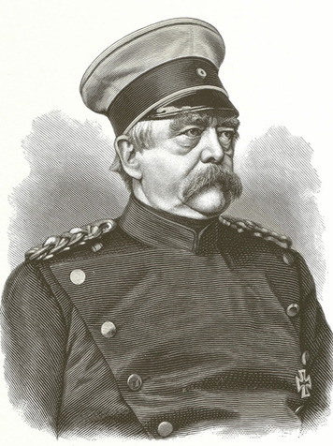
The settlement left Austria in charge of the Italian state of Venetia. It also allowed rulers of states in central Italy to maintain their control. Sardinia moved to annex those states. It succeeded, but only after allowing their inhabitants to vote on the annexation. In 1860, the fighter and revolutionary Giuseppe Garibaldi led his army of red-shirted volunteers into southern Italy. He conquered Naples and Sicily and later turned them over to Sardinia. Nearly all of Italy was now unified. In 1861, the first Italian parliament proclaimed Victor Emanuel II the king of Italy. Complete unification came nine years later, after Venetia and Rome had been annexed.
German Unification German nationalists, too, sought greater unity after the 1848 revolutions. They included a liberal middle class of business and factory owners—the bourgeoisie—who saw the need for a national market. Economic unity, however, would come only with political unity.
As in Italy, the Austrian Empire had long dominated the various German states. But Austria was growing weak. Prussia, the largest and strongest German state, took a leading role in the unification movement. In 1866, after defeating Austria in war, Prussia grew even larger and more powerful. It now controlled two-thirds of Germany’s population and territory. In 1867, Prussia unified this territory as the North German Confederation.
Prussia’s prime minister, Otto von Bismarck, was the architect of Prussia’s expansion. Although conservative, he adopted the goal of national unification, in part to ensure that Prussia would dominate Germany. To meet this goal, Bismarck needed a way to persuade the southern German states to unite with the northern states. He achieved this result by provoking France into a war. The southern states, their intense anti-French feelings aroused, joined with the North German Confederation in 1871. Together, they defeated France in the Franco-Prussian War and established a unified German Empire.

4. Revolutions in Latin America
Columbus’s voyage west across the Atlantic Ocean in 1492 initiated European interest in the Americas. In the years that followed, Spain claimed most of Latin America. Portugal acquired Brazil. There they established colonies, from which they extracted resources that brought them great wealth. They held on to those colonies for some three centuries, until a string of revolutions rocked the entire region.
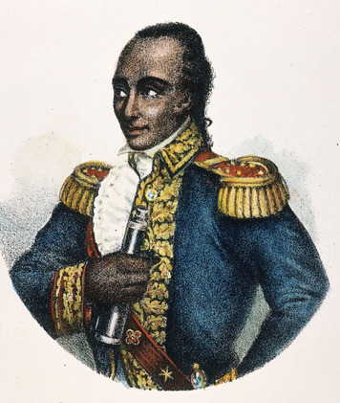
Haiti In 1791, inspired by the French Revolution, slaves in the French colony of Saint-Domingue revolted. In this sugar- and coffee-producing colony on the Caribbean island of Hispaniola, slaves far outnumbered the dominant whites. A third class included freed people of color and mulattos, or people of mixed black and European ancestry. This class lacked social and political equality with the whites.
A free black, Toussaint L’Ouverture, joined the rebels and helped lead what became known as the Haitian Revolution. It was a combined slave rebellion and anti-colonial uprising. By 1800, L’Ouverture and his army had eliminated their opponents and taken control of the colony. After Napoleon gained power in France, he sent a French force to the colony to suppress the revolt. Mulattos joined with black leaders to defeat the French troops in 1804, declaring their independence from France and massacring thousands of French colonial administrators and their families. They founded the first black republic in modern history, which they renamed Haiti.
Revolution in the Spanish Colonies Social tensions within Spanish America’s multiracial societies also played a role in the drama that unfolded there. After the Haitian Revolution, whites feared that rebellions might arise among the lower classes of Indians, enslaved Africans, and people of mixed blood. The minority white population dominated politically. It consisted of Creoles and peninsulares. Creoles were American-born descendants of Spanish colonists. Peninsulares were Spanish-born settlers. No major slave rebellions took place. But a series of Creole-led revolutions resulted in the founding of new nations throughout Spanish America.
Creoles had once played a leading political role as colonial officials. But in the late 1700s, Spain’s leaders decided to exert greater control over their colonies. They introduced reforms that took the right to rule their own areas away from the Creoles. From then on, Spain entrusted important political and military positions to the peninsulares and generally snubbed the Creoles.
In 1808, French forces under Napoleon invaded and occupied Spain, severing the link between Spain and its colonies. Many Creoles saw this as an opportunity to restore their position in colonial society—both political and economic. The more radical among them, influenced by Enlightenment ideas and motivated by the American Revolution, sought to free themselves from Spanish rule. Wherever these liberal-minded patriots could gain control, they set up local councils to govern themselves.
The peninsulares, too, established councils. But these Spanish citizens were not revolutionaries or liberals. They were royalists—they, along with a significant number of Creoles, remained loyal to the Spanish king. They fully expected Spain to restore its control of the colonies one day.
These differing visions collided throughout Spanish America as the revolutionary movement grew. Spain had divided its colonial territory into regions, called viceroyalties. New Granada occupied northwestern South America. Río de la Plata, present-day Argentina, was located in the south. Peru lay between them. New Spain included Mexico and most of Central America, as well as Spain’s Caribbean colonies. The story of the revolutions in Spanish America varied from one viceroyalty to another.
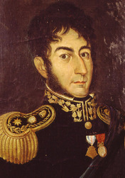
San Martín in Río de la Plata The first solid achievement for the Creole patriots occurred in Buenos Aires. They established self-rule in this southeast coastal city and maintained it in spite of several assaults by royalists. Buenos Aires became a base for spreading the revolution throughout the southern part of South America. In 1816, patriot groups within the viceroyalty joined together to form the United Provinces of the Río de la Plata and declared their independence from Spain. They chose Buenos Aires as the new country’s capital.
The patriots realized that their country could not be secure until the Spanish had been driven from power throughout the continent. The viceroyalty of Peru, a key royalist stronghold, had to be conquered. In 1817, patriot leader José de San Martín formed and trained an army in Río de la Plata. It included blacks, mulattos, and mestizos—people of mixed Indian and European ancestry. He led this 4,000-man army across the Andes on a bold mission against royalist forces in Peru.
First, Martín’s Army of the Andes marched into Chile, south of Peru. In 1814, a Peruvian army had stamped out the revolutionary movement in this province. San Martín restored the Chilean patriots to power in 1818 by defeating the royalist forces.
In September 1820, San Martín and his army headed north, by sea, to Peru. By July of the next year, the Army of the Andes had carried the revolution all the way to Lima, Peru’s capital. The royalist army fled into the mountains. In July 1821, San Martín declared Peru independent. The patriots had succeeded in taking control of the towns, but a powerful royalist army still had support in the countryside. To plan his next move, San Martín decided to consult with another great patriot commander, Simón Bolívar.
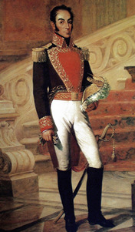
Bolívar in New Granada Bolívar, a wealthy Creole, had led the revolution in New Granada. That revolution began in his home state of Venezuela. He and his small Army of the North supported independence movements there and elsewhere in the viceroyalty. For his success in freeing various regions, he received the title “The Liberator.”
However, the road to independence was not easy. Bolívar suffered many defeats along the way, and the rule of key cities often shifted back and forth between patriot and royalist forces. Patriots in Caracas, Venezuela, for example, twice established a republic only to later lose control. The second republic was overturned in 1815 by a large army sent from Spain. That army forced Bolívar to flee to Jamaica. From there he sailed to Haiti, which provided him the resources needed to continue the fight for independence.
Still, the Army of the North made little headway in New Granada until 1819. By then, Bolívar had changed his strategy. He and his army had relocated to the Venezuelan countryside to escape Spanish forces. They engaged in guerrilla warfare, living off the land and making quick, hit-and-run strikes against the enemy. Bolívar’s army now consisted of not only Creoles but also a number of British and Irish troops and, for the first time, mulattos. In addition, Bolívar had help from an unlikely source, the llaneros. He persuaded these horse-riding cattle herders of the plains to switch sides after being poorly treated as mounted soldiers in the royalist army.
In the spring of 1819, Bolívar led his diverse army on a long and perilous march west across the Andes into present-day Colombia. There he launched a surprise attack on the Spanish force. It was the first in a series of patriot victories that, by May 1822, had brought independence to New Granada.
Resistance to Revolution in Peru and Mexico In July 1822, Bolívar and San Martín met in Ecuador. There San Martín decided to step aside and let Bolívar take the lead in the effort to liberate Peru. Bolívar and his army accomplished this task in a series of battles starting in August 1824. By April 1825, he had tracked down and defeated the remaining royalist forces in the region then called Upper Peru. The nation formed from Upper Peru would rename itself Bolivia in honor of their Liberator.
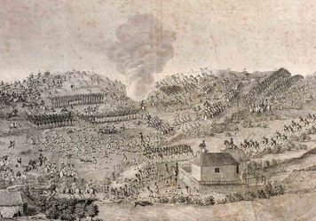
Mexico, like Peru, remained staunchly loyal to Spain. Peninsulares there ran the government and blocked attempts by Creoles to introduce liberal reforms. In 1810, a radical Creole priest, Miguel Hidalgo, called for independence. He inspired a nationalist uprising of Indians and mestizos across the Mexican countryside. Their goal was to force the Spanish out of Mexico. Hidalgo’s followers killed many peninsulares and destroyed much property. The independence movement threatened to become a social revolution. Fearing that, many Creoles joined Mexico’s royalist army.
The army finally overpowered the rebel forces and executed Hidalgo and his successor, José María Morelos. But the movement for independence did not die. In 1821, in an unexpected turnabout, Creole soldiers conducted a successful coup d’état against their Spanish officers. They achieved independence and the promise of a constitutional monarchy. But their leader, the former royalist Agustín de Iturbide, declared himself emperor. His reign lasted less than a year, as Mexicans from across the political spectrum opposed him.
Mexico remained unstable in the years that followed, as political, economic, and social ills plagued the country. This was the case in many of the nations to which the revolutions of Latin America gave birth. Liberals and conservatives continued to clash. Military strongmen—known as caudillos—vied for control at the local, provincial, and national levels. They promised order but often used oppressive measures to secure it. Economies wrecked by revolution could not bring about the prosperity that people hoped for. Also, hostility among the various social classes persisted.
Brazil Napoleon’s invasion of Portugal in 1807 did not set off a major uprising in Brazil, a Portuguese colony. It did, however, cause a reversal in the relationship between the mother country and the colony. The French army’s conquest of Portugal forced the nation’s royal family to flee to Brazil. They arrived in the city of Rio de Janeiro in March 1808, along with thousands of members of their court.
The Portuguese ruler enacted economic reforms that pleased Brazil’s privileged class and helped keep liberal-minded Brazilians in check. Brazil quickly became the political center of the Portuguese empire. When the king finally returned to Portugal in 1821, he put his son, Dom Pedro, in charge of the colony. The following year, faced with growing calls for political reform by republicans, Dom Pedro declared Brazil’s independence.

5. Revolutions in East Asia
The late 1800s found two East Asian countries, China and Japan, moving in opposite directions. China, the traditional East Asian powerhouse, was steadily declining. Japan, on the other hand, was enjoying an economic and military revival. Japan owed its rise to a revolutionary restoration of the monarchy. China’s political upheaval would come later, in the form of a republican revolution.
Meiji Japan In 1853, Japan received a “wake-up call” from the United States. It came in the form of a squadron of four warships, two powered by steam and two by the wind. The ships, commanded by Matthew Perry, arrived unannounced in a Japanese harbor. Their mission was to open Japan to trade and diplomatic relations. Perry completed his mission the following year, when Japan signed a treaty that allowed an American diplomat to reside in Japan and opened the door to trade. Other European powers began demanding similar privileges.
Perry’s success revealed to the Japanese just how weak their country had become. The shogun—the dominant warlord and supreme ruler of Japan—lacked the military might to resist American demands. He could no longer preserve Japan’s traditional isolation from the West (Europe and North America). That isolation may have helped keep Japan stable and peaceful, but it also prevented the country from moving forward into the modern age.
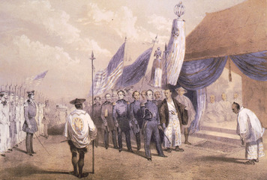
The shogun came under increasing pressure. Many Japanese blamed him for the unprecedented presence of “barbarian” diplomats and traders on Japanese soil. They also held him responsible for the woeful state of the Japanese military, especially its outmoded weaponry. During the shogunate, Japan’s emperor had remained a figurehead, with only ceremonial power. Support for restoring imperial rule began to grow.
In 1867, rising contempt for the shogun boiled over into rebellion. The uprising succeeded in part because members of the main rebel group had learned how to make and use modern weapons. In 1868, the Meiji emperor officially ended the shogunate and took control of Japan. The return of power to the emperor, however, was just the start of a political revolution known as the Meiji Restoration.
Meiji reformers took steps to strengthen Japan, using the West as a model. They wrote a constitution and set up a representative government. They abolished the feudal system, shifting power from local lords to the central government. The reformers introduced Western technology, improved education, and modernized the economy.
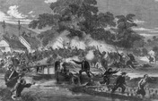
Qing China Since ancient times China had thought of itself as the center of the universe—the Middle Kingdom. Outsiders were “barbarians.” In the 1800s, however, China’s great civilization fell into decline Foreign threats helped trigger internal clashes that threatened to tear the country apart.
A non-Chinese people, the Manchus, gained the Mandate of Heaven—the divine right to rule—in 1644. They formed the Qing (ching) dynasty, which maintained peace for nearly two centuries. During this time, China allowed European Christian missionaries to bring their religion into China. It also engaged in foreign trade through a single port, Guangzhou.
At Guangzhou, foreign merchants bought Chinese tea, silks, and porcelains. But China neither needed nor wanted much that the Europeans could offer—except opium. The British brought this drug, grown in its colony in India, to China while Chinese smugglers then sneaked it into the country. In 1840, after China cracked down on the opium trade, the British sent warships to China. In the Opium Wars that followed, the British navy proved too powerful for the poorly armed Chinese forces. In 1842, Britain secured a treaty with China that opened several Chinese ports to trade. Soon other European powers demanded and gained access to these treaty ports.
The inability of the alien Qing dynasty to restrain foreign powers or to improve economic conditions led to an uprising known as the Taiping Rebellion. The Taiping movement, which arose in the south, was loosely based on Christian teachings. It called for the redistribution of land to the peasants, equality of the sexes, and other social changes that threatened to undermine Chinese tradition. Starting in 1853, thousands of peasants joined the rebellion and marched, as an army, northward.
The rebels captured several cities along the way, including the former capital of Nanjing, and added many more people to their cause. Fanatics in battle, they slaughtered all who opposed them. After more than a decade of fighting, the Manchus—with help from Europeans and their advanced arms—ended the rebellion. Tens of thousands of Taiping rebels were killed in the retaking of Nanjing in 1864.
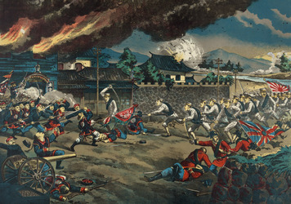
Another peasant movement, this time in northern China, arose from a group calling itself the Righteous Harmonious Fists. Westerners called them the Boxers. The goal of what became known as the Boxer Rebellion was to rid China of foreigners, especially Christian missionaries and their converts. The Qing government, frustrated by years of European abuse, encouraged the movement. Peasants, suffering from a long drought, swelled the Boxer ranks, and in June 1900, they marched on the capital, Beijing. Western troops moved in to protect their diplomats, and when the Qing threw its support behind the Boxers, eight foreign powers sent in a much larger military force. This small army ended the siege of the capital. Later, the Qing reversed course, helping the foreign powers end the rebellion.
After the Boxer Rebellion, the Manchus instituted some reforms. They supplied China’s army with modern weapons. They built railroads and boosted industry. They also promised to move toward a constitutional government. For some Chinese, they did not move fast enough.
Led by a U.S.-educated physician named Sun Yat-sen, a group of radical nationalists made plans to end the Qing dynasty and install a republican government. In 1911, an uprising started that came to be known as the Chinese Republican Revolution. Some provincial officials and army commanders joined the revolution, which quickly toppled the Qing government. In January 1912, Sun Yat-sen won election as president of the newly formed republic. A month later, China’s last emperor stepped down. The Qing had lost the Mandate of Heaven.

Summary
In this lesson, you read about the political revolutions that occurred throughout the world in the 1700s and 1800s. Many of these revolutions were influenced by the democratic ideals of the Enlightenment.
Cultural Interaction Political revolutionaries in the Americas, Europe, and Asia based many of their actions on ideas formulated in Europe during the Enlightenment. Those ideas later appeared in the constitutions put in place by newly formed nations.
Political Structures The revolutions that took place from the late 1700s to the early 1900s sought to replace monarchies with more representative political systems. The French Revolution encouraged the spread of nationalism and, along with the American Revolution, inspired political upheavals elsewhere.
Economic Structures Liberal ideas, which called for individual economic freedom and the protection of private property, appealed to business interests and helped bring about revolutionary political change in the West. In the mid-1800s, the desire by Western powers to trade with China and Japan put pressure on those countries to modernize their economies.
Social Structures Tensions among social classes in France played a key causal role in the French Revolution, and the revolution itself transformed French society. The social structure in Haiti was also changed, by a slave rebellion that turned into a political revolution. During the revolutions in Spanish America, white society split along class lines.

