Unit 16-The Industrial Revolution

1. Introduction
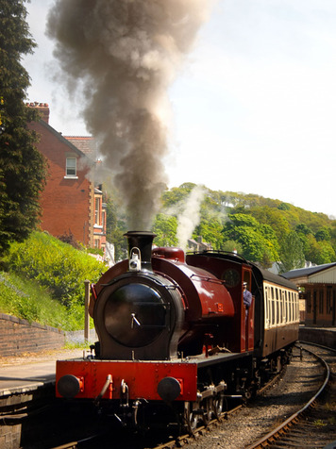
In the 1700s, metalworkers used large amounts of coal, which burned with the intense heat needed for making iron. Coal suppliers, however, had a problem. Coal mines, dug deep in the ground, tended to fill with water. A British inventor named Thomas Newcomen designed an engine to pump water out of the mines. His engine burned wood or coal to boil water and produce steam. It converted the steam’s heat energy into mechanical energy to drive the pump. The Newcomen engine worked, but not very efficiently.
In 1763, James Watt had the job of repairing a Newcomen engine. Watt made scientific instruments for a living, and he had an inventor’s mind. He knew he could make an engine that did not waste so much of the potential energy of the fuel. The solution eluded him for months. But then, one day, while strolling through his hometown of Glasgow, Scotland, the answer suddenly came to him. Watt set to work right away building a model, and in 1769 he won a patent for his much more efficient steam engine.
Watt spent the next two decades perfecting his steam engine. By 1790, he had turned his steam engine into a sturdy, practical, powerful machine. It would be put to use not only in coal mines but also in steamboats, locomotives, and factories. The steam engine would power the Industrial Revolution.
Many scholars are reluctant to call this period of industrialization a “revolution.” It took place over too long a period, they say, and affected the whole world. Yet the changes brought on by this shift from muscle power to machine power were enormous, and revolutionary in their scope. This chapter explores the Industrial Revolution, starting where it all began: Great Britain.

Themes
Economic Structures As a result of the Industrial Revolution, economies shifted from a focus on agriculture and manual labor to a focus on industry and mechanization.
Social Structures The pool of low-paid industrial laborers formed the core of a new social group, the working class.
Human-Environment Interaction Industrialization drew migrants from rural areas and from distant lands to cities and newly urbanized factory towns.

2. Great Britain Leads the Way
The Industrial Revolution, led by Great Britain, completely transformed how work was done. By the mid-1800s, British manufactures far exceeded those of any other country. Industrialization happened so quickly in Great Britain that it earned the nickname “workshop of the world.” Why did the revolution start in this small, European island nation?
Factors of Industrialization Great Britain became the first nation to industrialize because it had all of the necessary factors:
1. Political Stability Britain had a stable government that supported individual political freedom, property rights, and equality of opportunity. These traits encouraged entrepreneurs to take risks in pursuit of profit.
2. Labor Britain had plenty of people available for work. British farmers produced so much food that many of its people were freed to do different kinds of work. Many of those people went to work in industry.
3. Raw Materials Britain had plentiful supplies of the raw materials needed in industry, such as coal for fuel or wool for textiles.
4. Banking System Britain’s banks provided loans to entrepreneurs to finance large projects, such as factories, railroads, and coal mines.
5. Transportation System Britain had a network of navigable rivers and seaside ports. It built a nationwide system of canals. Later, it developed a railroad network, making the transportation of goods and raw materials cheaper and faster than ever before.
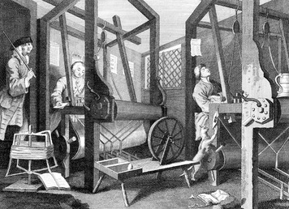
Innovation in Textiles The first industry to be transformed in Great Britain was textile production Before industrialization, every step of cloth making had to be done by hand. The raw fiber, like wool and cotton, had to be cleaned and untangled. The fibers had to be twisted into thread. Then the threads had to be woven into cloth. Each step was laborious and time-consuming. Skilled artisans used simple tools and equipment to make cloth in their own homes.
In the mid-1700s, English inventors created machines to speed up the cloth-making process. In 1733, John Kay invented the flying shuttle to automate the weaving process. Now weaving was faster, but spinners could not spin thread fast enough to keep up. James Hargreaves invented the spinning jenny in 1764 to allow one person to spin dozens of threads at the same time.
But threads produced on a spinning jenny often broke. Richard Arkwright solved this problem in 1769 with his water frame, an invention capable of producing stronger thread. The water frame was powered by a waterwheel turned by a fast-flowing river.
These machines were too large and expensive for ordinary workers to use in their own homes. Owners of textile businesses began building factories where they could install multiple machines to make textiles faster than ever before. Now workers would come to the factories to make fabric.
Resources Great Britain had plenty of rivers, and its earliest factories took advantage of the water power they provided. Eventually steam engines replaced water wheels, and they needed coal to fuel them—and Britain had an abundant supply of coal. Now factories could be built away from rivers, in more places than ever before.
Great Britain also had a steady supply of fiber. Britain had a long tradition of raising sheep for wool, and wool production more than doubled between 1700 and 1850. British textile merchants also imported cotton from Great Britain’s colonies in India and the Americas, and later, the United States.
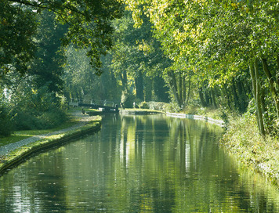
Transportation Great Britain also had a good transportation network. Britain had many navigable rivers and seaports that had long made coastal trade possible. By the 1770s it had built a system of well-maintained toll roads. Moving goods by road was slow, however, so Britain created a nationwide network of canals. Goods and raw materials could travel faster and more cheaply along canals.
Eventually, the steam engine was applied to transportation, resulting in the development of the steam locomotive and the development of railroads.
Soon, steam locomotives crisscrossed the country on a complex network of rails. By 1852, Great Britain had built some 7,000 miles of track. Railroads carried heavy loads of food and freight quickly and reliably, helping create a national market for goods. The economy boomed as manufacturers could create a product in one location and sell it anywhere in the nation.

3. The Revolution Spreads
Industrialization steadily improved Great Britain’s economy. It increased the amount of goods produced and greatly raised worker productivity, or the amount of goods each worker, on average, produced. Wealth generated by industrialization enhanced the standard of living for many people. It also made more tax revenue available to the government. Competing nations took notice and sought to develop their own industries. Generally, they adopted the elements of the British model that suited their circumstances.
Belgium Belgium, located across the English Channel from Great Britain, was the second country to take part in the Industrial Revolution. Belgium borrowed techniques and technology from the British, but its industrialization followed a different pattern. The people of Belgium had long been known for their woolen textile industry. By 1820, they had begun to mechanize that industry. But the traditional hand weaving of complex designs persisted into the mid-1800s. Belgium’s textile industry grew, but not as fast as Great Britain’s.
Belgium’s industrialization focused more on its abundant reserves of coal and iron ore. Exports of coal brought in valuable revenue, and the coal itself fueled the iron-making process. Belgium used the iron to produce machinery, locomotives, ships, and weapons. Later, Belgium developed a thriving steel industry.
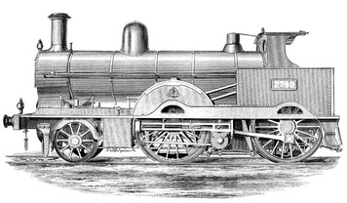
France France, with the help of British equipment, entrepreneurs, and engineers, also began to industrialize in the 1820s. It established numerous textile mills for the production of cotton cloth. Other factories produced machinery, including steam engines. France later had to import coal from Great Britain and from Belgium, because it lacked significant reserves of its own. As a result, France’s factories relied more on waterpower than steam power.
The United States As in France, early industry in the United States depended on waterpower, abundant in New England. Cotton textile mills mushroomed in New England in the 1820s. The mills modeled their technology and organization on those of British factories. Like the British, New Englanders’ raw cotton came from the American South.
New England factories also made metalwork. They used specialized equipment to produce metal parts for machinery and for guns. They owed their success to the earlier work of Eli Whitney and Simeon North, who established a method of manufacturing interchangeable parts. These inventors devised machine tools that could cut, plane, and drill part after part to nearly the exact same size and shape. The use of interchangeable parts allowed the rapid assembly of machines or other complex devices in a factory, based on a series of simple operations.
Further innovations sparked the Industrial Revolution in the United States. One was the cotton gin, another accomplishment of Eli Whitney. His machine for cleaning cotton led to a vast Southern expansion of cotton production—and slavery. The Bessemer process, an inexpensive way to convert iron into higher quality steel, greatly increased steel production. Cheap steel helped the heavy industries of the American Midwest to expand. They used the region’s plentiful iron ore and coal to build steel plants and factories that produced machinery and railroad rails—and the steel girders that, in the 1880s, made possible the first true skyscrapers.
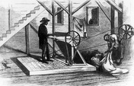
The heart of any factory was its machinery, and machinery has moving parts that interact. Without lubrication, that machinery would overheat and eventually grind to a halt. Through much of the 1800s, workers lubricated their machines with whale oil. In the 1850s, scientists developed a new and less expensive lubricant—coal oil.
Then, in 1859, an entrepreneur in Pennsylvania drilled the world’s first commercially successful oil well. Products that can be made from oil include gasoline and kerosene. Kerosene soon became industry’s lubricant of choice. Oil, also known as petroleum, slowly began to replace coal as the basic energy source of the Industrial Revolution. Gasoline fueled the automobile, which was powered by a ground-breaking invention, the internal-combustion engine.
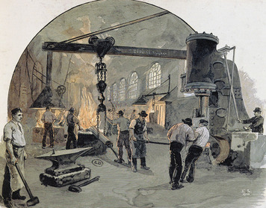
Germany Germany began industrializing fairly late, in part because it consisted of a number of independent states for most of the 1800s. In 1834, however, many of those states joined in creating a free-trade zone. Germany soon established itself as a leader in heavy industry, especially metalwork. Using its abundant coal and iron ore, Germany produced the rails needed to establish an efficient railway system.
Railroads and their support industries, including steel-making, remained the leading sectors of the German economy through the 1800s. Late in the century, the chemical, electrical equipment, and weapons industries also prospered. By 1914, Germany was second only to the United States as an industrial power.
Japan Industrialized Western states used their wealth to build up a strong merchant fleet and navy. They sailed across the world in search of trade. Until the mid-1800s, Japan had kept itself isolated from outsiders. Now the increased contact by Westerners helped push the Japanese into a political revolution. The Japanese ousted the shogun, or strongest warlord, from power and restored their emperor to the throne, in what is called the Meiji Restoration.
The new government followed a course of modernization, using the West as a model. This included industrializing. The Japanese mechanized the silk-weaving industry and built railroads and ships. Japan quickly gained a position of economic dominance in East Asia. From its colonies and through concessions forced from China, Japan extracted needed resources, such as coal, and found markets for its industrial products.

4. Economic Transformation
The industrialization that got its start in Great Britain was a slow revolution. It took decades to blossom. Wherever it spread, the Industrial Revolution transformed the economy. Ways of crafting goods changed. Ways of growing crops changed. New financial and business structures developed.
The Domestic System Long before the Industrial Revolution, some people made their living at craftwork. Skilled artisans, both in towns and in rural areas, produced goods needed locally. These included tools, pots and pans, glassware, furniture, and much more. One sign of a shift toward a new form of production was the growth of cottage industry, also known as the domestic system.
In the domestic system, cottage workers produced goods in home workshops. They made goods not for local use but for national and international markets. Typical cottage workers lived in the countryside, farmed for most of the year, and in the off-season made cloth. They provided the cheap labor needed at the time to meet the demands of a competitive textiles market.
The production of wool cloth usually followed a certain process. A textile merchant, based in a town, bought wool from a sheep farmer. He delivered this raw material, along with instructions about what he needed, to a household in the countryside. Family members carded the wool, spun it, and wove it into cloth on a hand loom. The merchant paid them for their work and took the cloth to another workshop, where skilled workers dyed the cloth and otherwise completed the processing. The merchant then retrieved the finished fabric, which was ready for market.
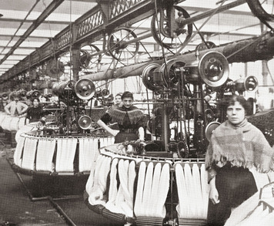
The Factory System The domestic system naturally gave way to the factory system. Instead of traveling from cottage to cottage, some cloth merchants decided that they could save themselves time and better meet rising demand by gathering workers together in a single factory. The merchants provided their workers with spinning wheels and looms and whatever other equipment they needed. In time, many other goods besides textiles were made in factories.
The factory system had several advantages over the domestic system. In a factory, merchant-entrepreneurs could supervise their workers. They could also take advantage of innovations in technology and new sources of energy, especially the steam engine. In short, they could make the revolutionary shift from muscle power to machine power.
In addition, factory owners developed new ways of organizing work. They saw that when individual skilled workers carried out all the tasks to make a product, each worker needed a variety of different tools, but most of the tools sat idle much of the time. In the factory system, unskilled or semi-skilled workers specialized in just one of the tasks needed to make a product. Each worker did only that task, all day long, and they learned to do it rapidly.
The factory and the shift to simplification were two key aspects of what became known as mass production. Another was the use of interchangeable parts. Factory workers could sit at their station with a pile of standardized parts in front of them and know that the parts were all the same and that any one of them would fit properly.
The desire to speed up the manufacturing process even more led to the use of the moving assembly line. An assembly line carried a product on a conveyer belt or track from one station to the next. Workers added one new part at each station. Starting in 1913, Henry Ford of the United States built his Model-T automobile using an assembly line. He was the first to apply assembly-line principles to large-scale manufacturing. The practice soon spread to other industries.
All of these changes increased efficiency and productivity. They also lowered the cost to produce many goods. Lower costs meant lower prices for consumers. By the late 1800s, incomes were rising, especially among the middle class in industrialized countries. This helped strengthen consumer demand for manufactured goods.
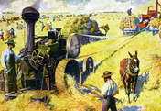
A Revolution in Agriculture The mechanization that took place in industry also helped transform agriculture. No longer did farmers have to harvest their grain with hand tools. In the 1830s, the American inventor Cyrus McCormick developed a horse-drawn mechanical reaper that could cut and collect the grain. In the years that followed, a variety of other machines appeared to help farmers plant, harvest, and process crops. Through mechanization, farmers could expand their production while cutting back on the amount of labor needed to produce food.
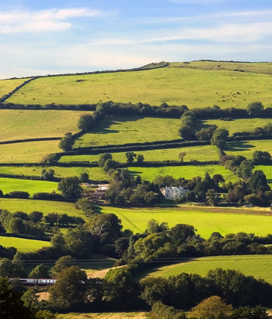
Besides using new machinery, farmers used new agricultural methods. They improved the soil with chemical fertilizers and cover crops. Cover crops, such as clover, add nutrients to the soil when plowed under. Farmers also worked to control pests, increase irrigation, and breed superior livestock. The agricultural revolution helped expand the population by making more healthful food available, and it helped farmers produce enough food to feed the growing population.
The agricultural revolution coincided with a changing perspective on land rights. Traditionally, peasants had raised crops and grazed animals on so-called common lands. But technically, the land was private property. Peasants who farmed the land paid dues to the landowner.
During the 1500s in England and continuing there and elsewhere into the 1800s, landowners took back the rights to their land. Historians call this the enclosure movement. Landowners, often under force of law, enclosed their land with hedges or fences to mark its boundaries.
One reason for enclosure was economic. Large landowners realized that they could earn more from growing cash crops such as grain, or raising sheep for the growing textile industry, than they could from renting the land to peasants. The enclosure movement had several important consequences. Many peasants were left with no land to cultivate. The same was true for many smallholders—farmers owning smaller amounts of land. Because of economic downturns or the expense of fencing in their land, they sold their plots to wealthier landowners. On their estates, many large landowners established commercial farms.
Some peasants and former smallholders stayed on the land as wage laborers. Others turned to manufacturing in their homes and later in independent shops or small factories. But many became landless and unemployed—or, at best, seasonally employed—workers. As countries began to industrialize, these former farmers provided a ready workforce for the early factories as they migrated to urban areas in search of work.
The enclosure movement had moral and legal effects as well. It helped develop the notion that making a profit from one’s land—even if that meant ending traditional land rights of peasants—was acceptable. It also marked the appearance of capitalist agriculture, or the large-scale growing of crops and raising of animals for profit. Through the years, this commercialization of agriculture led to the establishment of a legal system that would support the rise of industrial capitalism.
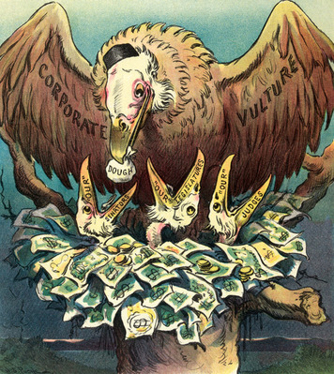
Financing Industry Without capitalism, there might not have been an Industrial Revolution. As the saying goes, it takes money to make money. Wealthy individuals, or capitalists, saw the potential profits to be made by investing in factories and machinery. Their money helped boost industrialization. A broader pool of investor-owners developed with the rise of corporations. A corporation could accumulate great amounts of investment capital. The more money that capitalists had to invest in businesses, the larger the businesses could grow. This allowed for the formation and expansion of the huge enterprises that came to dominate the Industrial Revolution.
The banking system also played a key role in industrialization. Through loans to industrialists and manufacturers, private banks directed customers’ savings into projects such as the building of railroads and factories and the mining of coal. They encouraged the formation of capital in its physical form—the buildings, machines, tools, and equipment used to manufacture goods. Also, governments set up national banks to improve domestic and international trade. Together, private and national banks provided financial backing that stimulated the growth of industry.
Big Business Industry grew, along with the companies that thrived in the competitive, capitalist world. They won a greater share of the profits available from selling in a national market. Their wealth allowed them to buy up smaller competitors, merge with them, or drive them out of business. By the late 1800s, big business dominated industrial economies.
In the United States, several firms and the industrialists who ran them gained enormous wealth and power. In the oil business, John D. Rockefeller established a monopoly with his Standard Oil Company. Andrew Carnegie built his Carnegie Steel Company into the world’s largest corporation. Powerful companies ruled other economies as well. France had its Parisian Gas Company and Great Britain its Midland Railway. In Japan, big business consisted of firms known as zaibatsus. Through investment, they controlled many of Japan’s industries and banks.
Big businesses were able to gather enough capital to meet the needs of a growing consumer market. They built huge factories and filled them with hundreds of workers. They mass-produced goods at lower prices to meet rising consumer demand—and increase their own profits. A growing assortment of shops and stores sold the many new products that appeared. They included the sewing machine, typewriter, telephone, phonograph, light bulb, bicycle, dishwasher, radio, vacuum cleaner, and washing machine.

5. Social and Political Consequences
The Industrial Revolution was, first and foremost, an economic phenomenon. But it can be termed a revolution in part because it also transformed the social and political spheres. Industrialization changed the structure of people’s day-to-day lives. Moreover, industrialization led to the rise of big government.
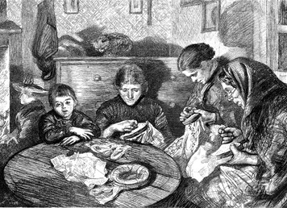
Industrial Labor In the domestic system, the making of cloth was often a family business. Father, mother, and children all had roles in the various processes needed to turn raw fiber into fabric. Families worked together in the familiar environment of their home. Family members could work at their own speed and take breaks when they wanted. They could eat meals together and manage the household together. The spinning or weaving or dying was part of their daily domestic routine. Furthermore, they had a personal, and socially equal, relationship with the merchant who directed their work.
Laboring in a factory was far different. The main goal there was productivity, and employers strived to get the most out of every worker. The key was discipline. Factory laborers had to follow orders and obey the rules or they could be fined. Workers were expected to show up at the workplace six days a week, on time, and to put in a full day—typically 12 hours for much of the 1800s. By 1900, workers were punching time clocks to mark their arrival and departure times to the minute.
In the home workshop, families chatted or sang as they worked. Not so in the factory. Employers insisted that factory employees focus completely on their work. In the late 1800s, employers began hiring efficiency experts. These industrial engineers devised specific instructions for how workers should do each job, down to such details as the best way to move their hands. The goal was always to speed up production. Employer and employee now had an impersonal relationship. Beyond that, employees now occupied a separate—and lower—social group, the working class.
More and more, workers were treated like the machines that they ran. A British writer, John Byles, characterized factory work this way:
Night and day, the indefatigable [untiring] and ponderous piston stamps. Night and day, relays of human flesh struggle to keep up with its remorseless and unwearied march.
—Sir John Barnard Byles, Sophisms of Free-Trade and Popular Political Economy Examined, 1872
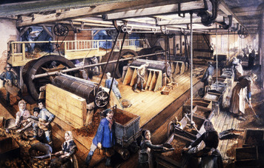
Women and Children In cottage industry, women and children performed vital tasks in the home workshop. At the start of the Industrial Revolution, women and children continued to take part in the manufacture of goods. Factory owners could rely on them to perform the unskilled labor, but they could pay them a lower wage than men.
The New England textile industry, in its early years, hired many women to run the machines that spun and wove cloth. Most female mill workers were young and unmarried. They were known as “factory girls.” When Russia and Japan industrialized later in the century, they needed cheap labor to compete with Western textiles. That meant that women filled many of the jobs in textile factories.
Nevertheless, many women were put out of work during the shift from the domestic system to the factory system. Some managed to find work outside the home, often as household servants or teachers. Some started a laundry service in their own home.
By around 1900, Western societies had generally come to the conclusion that industrial labor was primarily the province of men. Only 20 percent or so of women continued to work in manufacturing. Of these, many labored in sweatshops—small factories, typically in the garment industry, where wages were low and conditions unhealthy.
Children, too, helped in the manufacture of cloth, working in textile factories in Great Britain, the United States, France, Belgium, and elsewhere. They also labored in other industrial sectors, such as coal mining. Like women, they worked for a low wage. Yet the incomes of many families were so low that they depended on the earnings of all of their members—including the children. Toward the end of the 1800s, the education of children gained importance, and governments began regulating child labor. First, children’s working hours were cut back. Later, laws prohibited factories from hiring children.
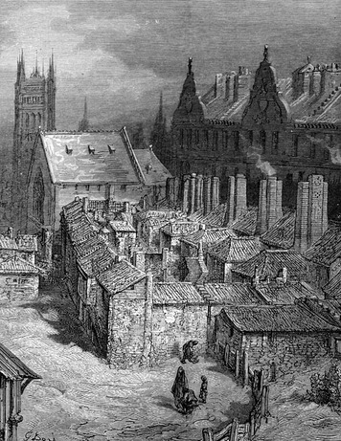
Urbanization Before the Industrial Revolution, manufacturing took place largely in the countryside, in home workshops. Towns served mainly as centers of government and commerce. With industrialization, the town became the main location of manufacturing. Factories attracted a steady stream of workers from the countryside, where the agricultural revolution had reduced the need for farm labor. These migrants settled near the factories, greatly expanding the population of existing towns and cities or creating towns where none had previously existed.
Industrialization also encouraged mass migration from one country to another. Throughout the 1800s, the United States was a major destination for immigrants. Some traveled across the Pacific Ocean from China and Japan. Most, however, came from Europe—even from industrializing countries such as Germany, where too many people competed for too few jobs. The growing United States offered factory work, but it also lured immigrant farmers to its wide-open spaces out West.
The explosion in the number of factories and the flood of migrants to factory towns resulted in rapid urbanization. Within those newly urbanized centers, living conditions were often appalling. Unlike today, government regulation, or legal restriction, of industry was practically nonexistent. Outdoors, smoke belching from factories polluted the air. Chemicals and other industrial wastes fouled rivers, lakes, and coastal waters. So did raw sewage from rapidly expanding towns and cities.
Indoors, living conditions in urban areas were just as bad. Filthy, overcrowded apartment houses encouraged the spread of communicable diseases such as cholera, smallpox, and typhoid fever. Yet few government programs for dealing with public-health issues existed until the second half of the 1800s. Urban death rates soared.
Labor Unions For many industrial laborers, conditions at work were no less harsh than those they experienced at home. They often spent their 12-hour work day in a dark, damp, dirty factory amid the deafening whine and clank of machinery. Factories were dangerous too, with few of the safety precautions that we take for granted today. Pay was another issue. To make a living, merchants have goods to sell. Farmers have crops. Workers, however, have only their labor. Yet employers sought to keep wages as low as possible.
The quest for profits drove the industrialists who ran the factories. They could increase profits by keeping expenses low. Thus it made sense—from a purely economic viewpoint—for them to pay as little as possible in wages and spend as little as possible in improving working conditions. For most of the 1800s, government did not fight for workers’ rights. For this, workers had to turn to labor unions.
A labor union, also known as a trade union, is an organization formed by workers to negotiate with employers to resolve work-related issues. During the era of industrialization, those issues usually involved wages, hours, and working conditions. By the late 1800s, strong unions in Europe and the United States had begun to make economic gains for workers, often through strikes or the threat of strikes. A strike is an agreement among workers to stop working until the employer meets their demands. Strikes could turn violent, with workers battling police or private guards hired by companies to try to break the strike to force employees back to work.
By 1900, through strikes as well as through changes in the law, most workers in the West worked fewer hours. Although hours still varied from one industry to another, the 10-hour workday and 6-day workweek became the standard. Still, many issues remained, and workers continued to rely on labor unions to resolve them well into the 1900s.
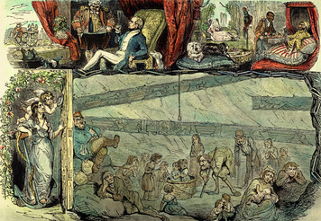
From Laissez-Faire to Regulation Through the first century or more of the Industrial Revolution, industries grew without government intervention. Western governments largely heeded the economic laws set down by Adam Smith in his book The Wealth of Nations, published in 1776. Smith famously wrote, “It is not from the benevolence of the butcher, the brewer, or the baker, that we expect our dinner, but from their regard to their own interest.” In other words, because producers seek profit, they create food and other goods. Government, Smith maintained, should not interfere in this process.
Smith’s economic laws lay at the heart of a doctrine known as laissez-faire (les-ay FAIR), a French term that loosely translates as “leave it alone.” Western industrialists did not want the government interfering with the economy. Their economic strength gave them political power. As a result, the government largely left them and the economy alone. Government’s laissez-faire policies were rooted in a key element of liberalism—the right to private property.
In the late 1800s, however, the rise of big business led government, especially in the United States, to rethink its position on laissez-faire. Corporations were joining together in various combinations—pools, mergers, trusts, cartels—to gain control of markets. These activities hurt consumers because by gaining control of markets, corporations could set prices artificially high and keep competitors from entering the market. The U.S. Congress gradually took steps to restore fairness and competition through laws and regulations. In time, big government would curb the excesses of big business.
A Worldwide Trend Until the 1900s, industrialization was limited to a handful of Western countries, as well as Russia and Japan. But the desire for profits and the general wish to improve living standards led to a widespread push for industry. Also, as more and more peoples throughout the world have demanded a voice in government, liberal democracy has spread across the globe. Capitalism, with its doctrine of private property, has been closely tied to democratic government.
Another phenomenon owed its success, at least partly, to the Industrial Revolution. Nations that industrialized often used their newfound wealth to strengthen their military. In the late 1800s, some of those nations exercised their power by establishing colonies in foreign lands. On that basis, they formed or expanded empires. Their imperialism is the subject of the next chapter.

Summary
In this lesson, you read about the Industrial Revolution, which began in Great Britain and spread to countries throughout the world. Industrialization fundamentally transformed the way people worked and lived.
Economic Structures The Industrial Revolution transformed economies by mechanizing manufacturing and agriculture and shifting from the domestic system of producing goods to the factory system. The need for a means of financing industrialization led to the rise of industrial capitalism.
Social Structures In cottage industry family members worked together to produce goods at their own pace. Factory work called for much more discipline. It also distanced employers from employees, whose unskilled labor and low wages marked them as members of the working class. In the West, women and children were steadily pushed out of factory work.
Human-Environment Interaction New technology, such as the steam engine, made the factory system practical. Factory work attracted migrants from rural areas and from other countries. As a result, the urban population increased greatly, as did air and water pollution and deadly diseases, which spread quickly through overcrowded apartment houses.

