Unit 17-Imperialism Throughout the World

1. Introduction
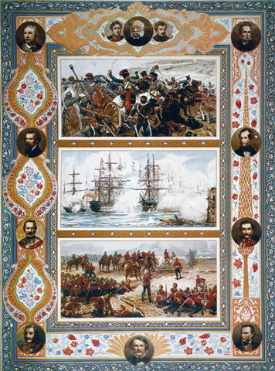
In September 1898, a British-led army steadily approached Omdurman, a city in the Sudan just west of the Nile River. The British planned to capture the city and thus take command of the entire Nile Valley before their rivals, the French, could do so. Britain had gained control of Egypt in 1882. This expedition would extend Britain’s rule more deeply into the African continent.
An army of Mahdists opposed the mixed British and Egyptian force. The Mahdists, Sudanese followers of the Muslim religious leader al-Mahdi, greatly outnumbered their opponents. Yet they had nowhere near their technical skill or firepower. The campaign to conquer the Sudan showcased British industrial might. British engineers had built a 383-mile-long railway across the desert to transport troops and supplies. Their steam-powered gunboats controlled the Nile River. Their modern rifles and machine-guns could fire a barrage of bullets a distance of 1,500 yards or more.
Many Mahdists carried rifles, but they were older, less effective models. Most fought with spears or swords. During the battle, British artillery shells and bullets mercilessly cut down the Mahdist warriors as they charged across the sandy plain. Thousands of them died. Winston Churchill, a British soldier at Omdurman, later wrote that the slaughter was “a matter of machinery.” He called his fellow troops “soldiers of scientific war.”
Industrialization, with its advances in military science and technology, was a key factor in the British victory at the Battle of Omdurman. By 1914, Britain and a handful of other industrialized European nations would control most of Earth’s surface—both land and sea. Along with Japan and the United States, they comprised the world’s main imperialist powers.

Themes
Cultural Interaction Western imperialist powers introduced new technologies, political ideals, and religious beliefs into Asia and Africa.
Economic Structures The age of industry helped trigger the new imperialism, through which Western powers sought new sources of raw materials and new markets for their exports.
Social Structures Conquests led Europeans to see themselves as superior to conquered Asian and African peoples.

2. The New Imperialism
Starting around 1500, European states practiced imperialism by establishing coastal outposts and colonies in Africa, the Americas, and Asia. Their purpose was to support overseas trade. Independence revolutions and the ending of the slave trade severely eroded the imperial system. By the early 1800s, the extent of Western empires had decreased considerably. However, later in the century, a new form of imperialism appeared. A different set of imperialist powers once again sought to expand by exerting control over lands, resources, and peoples beyond their borders.
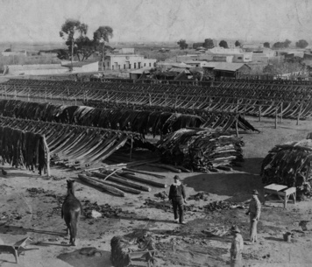
Click to read caption
Renewed Expansion The new imperialism varied from the old style. Typically, under the old imperialism, a European merchant ship would sail to a colonial port, where it picked up a load of slaves or spices or other goods. Often, with demand being low for Europeans’ products, they paid in silver—a “cash-and-carry” arrangement. By around 1800, this mercantile economic system had faded away. Later, a new system evolved. Europeans still took control of foreign lands. But the resulting colonies served not only as sources of raw materials and food but also as markets for machine-made products.
What gave rise to this new imperialism? The answer is not clear-cut. Trade still played a part. But it was no longer the key driving force. The European expansion of the last quarter of the 1800s appears to have come about in a haphazard, unplanned manner. Historians cite a complex mix of possible economic, political, and social factors to explain the rise of new imperialism.
Industrialization One factor that nearly all historians agree on is industrialization. As French statesman Jules Ferry wrote in 1890, “Colonial policy is the daughter of industrial policy.” Nations that mechanized their manufacturing sector became more productive. As a result they needed an increasing supply of natural resources—such as cotton, wool, timber, ore, dyes, and petroleum—to feed their growing industries. And those industries needed larger markets for their manufactured goods. By dominating lands overseas, a country could help fulfill both needs.
Industrialization also increased nations’ wealth and power. That gave them a huge advantage in warfare against less developed countries, as the Battle of Omdurman showed. Advances in military technology included rifles that shot farther and more accurately and steam-powered warships that served as platforms for artillery. Some scholars argue that such military advantages led naturally to imperialism. Industrialized European states, they say, expanded because they could.
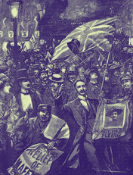
Political and Socio-Economic Motives Western powers also had political reasons for engaging in imperialism. In the 1800s, competition among those powers was as fierce as ever. Control of key locations or resources could give a country a strategic edge over rival states.
Imperialism also gave political leaders an edge at home by helping them unify public opinion. Social and economic issues—poverty, labor strikes, business downturns—multiplied as countries industrialized. That led to political fragmentation as various interest groups arose to push for reforms. The ability to dominate other lands enhanced a country’s status and prestige, giving its citizens a sense of national superiority that encouraged unity. Thus the popularity of an imperialist foreign policy helped politicians overcome political differences and gain support for their domestic policies.
“White Man’s Burden” Feelings of superiority also had a cultural aspect. Europeans saw themselves as a culturally advanced people with a mission, or duty, to civilize more “backward” peoples. This led Christian missionaries to travel to foreign lands to bring their religion and culture to those they considered less fortunate. British poet Rudyard Kipling called this the “White Man’s burden”:
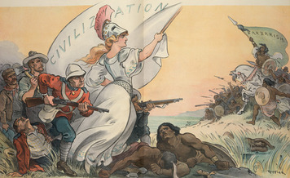
Take up the White Man’s burden—
Send forth the best ye breed—
Go, bind your sons to exile
To serve your captives’ need;
To wait, in heavy harness,
On fluttered folk and wild—
Your new-caught, sullen peoples
Half devil and half child.
—Rudyard Kipling, “White Man’s Burden,” 1899
In the late 1800s, Western peoples knew that they had far outstripped others in creating new technology. That led them to believe that they were not only culturally but also biologically superior to the races of peoples in Africa and Asia that they dominated. This racist viewpoint helped them justify their imperialism and the way they treated people in their colonies.

3. Colonies and Spheres of Influence in Asia
In Asia in the late 1800s, European states held colonies in a number of prime locations. Where colonies were not practical, they established spheres of influence. A sphere of influence is an area within which the political and economic interests of one nation are favored over other nations. Britain, with its large and powerful navy, led the domination of the continent. Its imperialist ventures centered on South Asia.
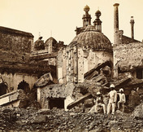
South Asia The story of imperialism in South Asia is the story of the British in India. Until 1858, the British East India Company had administered colonial India. The Company’s control ended after the Great Rebellion, sometimes called the Indian Mutiny.
The Great Rebellion broke out in 1857 among soldiers of the British-led Indian army. British distribution of cartridges greased with animal fat triggered the rebellion. Before loading a cartridge into their gun, soldiers had to bite off the end of it. Indian soldiers found this extremely offensive culturally. Their Hindu and Muslim religions both forbade oral contact with animal fat. However, the Great Rebellion actually reflected pent-up hostility toward the British, who had, over the years, not only challenged Indians’ religious beliefs but also dominated their political and economic lives.
The British squelched the rebellion, but it caused them to alter their Indian foreign policy. The colony came under the direct control of Parliament, a period known as the British Raj. British rule grew more authoritarian. A former British official in India, Sir James Stephen, offered a reason for taking a harsh approach to governing. “It will never,” he wrote in 1883, “be safe for the British Government to forget for a moment that it is founded not on consent but on conquest.”
The Great Rebellion shocked the British. They had misjudged the extent of Indian resentment. Afterward, the British cut back on efforts to turn members of India’s upper classes into Europeans. They did train Indians for government jobs in the Indian Civil Service. But they were kept from rising to policy-making positions, which were held by the 1,000 or so British members of the Civil Service. Britain continued to manage much of the Indian economy, introducing some industrial technology into a society based on farming. India’s population rose, but so did the incidence of famine.
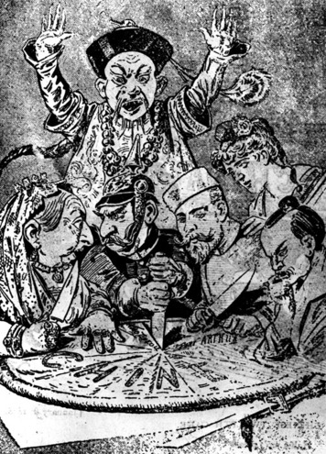
Central and Southwest Asia British defense of its Indian colony included attempts to check the expansion of Russia. Since the 1500s, Russia had steadily advanced southward from its original homeland surrounding Moscow. By 1885, Russia extended its control of Central Asia to the northern borders of Persia (Iran) and Afghanistan, India’s neighbors to the west. Its influence on those countries deepened.
Britain deemed Russia’s advances a threat to the future of India. During this period, it invaded both Persia and Afghanistan to keep Russia from dominating. In 1907, Britain and Russia ended up splitting Persia into commercial spheres of interest. Afghanistan became a buffer between Russia and India.
East Asia Europe’s imperialist powers competed intensely in East Asia. For them, the biggest prize was China. China had begun industrializing in the 1860s, using the West as a model. It failed, however, to develop a strong manufacturing base. With the world’s largest population, China offered the Europeans an enormous market for their products.
China’s weak military could not resist European advances. Britain, France, Germany, and Russia all demanded and received concessions from the weak Chinese government. They carved out spheres of influence over key ports and large chunks of Chinese territory. Britain held sway over the fertile Yangtze River valley. France gained hegemony over a large region in the south. Germany forced China to yield control of a smaller region on the northern coast. Russia’s sphere of influence lay to the north of the Korean peninsula.
In the 1890s, Japan joined in the China land grab. Like China, Japan had once been one of the West’s commercial targets. But the country had grown much stronger since 1868. At that time the Meiji Restoration had restored Japan’s emperor to power. It had also started a period of modernization based on Western ways. A popular slogan, “A rich country, strong army,” reflected the country’s newfound imperialist ambitions.
Japan, a small, mountainous island nation, envied China’s expansive farmlands. It also saw China as a possible source of coal and iron ore, which Japan needed in order to compete in an industrializing world. China had plentiful reserves of those minerals. So did China’s neighbor Korea, a country that China had traditionally ruled.
In 1894, Japan went to war with China over control of Korea. Despite being seen as the underdog, Japan won the nine-month-long Sino-Japanese War. (Sino stands for “Chinese.”) As a result, China had to recognize Korea’s independence. It also had to pay Japan’s war costs and give Japan the island of Formosa (present-day Taiwan) and the Liaodong Peninsula in Manchuria.
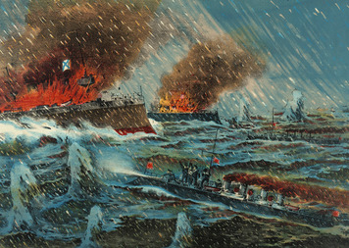
Japan’s status in the region was growing, which alarmed some Western powers. Russia, Germany, and France soon forced Japan to give up its newly won control of the Liaodong Peninsula. Russia took over that territory. The Japanese resented this maneuver. A few years later, they took their revenge.
In 1904, a strengthened Japan declared war on Russia, whose troop buildup in Manchuria appeared to threaten Japan’s sphere of influence in nearby Korea. Japanese troops landed in Korea and pushed through into Manchuria. The land war dragged on for more than a year. At sea, however, the Japanese proved dominant. In May 1905, the Russian fleet completely crumpled in the face of a Japanese assault. Russia was forced to seek peace.
Japan’s victory in the Russo-Japanese War marked the first modern case of an Asian nation’s defeating a European nation. It gave the Japanese control of Korea and hegemony over Manchuria, and it whetted their appetite for further expansion. Japan had joined the small circle of imperialist powers.
Southeast Asia and the South Pacific By the late 1800s, China had lost much of its traditional influence over Southeast Asia. This allowed Britain and France to divide much of the region between them. The British moved from India east into Burma, which they annexed in 1886. They already held Singapore and parts of Malaya.
Meanwhile, French Catholic missionaries had long been active in what is today Vietnam, Laos, and Cambodia. So had French traders, who sought access through this area to markets in southern China. The French government also targeted this region. Its aim was to establish a strategic outpost on the China Sea. By the mid-1890s, France had achieved their goal through conquest, sending tens of thousands of troops to secure what became known as French Indochina.
The conquest of Indochina brought France a significant amount of prestige and a limited amount of trade. The inhabitants, for the most part, governed themselves. A French governor-general, however, oversaw the colony. A small number of French troops remained to look after the interests of France. Few French citizens, however, called Indochina their home.
The many islands in the South Pacific also attracted the attention of Western powers. Germany, Britain, and the United States vied with one another for ports to serve as coaling stations for merchant steamships and as strategic naval outposts. The United States had joined the ranks of imperialists through conflict. Their victory in the Spanish-American War in 1898 brought them the Philippines and Guam in the Pacific as well as Puerto Rico and Cuba in the Caribbean Sea.

4. The Partition of Africa
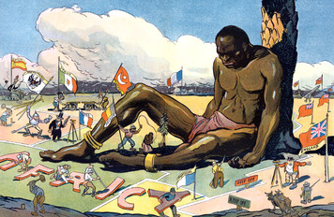
During the era of the new imperialism, nearly all of Africa came under European control. The colonizers partitioned the continent, dividing it into distinct parts. They turned tribal regions with fluid boundaries into states with fixed borders. Many of these states received clearly European names, such as British East Africa, French Equatorial Africa, German Southwest Africa, Italian Somaliland, Spanish Sahara, and Belgian Congo. All faced a future of European political, economic, and social domination.
Early Inroads into the Continent Starting around 1500, European states established outposts along the African coast. Those stations had two main functions. They provided links with the interior for trading in slaves and gold. They also served as stopover points for ships sailing to Asia. True colonies—those with a substantial number of settlers from the home country—were rare in Africa. The Dutch, followed by the British, established one such colony in South Africa.
To geographers at the time, South Africa included several present-day southern African countries, including what is now the Republic of South Africa. In the 1650s, Dutch farmers established the first settlement there, on the Cape of Good Hope. They admitted immigrants, including Germans and Huguenots. Huguenots were French Protestants, who faced persecution in France. They also brought in slaves from India and other parts of Africa to perform manual labor. The settlement was called the Cape Colony. It would have the largest number of white settlers on the continent.
In 1814, Britain took control of the Cape Colony. In the years that followed, several thousand British settlers arrived. By then a number of its earlier settlers, known as Boers or Afrikaners, had migrated away from the coast in search of land to farm. Their quest for land and slave labor brought the Boers into continual conflict with indigenous, or native, African peoples.
The Boers also clashed with their new British overlords, who tried to restrain their expansion. Then, in 1834, the British abolished slavery. As a result, from 1835 to 1837, many Boers left the colony altogether in what historians call the Great Trek. Those Boers eventually established three republics—Natal, the Transvaal, and the Orange Free State. The British annexed Natal but recognized the other Boer republics’ independence. However, ongoing tensions between the British and the Boers later led to two wars, in 1881 and 1899. The treaty ending the second Boer War also brought an end to the Boer republics.
Unlike most of the rest of the continent, South Africa was blessed with enormous mineral wealth. In the 1860s, settlers discovered diamonds. The diamond fields attracted thousands of prospectors, including immigrants from Europe and the United States. Railway construction, trade, and employment all boomed.
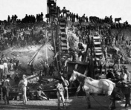
Then, in 1886, South Africans struck gold. This set off an industrial explosion. Much of the gold was located deep underground. Large enterprises formed to acquire land, using capital raised in New York and London. Commercial mining companies went to work, using steam-powered machinery to do the digging. They bought South African coal to fuel their machines and to run the steam locomotives that serviced the goldfields. They hired tens of thousands of workers. South Africa’s economy surged.
While Britain established a thriving, if troubled, colony in South Africa, France was also making inroads into the continent. By 1850, the French colony of Algeria, in North Africa, had attracted several thousand settlers from France. They came as traders, government officials, and farmers. Native Algerians violently resisted French expansion. To protect its colonists, France had to maintain a large army in Algeria.
By 1880, Britain and France had invested a lot of time and money in Africa. In the next 30 years, other European powers would do the same. Their rush to establish colonies became known as the scramble for Africa.
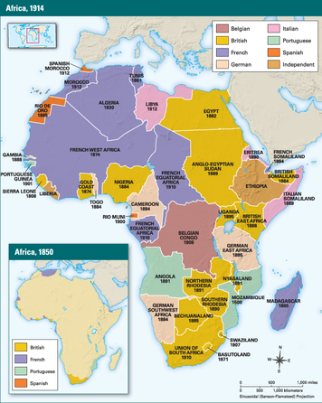
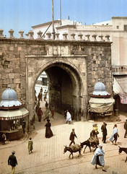
The Scramble for Africa Instability in Egypt helped trigger the scramble for Africa. Egypt fell deeply into debt in the 1870s, in part because of the expense of building the Suez Canal. The canal, which ran through Egypt, was completed in 1869. It linked the Mediterranean and Red seas. For the British, the canal brought their most valuable colony, India, much closer. Compared with a voyage around Africa, sailing by way of the Suez Canal chopped some 4,500 miles off the trip.
France and Britain worked to keep Egypt stable. Both countries had invested heavily in the country. But they also recognized the Suez Canal’s strategic importance as the gateway to India and East Asia. By 1880, they had taken financial control of the country. Their intervention in Egypt set off protests by Egyptian nationalists who, in 1882, led an uprising. In part to protect their access to the canal, the British put down the rebellion and occupied Egypt.
France decided not to join Britain in the assault on Egypt. But it undertook its own expansion, from Algeria east into Tunisia. Then, in 1884, Germany laid claim to the western coastal region of South Africa and three other substantial areas. Belgium quickly followed by claiming the Congo Basin, a huge region in Central Africa drained by the Congo River. In the years that followed, Spain, Portugal, and Italy all asserted their rights to various territories.
The scramble for Africa had started, and with it came multiple disputes. Europeans met at the Berlin West Africa Conference of 1884–1885 to try to iron out their differences. The stated goal of the conference was to open the interior of Africa to free trade and, in the process, bring civilization to the native peoples. The “interior” referred mainly to the vast Congo River basin, a million square miles of Central Africa. The formal conference achieved written agreement on this goal. In informal negotiations, members of the conference resolved other disputes. Then and later, diplomats signed treaties and had maps of Africa drawn to show who “owned” which slice of the vast continent.
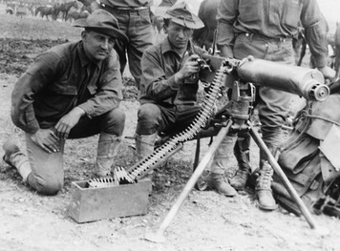
Resistance to Imperialism Claiming a territory on paper was easy. Actually taking physical control of that territory was not so simple. Sometimes, African elites cooperated with European occupiers. But nearly everywhere, native peoples resisted imperialist expansion. Much of that resistance was violent—and largely unsuccessful. As the Sudanese found out at the Battle of Omdurman, sheer courage could not effectively combat modern weaponry.
Throughout Africa this point was proven over and over again. Europeans used superior firearms to put down popular resistance. Uprisings by the Ashanti people in Gold Coast, the Ndebele in Rhodesia, and the Zulu in Natal all ended fairly quickly. Some rebellions, though unsuccessful, lasted much longer. In West Africa, a Mande tribe led by Samory Touré fought against French occupation from 1883 to 1898. In East Africa, the Tutsi and Hutu resisted the Germans and British from 1911 to 1917.
One major African resistance campaign did meet with success. It involved Ethiopia and Italy. Menelik, Ethiopia’s emperor, had modernized his country, which included acquiring up-to-date weapons for his sizeable military. When Italy sent 18,000 soldiers to take control of Ethiopia, Menelik declared war. On March 1, 1896, at the Battle of Adowa, the emperor sent out a force of some 100,000 troops, most of them well-armed. They quickly overwhelmed the Italian army, which suffered heavy losses. Italy gave up its goal of conquest and, instead, accepted Ethiopia as a sovereign and independent nation.

5. Western Influence in Latin America
Western powers dominated countries and territories by occupying them and ruling them directly. Scholars refer to this as formal imperialism. In contrast, informal imperialism is marked by indirect rule. The dominant country exerts pressure or influence without physical conquest. Informal imperialism is often economic in nature, but it can also include force or the threat of force, and cultural imperialism, or influence. The informal version of imperialism, often called hegemony, was the type most often wielded by Western powers in Latin America.
Independent Politically but Not Economically By 1830, nearly all of Latin America had gained its political independence. Yet many issues remained unresolved. They ranged from the clash of liberal and conservative ideals to power struggles waged by military strongmen.
In that volatile atmosphere, even resource-rich nations in Latin America failed to industrialize. They remained largely dependent on Britain, France, and other Western countries for manufactured goods. Political turmoil and economic dependence opened these Latin American states to imperialism, both formal and informal.
Western Economic Control Through most of the 1800s, Britain remained the most highly industrialized nation on Earth. As such, it needed easy access to raw materials as well as markets for its goods. In its own economic interest, therefore, it favored the removal of all barriers to trade. As applied to Latin America, scholars call this “free-trade imperialism.” It involved both trade and capital.
Britain viewed the Latin American revolutions as a way to strengthen its commercial ties with the region. The economies of the new Latin American countries produced mainly raw materials. They depended on industrializing nations, especially Britain, to buy those goods. Argentina, for example, based its economy on the export of meat, hides, and grain into the early 1900s.
British capital added to the control that Britain exercised over Latin America. British investors saw potential profit in expanding the ability of countries such as Brazil, Argentina, and Uruguay to export their raw materials and foodstuffs. British business people migrated to Latin America to oversee these investments, which included the raising of sheep and cattle and the building of facilities to transport goods. British banks financed the capital expansions through loans. Managing those loans gave the banks further influence over Latin American economies.
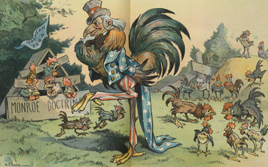
As they industrialized, France and the United States duplicated Britain’s approach to Latin America. French and American businesses and banks invested in Latin America and provided loans for capital expansion. The United States, however, also got politically involved in the region.
United States Foreign Policy During the 1800s, the United States came to view Latin America as its personal sphere of influence. In 1823 President James Monroe put forward the Monroe Doctrine, which banned the nations of Europe from further colonizing Latin America.
In 1904, President Theodore Roosevelt extended the Monroe Doctrine in an address to Congress that became known as the Roosevelt Corollary.
Roosevelt noted that the Monroe Doctrine was designed to prevent European meddling in the Americas. Yet he pointed out that nearly a century later many countries in Latin America were still too weak to defend themselves. Roosevelt stated that the United States therefore must use “international police power” to preserve peace and order in the hemisphere and protect American interests. The Roosevelt Corollary implied two things. Europe had no reason to interfere in Latin America, and the United States was now powerful enough to police the entire region.
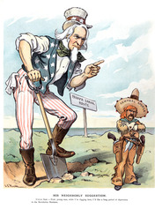
Western Aggression Much of Western imperialism in Latin America was informal, but not all. In spite of the Monroe Doctrine, Britain and France continued to practice imperialism in the region. Britain established or formalized its control of British Guiana in 1831, the Falkland Islands in 1833, British Honduras in 1859, and Jamaica in 1866.
France tried to conquer Mexico in 1862. Mexico’s failure to pay its debts to European banks had led Britain and France to send a naval force there in 1861 as a threat. France ended up occupying the country and installing its own emperor. Mexican resistance and pressure from the United States forced France out in 1867.
In 1898, the United States itself engaged in formal imperialism. After winning the Spanish-American War, it occupied Cuba and seized Puerto Rico. Later, under the pretext of ensuring stability, the United States intervened militarily in Nicaragua, Haiti, and the Dominican Republic. It also helped Panama break away from Colombia in order for the United States to acquire the right to build the Panama Canal.

6. Impact of Imperialism
By 1900, powerful Western states controlled half the continent of Asia. They ruled some nine tenths of Africa. Their influence extended over a quarter of the Americas. The actions of these imperialist powers had a complex mix of positive and negative effects on colonized peoples.
Imperialism killed people, especially in Africa. European armies used force—often brutal—to secure and hold on to territory. One example is the rebellion by the Herero and Nama people in German South West Africa. In 1904, the rebels killed about a hundred traders and farmers. The German response was to try to exterminate the two African groups. Only a quarter of the original population of 100,000 Herero and Nama survived the slaughter that followed.
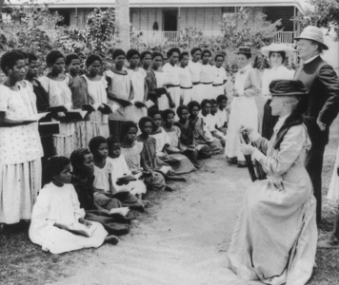
At the same time, imperialism had some humanitarian consequences Through the 1800s, European societies developed a sense that slavery was morally wrong. It went against their ideals of liberty and equality. By 1888, all Western nations had abolished slavery. They used their wealth and superior military power to try to root out this evil not just in their colonies, but everywhere. As a result, slavery declined markedly in Africa, the Philippines, Indonesia, and elsewhere.
Many other aspects of Western society found their way into distant colonies, in a process known as Westernization. The imperialists imposed their own legal systems, taxes, and political administration. They introduced Western education, medicine, technology, languages, and dress. They worked to convert native peoples to Christianity.
Colonizers also improved their colonies’ infrastructure. This supported their key economic goal—expansion of a colony’s exports. Europeans built railroads to transport goods from plantations and mines to the nearest port. There they constructed warehouses to hold the goods and harbor facilities to serve the cargo ships that carried the goods. However, they stopped short of encouraging their colonies to industrialize. In general, colonized lands continued to serve solely as sources of raw materials and a few consumer goods well into the twentieth century.

Summary
In this lesson, you read about the second era of European imperialism, during the 19th and early 20th centuries. In this period, a few European nations with great military and industrial power took control of much of the world.
Cultural Interaction Western imperialist powers used their advanced military technologies, such as the machine-gun and the steam-powered gunboat, to conquer new territories. They introduced their culture—including education, language, political ideals such as equality and liberty, and the Christian religion—into Asia and Africa.
Economic Structures Industrialization helped trigger the new imperialism, through which capitalistic Western powers sought raw materials for their factories and markets for their machine-made goods. The colonized lands themselves failed to industrialize during the imperialist period.
Social Structures Racist attitudes supported Europeans’ notion that they were culturally and even biologically superior to the Asian and African peoples that they dominated.
At the same time, imperialism had some humanitarian consequences Through the 1800s, European societies developed a sense that slavery was morally wrong. It went against their ideals of liberty and equality. By 1888, all Western nations had abolished slavery. They used their wealth and superior military power to try to root out this evil not just in their colonies, but everywhere. As a result, slavery declined markedly in Africa, the Philippines, Indonesia, and elsewhere.
Many other aspects of Western society found their way into distant colonies, in a process known as Westernization. The imperialists imposed their own legal systems, taxes, and political administration. They introduced Western education, medicine, technology, languages, and dress. They worked to convert native peoples to Christianity.
Colonizers also improved their colonies’ infrastructure. This supported their key economic goal—expansion of a colony’s exports. Europeans built railroads to transport goods from plantations and mines to the nearest port. There they constructed warehouses to hold the goods and harbor facilities to serve the cargo ships that carried the goods. However, they stopped short of encouraging their colonies to industrialize. In general, colonized lands continued to serve solely as sources of raw materials and a few consumer goods well into the twentieth century.

