Unit 20- The Russian Revolution

1. Introduction
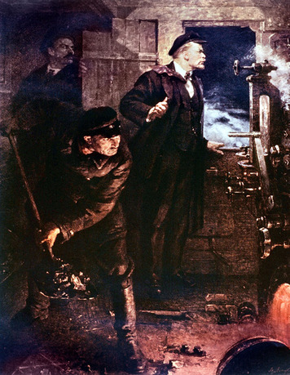
Czar Nicholas II was at the front in February 1917, rallying his troops in World War I, when word arrived of a strike in Petrograd. (Russia’s capital city, St. Petersburg, was renamed Petrograd in 1914.) The czar’s aides in Petrograd assured him that the incident was minor and would end when the bitterly cold weather sent the protestors home. Instead, the strike spread, filling the streets with thousands of angry men and women. The Duma, Russia’s legislature, wrote to the czar that the situation was serious.
Czar Nicholas turned to the army to restore order. When it could not, he decided to return to the capital to deal with the crisis. However, the Duma knew what had to be done. Duma members met the czar’s train as it neared the city. They told Nicholas that the only way to restore order was for him to step down as czar. He tried to abdicate, or formally give up power, in favor of his brother, Mikhail. When Mikhail refused to take the throne, Russia’s monarchy came to an end.
Within days, news of these events reached exiled Russian revolutionary Vladimir Ilich Lenin in Switzerland. He quickly contacted German officials for permission to travel through Germany on his return to Russia. Germany and Russia were wartime enemies, but the Germans were eager to grant Lenin’s request. He openly opposed the war and would end Russia’s involvement in it if he came to power there. The Germans offered him safe train passage and money to support his revolutionary activities.
Traveling in secret at night, Lenin arrived in Russia in early April. There he would take control of a revolution that changed not only Russia, but also the world.

Themes
Political Systems Russia’s monarchy was ended by revolution in 1917 and was replaced by a communist government.
Economic Systems As a result of the Russian Revolution, socialism replaced capitalism in the former Russian Empire.
Social Structures The Russian Revolution radically changed the structure of Russian society.

2. Russia Under the Czars
The overthrow of Nicholas II in 1917 ended more than 300 years of czarist rule in Russia. Russian czars were autocrats—that is, they held unlimited power to rule. While most European nations, over time, had gradually limited the power of their monarchs, Russia’s czars continued to govern without being controlled by a constitution until the early twentieth century.
Russia also lagged behind the rest of Europe in social and economic development. The Industrial Revolution came late to Russia. By 1900 Russia’s economy was still based mainly on agriculture. About 20 percent of the nation’s farmland consisted of large estates owned by wealthy nobles. Some 80 percent of Russians were rural peasants who farmed small tracts of land and lived in grinding poverty. Peasants who moved to cities to work in Russia’s developing industries often scrimped and saved to send money back home.
However, industrialization and city growth did provide opportunities for entrepreneurs, managers, and engineers. Along with other educated professionals, these Russians created a new social class—Russia’s first middle class. Like the nation’s wealthy nobles, these middle-class Russians chafed at their lack of power in government. Combined with the discontent of millions of impoverished peasants and urban workers, this situation made Russia ripe for revolution.
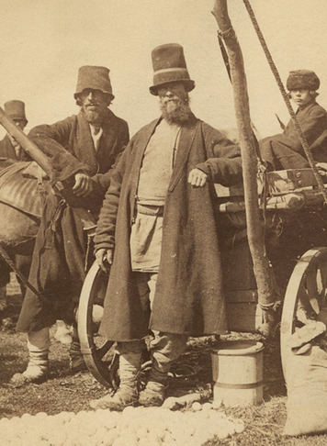
The Beginnings of Unrest The unrest that would end in the Russian Revolution of 1917 began in the mid-1800s. At that time, most Russian peasants were still serfs—peasants tied to the nobles’ land in a feudal system that the rest of Europe had abandoned long ago. Czar Alexander II, who came to the throne in 1855, saw danger in continuing this system. “It is better to abolish serfdom from above,” he told Moscow’s nobles in 1856, “than to wait until the serfs begin to liberate themselves from below.”
The Crimean War finally convinced Czar Alexander II to liberate the serfs. In this war, Russia was defeated by the forces of Great Britain, France, and the Ottoman Turks. This defeat revealed how advanced the western European nations were in comparison to Russia. It also proved to the czar that Russia must reform itself to stay competitive with the more advanced Western nations. One significant reform was to liberate the serfs.
Many peasants were disappointed by emancipation. They expected that freedom would include being granted the land that they and their ancestors had farmed for centuries. Instead, those who received land had to pay for it. Emancipation also caused discontent among the nobles. Although they were paid for land that went to the peasants, they lost its use for future income. Some nobles went bankrupt as a result. Others sold all their land and moved to cities where they built factories and started other businesses.
The nobles were also upset by their lack of political power. They pressured Alexander II for a national assembly to represent the wealthy and educated members of Russian society. The czar rejected this reform. Instead, he created a system of regional assemblies empowered to deal only with local issues, such as road construction and education. All classes, including the peasants, had a voice in these assemblies and in electing their members, though in practice they were controlled by the nobility.
Revolutionary Movements Alexander II launched other reforms as well. He made changes in the education system that gave more people an opportunity to attend school. Alexander also relaxed laws that made speaking against the government a crime. These two reforms encouraged public discussion of political and social issues. Much of this discussion was highly critical of the government. It inspired revolutionary groups to form that sought to overthrow the government. These organizations drew their membership from the “intelligentsia”—the term Russians used to describe well-educated citizens who had a strong interest in politics and society. Most members of the intelligentsia were not revolutionaries, but it was from this group that the revolutionaries came. The most radical of them called for socialism and an end to czarist rule.
At first, the revolutionaries viewed the peasantry as the best source for creating change. Most peasants lived in villages organized into communes, in which all members owned the land jointly. From time to time, this land was redistributed according to each family’s need. In 1873 and 1874, radical university students went into the countryside to rouse the peasants to revolt. However, most peasants did not understand the students’ message or were not interested in it. Others resented educated young people from the cities telling them what to do. Police arrested hundreds of these students. They were imprisoned or sent to live in remote parts of the empire.
The students’ failure caused great changes in the revolutionary movement. First, it split the movement into three groups. One group continued to rely on peasants as the source of revolutionary action. A second group began to focus on urban factory workers instead. The third group completely gave up on the people and turned to terrorism to spark change. Finally, the government crackdown which started with the students eventually drove all the groups underground.
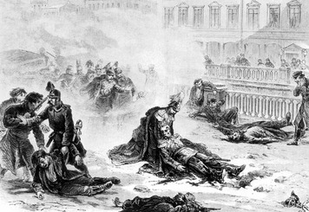
The Last Czars The terrorist group achieved its main goal in 1881 with the assassination of Alexander II. But instead of weakening the government, the czar’s death had the opposite effect. His successor, Alexander III, greatly reduced educational opportunities, weakened the regional assemblies, and tried to bring the peasants’ communes under closer control. He also stepped up censorship and the surveillance of revolutionary groups. These and other repressive measures kept the revolutionaries in check for the next 20 years.
Discontent increased again after Alexander III died in 1894 and was succeeded by his son, Nicholas II. Nicholas inspired neither the fear nor the respect that his father had commanded. He had few political ideas beyond protecting his power as czar. He angered moderate reformers by calling their goals “senseless dreams.” Meanwhile, rapid changes in Russia were creating conditions for the growth of more radical movements and reforms.

3. Moving Toward Revolution
Nicholas II ruled a Russia that was vastly different from the society Czar Alexander II had inherited less than 40 years earlier. Russia’s population doubled between 1850 and 1900—the fastest growth rate of all the Great Powers of Europe. The pace of urban and industrial growth was also fast. Russia had some 1.4 million factory workers in 1890 and 3.1 million in 1913. If all non-agricultural workers are counted, Russia’s working class totaled 15 million by 1913—four times its size in 1860.
Most industrial workers had once been peasants. Despite their migration to cities, most workers stayed in touch with their villages in the countryside. Life for these recent migrants was both different and difficult. However, like their rural brethren, most lived in grinding poverty. Both women and men worked 12 to 14 hours a day for low pay, often in harsh, unsafe, or unhealthy conditions. Housing was equally bad. Families often shared unclean and overcrowded rented rooms with other families or single workers.
If Russia’s peasants were discontented, its industrial workers were even more so. Industrial workers had no avenues to seek change, and the government blocked their efforts to create them. Many workers came to believe that a change of government was required before their conditions could improve. In addition, most industries were concentrated in a small number of places—especially in St. Petersburg and Moscow. The high numbers of workers in these locations gave workers a political strength far beyond their small percentage of Russia’s total population. To some revolutionary leaders, these factors made industrial workers a great potential source of revolution.
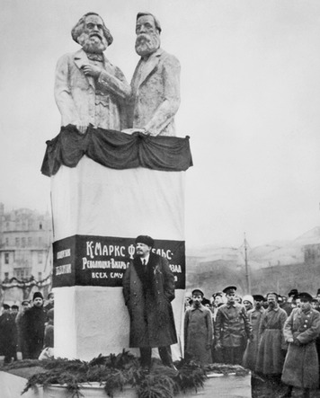
The Rise of Political Parties By the early 1900s, Russia’s revolutionary and reform movements had evolved into formal, organized political parties. Since Russia was an autocracy, political parties were outlawed and had to operate in secret at first. However, they became legal in 1905.
The Socialist Revolutionary Party was founded in 1901. It called for the czar’s overthrow and the seizure and redistribution of all land to the peasants. Its members believed that Russian society should be based on the type of socialism and equality found in peasant communes.
The other major revolutionary party was the Russian Social Democratic Workers’ Party, or Social Democrats. Founded in 1898, the Social Democrats believed that Russia’s future lay with industrialization and a society built around the industrial working class. Their views were based on the theories of the radical nineteenth-century political thinker Karl Marx. However, the Social Democrats differed over how to apply Marx’s ideas to bring about a socialist revolution in Russia. This dispute split the party in 1903. One group, led by Lenin, took the name Bolsheviks, from the Russian word for “majority.” Several other groups that were by no means united became known as the Mensheviks, from the Russian word for “minority.”
In 1905, reformers who were opposed to both socialism and revolution formed the Constitutional Democratic Party—also known as the Kadets. The Kadets were Russia’s main moderate political party through the revolutions of 1905 and 1917, and the civil war that followed.
Marxism and Leninism Karl Marx believed that in industrial societies a class of owners, which he called the bourgeoisie [boorzh-wah-ZEE], took advantage of the working class or proletariat [proh-luh-TAYR-ee-uht] in order to make profits. He predicted that when workers had been driven deep into poverty as a result of this system, they would revolt and establish a socialist state. Over time, a classless society would emerge in which people would live cooperatively without a need for government. Marx called this final stage of revolution communism.
Marx’s theories became known as Marxism. Russia’s Mensheviks thought that the revolution they wanted would follow this pattern. Lenin held a different view. He believed that pure Marxism did not apply to Russia because its industrialization was more recent and its workers were unlike the proletariat of industrial nations such as England or Germany. Lenin argued that Russian workers did not yet have the class consciousness they needed to launch a revolution. He claimed that a group of professional revolutionaries from the intelligentsia would have to lead Russia’s proletariat to revolution instead. This adaptation of Marxism is called Leninism. Lenin shaped the Bolshevik Party around these views.
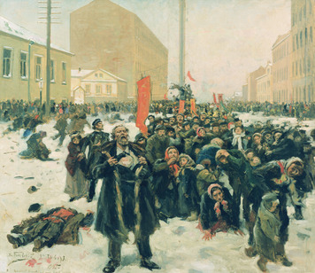
The Revolution of 1905 Russia’s humiliating defeat in its war with Japan in 1904 and 1905 added to a growing discontent with the czar’s rule. Peasant groups, industrial workers, the intelligentsia, and non-Russian nationalists within the empire were all seeking a voice in the government. Moderate reformers and others called for the creation of a national legislature elected by the people.
In January 1905, a huge throng of St. Petersburg workers marched on the czar’s palace to present him with a long list of demands. The peaceful march was met by troops who opened fire. About 130 protestors were killed in what came to be known as Bloody Sunday. News of this event was soon followed by news of Japan’s crushing defeat of Russian forces in battles on land and sea. The empire erupted in uproar. Widespread strikes took place. Peasants began seizing land or other property from landowners. Nationalists in Finland, Poland, and other non-Russian parts of the empire rose in revolt. Units of the army and navy mutinied.
Workers in Russia’s industrial centers formed councils called soviets . Each soviet consisted of elected delegates from all the factories and workshops in the city or town. The soviets organized strikes and negotiated with employers and police. Some even helped run their city or town during the crisis.
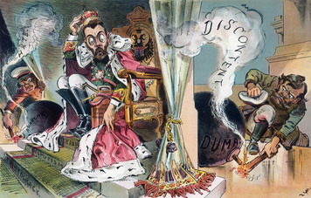
Reform, Repression, and Continued Unrest In October 1905, Nicholas II finally gave in. He reluctantly agreed to allow an elected national legislature, called the Duma, to accept a written constitution, and to grant the people basic civil liberties. However, these actions did not end the unrest. In December, the Moscow soviet launched an armed revolt. It was crushed by the army with great loss of life. Bands of the czar’s supporters, who opposed the reforms, attacked Jews, university students, and known radical leaders. Terrorists from the Socialist Revolutionary Party murdered hundreds of police officers and other government officials.
Meanwhile, Nicholas tried to pull back on the reforms he had granted and to crack down on those who threatened his power. The first Duma was elected in March 1906. Although it was controlled by the Kadets, it still proved too radical for the czar. When he and the Duma deadlocked over a constitution and other proposed reforms, he dissolved it and called new elections. The second Duma contained a large number of members from revolutionary parties. So Nicholas dissolved that Duma, too, and changed the election laws to give the lower classes less power and more power to the nobles. That produced a third Duma in 1907 that was more to his liking—as was the fourth Duma, elected in 1912.
At the same time, the czar continued to rely on the police to help him keep control. Police spies became members of soviets, political parties, and other organizations. Thousands of suspected radicals and others were arrested. Many of them were imprisoned or executed. Some revolutionaries left the country to avoid arrest. Among them was Lenin, who fled Russia in 1907. He did not return until 1917.
The government also launched a program to give every peasant his own land. Nicholas hoped to weaken the communes, turn peasants into successful small farmers, and increase the peasants’ loyalty to the czar. This was perhaps the most genuine and successful of Nicholas’s reforms. However, it came too late. It would have required decades to achieve, and the monarchy would survive for just a few more years.

4. The Bolsheviks Take Control
The reforms and crackdowns that followed the Revolution of 1905 slowed peasant disturbances, strikes, and other protests. For a time, a degree of calm returned to the empire. However, the complaints of the industrial working class had not been addressed, and tensions remained high. After 1912, violent strikes took place with increasing frequency across the empire. Many of them were efforts to improve workers’ conditions. Strikers expressed the view that their goals could only be achieved with the overthrow of the monarchy.
The outbreak of World War I in 1914 greatly influenced the coming of the revolution of 1917, as well as the course the revolution took, its outcome, and the government that emerged. Russia was poorly prepared for the war, and it put an enormous strain on Russian society. Nearly 15 million men were called to military service. Of these, nearly 6 million had been killed, wounded, or captured by 1917.
Most Russians supported the war at first, and the violent strikes initially subsided. Patriotic fervor soon faded, however, as the Russian army suffered defeats and economic hardships developed at home. By 1915, war protests appeared in every social class. The protests increased in 1916, as the call-up of millions of peasants into the army reduced the food supply. The high costs of fighting the war caused prices to rise, while workers’ wages remained low. By late 1916, conditions on the home front had become grim. Worker and peasant opposition to the war and the government grew even stronger. Most upper- and middle-class Russians continued to support the war itself, but they became increasingly critical of the government.
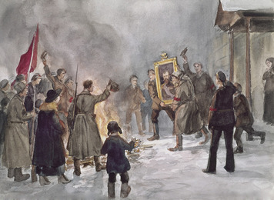
The February Revolution The Russian Revolution of 1917 was actually two revolutions. The first, called the February Revolution, toppled a 400-year-old monarchy and established a democracy. The second, called the October Revolution or the Bolshevik Revolution, brought even more drastic change to Russia.
The February Revolution began in Petrograd (formerly St. Petersburg) on February 23, 1917, when women factory workers, angered over the food shortages, protested having to stand in line for bread They called on men at nearby factories to join them. Within days, nearly all workers in Petrograd were on strike. They were joined by students and members of the city’s middle class. Troops called out to end the demonstrations refused to do so. Instead, many soldiers joined the protests. Meanwhile, the uprising spread to cities and army units across the empire.
Nicholas, who was away at World War I’s Eastern Front, responded to the crisis by dissolving the Duma. However, it refused to disband. Instead it formed a temporary government, called the Provisional Government, to rule Russia until a democratic assembly could be elected to create a new, permanent system of government. Russia’s top military commanders decided to support the Provisional Government in the hope that it could end the unrest that was hurting Russia’s war effort. Having lost control of his army, his government, and his people, Nicholas gave up the throne.
Dual Power The Provisional Government tried to rule for the entire nation, but most of its members were from the middle class. Working class Russians instead placed their loyalty in the Petrograd Soviet, and in similar councils, called soviets, that quickly sprang up in other cities. In the summer of 1917, the leaders of these local soviets united to form the All-Russian Soviet in Petrograd.
The All-Russian Soviet and the local soviets became a sort of second government for Russia. When they disagreed with the Provisional Government, they passed laws and issued orders on their own. This system of “dual power” contributed to the chaos that developed, as peasants seized land, soldiers deserted, and ethnic minorities demanded self-rule.
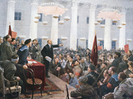
The October Revolution In April, Bolshevik leader Lenin returned to Russia after 10 years in exile. He immediately called for the soviets to overthrow the Provisional Government. However, the Mensheviks and other less radical revolutionaries controlled most soviets. The Bolsheviks were in the minority. When Bolshevik workers and soldiers took to the streets of Petrograd in July 1917, the Petrograd Soviet refused to support them. Government troops easily ended the uprising.
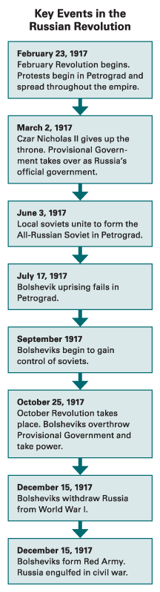
Events soon turned in the Bolsheviks’ favor. By mid-August, the government’s war offensive was going badly and shortages of food and other goods had become severe. An increasing number of Russians supported transferring all government to the soviets. “All Power to the Soviets!” became their cry. This caused Russia’s more conservative elements, like the Kadets, to call for extreme measures.
The government sent troops to seize the Petrograd Soviet. The attack collapsed, however, when Soviet members told the soldiers that they were being used to put the upper classes back in control. In September, the Bolsheviks began gaining majorities in some soviets, including the Petrograd Soviet, the country’s most important. They decided that the time was right to seize power.
Lenin decided to overthrow the Provisional Government when the All-Russia Congress of Soviets met in Petrograd on October 25. This plan made the revolt look like a takeover by all the soviets instead of the act of a single political party. During the night of October 24, Bolshevik soldiers quietly took control of bridges, telegraph offices, railroad stations, and other key points in the city. The next morning Lenin announced that the government had been overthrown and that the Congress of Soviets had taken power. By the end of the day, the Provisional Government had surrendered.
On October 26, 1917, the Congress of Soviets voted to approve the Bolsheviks’ actions and formed a leadership council to head the new government. It put Lenin in charge and named Bolsheviks to other key posts. At Lenin’s request, the Congress passed decrees giving all private land to the peasants and giving workers control of their factories. A second revolution had taken place with hardly a shot being fired, and Lenin had turned the people’s demand for “All Power to the Soviets” into a Bolshevik government.
Civil War The Bolsheviks moved quickly to solidify their power. They reaffirmed censorship of the press, created a new secret police force to deal with those who opposed them, and ended Russia’s participation in the Great War. They also had to deal with the democratic elections the people had been promised after the February Revolution. The Bolsheviks controlled only Petrograd, Moscow, and some other industrial regions, so Lenin only reluctantly agreed to let the elections take place. Less than 25 percent of the delegates elected to the new national assembly were Bolsheviks. Rather then share power with other parties, Lenin forced the assembly to disband. This plunged Russia into a complicated, three-year civil war.
The Bolsheviks formed an army, called the Red Army, in February 1918. In Europe, the color red historically symbolized socialist revolution. In March they changed the name of their party to the Communist Party. The communists, or “Reds,” were opposed by anti-communist forces called the “Whites.” The Whites included Russians who wanted to restore the monarchy, supporters of the Provisional Government and capitalist democracy, and some Mensheviks and Socialist Revolutionaries. Peasant forces, called the “Greens,” fought to keep their lands free of both Red and White control.
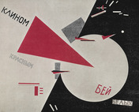
The Whites were aided by the Allies—mainly the United States, Britain, and France—who provided troops and supplies. The Allies did this in part because they did not want Russia to pull out of World War I. But they also did this because they feared that the communists would spread their revolution if they were not defeated. Indeed, Lenin formed an organization called the Comintern in 1919 to organize and aid communist parties in other nations. However, the White armies were hopelessly divided by both geography and the causes for which they were fighting. These factors weakened the Whites and helped lead to their defeat.
The Red Army also had to deal with nationalist movements in non-Russian parts of the former empire. Rather than granting these regions complete independence, the communists established six self-governing Soviet republics. By 1922, they had defeated the Whites and the Greens and joined these republics with Russia to form the Union of Soviet Socialist Republics (also known as the Soviet Union and USSR).
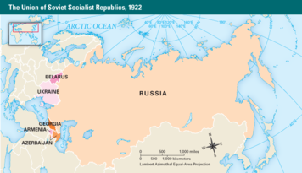
War Communism and the Red Terror The civil war caused Lenin to introduce an economic policy called war communism. The government took over all private businesses and industries and dictated what was to be produced. Workers, who understood communism to mean that they would control the means of production, resisted with frequent strikes. In the countryside, the peasants were forced to provide grain and other produce so that Russia’s cities and the army could be fed. Armed bands of party members and Red Army troops were sent to villages to collect this food. Groups of unhappy peasants rose in revolt.
Faced with such unrest as well as civil war, the communists used extreme measures to stay in power. They called these measures the Red Terror. Lenin ordered the secret police to arrest any person suspected of being an enemy of the revolution. Potential enemies included nobles, religious leaders, merchants, former government officials, noncommunist revolutionaries, and other members of the educated middle class. Striking workers and peasants who resisted war communism also faced harsh punishments.
The police were permitted to execute anyone they arrested. It is estimated that as many as 300,000 persons met this fate. They included the czar and his entire family, whom Lenin ordered to be killed in July 1918. Thousands of other “enemies” were held in prisons or under harsh conditions in prison camps, where many more died. Lenin was motivated by his firm belief that the only way the revolution would survive was if the Bolsheviks retained control.
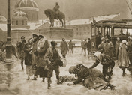

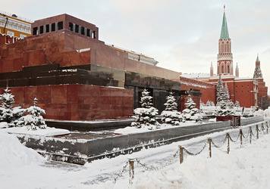
In 1921, Lenin replaced war communism with the New Economic Policy, or NEP. The civil war had ended in victory for the Reds, but the peasant revolts continued. Lenin realized that the Bolshevik Revolution could not survive if the countryside opposed it. The NEP relaxed the extreme policies of war communism. Taxes replaced the requirement that peasants provide the government with food. Farm products could now be freely bought, sold, and traded. Communications, transportation, and major industries such as mining, oil, and steel remained under government control. However, other businesses could be privately owned and operated for profit.
As Lenin was reshaping Soviet communism, his health was beginning to fail. His death in 1924 set off a power struggle in the Communist Party. Over the next four years, party secretary Joseph Stalin outmaneuvered and eventually ousted his rivals. By 1928, he was securely in power.

Summary
In this lesson, you learned about the origins, causes, development, and phases of the Russian Revolution of 1917, and the changes it brought to Russia’s government, economy, and society.
Political Systems The conditions that led to the Russian Revolution arose in the mid and late 1800s. Russia’s czars resisted giving up power in the face of growing discontent. The reforms they did make increased Russians’ desire for greater change. The revolution that eventually resulted had two phases. The first ended the monarchy and replaced it with a government that represented the upper and middle classes. The second phase, which brought more radical reformers to power, drew its support from the working class.
Economic Systems Russian industry was growing rapidly by the early 1900s, but most Russians remained involved in agriculture. Wealth was unevenly divided. The few nobles and other Russians who owned large estates and businesses were well off, while the rural peasant masses and urban industrial workers lived in great poverty. The Bolshevik Revolution established a system in which the government controlled production in the hope of redistributing the wealth and bettering workers’ lives.
Social Structures Russian society historically consisted of a small class of nobles and a huge peasant class. Industrialization in the late 1800s helped to create an educated middle class as well as an industrial working class that was closely linked to the rural peasantry. The Bolshevik Revolution made society more level by elevating the status and power of the working class while destroying Russia’s upper and middle classes.

