Unit 21- Foreign Influences and Revolutions in the Americas

1. Introduction
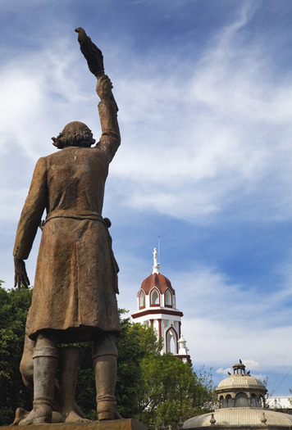
It was still dark that morning of September 16, 1810, when Father Miguel Hidalgo rang the bells of his church in the rural village of Dolores to summon his Indian and mestizo, or mixed-race, parishioners. “My children!” he shouted to the crowd. “Will you free yourselves?” This call to action launched Mexico’s 11-year fight for freedom from Spanish rule. Father Hidalgo’s famous cry, known as the “Grito de Dolores,” is still reenacted every year throughout Mexico on September 15, the eve of Mexico’s Independence Day.
So it was on September 15, 1910, when dignitaries from around the world gathered in Mexico City to celebrate the 100th anniversary of Mexico’s independence and the 80th birthday of its long-time authoritarian leader Porfirio Díaz (pohr-FEE-ree-oh DEE-ahz). Díaz spared no expense on the lavish, month-long event. Its cost was greater than his country’s entire education budget.
Díaz arranged for a costly exhibit of Spanish art in a new building specially constructed to display it. The building also housed a theater, and an elaborate, one-of-a-kind stained glass curtain was created for the occasion by the famous designer Louis Tiffany. At one grand ball, Díaz provided 20 train carloads of imported French champagne. It was served by European waiters or by Mexicans who looked European. Díaz wished to portray Mexico as the land of Cortés, not the land of Montezuma. He had the city’s poor, who were overwhelmingly Indian and mestizo, rounded up to keep them out of sight.
In his 30th year of rule, Díaz seemed to be at the height of his power. Few could have imagined that in just a few months he would be overthrown in what became one of the greatest political and social revolutions of the 20th century. The Mexican Revolution of 1910 would upset the political and social status quo throughout Latin America.

Themes
Political Systems Latin American governments were unstable in this era as liberal and conservative elites, often backed by the military, struggled for control.
Economic Systems Largely rural resource-based and export-based economies grew and changed in response to global economic conditions.
Social Structures Vast disparities between social classes created tensions and helped to trigger unrest and political change.

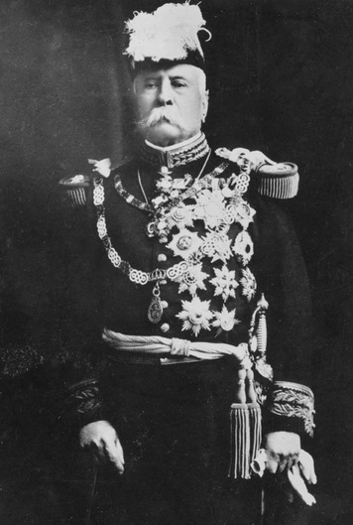
2. Continuity and Change
The revolutions in Latin America in the early 1800s brought independence from Spanish and Portuguese control, but they changed very little else. The social structure of the new nations remained essentially intact. The new nations adopted constitutions based on U.S. and European models. These new constitutions promised representative government and equality. However, Latin America did not have much of a democratic tradition. In practice, most nations became oligarchies ruled by upper-class citizens of European descent. The majority of people had little or no voice in government.
The decades that followed independence from Europe were marked by instability and unrest. Much of it involved disputes between caudillos . Caudillos were army generals or powerful civilian leaders backed by armed groups of followers. Not all caudillos came from the upper classes. Some had very humble backgrounds. However, they usually ruled with upper-class support. In return, caudillos protected their supporters’ wealth and property.
Caudillos, Conservatives, and Liberals A few caudillos actually brought order to their nations. For example, Juan Manuel de Rosas ruled Argentina as dictator from 1835 to 1852. He was supported by ranchers from his area and a force of gauchos (cowboys). His brutal tactics allowed him to maintain stability. He was able to defeat attempts by caudillos from other regions to overthrow him.
More often, however, caudillos and dictators brought political instability. They usually did not have the support of most of the people. Some were elected with the support of only the upper classes. Others seized power through force. Mexico had 48 governments between 1825 and 1855. Chile had 30 between 1823 and 1830.
In most Latin American countries, two competing groups struggled for power. These groups were usually known as liberals and conservatives. Both groups were made of elites of European descent. They shared the goals of protecting their property and keeping their own class in power.
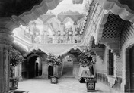
The conservative elite worked to preserve the old colonial culture. Conservatives generally opposed modernization and economic development. In general, the conservative elite consisted of large landowners.
The liberal elite tended to be wealthy merchants and professionals. They claimed to support the Enlightenment ideal of rights and freedom for all people. However, they also believed that the common people were not ready to exercise most rights and freedoms wisely. Liberals therefore supported powerful governments. They thought this was the best way to modernize society and prepare the people for freedom and equality. This approach often produced dictatorships. They sacrificed people’s rights in the name of “progress.”
Throughout the 1800s, liberals and conservatives competed for control of government in many countries. Argentina, Colombia, Uruguay, and Venezuela experienced long periods of unrest. In the 1880s, conservatives emerged victorious in Argentina, Bolivia, Brazil, Colombia, and Paraguay. In Venezuela, unrest continued until a military dictator took over in 1908.
Elsewhere in South America, the liberals gradually gained control. By World War I, they had replaced conservative governments in Argentina, Bolivia, and Paraguay.
Economic and Social Trends Latin American economies in the 1800s were based on the export of agricultural products and other raw materials. Americans and Europeans bought coffee and sugar from Brazil. Cattle and sheep from Argentina and Uruguay supplied meat to Great Britain. Rubber from Brazil, wool from Argentina, and copper and nitrates from mines in Chile and Peru provided raw materials for European industries.
Many countries began developing their infrastructure in the mid-1800s to meet demand for their raw materials. Governments and business people built roads and railroads to bring goods to cities on the coast. They expanded and modernized harbors. Merchant ships switched from sail to steam. Foreign investors financed most improvements. Foreign banks often made loans to Latin American governments or business people to pay for such projects. In many cases, foreigners owned local railroads, mines, ranches, and plantations. At first, most investment was European—and mainly British. However, by the early 1900s, the United States had replaced Britain as the biggest investor in Latin America.
The growth of industry in the United States and Europe in the late 1800s and early 1900s brought rapid growth to Latin American economies. By World War I, the region was exporting 18 percent of the world’s grain, 38 percent of its sugar, and 62 percent of its coffee, cocoa, and tea. Many Latin American elites became rich as a result. The masses, however, did not benefit as much.
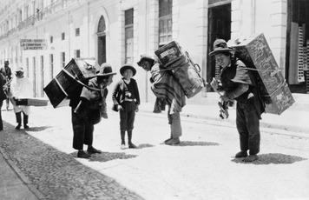
Other changes also took place as Latin American economies developed. In rural regions, Indians and other peasants were forced off their land as ranches and plantations grew. Some became hired hands. Others moved to cities to find jobs. Factories appeared to process agricultural products for export. In Mexico City, hundreds of new factories opened. Manufacturing also sprang up in countries like Chile and Brazil.
As workers left the countryside for jobs in factories, urban populations grew quickly in some Latin American countries. São Paulo, Brazil, increased from 35,000 people in 1883 to 350,000 by 1907. Rio de Janeiro’s population doubled to one million between 1890 and 1920. By the mid-1900s, about 40 percent of Latin Americans lived in urban areas. However, in less developed countries like Bolivia, Ecuador, Paraguay, and Peru the population remained largely rural.
As cities grew, an urban middle class emerged. Economic growth attracted large numbers of immigrants from Europe. Argentina and Brazil received the most European immigrants. Immigrant workers organized Latin America’s first labor unions. This kind of social and economic change and the example of a revolution in Mexico would bring even greater unrest to South America in the 20th century.

3. The Mexican Revolution and Its Impact
By 1910 Mexico had enjoyed 30 years of stable government and economic growth under General Porfirio Díaz. Díaz was returned to the presidency time after time in rigged elections. He paid little attention to Mexico’s constitution. Over time, Díaz gained near total control of the government. He packed the legislature and courts with his friends and silenced the press. He suppressed his enemies through intimidation, imprisonment, and murder.
Díaz defended his rule by claiming that he was modernizing Mexico in order to prepare it for democracy. His economic policies and the political stability he achieved did encourage development. Foreign investors built railroads and factories. They opened mines, brought irrigation to commercial agriculture, and launched Mexico’s oil industry. However, most of the wealth gained from these ventures went outside the country or into the hands of a few upper-class Mexicans. Tensions grew within Mexico’s developing middle class. Most urban and rural workers remained landless, powerless, and poor. As criticism of Díaz increased, so did his crackdown on critics.
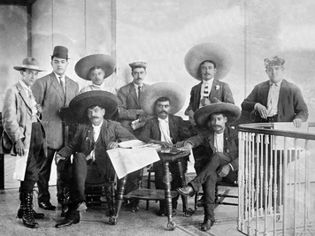
The Revolution of 1910 In 1910, the wealthy landowner Francisco Madero (mah-DAY-row) ran against Díaz for president. Díaz thought he could control this election as he had controlled previous ones. However, support for Madero grew. Díaz responded by having Madero arrested. Díaz was then re-elected in a rigged election. Madero escaped to Texas and called on Mexicans to revolt. When no uprising took place, Madero used his wealth to arm bands of peasant guerillas in northern Mexico. One of these bands was led by a bandit named Pancho Villa (VEE-yah). In the south, Madero was aided by the Indian leader Emiliano Zapata (ay-mee-lee-AH-no zah-PAH-tah), who raised an army of 5,000 men. By May 1911, Madero’s peasant forces had defeated Mexico’s army. Díaz fled to Europe, and Madero became president.
Continued Unrest and Civil War Madero’s presidency was unstable and brief. He made democratic reforms, but lost Zapata’s support when he refused to return lands that wealthy landowners had seized from the Indians. Unhappy industrial workers took advantage of their new democratic freedoms by forming unions and going on strike. Those who still supported Díaz were also upset and launched revolts. These revolts were put down by army general Victoriano Huerta (WHERE-tah).
Madero also lost favor when he placed a tax on Mexico’s oil production, much of which was under U.S. and British control. Hoping to protect American investments, U.S. President William Howard Taft supported Huerta. He mobilized U.S. troops on the border and in the Gulf of Mexico although they never engaged in battle. In February 1913, Huerta forced Madero to resign. He then had him executed, and became president. However, Huerta was soon overthrown by forces loyal to Madero’s ally Venustiano Carranza (vay-noo-stee-AHN-noh cahr-AHN-zah). These forces were led by Villa, Zapata, and a rancher named Álvaro Obregón (AHL-vahr-oh oh-bray-GOHN).
U.S. President Woodrow Wilson, who succeeded Taft in 1913, sent arms to the pro-Carranza rebels, despite the fact that the United States had supported Huerta in the previous administration. He also sent U.S. forces to seize Mexico’s main port city of Veracruz to help in Huerta’s defeat. Huerta fled. In August 1914, Carranza declared himself president. This turned Villa and Zapata against him. However, by late 1915 both had been defeated by Carranza. Widespread warfare ended, although sporadic fighting continued until 1934.
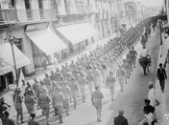
The Constitution of 1917 President Carranza presided over the writing of a new constitution for Mexico. The Constitution of 1917 placed into law the reforms that the revolution’s supporters had fought for. It empowered the government to seize and redistribute the land of wealthy landowners. It set minimum wages and maximum hours for workers. It created government-sponsored retirement, life, health, and unemployment insurance programs. It also gave workers the right to form unions and to strike. It provided all Mexicans with a free public-school education and granted them freedom of religion. These measures greatly reduced the long-held power of the Catholic Church. Finally, the new constitution nationalized all the country’s mineral and oil resources. The Constitution of 1917 made the Mexican Revolution a social revolution as well as a political one.

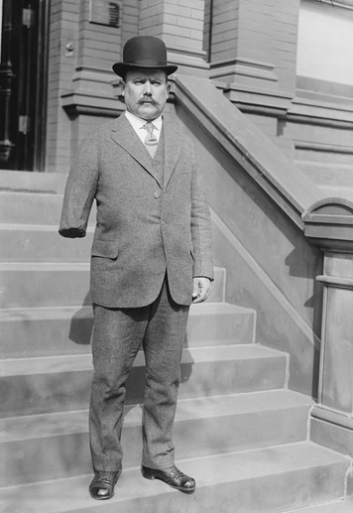
However, Carranza failed to carry out most of the reforms called for in the Constitution. As a result, workers and peasants backed the war hero Obregón for president in 1920. When Carranza tried to arrest Obregón, fighting broke out again. Carranza fled with the nation’s treasury but was captured and killed. Several months later, Obregón became president in Mexico’s first fair and peaceful election.
Post-Revolutionary Mexico Many historians view Obregón’s election as the end of the Mexican Revolution. Obregón was committed to social reform. However, he had to move carefully to avoid angering the Catholic Church, foreign investors, and other elites. Periodic rebellions, assassinations, and other unrest continued.
In 1928 Obregón was elected president again but was assassinated before he could take office. The outgoing president Plutarcho Calles (pluh-TAHR-koh CAH-yays) devised a plan to both stay in power and make Mexico politically stable. He formed a political party to choose the new president. The party was named the National Revolutionary Party. It survives to this day but is now called the PRI. Calles used the party to put three weak presidents in office. He invited military, labor, peasant, and regional political leaders to join the party.
By 1934, some of these leaders had become more powerful than Calles. They forced him to name the radical reformer Ĺazaro Cárdenas (LAH-zahr-oh CAHR-day-nahs) as the presidential candidate. Cárdenas was elected and served as president until 1940. He finally carried out the reforms promised by the Constitution of 1917. He distributed land to previously landless farmers. He also strengthened Mexico’s labor unions. In 1938, Cárdenas seized Mexico’s railroads and oil industry from foreign control and nationalized them.
Cardenas also expanded the PRI. He strengthened the peasants’ power in the party. He also doled out government benefits to various groups in return for party support. Under Cárdenas, Mexico became what has been called a “one-party democracy.” The PRI controlled Mexican government for the rest of the 20th century. Cárdenas’ reforms cause some historians to view 1940, instead of 1920, as the true endpoint of the Mexican Revolution.
The Revolution’s Impact Many Latin Americans admired the Mexican Revolution for its political, social, and economic reforms. The influence of the Mexican Revolution weakened the power of South America’s traditional elites. Argentina, for example, gave all males the right to vote in 1912. Four years later, the Radical Civic Union, a political party supported by Argentina’s growing middle class, came to power. Its leader became Argentina’s first president elected by the people instead of selected by the oligarchy.
Reforms continued in other Latin American nations as well. By 1920, Peru and Chile had reform-minded governments. In Peru, reformers advocated for rights for the nation’s Indian peasants. Chile’s new constitution of 1925 allowed reforms that benefitted urban workers. In 1929, Ecuador became the first Latin American nation to grant women the right to vote. By 1934, Brazil, Cuba, and Uruguay had done the same.
Elsewhere, calls for reform often resulted in military intervention. In 1925, urban and labor unrest in Ecuador caused the army to overthrow the government. Unrest in Ecuador prevented any meaningful social reforms. In Bolivia, war with Paraguay delayed reform. In 1936, radical army officers ended more than 50 years of civilian government. Bolivia’s new military rulers enacted worker-friendly labor laws, but little else changed. In Paraguay, the war was followed by a military coup, dictatorship, and even less change.
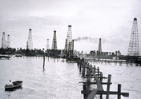
In Brazil, the country’s wealthy landowners controlled the government. They were known as the “coffee elite” because of the source of their wealth. In the 1920s, members of Brazil’s growing urban middle class joined with young army officers to oppose the government. They called for labor and land reforms and for nationalizing the country’s natural resources. Their efforts to incite revolts plunged Brazil into a decade of unrest.
The dictatorship of Juan Vicente Gomez that began in Venezuela around 1910 continued until 1935. By then, Venezuela was the world’s leading exporter of oil. The oil boom brought high-paying jobs and paid for roads and other improvements. It also enriched Gomez and his supporters. However, most Venezuelans continued to live in poverty. Political activity was outlawed. Dissent brought harsh punishment, including execution.
After 1935, Venezuela went back and forth between dictatorship and a more open government. For a brief time, civil liberties and the right to political activity were protected. However, Venezuela’s president restored the dictatorship in 1937. Political activity was permitted again in 1941. Four years later, the president was overthrown by a group of military officers and civilian leaders who enjoyed popular support. This action marked the first time in Venezuela’s history that a political party supported by a majority of the people came to power.
The Great Depression In 1929 the United States plunged into the Great Depression. It spread worldwide in the 1930s. The Great Depression had a strong impact on Latin America. Prices for the region’s major exports—including sugar, bananas, copper, and oil—fell because of reduced demand. The elites whose wealth came from the sales of these products lost much of their wealth and power. In Brazil, for example, the Depression brought down the coffee elite, finally accomplishing what the middle-class reformers could not.
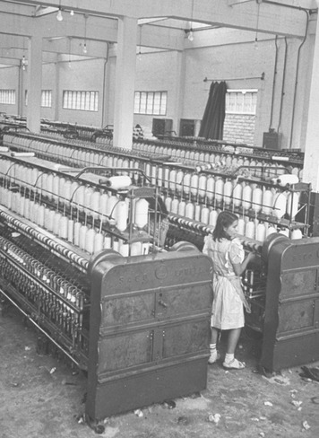
In much of Latin America, increased unemployment led to unrest. Instability followed, and progress toward democracy stalled. After military coups, army officers replaced civilian leaders in Argentina, Bolivia, and Peru. Even in those nations where civilian rule continued, government control increased. In Uruguay and Peru, governments cracked down on labor and peasant groups. This postponed further social reform. In Bolivia, Brazil, and Venezuela, undemocratic leaders moved forward with some reform, hoping to prevent unrest.
The Depression also fostered economic independence in some countries. As earnings from exports declined, many nations could no longer afford to import manufactured goods. As a result, the region had to develop its own sources for these goods. Industry grew in many nations. Colombia, for example, became a major producer of cotton textiles. In Brazil, the government encouraged manufacturing. This quest for economic self-sufficiency aroused economic nationalism in Latin America. The boldest expression of economic nationalism came when Bolivia and Mexico seized their nation’s foreign-owned oil companies.
In the years between 1910 and 1945, life in Latin America had both radically changed and remained the same in many ways. In many places life had changed very little. Paraguay, for example, remained almost totally rural and isolated. In Brazil, residents of the vast interior were barely affected by changes in the nation’s fast-growing industrial cities. At the same time, by the mid-20th century more people in Latin America had been exposed to a basic public education. In cities, an industrial working class was growing. Changes in communication and transportation were drawing people together and linking them to the national and world economies. These trends would continue through the rest of the twentieth century.

4. Central America and the Caribbean
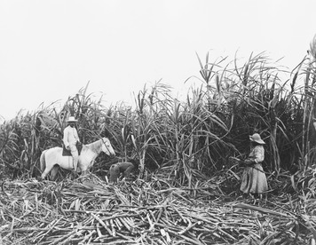
The Mexican Revolution had little effect on Central America and the Caribbean. Most of the Caribbean islands remained French, Dutch, or British possessions. Only Haiti, the Dominican Republic, and Cuba gained independence before World War II. Like the nations of South America, their economies were based on the export of agricultural products and natural resources. Economic development was financed by foreign investment. U.S. investment built huge coffee and sugar plantations. By the 1920s, American-owned companies in these nations were producing most of the world’s sugar.
Most of Central America followed a similar course. Costa Rica, Guatemala, Honduras, Nicaragua, and El Salvador gained independence from Spain, as part of Mexico, in 1821. In 1823, they declared their independence from Mexico and formed the United Provinces of Central America. But the United Provinces did not stay together very long. Peasant revolts and conflicts between liberals and conservatives split the United Provinces into separate nations by 1840.
By the 1870s, the liberals had gained control in all these nations but Nicaragua. Meanwhile, the United States and Britain competed over development rights. Coffee and banana plantations provided the major exports. They also promoted the rise of a landowning liberal elite. In every country but Costa Rica, elites and foreign investors relied on dictators to provide stable government and protect their interests.
Cuba The Caribbean island of Cuba was home to many American-owned sugar plantations. In the 1890s, it revolted against Spanish rule. U.S. troops invaded Cuba in 1898 and forced Spain to grant its independence. To protect U.S. interests, troops remained in Cuba until 1902. They built roads and schools. They established economic and educational systems modeled after those in the United States.
The United States pressured the Cubans to amend their new constitution to give them the right to oversee Cuban affairs. U.S. officials supervised the election of Cuba’s first president. American rule returned between 1906 and 1908, following his resignation. U.S. troops occupied Cuba again from 1917 to 1923, when more political unrest threatened to disrupt the booming sugar economy. In 1933, the United States helped bring about the overthrow of a brutal dictator. Army sergeant Fulgencio Batista (fuhl-GEHN-see-oh bah-TEES-tah) seized power. Backed by U.S. business interests, Batista ruled Cuba for most of the next 25 years.
The Dominican Republic and Haiti The Dominican Republic and Haiti share the island of Hispaniola. Both experienced unrest throughout most of the 19th century. Starting in 1822, Haiti ruled the Dominican Republic. In 1844 the Dominicans drove the Haitians out. From 1844 to 1899, the Dominican Republic was ruled by a series of caudillos. Most of them opposed democracy. They all borrowed heavily from foreign banks. Eventually all were forced from power. Haiti had 20 rulers between 1843 and 1915. Nearly all of them were assassinated or overthrown. Despite the political instability, U.S. and European businesses continued to make major investments in both nations.
By 1905 Haiti and the Dominican Republic were in serious financial trouble due to heavy borrowing and political corruption. U.S. officials feared that Germany or some other European power might take over one or both countries to collect on unpaid debts. In 1905, the United States took control of both countries’ customs operations. It used the money collected to pay each country’s creditors. U.S. President Theodore Roosevelt justified this action by stating, “Chronic wrongdoing, or an impotence which results in a general loosening of the ties of civilized society, may . . . ultimately require intervention by . . . the United States . . . to the exercise of an international police power.”
This policy statement became known as the Roosevelt Corollary. It was used by later U.S. presidents to justify other interventions in Latin America. Following renewed unrest, U.S. troops occupied Haiti in 1915 and the Dominican Republic in 1916. The Dominican Republic remained under U.S. control until 1924, and Haiti until 1934. In both countries the Americans built roads, schools, and health clinics. They also improved sewer, water, and communications systems.
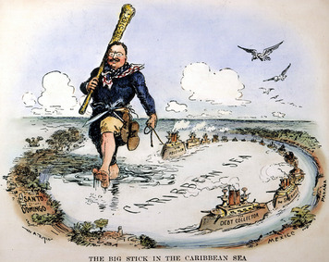
U.S. troops trained and armed national guards in each country. These groups often sought power after the United States left. As a result, Haiti underwent frequent military rebellions and coups. In 1957 François “Papa Doc” Duvalier (frahn-SWAH doo-vahl-YAY) began a long and feared dictatorship. In the Dominican Republic, the military put General Rafael Trujillo (rah-fay-EL troo-HEE-yoh) in power in 1930. His 31-year rule became one of the cruelest dictatorships of modern times.
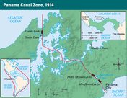
Panama In the late 1800s, Europeans and Americans began seeking a shortcut across Central America to create a more direct trade route with Asia. A French company began digging a canal across Panama in the 1880s, but it ran out of money. In 1902, it offered to sell the project to the United States. However, the government of Colombia (to which Panama belonged) refused to approve the deal. The French then encouraged a group of Panamanians who wanted independence from Colombia to rebel. President Roosevelt aided the revolt. In 1903, the new government of Panama gave the United States control of the Canal Zone. This was a 10-mile strip of land along the canal route. Construction resumed the next year, and the Panama Canal opened in 1914.
The canal gave the United States a major interest in Panamanian politics. Unrest in Panama led U.S. troops to intervene several times between 1908 and 1925. Panamanian nationalism grew during the 1930s. This resulted in the election of two successive anti-American presidents. The second was overthrown in 1941. The new president turned his nation’s defense over to the United States. U.S. troops occupied Panama until massive public protests forced them to leave in 1947.
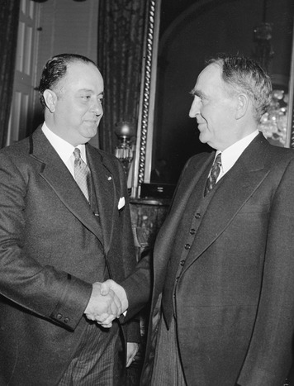
Nicaragua Conservative rule in Nicaragua brought stability from 1857 to 1893. In 1893 the liberal General José Zelaya (hoh-ZEH zeh-LAH-yah) came to power. He established a brutal dictatorship that lasted 16 years. During that time, Zelaya opened Nicaragua to foreign investment. New roads, railroads, and seaports were constructed. Banana and coffee exports increased. By the early 1900s, Americans controlled the country’s banana and coffee industries.
In 1909, Zelaya invited German and Japanese investors to build a canal across his country to compete with the canal the Americans were building in Panama. The United States responded by sending 400 Marines to help the conservatives overthrow him. U.S. military troops were stationed in Nicaragua from 1912 until 1933. They helped to keep several conservative presidents in power. They also armed and trained a Nicaraguan National Guard to keep the peace after they left.
In 1936, the National Guard commander General Anastasio Somoza (ah-nah-STAH-see-oh soh-MOH-zah) overthrew Nicaragua’s elected president. After a rigged election, he became president himself. He used the National Guard to create a brutal dictatorship that lasted until he was assassinated in 1956.
Other Nations in Central America Clashes between liberals and conservatives also divided Guatemala, Honduras, and El Salvador. All experienced violent dictatorships during the first half of the 20th century. These dictators protected U.S. financial interests. In return, they received money and support. Only Costa Rica avoided this fate. In 1889 it held the first entirely free and fair presidential election in all of Central America. Costa Rica became the region’s only stable democracy.

Summary
In this lesson, you learned about the causes and effects of political unrest in Latin American nations during the 1800s and 1900s.
Political Systems Liberal and conservative elites competed for control of government. Both groups favored strong leaders who could protect private property and control the pace of change. This often meant military or civilian dictators who came to power with a group’s backing, either through rigged elections or by violent means.
Economic Systems Most Latin American economies were based on the export of agricultural products—such as coffee, sugar, and bananas—as well as natural resources such as copper and oil. Growth and development was largely accomplished through foreign investment and loans. Early industry centered on processing raw materials for export. Later, the Great Depression caused some countries to begin manufacturing for the home market, as imported goods became scarce or too expensive.
Social Structures Initially society consisted of a wealthy upper-class minority and a mass population of poor, often landless rural peasants. As cities and industry grew, an urban middle class and working class developed. Governments used repression and reform to keep workers and peasants under control. Over time, however, the middle class began to challenge the elites for political power.

