Unit 22 North Africa and the Middle East

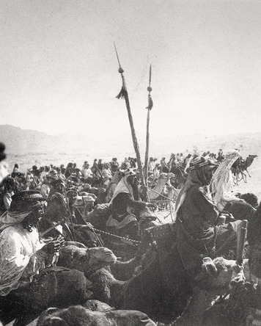
1. Introduction
In July 1915, as World War I raged in Europe, Sir Henry McMahon, Great Britain’s High Commissioner in Egypt, received an intriguing letter. The emir, or commander, of Mecca, a man named Hussein ibn Ali (hoo-SAYN ib-NAH-lee) offered to launch an Arab revolt against the Ottoman Empire in return for British support for an independent Arab nation after the war.
The Ottoman Empire had entered the war in 1914 on the side of the Central Powers. Mehmed V, the Ottoman sultan and caliph (head religious leader) claimed that the Allies were intent on destroying Muslim rule and that the war was a fight for the survival of Islam. The Ottoman declaration of war was designed to unify the empire’s Muslims. In part, it arose from the desire of the Ottoman rulers to make sure they kept the loyalty of the empire’s Arabs, who spoke a different language from the Ottoman rulers. In 1915, the Ottomans began arresting and publically executing Arab leaders suspected of disloyalty. Rather than strengthening Muslim unity, the Ottoman actions caused Arabs like Hussein to reach out to the Ottomans’ enemy, Great Britain.
The prospect of an alliance with someone of Hussein’s stature and prestige excited British leaders. McMahon’s superiors instructed him to write back to Sharif Hussein, and the two men exchanged a series of letters. Hussein agreed to denounce the Ottomans as enemies of Islam and to lead an armed rebellion. The British pledged to provide funds, weapons, and supplies for the revolt. They also agreed to an independent Arab state after the war, although the exact borders of that country were left vague. But history did not turn out quite as Hussein hoped.
The Hussein-McMahon letters are famous today. They form the basis for a huge controversy over whether the British broke promises they made to Arabs about the future of the Middle East. The debate contains the roots of tensions that still challenge the Middle East today.

Themes
Cultural Interaction Religious tensions played a major role in shaping events in the Middle East before and after World War I.
Political Systems The decline and end of the Ottoman Empire aroused the conflicting forces of nationalism and imperialism in both North Africa and the Middle East.

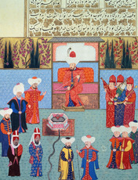
2. The Ottoman Empire
By the early 20th century, the Ottoman Empire had been in existence for six centuries. At its height in the late 1600s, it reached into Eastern Europe almost to Vienna and across North Africa to the Atlantic Ocean. Much of the Middle East (also called Southwest Asia) was also under Ottoman control. The Ottoman sultans ruled over a multi-ethnic empire in which the people spoke many languages and practiced many religions.
Tensions with Neighboring Peoples The Ottoman Empire shared some of its borders with the Safavid Empire, which was ruled by the Persians. The Safavid Empire included present-day Iran, eastern Iraq, and western Afghanistan. The border between the two empires changed over time and was a source of conflict for more than a century. However, the rivalry between the Ottomans and Safavids was more than geographical. It was also based on their religious beliefs. Safavid leaders made the Shi’a branch of Islam their empire’s official religion. This development increased tensions with the Ottoman Empire, where the Sunni branch of Islam was the majority religion.
Ottoman Organization and Government The overall head of the Ottoman Empire was the sultan. The early sultans were descendants of Osman I, the ruler of a region in what is now northwest Turkey. In the early 1300s, Osman began conquering nearby territory and established the Ottoman Empire. The name Ottoman is derived from Osman’s name.
As the empire expanded, the sultans relied on armies that were brought together by members of the elite living around the empire. The sultans rewarded them for their service by giving them the revenues of specific regions in the empire. Unlike European feudalism, these military leaders had no rights over the communities or political control over the areas.
In order to allow each of the religious groups to practice their own laws, the Ottomans established the millet system. Each millet was headed by a religious leader and had limited power to set its own rules under the overall supervision of the Ottoman administration. The millets supervised marriage, divorce, and baptism according to their own laws, so that Christians and Jews did not have to obey Muslim laws. Nonetheless, Muslims, Christians, and Jews lived in the same communities and sold their goods in the same markets, despite intermittent ethnic and religious conflict.
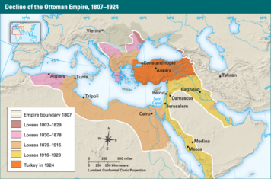
The Long Decline Historians have offered many possible explanations for the decline of the Ottoman Empire. Some claim that the sultans became less powerful. Others argue that there were economic reasons for the decline, beginning when Europeans reached the New World and brought back huge amounts of silver. Since the Ottomans used silver-based currency, the inflation that resulted left the empire without enough funding to continue to grow. Some thinkers inside the empire argued that the problem was that they had strayed too much from the laws of Islam, and that returning to the faith would reinvigorate the empire. Other Ottoman thinkers claimed the problem was that the empire had not changed enough with the times.
In 1683, the Ottomans tried but failed to capture the European city of Vienna, located in Austria. This defeat exposed the empire’s military weakness. It also encouraged Austria, Russia, and other European powers to fight several wars with the Turks between 1710 and 1812, taking much of the empire’s European territory. Austria and Russia also worked to stir up unrest among the empire’s non-Muslim peoples.
In the 1800s, the Ottoman Empire became caught up in the rivalries of Europe’s Great Powers as they competed for colonies and spheres of influence. Russian and British aid helped the Ottomans drive French forces out of Egypt in 1801. Six years later, however, it was France that helped them resist a British invasion of Egypt. With British, French, and Russian help, Greece ended Ottoman rule and gained independence in 1832. Yet in the 1830s, Great Britain and Russia also helped the Ottomans defeat Muhammad Ali, the viceroy of Egypt, after he rebelled and seized the region of Greater Syria.
“In my cabinet there are two opinions about Turkey,” Russia’s Czar Nicholas I told British leaders in 1844. “One is that she is dying; the other is that she is already dead.” Britain’s policy, however, was to preserve the Ottoman Empire. The British believed that doing this would help maintain the balance of power in Europe. However, completion of the Suez Canal in Egypt in 1869 gradually brought a change in British policy. The canal became a vital transportation link between Britain and its colony of India. To help the British protect the canal, the sultan allowed them to take over the island of Cyprus in 1878. Four years later, following France’s occupation of nearby Tunisia, Britain took control of Egypt itself.
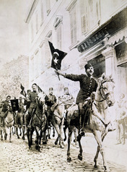
The End of an Empire By the late 1800s, most of the Ottomans’ European empire was gone. So was Ottoman control over most of North Africa. Reformers proposed creating a constitutional democracy and combining the remaining provinces into a unified Turkish state. The sultan agreed to a constitution in 1876. However, he soon cancelled it and ruled as an autocrat for the next 30 years.
In 1909, a nationalist group called the Young Turks overthrew the sultan and replaced him with his brother. The new sultan allowed the constitution to be implemented. The Young Turks also strengthened ties with Germany in an effort to modernize, westernize, and industrialize the empire. These policies drew the empire onto the losing side in World War I. They also aroused Arab nationalism. In 1916, an Arab army helped Britain to defeat the Ottoman Empire. In October 1918, the Ottoman government surrendered. The Allies dissolved the empire and placed its territories under their control.

3. Turkey and Iran
In a series of agreements made during World War I, the Allies planned for the division of the Ottoman Empire once the Central Powers had been defeated. By this time much of North Africa was already under European control. Great Britain and France now took over the empire’s Arab provinces as well.
In December 1918, Allied forces entered Constantinople (now called Istanbul), the Ottoman capital, and took the sultan into custody. They began carrying out plans for changes in Asia Minor, the peninsula between the Black and Mediterranean Seas that the Turks viewed as their homeland. An eastern region was stripped away to create a separate nation for the Armenians, who had suffered horribly during World War I under Ottoman rule. Greek forces seized other territory. Much of the rest of Asia Minor came under British, Italian, and French influence or control.
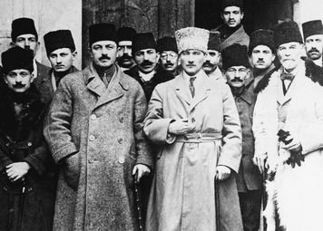
The Birth of Turkey The sultan had little choice but to accept these developments. Other Turks would not, and widespread revolts broke out. The sultan sent the Turkish war hero General Mustafa Kemal to urge cooperation with the Allies. Instead, Kemal helped organize the resistance. In 1919, a nationalist gathering led by Kemal called for all of Asia Minor to be included in an independent Turkish state. When the Ottoman parliament supported this demand, the occupying Allied forces dissolved it and arrested nationalist leaders.
In 1920, the nationalists formed another parliament, with Kemal at its head, in the city of Ankara. Called the Grand National Assembly (GNA), it declared itself the government of a new nation called Turkey. It also declared that the sultan’s government was controlled by infidels and that Muslims had a duty to resist the foreign occupation.
By late 1922, Turkish nationalist forces had pushed the Greeks out of Asia Minor. France and Italy had also withdrawn their troops and the sultan had fled. In 1923, the Allies signed a new peace treaty with the nationalist government. The treaty recognized Turkey’s independence and new borders. The GNA declared Turkey to be a republic and elected Mustafa Kemal as its first president.
Kemal quickly launched a series of reforms to modernize and westernize Turkey. Islamic law was discarded and religious courts were abolished. Parts of the German, Italian, and Swiss legal systems were adopted in their place. Women gained civil rights and the right to vote. Calling on people to become “modern,” Kemal banned men from wearing the fez, a traditional Turkish hat. He required government workers to wear Western-style clothing. The Latin alphabet replaced Arabic script for writing the Turkish language. Kemal traveled throughout the country with a chalkboard teaching people the new writing. All Turks were required to take surnames. The GNA gave Kemal the name Atatürk, which means “Father of the Turks.” Today he is Turkey’s greatest national hero.
Atatürk controlled Turkey’s government until his death in 1938. By then the threat of another major war was developing in Europe. Although some pro-German and anti-Russian feelings existed, Turkey remained neutral through most of World War II. It declared war on Germany just weeks before the Germans surrendered. This allowed Turkey to take part in creating the United Nations, the world organization founded in 1945.
World War II brought change to Turkey, despite its neutrality. The war encouraged industrial growth. In addition, the Allies’ victory encouraged the growth of Turkish democracy. Political parties arose to challenge the one-party system under which Atatürk had ruled. Threats from the Soviet Union caused the United States to begin providing economic and military aid in 1947. This relationship drew Turkey even closer to the West.
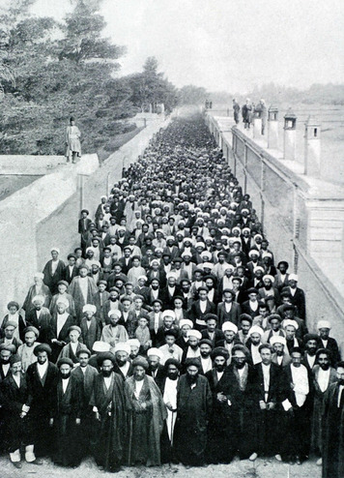
\Persia Becomes Iran By the late 1800s, Great Britain and Russia had become involved in the internal affairs of Persia, an ancient country ruled by a series of shahs between 1797 and 1896. Russia carved out a sphere of influence in the north, while Great Britain did so along the Persian Gulf. The British pressured Persia to open the nation to foreign trade and investment. Manufacturing suffered as Persia became a source of cheap raw materials and a market for Western industrial goods.
Persia’s merchants objected to the favored treatment that European businesses received. They called for political and legal reforms. Shiite clerics supported the merchants and the protests they organized. The unrest that resulted showed the growing power of religious leaders and the merchant class. In 1906, widespread demonstrations and strikes finally forced the shah to agree to a constitution and a national legislature called the Majles (MAHJ-less).
The Majles took a strong stand against European involvement in Persia. It also passed laws granting freedom of speech and the press. The Majles established secular schools, including some for girls. These reforms caused tensions with some Muslim clerics. The shah, who also opposed the Majles, shut it down in 1908. Civil war followed, but Russia intervened and ended the war in 1911. Russia withdrew its troops when World War I broke out in 1914. Although Persia declared neutrality, it became a battleground in the war.
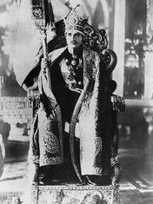
At the end of World War I, Great Britain was the only European power left in Persia. In 1921, Britain gave in to international pressure and also withdrew. However, the British supported army officer Reza Khan in taking control of Persia’s government. He deposed the shah in 1925. Crowning himself Reza Shah Pahlavi, he began the Pahlavi dynasty, which held power until its overthrow in Iran’s Islamic Revolution of 1979.
Reza Shah launched a broad program of reforms to create a modern state. He changed the country’s name from Persia to Iran, the ancient name of the original settlement. The system of secular schools was expanded and Iran’s first western-style university opened in Tehran. The status of women changed and the requirement that women wear veils ended. In addition, women were encouraged to enter the work force.
To promote economic growth, the shah built roads, completed a railroad across Iran, and opened state-owned factories that produced basic consumer needs such as textiles and canned goods. Because he distrusted the British and Russians, he expanded trade by developing ties with Nazi Germany. By World War II, Germany was Iran’s largest trading partner. Nevertheless, Reza Shah declared Iran neutral when the war began in 1939.
Despite his reforms, Reza Shah was an autocrat. He controlled the Majles and silenced the press. He also jailed, exiled, or executed his opponents, including some religious leaders. In 1941, the Allies used his ties with Germany as an excuse to invade Iran and replace him. They forced the shah to step down, and they replaced him with his young son Mohammad Reza Shah Pahlavi.
Reza Shah Pahlavi allowed the Allies to move war supplies through Iran to help the Soviet Union resist a German invasion. The new shah did not yet wield the same power over Iranian politics, and many political parties formed, including a pro-Soviet communist party. Instability and unrest developed as these parties competed for power after World War II. Iran’s internal politics were further complicated by Soviet, British, and American competition for control of the nation’s oil resources. Concerns about communism also continued to involve Great Britain and the United States in Iranian affairs.

4. The French Mandate
Even as World War I raged on, imperial powers were seeking ways to benefit afterward. Expecting that the Ottoman Empire would not survive the war, Great Britain and France made secret plans to divide much of it between themselves. They signed a secret treaty called the Sykes-Picot Agreement in May 1916. This agreement recognized French and British claims in different parts of Greater Syria. It also granted Great Britain control of Iraq.
This secret agreement came just weeks after Britain promised Hussein ibn Ali, the emir of Mecca, an independent Arab state in return for Arab help against the Ottomans in the war. Unaware of the secret treaty, Hussein launched his Arab revolt in June 1916 by attacking Ottoman troops defending Mecca. Within months, most of the Hejaz was in Arab hands. Hussein’s son Faisal ibn Hussein commanded the Arab forces. Faisal led his troops into the Syrian city of Damascus shortly before the Ottomans’ surrender in October 1918.
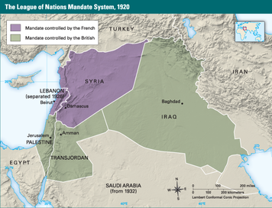
An Independent Greater Syria With the war over, Faisal acted on the pledge the British had made to his father and formed a government. In March 1920, a Syrian national congress meeting in Damascus proclaimed Greater Syria to be an independent nation and named Faisal as king. The Allies, however, refused to recognize this action. Instead, at the San Remo Conference in April 1920, Allied leaders decided to divide Greater Syria. Largely following the Sykes-Picot Agreement, they handed the northern region over to France under the mandate system created by the new League of Nations. The southern region—including the geographic area commonly referred to as Palestine—became a British mandate.
Arabs reacted to this development with anger and frustration. When Arab nationalists urged defiance, French troops in Beirut marched on Damascus, defeated King Faisal’s army, and drove him from power in July 1920. The independent Arab state of Greater Syria vanished after just five months of existence.
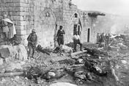
Syria and Lebanon Under the League of Nations’ rules, the mandate system required Great Britain and France to promote economic development in their mandates and to prepare them for self-government. The British and French took different approaches to achieving these goals. Britain ruled by controlling Arab leaders that it placed in power. France’s rule was more direct and resulted from a desire for long-term French control.
France sent large numbers of French officials, supported by an occupying army, to govern its mandate. They gave Muslim Arab leaders only limited opportunities to practice self-government. These policies were largely driven by three factors: concern for the Christian minority, which France had long pledged to protect; French investments in railroads, ports, and other economic activities made during the Ottoman Empire; and France’s rivalry with Britain for power in the Middle East.
The French organized their mandate into several governing districts based on cultural and religious differences. However, this division did not weaken Arab nationalism. Many minorities wanted a free and united Greater Syria too. That became clear in 1925 when a minority group called the Druze rebelled against French rule. They were soon joined by Arab nationalists from across the region in a revolt that took two years to put down.
Major changes followed the Druze Revolt. In 1926, the French separated Lebanon from the rest of the mandate and gave it a constitution and limited self-government. The constitution required that the three largest religious groups in Lebanon—Christians, Shi’a Muslims, and Sunni Muslims—share power. Lebanon’s president was to be Christian, its prime minister a Sunni, and the head of its legislature a Shiite. But Lebanon did not have total self-government. The French governor retained the right to veto actions of Lebanon’s government.
In 1928, France allowed Arabs in the rest of its mandate to form a limited government too. The government had an elected legislature controlled by Arab nationalists, and it wrote a constitution, approved by the French governor only after removing references to a united Arab state. In 1936, Arab leaders and French officials negotiated a treaty allowing limited independence for a nation to be called Syria. This was a much smaller nation than the united Arab state of Greater Syria that had existed briefly after World War I. The Syrian legislature approved the treaty, but France never did. In 1939, Syria’s elected government resigned and the constitution was suspended.
War and Independence Syria and Lebanon followed nearly identical paths to gain independence during World War II. After Germany occupied France in 1940, Hitler allowed the French to form a pro-Nazi government called the Vichy government. France’s former government leaders fled to Great Britain. They became what was called the Free French government.
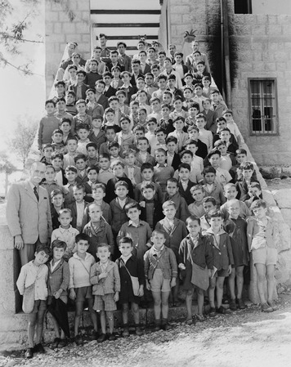
Vichy officials took over France’s Middle East mandate. However, they were driven out in 1941 by British, Arab, and Free French forces. The Free French officials who replaced them promised that independence would soon follow. The Free French allowed new elections in Syria and Lebanon in 1943. The elections again put the nationalists in power. Both governments passed laws and took other actions to end French rule. The French responded by arresting the leaders of Lebanon’s government. In Syria, French troops tried to restore control.
The British pressured Free French leaders to accept Lebanon’s autonomy in 1943 and Syria’s in 1945. However, the French refused to remove their troops. France’s other wartime Allies—the United States and Soviet Union—recognized both nations’ independence in 1944, which increased the pressure on France to withdraw. In 1946, the last French troops left Syria and Lebanon. British forces also withdrew, leaving both nations finally free.
The Legacy of French Rule While ruling their mandate, the French had made many improvements. They built roads, promoted improved agricultural practices, expanded education, and improved public health and education. The French enlarged the harbor in Beirut, a major trading port, and they improved public utilities in Damascus and other ancient cities. However, more than two decades of French rule had left many Arabs bitter.
In Syria, French policies prevented development of a strong system of democratic self-government. Lebanon was somewhat better prepared for autonomy. However, the system of government the French created there ensured the development of religion-based struggles for power. These legacies would shape the future of both nations.

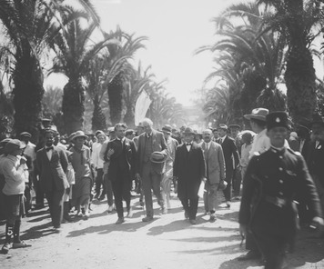
5. The British Mandates

In the secret Sykes-Picot Agreement of 1916, Great Britain and France decided that the region of Palestine should be handled differently than the rest of Greater Syria. Three world religions— Judaism, Christianity, and Islam—considered its ancient city of Jerusalem holy. Palestine also contained many other places that were sacred to one or more of these faiths. The British and French agreed that, for this reason, it should be under international rule. However, the British wanted to control the area because they believed its proximity to Egypt would help protect the Suez Canal.
In 1917, Britain issued the Balfour Declaration, announcing its support for “the establishment in Palestine of a national home for the Jewish people.” The declaration also pledged that “nothing shall be done which may prejudice the civil and religious rights of existing non-Jewish communities in Palestine.”
The Balfour Declaration reflected the growth of Zionism, a nationalist movement that called for Europe’s Jews to move to their ancient homeland. In part, this statement was designed to rouse support among American and European Jews for the Allies’ war effort—especially in Russia, where calls to withdraw from World War I were increasing. In part, this statement was an expression of genuine understanding and support for Zionism.
The other Allied powers endorsed the Balfour Declaration. The San Remo Conference abandoned the plan for international control in Palestine and made it a solely British mandate. This Mandate for Palestine included area between the Jordan River and the Mediterranean Sea and a larger region to the east, which was later called Transjordan. The special situation in the area west of the Jordan River, ultimately caused Britain to govern each region separately.
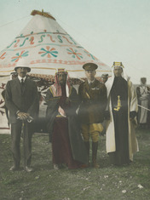
Transjordan Becomes a Nation Statehood for Transjordan was achieved fairly smoothly. In 1921, British authorities appointed Abdullah ibn al-Hussein emir of Transjordan. Abdullah was another son of Sharif Hussein and the brother of Faisal. The Bedouin tribes who lived in the region were willing to accept Abdullah as their ruler, which would help to unify Transjordan as a nation. Giving Abdullah his own country also encouraged him not to oppose France’s overthrow of Faisal as king of Greater Syria.
In 1923, Great Britain proclaimed Transjordan a nation preparing for independence under protection of the British. Technically it remained part of the Mandate for Palestine. That relationship was clarified by a treaty five years later that gave the British control of Transjordan’s finances, foreign policy, and army. Britain relaxed these controls slightly in 1936 to allow Transjordan to establish relations with other Arab countries.
The British provided financial aid to improve Transjordan’s roads, communications, education, and other public services. This aid also built a strong army, led by British officers, which Abdullah used to keep the area’s Bedouin tribes under control. Part of this army, a force called the Arab Legion, helped the British drive the Vichy French from Syria and a pro-Nazi ruler from Iraq during World War II. Six months after the war ended, another treaty with Britain gave Transjordan full independence, and Abdullah named himself king. In 1949, Transjordan officially became the Hashemite Kingdom of Jordan, or simply Jordan.
Tensions Over Palestine Growing anti-Semitism in Europe in the late 1800s strengthened the Zionist movement. After the Russian Revolution of 1905, persecution caused thousands of young Russian Jews to flee to Palestine. There they joined the small number of Jews who had lived in the area since it was a Jewish kingdom millennia before. By World War I, Palestine’s Jewish population numbered 85,000—compared to 535,000 Muslims and 70,000 Christians, most of whom were Arabs.
Over time Arab opposition to Jewish immigration grew. At first, Arabs viewed Jewish immigration with only mild concern. Some even felt that Jewish immigration would help the area modernize. In 1919, Syrian leader Faisal agreed to support Jewish settlement in Palestine. But his acceptance was based on the condition that the Allies recognize Greater Syria’s independence.
The British gained control over Palestine in 1917 and remained in control there for the next 30 years. British officials tried to keep peace between Arabs and Jews and to involve both groups in the Mandate’s economic development. Both goals proved difficult to achieve. Meetings of Arab leaders rejected the Balfour Declaration in 1920 and again in 1921, and anti-Zionist riots broke out in Palestine. In 1922, however, the League of Nations recognized the Jewish historical connection with Palestine. It authorized Britain to establish a Jewish homeland “while ensuring that the rights and position of other sections of the population are not prejudiced [damaged].”
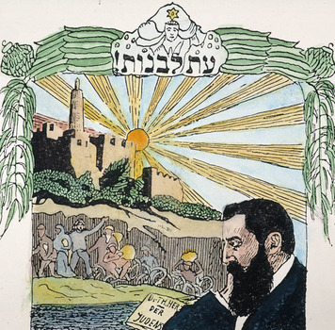
Jewish immigration slowly increased after World War I. In the 1920s and 1930s, Jewish and Arab populations grew by roughly the same amount. Since the Jewish population was smaller, this equal growth resulted in Jews becoming a larger percentage of the population. This increased Arab opposition to the growing Jewish presence.
By 1933, nearly 240,000 Jews lived in the Palestine Mandate—about 20 percent of the population. The Zionists were determined to settle as many Jews there and to buy as much land as they could. Palestinian Arabs were equally determined to slow both developments and to stop them if possible. The British, whose task it was to prepare the Palestine Mandate for self-rule, found themselves caught in the middle of this conflict.
The British created a workable government, made transportation improvements, and brought water and electricity to cities and towns throughout the region. Jewish leaders believed it was in their best interests to cooperate with the British. Arabs generally opposed British rule because of its support of Zionism and tensions between powerful Palestinian Arab families weakened Arab unity. As a result, the Jewish population often seemed to benefit more economically from British policies than the Arabs did.
Hitler’s rise to power in Germany brought a huge wave of mostly German Jewish immigration to the Palestine Mandate in the 1930s. This influx of Jewish immigrants alarmed Palestinian Arabs, who launched a major uprising in 1936. Arab workers went on strike, and militias attacked Jewish settlements and British military outposts. Britain sent 20,000 troops and finally put down the revolt in 1939. Meanwhile, the Zionists armed a Jewish militia force to protect themselves from these attacks that grew to 15,000.
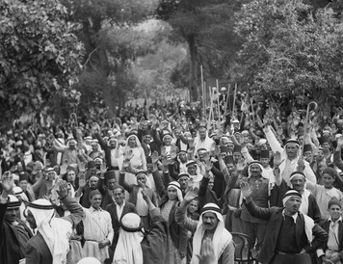
The Palestinian Revolt forced Britain to change its policies. British leaders feared that if war came in Europe, they would not be able to also deal with Arab unrest in the Palestine Mandate. In 1937, British leaders proposed dividing the Mandate into separate independent Jewish and Arab states. Arab leaders stated they would not accept any Jewish state. Zionist leaders stated they could not accept the proposal without negotiations over the borders. With tensions growing sharply in Europe in 1939, Britain withdrew its support for a Jewish homeland. The British promised that the Palestine Mandate would become an independent Arab state within 10 years. They also restricted the right of Jews to purchase land and limited Jewish immigration to 75,000 over the next 5 years and pledged that the Palestinian Arabs would set the limit after that.
The British announcement came as reports of the Holocaust, the Nazi effort to murder all of Europe’s Jews, were beginning to be made known. Jewish leaders in the Mandate were shocked and furious. However, there was little they could do at the time and many Zionists volunteered to help Britain’s war effort despite the restrictions.
As the war neared an end, however, radical Zionist leaders launched a guerrilla campaign against British rule. Assassinations, kidnappings, bombings, sabotage, and some acts of terrorism followed. The vast majority of Zionists, including the leadership, condemned terrorism and worked to stop it, for example, by reporting terrorist suspects to the British.
Meanwhile, the United States pressured Great Britain to let some 100,000 Holocaust survivors into the Palestine Mandate. Arabs responded to this development with additional violence. By 1947 the British had had enough. They turned to the newly formed United Nations to find a solution.
Iraq and Independence Like other Arabs, Iraqis expected independence after the Ottomans’ defeat in World War I. Instead, Iraq became a British mandate. When Arab nationalists resisted the French mandate in Syria in 1920, Iraqis also rose in revolt. As French forces deposed Faisal, the Arabs’ new king in Syria and brought an end to the independent Greater Syria, British troops put down the rebellion in Iraq.
After putting down the rebellion, Great Britain tried to reach a settlement with Iraqi nationalists. The British offered to make Faisal king of Iraq and to create an Arab government under the British mandate. Faisal accepted, with two conditions. He wanted the people to offer him the throne, and he wanted the mandate replaced by a treaty of alliance. Faisal’s selection as king was confirmed by a plebiscite in 1921. The next year the mandate was replaced by a treaty of alliance with Great Britain.
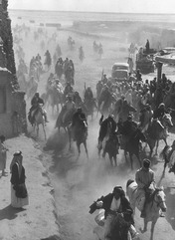
The constitution Iraq adopted in 1924 created a constitutional monarchy with a national legislature and parliamentary government. New treaties in 1926 and 1927 changed the Iraqi-British relationship, but nationalists continued to call for full independence. Britain finally announced that this would take place in 1932. Just before surrendering control, Britain set Iraq’s border with the British protectorate of Kuwait. This action was never approved by the government of free Iraq, however, and this would lead to future border disputes.
Faisal’s death in 1933 set off a power struggle among Iraq’s political leaders. His son took the throne, but instability followed. In 1936, the army took over and controlled Iraq’s government until 1941. During this period, Iraq enjoyed economic growth. Oil had been discovered in 1927. By the mid-1930s oil revenues were financing new railroads, schools, and irrigation projects. Oil also played an important role in Iraq’s foreign relations, especially during World War II and afterward.
When World War II broke out, Iraq remained neutral, despite its treaties with Great Britain. Iraq’s neutral position changed after Germany conquered France. Expecting the Allies to lose the war, nationalist leaders urged Iraq to free the Palestine and Syria Mandates from the British and French. Some called for an alliance with Germany and opened negotiations with the Axis Powers. Britain responded in 1941 by invading Iraq and putting a pro-British government back in power.

6. The Arabian Peninsula
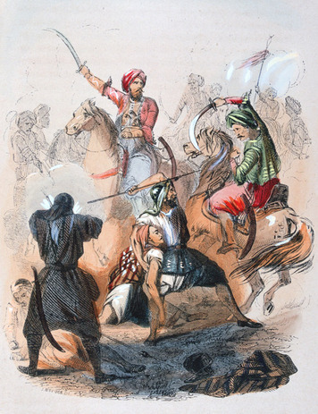
In contrast to events in the British and French mandates, Arabs on the Arabian Peninsula remained free from European control. Like Turkey, the nation of Saudi Arabia was shaped by the vision of its creator, Ibn Saud (IB-uhn sah-OOD). However, while Kemal Atatürk created a secular Turkey, Ibn Saud built his state around the teachings of Wahhabi Islam. Ibn Saud was the only Arab leader who was truly independent of the western powers between World Wars I and II.
The Kingdom of Saudi Arabia The first Saudi state arose about 1750, when local ruler Muhammad ibn Saud joined with Islamic religious reformer Muhammad ibn ‘Abd al-Wahhab to form a kingdom. The kingdom rose and fell several times over the next 150 years as Saudi rulers fought other Arab families, Egypt, and the Ottoman Empire for control on the peninsula.
In 1902, the Saudi ruler Ibn Saud recaptured Riyadh, the kingdom’s traditional capital, from a rival Arab leader and reestablished the Al Saud dynasty. By the end of World War I, he controlled most of the central peninsula. However, he worried that the British might oppose his further expansion. These suspicions grew when Britain put members of a rival Arab family—Abdullah and Faisal, the sons of Sharif Hussein ibn Ali, the ruler of the Hejaz—on the thrones in Transjordan and Iraq.
Ibn Saud addressed this concern in 1924, when he led a force into the Hejaz, seized the Muslim holy cities of Mecca and Medina, and drove Hussein from power. Ibn Saud then negotiated treaties to set his country’s borders with Transjordan and Iraq. In 1927, Britain recognized him as king in return for his pledge to respect the British protectorates on the peninsula. In 1932, he united the territories he ruled to form the Kingdom of Saudi Arabia. Ibn Saud became known as King Saud.
King Saud used his powerful personal leadership, religious values, negotiating skills, and marriage alliances to turn warring tribal factions into a strong, centralized government. His marriage alliances produced 37 sons. Along with other family members, they eventually took important roles in government. A large royal family developed that saw its welfare and that of Saudi Arabia as identical. The early years were difficult, however, because the kingdom was very poor.
At first, the annual Muslim hajj, or pilgrimage, to Mecca was the kingdom’s main source of revenue. The Great Depression of the 1930s caused a decline in the number of people making the pilgrimage, thus shrinking Saudi Arabia’s income. A greater source of income arose in 1938 when an American company discovered oil in Saudi Arabia. World War II delayed the start of production, but large numbers of foreign oil workers began arriving after 1944. The Saudi government joined with several American oil companies to form Aramco (the Arabian American Oil Company) to manage production and share the wealth.
The Persian Gulf Emirates Several regions along the Persian Gulf did not become part of Saudi expansion because they were British protectorates. They are known today as the United Arab Emirates (UAE) and the nations of Qatar, Bahrain, Oman, and Kuwait. Great Britain became interested in this region in the early 1800s, largely from a desire to protect its routes to India from Arab pirates.
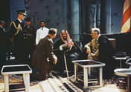
The British also did not want the Ottomans or any other of the Great Powers to create spheres of influence in the Persian Gulf. They worried that some of the 10 tribal families who ruled these regions might be pressured into turning over territory to an outside power. Between 1820 and 1916, the British concluded treaties with the sheikh, or tribal and family leader, in each region. Each treaty recognized the sheikh’s control within certain borders and stated that those borders could not be changed without Britain’s consent. In return, Britain promised to protect the sheikhdom.
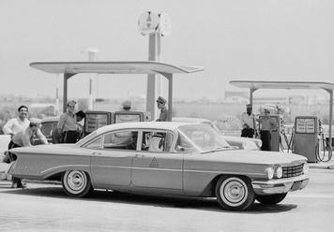
One result of these treaties was that they changed traditional tribal relationships. Tribal boundaries became clearer and tribal alliances became thought of in terms of land ownership. This became important when oil was discovered in Kuwait and Qatar in the late 1930s (and much later elsewhere). When foreign oil companies arrived to search for oil, they looked for the “owner” of the land. According to the British treaties, this meant the sheikh and his family. When oil production began, both became rich. Following Arab tradition, they distributed much of their new wealth to the region they controlled. At first this meant gifts for friends and food for anyone who needed it. Eventually, however, it paid for schools, hospitals, and roads in the sheikhdom.
Changing Control in Yemen The British captured Yemen’s port city of Aden in 1839. They gradually spread their control east along the Gulf of Aden. To the north, they came into conflict with the Ottoman Empire, which controlled the Hejaz along the Red Sea. In 1904, a treaty set the border between the two regions. North Yemen became independent at the end of World War I, when Turkish forces withdrew. South Yemen remained under British control. In 1937, Aden became a British colony. In the rest of South Yemen, the British negotiated peace among some 1,400 tribes and clans who had fought over the territory for decades and made it a British protectorate.

7. Colonialism in North Africa
By 1900, the power the Ottomans once had over North Africa was long gone. European imperialism began chipping away at that part of the empire in the 1830s and continued throughout the century. Only Morocco, which had successfully resisted Ottoman conquest, escaped European colonial rule. Nevertheless, it could not escape the Europeans’ battle for influence and control in the region.
Morocco’s location at the Strait of Gibraltar, which connects the Atlantic Ocean and the Mediterranean Sea, made it attractive to several European nations. France showed a strong interest as early as 1830. In the early 1900s, both France and Spain established spheres of influence there. In 1912, these spheres of influence became French and Spanish protectorates and remained so for the next 44 years.
France and the Barbary States The Mediterranean coast of North Africa extending west from Egypt was known in the early 1800s as the Barbary Coast. The four Muslim states that shared this coastline—Morocco, Algiers, Tunis, and Tripoli—were known as the Barbary States. Both names refer to the Berbers, a people indigenous to the area who had converted to Islam.
Pirates were a constant threat to traders along the Mediterranean coast. In 1827, France sent a government official to Algiers to discuss the situation. The Ottoman viceroy became angry and struck the Frenchman with a fly swatter. This insult provided the excuse for France to invade Algiers in 1830, bringing an end to three centuries of Ottoman control.
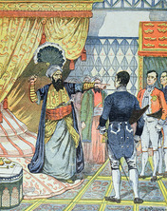
More than 40 years of unrest followed as thousands of Europeans poured in. They settled on Algerians’ land and took advantage of the native peoples. Frequent rebellions resulted. French troops brutally put down these revolts, seizing even more land and relocating its population to less desirable areas. When the fighting finally ended in the 1870s, nearly a third of native Algerians had died from disease, starvation, or warfare.
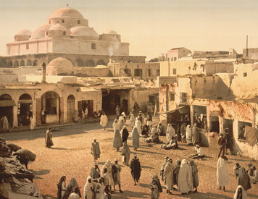
Although Tunis was officially a province of the Ottoman Empire in the 1830s, in reality it was an autonomous state. When the Ottomans overthrew the viceroy of neighboring Tripoli and reestablished direct control, Tunis turned for help to the French in Algiers. France responded with decades of military and financial aid. However, mismanagement, corruption, and unrest plagued Tunisian rulers. By 1869, Tunis was bankrupt and in debt to European banks. France forced Tunis to become a French protectorate in 1881. Although the Tunisian ruler remained in place, a French governor held all the real power.
The French strengthened the Tunisian finances, established modern communications, and developed mining and agriculture. But these improvements were not enough to dampen Tunisian nationalism. In the early 1900s, a group of French-educated Tunisians formed the Young Tunisians, a political party that called for less French control. A French crackdown drove the party’s leaders underground. They emerged again after World War I to lead a Tunisian nationalist movement.

A nationalist movement also arose in Algeria. About 173,000 Algerians served in the French army during World War I. Hundreds of thousands of others worked in factories in France. There they enjoyed a higher standard of living than they had at home. They also learned of democratic principles that French officials had long refused to apply to the Muslim majority in Algeria. Algerian soldiers who served with French forces in the Middle East were inspired by Arab nationalism. However, French officials and Algeria’s European settlers opposed reforms to give Algerians political power and equal rights.
By the 1930s many Algerians were supporting nationalist leaders who called for violent resistance to French rule. Tunisian nationalism also took a more radical turn. A demand for a constitution in the 1920s was answered by French troops and only minor reforms. French attempts to suppress a growing Tunisian independence movement in the 1930s only led to its spread and to greater unrest.
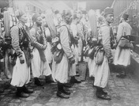
When World War II began, some Tunisian nationalist leaders were exiled to France. The Nazis released them after France fell and tried to gain their support. When Axis forces entered Tunisia, they were allowed to return home. There they joined the Tunisian ruler in forming a nationalist government. When the Free French regained control in 1943, this government was removed. After the war, Arab independence in the French mandate in the Middle East forced France to allow a nationalist government in Tunisia. During this period, the Tunisian independence movement continued to grow.
Algeria was not invaded by Axis troops. However, Axis radio broadcasts beamed into Algeria promised Muslims a better world after the war. The Free French responded in 1943 by offering French citizenship to some groups of Algerian Muslims. However, this limited reform did not change Algerian public opinion. In 1945, French authorities fired on peaceful demonstrators who were displaying Algerian nationalist flags. Thousands of Muslims were killed as French forces put down the violent uprising that followed. This event became the first battle in Algeria’s long war for independence that began in the 1950s.
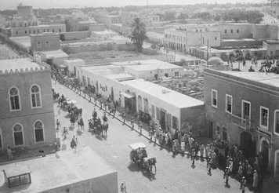
Italian Colonialism Italy gained a sphere of influence in Tripoli in the mid-1800s. By the early 1900s, Italian businesses had important commercial interests there. When the Ottomans failed to agree to demands to protect those interests, Italian troops invaded Tripoli and occupied it in 1911. Although they quickly defeated its Ottoman defenders, the native population proved harder to subdue. Years of warfare followed before Italy finally gained control. Meanwhile, it spent huge sums of money building towns, roads, and agricultural colonies for Italian settlers. In 1934, Italy united the region to form a colony called Libya.
Allied troops drove Italian and other Axis forces out of Libya during World War II. The British and French each governed part of Libya until 1951, when the United Nations granted it independence.
The British in Egypt In 1859 the Ottoman viceroy of Egypt authorized a French company to dig a canal across the strip of land that separates the Mediterranean and Red Seas. The Egyptian government had part-ownership of the Suez Canal, which opened in 1869. The canal cut the distance between Great Britain and India in half. When heavy debts forced Egypt to sell its share in 1875, the British government bought it and became the canal’s largest single owner. By 1881, more than 80 percent of the traffic through the canal was British.
In 1879, Egypt’s debt problems caused the European powers to demand that the viceroy be removed. The Ottoman sultan appointed a new viceroy. However, Egyptian nationalists, angered over the Europeans’ influence, rose in revolt. British troops invaded Egypt in 1882 to protect the Suez Canal and put down the rebellion. They remained for 74 years. The occupation made Egypt part of the British Empire. It was not a colony because officially the viceroy’s government continued to rule. However, the real power in Egypt was a British governor called an “agent,” backed by British troops. The British put Egypt’s financial problems in order. They cut spending, paid the debt, and used what money remained on agriculture and railroads. Education received little attention. This policy upset many Egyptians. They were also angered by the number of British in important government jobs, which denied Egyptians the opportunity to gain experience in self-rule.
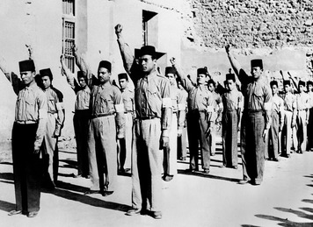
In the early 1900s, Egypt’s nationalists began calling on the British to get out. Instead, when the Ottoman Empire joined the Central Powers in 1914, Britain made Egypt a protectorate and placed it under martial law. Egypt’s Legislative Assembly was suspended and nationalist leaders were temporarily silenced. Thousands of Egyptians were forced into work supporting the British war effort.
Egyptian nationalism emerged from the war even stronger. A nationalist political party called the Wafd formed in 1918 to seek independence. It quickly became a powerful political force. Britain’s arrest of Wafd leaders in 1919 set off weeks of strikes, demonstrations, rioting, and acts of sabotage across Egypt. British troops crushed what Egyptians call the 1919 Revolution. Hoping to head off further trouble, Britain ended its protectorate and declared Egypt independent in 1922. A constitution was written and a legislature elected. An Egyptian king, Fu’ād I, took the throne. Little else changed, however. British troops remained in Egypt and the power struggle continued until World War II. This time the struggle was among the British, the Wafd, and the king.
The Wafd controlled Egypt’s legislature until the mid-1930s. Both the king and the British worked to break its power. In 1925 and again in 1928 Fu’ād dissolved the legislature and ruled alone. He also encouraged the formation of other political parties. Meanwhile, the British lured the Wafd into supporting an unfavorable treaty. When Fu’ād died in 1935, his son Farouk took the throne and signed the Wafd-backed treaty. Although the treaty reduced British control, it still did not give Egypt full independence. Many Egyptians blamed the Wafd. Some began to support newer, more radical nationalist groups like the Muslim Brotherhood and Young Egypt. The Wafd lost control of Egypt’s legislature in the elections of 1936.
The Wafd returned to power, with British support, during World War II. Early Axis victories in Europe increasingly convinced Egyptians that Germany would win the war. Many were pleased at this prospect because of their dislike for the British. Some groups, such as Young Egypt, openly supported the Nazis. The British were determined to prevent Egyptian cooperation with Germany. In 1942, as German troops advanced on Egypt, Britain ordered King Farouk to form a Wafd-controlled government. New elections at the end of the war ended the Wafd’s power and the party split into competing groups. Popular support swung toward organizations like the Muslim Brotherhood, which continued to push for the end of British control.

Summary
In this lesson, you learned about imperialism in North Africa and the Middle East and changes that took place there in the first half of the 20th century.
Cultural Interaction The Ottoman Empire’s subjects enjoyed religious freedom, but tensions often existed among religious groups because of mutual intolerance. The sultan failed to unite the empire’s Muslims against the Allies in World War I. After the Ottoman empire’s breakup, the Turks formed a secular government.
Political Systems As the Ottoman Empire declined, Great Britain and France took advantage of its weakness to control large parts of North Africa and the Middle East. Their presence was met with growing nationalism. By the end of World War II, Turkey, Syria, Lebanon, Jordan and Iraq had all established their own governments. However, except for Saudi Arabia, the rest of the Middle East and all of North Africa remained under Western control.

