Unit 23- The Rise of Fascism and Totalitarian States

1. Introduction
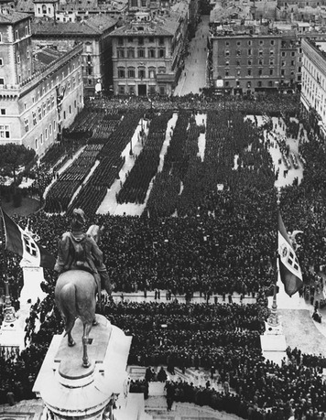
“The world must be made safe for democracy,” President Woodrow Wilson declared as the United States entered World War I in 1917. However, the Central Powers’ defeat did not produce that result. Hopes for democracy were soon crushed by the disappointing peace that followed—a peace in which even some of the war’s winners felt more like losers.
Anger seethed on the losing side as well. Resentment was most prominent among the Germans, who suffered from the harsh terms of the Treaty of Versailles peace settlement. While bitterness festered, nations also struggled to rebuild war-torn economies.
As a result, the peace of the 1920s was a troubled one, marked by instability within nations and between them. Unrest intensified in the 1930s, as the Great Depression that began in the United States spread around the world. The hard times that followed, when added to tensions that already existed, caused people in some countries to support autocratic leaders who promised order, prosperity, and a better future. To many, the sacrifice of freedom these leaders demanded seemed a fair price to pay for the benefits they offered. Dictatorships developed in Germany, Italy, the Soviet Union, Hungary, Portugal, Poland, Romania, and elsewhere.

Themes
Cultural Interaction Fascism was an ideology that placed patriotism, loyalty to strong leaders, and the welfare of the state above the rights and freedoms of its citizens.
Political Systems The political and economic disorder that resulted from World War I and the Great Depression helped communism and fascism to spread and totalitarian dictators to gain power.
Economic Systems Under both fascism and communism, many economic activities are tightly controlled by the government.

2. Italy Under Mussolini
Italy took a position of neutrality when World War I began. However, secret and sometimes vague offers of territory in Europe, Africa, and Asia Minor lured Italy to join the Allies against the Central Powers in 1915. The war proved highly unpopular among Italian troops—who were mostly peasants forced to fight for a cause they did not understand. Thousands of factory workers at home, compelled to work under military discipline, also opposed the war. By war’s end, bread riots, strikes, and other antiwar protests required troops to restore order. In addition, the peace settlement gave Italy less territory than Italian leaders expected.
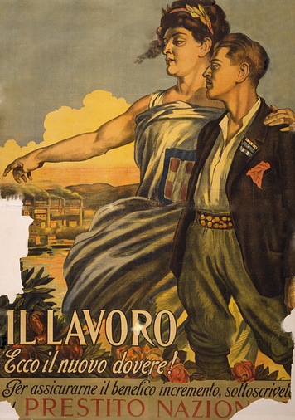
Post-War Problems and Unrest Italy’s small gains from the war came at great cost. Some 600,000 Italians were killed and another 950,000 were wounded. Money the government had printed to pay for the war caused disastrous inflation. By 1920, the lira (Italy’s unit of currency) was worth only a sixth as much as before the war. Prices soared and savings lost value as a result. Meanwhile, unemployment rose as the government cancelled orders for wartime goods. Adding to the economic crisis, jobless workers had to compete with returning soldiers for whatever work was available.
Strikes became widespread as unions demanded higher wages. Food shortages developed as farm workers went on strike. Other strikes paralyzed railroads and mail delivery. Massive rioting and industrial strikes plagued many of Italy’s urban regions. In rural areas, peasants seized land from large landowners. Socialists and radical Catholic reformers led much of this unrest, although the two groups opposed and distrusted each other.
By 1920, the Socialist Party held the largest number of seats in Italy’s parliament. Catholic reformers also had formed a political party called the Popular Party. Together, the two parties controlled the national government and almost half of Italy’s city governments. Some socialists called for a revolution like Russia’s 1917 Bolshevik Revolution. In 1921, radical socialists formed the Italian Communist Party.
Many Italians were greatly alarmed by these developments. Bands of war veterans, nationalists, students, and others attacked socialist reformers, destroyed socialist newspapers and labor union offices, and broke up strikes. Wealthy landowners and industrialists, who opposed socialism, gave money to help these groups operate. A war veteran and former socialist named Benito Mussolini led one of these right-wing antisocialist groups.
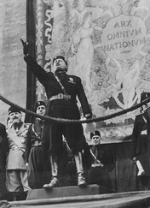
The Rise of Mussolini After holding various jobs, including two as a schoolteacher, Mussolini became the editor of Italy’s leading socialist newspaper in 1912. However, he resigned from this job after deciding to support Italy’s entrance into World War I and he was then expelled from the Socialist Party. Others who supported his pro-war views gave him the money to start a new paper, Il Popolo d’Italia (The Italian People). After he was wounded in the war, Mussolini returned to his newspaper. Claiming to speak for soldiers and workers, he used the newspaper to attack socialists as unpatriotic traitors. He suggested that a dictator was needed who could deal with Italy’s social and economic problems effectively.
In early 1919, Mussolini organized a new political movement. At first, his followers numbered fewer than 200. They were a mix of war veterans, former socialists, revolutionaries, and other discontented persons. Mussolini called them the fascio di combattimento (fighting band). The name arose from the fasces—bundles of birch rods bound with strips of leather—that were symbols of authority in ancient Rome. They illustrated the idea of strength through unity and give the term fascism its name.
Mussolini’s group was based in Milan, a city in northern Italy. Similar groups arose in other cities. These groups operated independently, but they took their inspiration from the ideas, words, and actions of Benito Mussolini. Each group included “action squads” that patrolled their cities, attacking organizations of socialists, communists, republicans, Catholics, and trade unionists. These armed bands soon controlled many rural areas as well. They were named the Blackshirts for the shirts that were part of their uniform.
Mussolini organized his followers into a political party in 1921. Surrounded by black-shirted supporters, he inspired crowds at fascist rallies with his grand gestures and dramatic speaking style. His facts were often wrong and his attacks often misdirected, but crowds became caught up in the anger, strength, and resolve he projected. Backed by industrialists, large landowners, shopkeepers, and other members of the urban middle class, the number of fascists grew from less than 1,000 in 1920 to more than 250,000 by mid-1922. Fascists captured 35 seats in Italy’s parliament in the 1921 elections and became part of the ruling coalition.
Mussolini Takes Power Mussolini had little respect for Italy’s democratic government, which he regarded as weak and ineffective. At a rally of 40,000 party members in October 1922 he declared, “Either the government will be given to us, or we will seize it by marching on Rome.” A few days later, as 25,000 Blackshirts marched toward Rome, Italy’s prime minister prepared to call out the army to crush them. However, the king, fearing an army revolt or civil war, instead appointed Mussolini prime minister and asked him to form a new government.
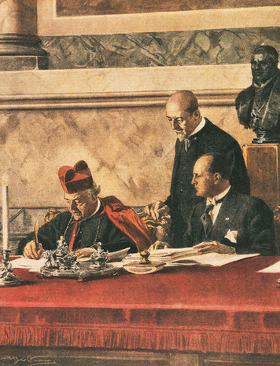
For the next 18 months, Mussolini headed a coalition government while he gradually concentrated power in his own hands. He made his Blackshirts into Italy’s national militia. Mussolini also pushed a law through the legislature that allowed the Fascists to secure a majority in parliament in 1924. When the leader of the Socialist Party declared that the elections were a fraud, he was murdered by a Fascist thug with connections to Mussolini’s government. The opposition parties quit parliament in protest. With the opposition gone, Mussolini began reshaping Italy into a totalitarian state. A law passed by the Fascist parliament in December 1925 effectively made him a dictator and he took the title of Il Duce (the Leader).
Only the Catholic Church, headquartered at the Vatican in Rome, remained free of Fascist rule. Mussolini cleverly gained the Church’s cooperation in 1929 by signing a treaty with the Pope. The treaty made Vatican City an independent state. It also recognized marriage laws of the Catholic Church as Italian state law, and allowed the Church to provide religious education in Italian schools. Catholic officials were persuaded to accept Fascist rule in order to preserve these benefits.
Life Under Fascist Rule “Fascism denies that the majority, by the simple fact that it is a majority, can direct human society,” Mussolini declared. “[I]t denies that numbers alone can govern by means of a periodical consultation”—that is, elections. Thus, elections were abolished. Local mayors and town councils were replaced by appointed officials. Opposition parties and labor unions were dissolved, and Fascist thugs killed some of their leaders.
“[A]ll individuals or groups are relative, only to be conceived of in their relation to the State,” Mussolini wrote to explain fascism in 1932. This part of fascist philosophy meant an end to basic individual rights and freedoms. Freedom of speech and the right to assemble disappeared. The press was tightly censored, as were two new forms of media—motion pictures and radio. Slogans such as “Mussolini is always right” and “Believe! Obey! Fight!” covered public buildings and schools. New textbooks reflecting the Fascist view of the world appeared in classrooms. Parents were strongly pressured to enroll their children in Fascist youth groups. Control was carried out by the army and police—and through a huge network of spies and secret police. Special courts were set up to try anyone who opposed fascism or Il Duce. Thousands of Italians were imprisoned or sent to live on remote islands.
Many Italians, especially among the middle class, accepted these changes. Tired of strikes, riots, and other chaos, they were willing to submit to dictatorship if Mussolini could restore order and economic prosperity.
The Corporate State In 1926, Mussolini began to manage Italy’s economy according to a principle called corporatism. The workers in an industry became part of a government-supervised organization called a corporation. The industry’s employers also had a corporation. In 1934, a government decree joined these groups to create corporations of both workers and owners for 22 major industries. The businesses in these corporations remained privately owned. However, within each corporation, representatives of workers, owners, and the government set prices, wages, and hours of labor.
This program helped Italy develop modern and efficient steel, power, chemical, and other industries, which helped the nation to weather the Great Depression. The huge public works programs Mussolini launched in the 1930s also helped Italy combat the Depression. Thousands of unemployed workers found jobs building roads, draining swamps, and building new towns on the reclaimed land.
Mussolini’s social and economic programs won him the admiration of those who had become disappointed in liberalism and democracy. Many hailed him as a genius for his success in transforming his divided and demoralized nation. By the late 1930s, however, his foreign policy was causing many people in Italy and elsewhere to change their opinions about him.
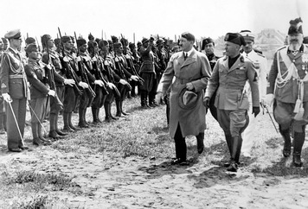
Mussolini’s Foreign Policy Mussolini was among those who felt betrayed by the Allies when they divided the German and Ottoman empires after World War I. Italy was largely denied any new territories in Africa and the Middle East. Mussolini told Italians that he would rectify this disappointment and restore Italy to the glory days of the ancient Roman Empire. He began to fulfill this pledge in 1935 by invading the East African nation of Ethiopia. In Ethiopia, the Italian army acted with great brutality. They carried out massacres and used poison gas, which horrified the rest of Europe. His aid to fascist forces in a civil war in Spain cost him even more international support. It also began to arouse opposition at home.
As other European leaders turned on Mussolini, he drew closer to another fascist dictator—Germany’s Adolf Hitler. In 1939, he allied Italy with Germany in a treaty called the Pact of Steel—an alliance that led to Italy’s disastrous involvement in World War II. Military disaster in World War II eventually led to Mussolini’s overthrow in 1943 and his death at the hands of the Italian

3. Hitler and Nazi Germany
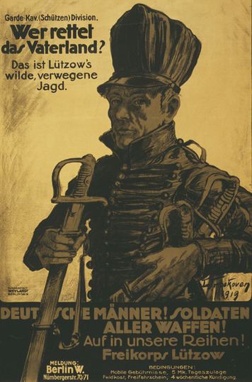
As Italy moved toward fascism after World War I, Germany moved toward democracy—at least at first. In November 1918, two days before Germany’s surrender in World War I, the German emperor fled the country and German leaders formed a republic. A National Assembly was elected to write a new constitution. The assembly met in early 1919 in the city of Weimar (VY-mahr).
The constitution that emerged was remarkably democratic. The head of government would not be a monarch, but a president elected by the people. Women gained the right to vote—a right that did not yet exist in the United States. Finally, the constitution granted everyone, including radicals who opposed democracy, the right to spread their views.
The new government of Germany was called the Weimar Republic, after the city where the new constitution had been written. Even after the government relocated to Germany’s capital Berlin in the spring of 1920, the name stuck.
Instability and Unrest The Weimar Republic was in trouble from the beginning. One huge problem it faced was that some of its leaders had signed the hated Treaty of Versailles in June 1919. The treaty stripped Germany of its overseas empire and took territory from Germany itself. It forced Germany to sign a “war guilt” clause, in which Germany had to accept responsibility for starting the war. It also required Germany to pay billions of dollars in reparations for the harm the war had caused. Many Germans viewed the leaders who signed the treaty as traitors. Some began to question if the leaders of the new republic were responsible for Germany’s defeat on the battlefield as well. These attitudes undermined the political legitimacy of the Weimar Republic from its very beginning.
In addition to facing huge payments for war damages, Germany suffered other hardships after the war. Peace did not bring a return to economic prosperity. Food shortages continued and unemployment remained high. The country was racked by strikes, street violence, and threats of revolution from both the right and the left. Organized armed groups known as Freikorps sprang up. Led by former army officers, their ranks included ex-soldiers, unemployed workers, and general malcontents. Most were intensely nationalistic and radically right-wing. In March 1920, one of these bands briefly seized control of the government, hoping to restore the monarchy. The coup (koo) collapsed when communists and socialists called a general strike that paralyzed Berlin.
Germans’ discontent with the republic was demonstrated when in the first elections, held in June 1920, the Weimar government lost its majority. More than 25 percent of the members elected to the Reichstag, Germany’s parliament, wanted to abolish the constitution. No group ever again held a majority of the seats. A series of unstable political coalitions tried to rule. More than a dozen coalition governments were formed by 1930. None of them was able to take effective action on major problems.
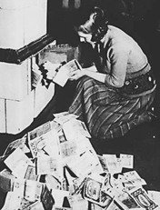
Trying to stimulate the economy, win public support, and deal with their massive war debt, the government printed huge amounts of money. Runaway inflation resulted. In 1920, a U.S. dollar was worth 40 German marks. Two years later, it was equal to 18,000 marks. By mid-1923, the mark was losing value with astonishing speed. In one instance, the price of a loaf of bread rose from 20,000 marks to 5 million marks in one day. By the end of 1923, inflation had spiraled so out of control that one U.S. dollar equaled 4.2 trillion German marks. Wheelbarrows were needed to carry enough money to pay for daily purchases. A lifetime’s worth of savings could no longer even buy the most basic necessities. The finances of people living on fixed incomes were utterly devastated.
The chaos caused by out of control inflation inspired radicalism in German society, on both the left and the right. Communists saw the opportunity for a Bolshevik-style revolution. Freikorps forces put down left-wing revolts throughout Germany. In Munich, Adolf Hitler, the leader of the right-wing National Socialist German Workers’ Party, also saw opportunity in the unrest caused by the economic crisis.
Hitler and the Nazis Like Mussolini, Hitler served in World War I. He was born and raised in Austria but moved to Munich, Germany, in 1913. After the war broke out, he volunteered for the German army. He served throughout the war but was eventually wounded. He was recovering in a hospital when Germany surrendered. Hitler was disappointed and enraged over the war’s outcome. He viewed the German leaders who signed the surrender and the Treaty of Versailles as criminals.
After his discharge from the hospital, Hitler returned to Munich in 1919. He soon joined the small, right-wing German Workers’ Party, which had been founded in the city earlier that year. In 1920, the party changed its name to the National Socialist German Workers’ Party, also known as the Nazi Party. The word Nazi was derived from the German words for National Socialist.
Hitler worked hard to increase party membership. Munich was home to large numbers of unhappy war veterans and people who opposed the Weimar Republic. Some 30,000 Freikorps members lived in the region. Hitler brought many of them into the party. The Nazis rewarded his efforts by making him their leader in 1921. One of his first acts was to form the party’s Freikorps members into a private army. They became the SA (from the German term for Storm Division), or Brownshirts for the uniform they wore. Like Mussolini’s Blackshirts they provided security at rallies, marched in parades, and terrorized communists and other enemies of the party.
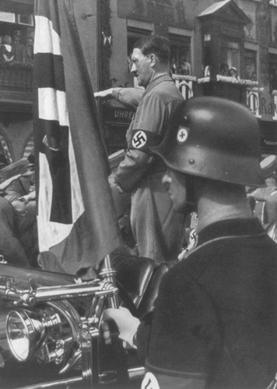
Hitler also created a 25-point platform for the Nazi Party It called for Germany’s rejection of the Treaty of Versailles and the expansion of German territory to include all German-speaking peoples. Other goals included the denial of citizenship and political power to those who were not ethnically German—and especially to Jews. Hitler proclaimed that Germans were superior to all other people and that Germany’s problems were the fault of its two greatest enemies, communists and Jews. He condemned the Weimar government for failing to solve Germany’s problems and pledged to restore Germany to greatness by creating a Third Reich—a third German Empire to replace the one stripped by the Allies.
This message appealed to many unemployed ex-soldiers, small farmers, and members of the lower middle class. By 1923, the Nazi Party had about 55,000 members. Hitler decided that it was time to take action. In November 1923, a force of Brownshirts and other Nazi supporters tried to seize the Bavarian state government in Munich. Hitler expected that other groups also agitating against the Weimar government would support him. They did not, and the coup failed following a gun battle with police. Hitler was arrested and jailed for nine months. He used this time to write a book, Mein Kampf (My Struggle), which outlined his plans for restoring Germany to greatness.
Hitler’s Rise to Power After his release from prison in 1924, Hitler worked to rebuild the Nazi Party. He decided to take power through legal means. He would organize a national party able to gain power through elections and use propaganda to attract mass support. Nazi groups soon sprang up throughout Germany. By 1928, party membership exceeded 100,000. However, in that year’s Reichstag (the German parliament) elections only 12 Nazis were elected to the 463-member parliament.
Four years later, everything had changed. The reason was the Great Depression. After the American stock market crashed in late 1929, U.S. loans to Germany stopped. The German economy depended on these loans. Unemployment rose from 8.5 percent in 1929 to 30 percent by 1932. Industrial production was cut nearly in half and German exports fell by two-thirds. Banks failed and credit dried up. As farmers went bankrupt, food shortages reappeared.
The Nazis launched an intense propaganda campaign. It emphasized a message that would appeal to unemployed workers, farmers, and young people eager to support the ideals of German nationalism. The Nazis said that the Treaty of Versailles, the Weimar government, communists, and Jews were responsible for the economic crisis. They promised to restore order, prosperity, and national pride to Germany. The Nazi message also appealed to middle class Germans who were being hurt by the Depression or had lost status during the 1920s. By the end of 1932, the party had more than 1.4 million members.
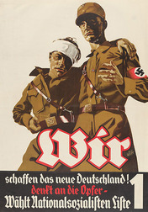
The desperate times made voters more willing to accept the Nazis’ extreme views. In the 1930 elections, the number of Nazis in the Reichstag jumped from 12 to 107. In 1932, the number reached 230. Although not a majority, the Nazis were by far the largest party in parliament. After months of delay, in January 1933 the republic’s president, Paul von Hindenburg, reluctantly appointed Hitler as chancellor—the top position in the cabinet.
Hitler in Control Once in power, Hitler moved quickly to end the republic and create a fascist totalitarian state. In March 1933, the Reichstag building was destroyed by fire. Hitler blamed the Communists and convinced President Hindenburg to authorize the Brownshirts to crush them. He also convinced the Reichstag to pass a law that gave him personal emergency powers to govern. Hitler used this law to bring Germany totally under Nazi control. All other political parties were banned. Nazis were appointed to head all state and local governments. Labor unions were dissolved and replaced with Nazi organizations. After Hindenburg died in 1934, Hitler combined the offices of president and chancellor and took the title of Führer (Leader).
Hitler also crushed all possible rivals, even those within the Nazi Party. During one night in June 1934, he had the head of the SA and many other SA commanders killed. Political opponents outside the party were also murdered. Hitler turned to the SS (SchutzStaffel or “Defense Corps”)—elite troops who pledged personal loyalty to the Fuhrer—to be his private army.
The SS was responsible for Germany’s internal security. Some units acted as police and rounded up people who the Nazis considered to be enemies of the state. Arrests, which at first focused on communists and socialists, soon extended to other groups—and especially to Jews. The SS was aided by the Gestapo, Nazi Germany’s secret police. Gestapo officers used torture, terror, and other brutal methods to gain information.
The Nazis gradually took control of all phases of German life. Most Germans supported Nazi rule, or at least accepted it. They were tired of the instability and unrest that characterized the Weimar Republic. Many welcomed the strong and seemingly effective government the Nazis provided. Unemployment fell as jobless Germans went to work on huge public-works projects. Many found work in weapons factories as Hitler prepared to restore Germany’s military power. Many Germans who opposed Nazi rule fled the country. Most of the rest were frightened into silence, hoping that Hitler would eventually be overthrown.
The Campaign Against Jews Hitler had explained his intensely anti-Semitic views in his book, Mein Kampf. He wrote that Jews were “a parasite within the nation” and “a menace.” He came to view them as the incarnation of evil. Within days of taking control, Hitler began his campaign against German Jews. It started with Brownshirt attacks on Jewish communities across Germany. The police did not stop the attacks. Violence against Jewish businesses and their employees caused many of them to close down. SA and SS members put up signs warning the public not to enter stores owned by Jews. Later, all Jewish businesses had to display signs indicating their Jewish ownership.
The Nazis tried to eliminate Jews from Germany’s economy by limiting their ability to work. In April 1933, all Jews in government jobs were forced to resign. In January 1934, they were banned from working for any non-Jewish business. They were also banned from farming. Their land was seized and turned over to non-Jewish farmers. Limits were set on the number of Jews who could teach school or practice medicine or law. Jewish communities set up organizations to help the unemployed.

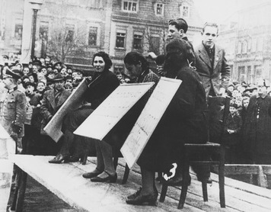

4. The Spanish Civil War
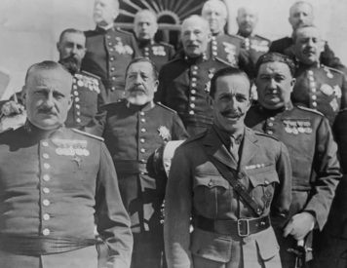
Although Spain was neutral in World War I, it was involved in a war in Morocco. As a result, Spain suffered from much of the same unrest that plagued Italy and Germany in the post-war years.
Morocco had become a French and Spanish protectorate in 1912. When some Moroccan tribes resisted Spanish rule, Spain sent troops to conquer them. A long and costly war resulted. Fighting continued until 1926. Meanwhile, at home, the war grew increasingly unpopular. Calls for more troops sparked riots, and disorder spread throughout Spain. Radical protesters burned churches and convents. Communist agitators, strikes, and assassinations contributed to the unrest.
Spain’s king and parliament seemed incapable of either restoring order or winning the war. In 1921, the king authorized a “final” campaign for victory in Morocco. The offensive ended in a terrible massacre of Spanish troops and caused a political crisis. The crisis ended when a coup led by General Miguel Primo de Rivera toppled the government in 1923. Although the king remained on the throne, Primo de Rivera dissolved the parliament and ruled as dictator. The army, with support from conservatives wanting social order, kept him in power.
Primo de Rivera brought the Moroccan War to a successful end. His economic policies and public works programs benefitted Spain and reduced unemployment. By 1930, however, he had lost the support of the army and the king forced him to resign. But the king’s years of cooperation with a dictator had cost him public support. A year later, he too stepped down, and Spain became a republic.
The Spanish Republic A left-wing government was elected in 1931. Its main support came from the working class. Government leaders pledged to convert Spain to socialism through the democratic process. They began a series of land and labor reforms and weakened the power of the Catholic Church by putting education under state control. However, the left became divided over the pace of change. This split allowed a right-wing government supported by wealthy Spaniards and the Church to be elected in 1933. The new government reversed the reforms. Revolts broke out across Spain, which authorities quickly suppressed.
The left-wing parties united into a coalition called the Popular Front, hoping to regain control of the government. The other parties formed an opposing coalition called the National Bloc. One of its members was the Falange, a new party inspired by Italian fascism. When the Popular Front won the 1936 elections, riots and other unrest followed. The National Bloc begged the army to save Spain from socialism and communism.
Civil War and the End of the Republic In July 1936, army units in Spain rose in revolt. They were joined by General Francisco Franco, commander of the Spanish army in Morocco. Franco moved troops across the Strait of Gibraltar and invaded southeastern Spain. Another rebel general seized parts of the north. The rebels chose Franco, a hero of the Moroccan War, as their leader. Backed by the Falange, he set up a government in the northern city of Burgos. It was a fascist military dictatorship in which Franco assumed the title of Caudillo (“Leader”).
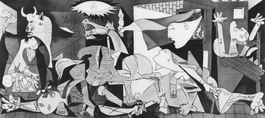
The rebel government ruled only part of the country. The Popular Front remained in power in other regions, including many of Spain’s cities. In some places, militias of workers armed by the Popular Front helped army troops overthrow their upper-class officers. These troops remained loyal to the left-wing government. A bloody, three-year civil war followed as each government tried to win control over all of Spain. Supporters of the Popular Front, the republic’s elected government, took the name Republicans. The rebels called themselves Nationalists.
Because of their close connection with the fascist Falange party, the Nationalists received aid from Hitler and Mussolini. Italy sent 70,000 troops while Hitler provided warplanes and pilots. Both also supplied tanks and artillery and the soldiers to operate them. The Republicans were aided by some 60,000 anti-fascists, republicans, communists and other volunteers from foreign nations. About 40,000 of these foreigners fought in what were called the International Brigades, largely under communist commanders. The Soviet Union supplied the Republicans with tanks and aircraft.
Both sides used harsh methods to control unrest in the regions they ruled. However, the Nationalists were especially brutal. They pursued a deliberate policy of terror. Franco used his German air force to bomb Madrid and other population centers. In the end, his army’s superiority exhausted the Republican forces. In March 1939 the Nationalists finally seized Madrid. The Republican government and some 500,000 soldiers and civilians fled across the border into France.
Franco’s Spain Peace did not end the Nationalist terror. For years after, Franco continued to rule using the emergency powers he gained during the war. After World War II, hostile world opinion labeled him the “last surviving fascist dictator” and Spain remained largely isolated by the world community. Although he loosened his hold on power slightly in his final years, his dictatorship continued until his death in 1975.

5. Stalin and the Soviet Union
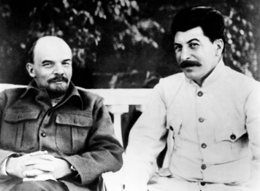
Vladimir Lenin’s death in 1924 set off a power struggle for leadership of the Soviet Union. Joseph Stalin eventually won this struggle. By 1929, he had gained control of both the Communist Party and the Soviet state.
Stalin’s Rise to Power Unlike most Communist leaders, Stalin was not a Russian. He was born and raised in Georgia, a region north of Turkey on the Black Sea that Russia had long controlled. He learned Russian in school and always spoke it with a distinct Georgian accent. After being expelled from school in 1899, he got involved with radicals who were working to overthrow Russia’s czar. He joined the Social Democrats and when they split in 1903, he sided with the Bolsheviks and became a devoted follower of Lenin.
By 1912, Stalin had been arrested six times for revolutionary activity. He had also changed his real surname to Stalin—derived from stal, the Russian word for “steel.” In 1912, Lenin appointed him to a leadership position on the Bolshevik Party’s Central Committee. Stalin was arrested again in 1913 and exiled to Siberia. When he was allowed to return in 1917, he did not go back to Georgia. Instead he went to St. Petersburg, Russia’s capital, where Czar Nicholas II had just been overthrown. Stalin played a major part in the October Revolution that finally brought the Bolsheviks to power, and in the civil war that followed.
In 1922, Stalin became the Central Committee’s secretary general—the head of the branch that handled the party’s daily operations. Other top Communists thought his job, with all its paperwork, was routine and boring. However, Stalin used it to influence the membership of important committees and appointments to key party positions. These tactics allowed him to build support in the party while weakening Lenin’s expected successor, Leon Trotsky.
After Lenin’s death, Stalin allied with two other top Communists to remove Trotsky from party leadership in 1925. He then formed another alliance to oust these allies. When he was strong enough, he used his position as secretary general to remove this second set of allies as well. Trotsky went into exile in Mexico, where Stalin had him murdered in 1940.
The Soviet Economy Stalin continued to support the Comintern, the organization Lenin created to encourage communist revolutions around the world. However, Stalin’s main goal was to make the Soviet Union a strong, modern, industrial nation. He replaced Lenin’s New Economic Policy (NEP) with another approach to the economy. He set production goals for a five-year period. This policy meant a return to war communism—the command economy that had followed the 1917 revolution.
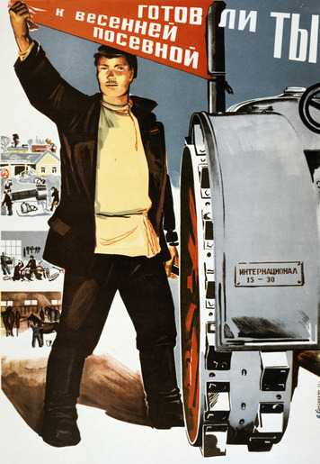
The First Five-Year Plan focused on industry and agriculture. The authorities seized the small businesses that Lenin had allowed under the NEP. Rural peasants were forced to merge their lands to create large, state-owned farms called “collectives.” Those who resisted faced attack by Russian troops. Thousands of peasants were arrested by Stalin’s “political police” and executed or worked to death in concentration camps in Siberia.
By 1932 Soviet society and the economy were under great strain. Most industries were failing to meet their goals. Agricultural production was down, but production quotas were set unrealistically high. In the Ukraine, foodstuffs were taken by government agents to meet the quotas, leaving too little food to support the population. About five million Ukrainians died from starvation between 1932 and 1933.
Nevertheless, Stalin announced that the First Five-Plan had met its goals and ended it a year early. He launched the Second Five-Year Plan in 1933. That plan focused on producing goods for the people. Its goals were more realistic and industrial output increased. In 1938, a Third Five-Year Plan shifted emphasis to weapons production, as Hitler pushed Europe closer to war. Stalin’s economic policies succeeded in creating an industrial economy. However, Soviet agriculture continued to show poor results.
Stalin’s Reign of Terror The failure of the First Five-Year Plan caused opposition to Stalin to grow. In 1934, he launched a terror campaign to eliminate this opposition and gain total control of the government. The assassination of a key Communist official—a rival whose death Stalin himself probably ordered—provided the excuse for the crackdown. Stalin had almost all the party’s Central Committee members arrested. The arrests marked the start of what became known as the Great Purge—an effort to eliminate anyone and everyone who might be “enemies of the people.”
Dozens of top Communist leaders were dragged to Moscow and placed on trial. At these very public “show trials,” they were forced to confess to fictitious crimes against the Soviet Union and were sentenced to death. Stalin’s former allies in the power struggle of the late 1920s were among those executed. He also executed much of his military leadership. Meanwhile Stalin’s secret police quietly rounded up thousands of lower-level Communists. They included local party officials, factory managers, military officers, and government office holders. The police also arrested ordinary citizens—engineers, lawyers, teachers, writers, artists, and many others. Some of them were shot. Others were sent to concentration camps.
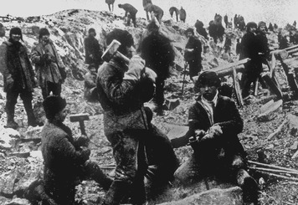
Just a year after the Great Purge began, more than 2 million people were being held in concentration camps. Most of these camps were located in far north Siberia near the Arctic Circle. In 1937 and 1938, the secret police set up special courts that tried people and sentenced them to death before their arrest. Hundreds of thousands were executed in this manner and were buried in secret mass graves.
By the time the Great Purge ended around 1940, nearly half of the Communist Party’s 2.3 million members had been executed or had died in concentration camps. About 4.5 million members of the general public met a similar fate.
Many supporters of communism put their faith in the Soviet experiment. However, Stalin’s rule proved that communism was far from an ideal solution to the problems of capitalist society. When Stalin destroyed economic and personal rights and freedoms to meet the needs of the state, communism became just another type of totalitarianism. Today, the term “Stalinism” is still used to describe brutal totalitarian rule.

Summary
In this lesson, you learned about the rise of totalitarian governments in the 1920s and 1930s. The years between World War I and World War II were marked by fascist and totalitarian government on an unprecedented scale.
Cultural Interaction Mussolini, Hitler, Franco, and Stalin all promised to restore order to their nations and return them to greatness. None had any respect for democracy or individual freedoms. Many citizens came to agree with these leaders that a strong nation was more important than individual rights.
Political Systems In Spain, Italy, and Germany, democratic governments were unable to restore stability or prosperity after chaos caused by war. In Italy, Mussolini overthrew the government by threatening to use force. Hitler used Germany’s democratic system to take power. In Spain, Franco gained power by defeating the elected government in a civil war. All three leaders used violence and terror against their people to secure their hold on power. Democracy never existed in the Soviet Union, but Stalin used similar brutality to gain total control of the ruling Communist Party and the nation.
Economic Systems Under both Mussolini and Stalin, government was involved in managing the nation’s economy. Mussolini created corporations in which workers and owners were forced to cooperate in setting wage, price, and production levels that the government had to approve. In Stalin’s communist state, the government owned all means of production and determined what and how much would be produced. Nazi Germany exercised less direct economic control. Both Hitler and Mussolini launched large public works programs to ease unemployment that resulted from the Great Depression. Hitler also used economic weapons and tools in his brutal campaign to persecute Germany’s Jews.

