Unit 5-The Decline of Feudalism

1. Introduction
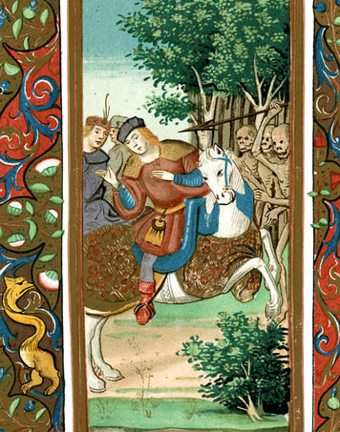
In this lesson, you will explore key events that contributed to the decline of feudalism. This decline took place in Europe from the 12th through the 15th centuries.
There were many causes for the breakdown of the feudal system. In this lesson, you will focus on three: political changes in England, a terrible disease, and a long series of wars.
In England, several political changes in the 12th and 13th centuries helped to weaken feudalism. A famous document known as Magna Carta, or Great Charter, dates from this time. Magna Carta was a written legal agreement that limited the king’s power and strengthened the rights of nobles. As feudalism declined, Magna Carta took on a much broader meaning and contributed to ideas about individual rights and liberties in England.
The terrible disease was the bubonic plague, or Black Death. The plague swept across Asia in the 1300s and reached Europe in the late 1340s. Over the next two centuries, this terrifying disease killed millions in Europe. It struck all kinds of people—rich and poor, young and old, town dwellers and country folk. Almost everyone who caught the plague died within days. In some places, whole communities were wiped out. The deaths of so many people led to sweeping economic and social changes.
Lastly, between 1337 and 1453, France and England fought a series of battles known as the Hundred Years’ War. This conflict changed the way wars were fought and shifted power away from feudal lords to monarchs and the common people.
How did such different events contribute to the decline of feudalism? In this lesson, you will find out.

Themes
Cultural Interaction Feudal culture declined as new military technology reduced the importance of castles and feudal lords.
Political Structures Reforms in England and the Hundred Years’ War weakened the nobility and strengthened the power of both the monarchy and the common people.
Economic Structures The plague caused trade and commerce to slow, and the feudal model of agricultural production was undermined as peasants gained greater opportunities.
Social Structures The hierarchical structures of feudal society were challenged by war and disease as the common people gained influence throughout this period.
Human-Environment Interaction The bubonic plague spread from Asia to western Europe and caused mass death along the way.

2. Political Developments in England
There were many reasons for the decline of feudalism in Europe. In one country, England, political developments during the 12th and 13th centuries helped to weaken feudalism. The story begins with King Henry II, who reigned from 1154 to 1189.
Henry II’s Legal Reforms Henry made legal reform a central concern of his reign. For example, he insisted that a jury formally accuse a person of a serious crime. Cases were then tried before a royal judge. In theory, people could no longer simply be jailed or executed for no legal reason. There also had to be a court trial. These reforms strengthened the power of royal courts at the expense of feudal lords.
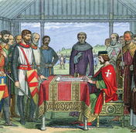
Henry’s effort to strengthen royal authority led to a serious conflict with the Catholic Church. In the year 1164, Henry issued the Constitutions of Clarendon, a document that he said spelled out the king’s traditional rights. Among them was the right to try clergy accused of serious crimes in royal courts, rather than in Church courts.
Henry’s action led to a long, bitter quarrel with his friend, Thomas Becket, the archbishop of Canterbury. In 1170, four knights, perhaps seeking the king’s favor, killed Becket in front of the main altar of Canterbury Cathedral. The cathedral and Becket’s tomb soon became a popular destination for pilgrimages. In 1173, the Catholic Church proclaimed him a saint. Still, most of the Constitutions of Clarendon remained in force.
King John and Magna Carta In 1199, Henry’s youngest son, John, became king of England. John soon made powerful enemies by losing most of the lands the English had controlled in France. He also taxed his barons heavily and ignored their traditional rights, arresting opponents at will. In addition, John quarreled with the Catholic Church and collected large amounts of money from its properties.
In June 1215, angry nobles forced a meeting with King John in a meadow called Runnymede, beside the River Thames, outside of London. There, they insisted that John put his seal on a document called Magna Carta [Magna Carta : a written legal agreement signed in 1215 that limited the English monarch’s power] which means “Great Charter” in Latin.
Magna Carta was an agreement between the nobles and the monarch. The nobles agreed that the monarch could continue to rule. For his part, King John agreed to observe common law and the traditional rights of the nobles and the Church. For example, he promised to consult the nobles and the Church archbishops and bishops before imposing special taxes. He also agreed that “no free man” could be jailed except by the lawful judgment of his peers or by the law of the land. This idea eventually developed into a key part of English common law known as habeas corpus [habeas corpus : the legal concept that an accused person cannot be jailed indefinitely without being charged with a crime] (HAY-be-us KOR-pus).
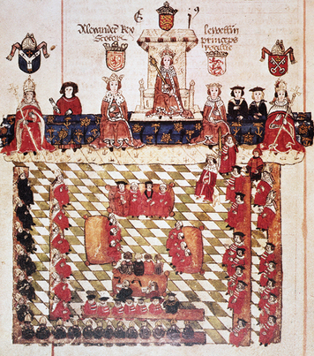
In many ways, Magna Carta only protected the rights and privileges of nobles. However, as time passed, the English people came to regard it as one of the foundations of their rights and liberties.
King Edward I and the Model Parliament In 1295, Edward I, King John’s grandson, took a major step toward including more people in government. Edward called together a governing body called the Model Parliament [Model Parliament : a governing body created by King Edward I that included some commoners, Church officials, and nobles] . It included commoners and lower-ranking clergy, as well as high-level Church officials and nobles.
The Impact of Political Developments in England These political changes contributed to the decline of feudalism in two ways. Some of the changes strengthened royal authority at the expense of the nobles. Others weakened feudalism by eventually shifting some power to the common people.
Magna Carta established the idea of rights and liberties that even a monarch cannot violate. It also affirmed that monarchs should rule with the advice of the governed. Henry II’s legal reforms strengthened English common law and the role of judges and juries. Finally, Edward I’s Model Parliament gave a voice in government to common people, as well as to nobles. All these ideas formed the basis for the development of modern democratic institutions.

3. The Bubonic Plague
You have learned how political developments in England helped to weaken feudalism in that country. Another reason for the decline of feudalism was the bubonic plague [bubonic plague: a deadly contagious disease caused by bacteria and spread by fleas; also called the Black Death] which affected all of Europe. The bubonic plague first struck Europe from 1346 to 1351. It returned in waves that occurred about every decade into the 15th century, leaving major changes in its wake.
Historians think the plague began in Central Asia, possibly in China, and spread throughout China, India, the Middle East, and then Europe. The disease traveled from Central Asia to the Black Sea along the Silk Road (the main trade route between Asia and the Mediterranean Sea). It probably was carried to Italy on a ship. It then spread north and west, throughout the continent of Europe and to England.
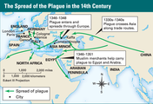
The Black Death Symptoms, or signs, of the plague included fever, vomiting, fierce coughing and sneezing fits, and egg-sized swellings or bumps, called buboes. The term “Black Death” probably came from these black-and-blue swellings that appeared on the skin of victims.
The dirty conditions in which people lived contributed significantly to the spread of the bubonic plague. The bacteria that cause the disease are carried by fleas that feed on the blood of infected rodents, such as rats. When the rats die, the fleas jump to other animals and people. During the Middle Ages, it was not unusual for people to go for many months without a change of clothing or a bath. Rats, covered with fleas, often roamed the floors of homes looking for food. City streets were filled with human waste, dead animals, and trash.
At the time, though, no one knew where the disease came from or how it spread. Terrified people falsely blamed the plague on everything from the positions of the planets to lepers and to Jews.
Persecution of the Jews did not begin with the plague. Prejudice against Jews had led the English government to order all Jews to leave the country in 1290. In France, the same thing happened in 1306 and again in 1394. But fear of the plague made matters worse. During the Black Death, many German cities ordered Jews to leave.
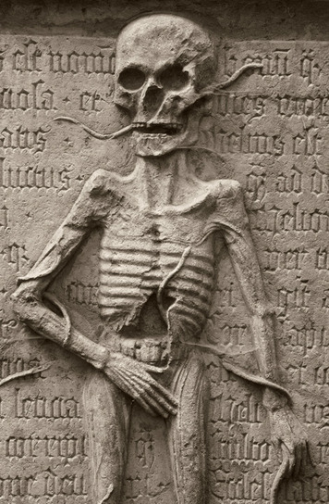
The Impact of the Plague The plague took a terrible toll on the populations of Asia and Europe. China’s population was reduced by nearly half between 1200 and 1393, probably because of the plague and famine. Travelers reported that dead bodies covered the ground in Central Asia and India.
Some historians estimate that 24 million Europeans died of the plague—about a third of the population. The deaths of so many people speeded changes in Europe’s economic and social structure, which contributed to the decline of feudalism.
Trade and commerce slowed almost to a halt during the plague years. As Europe began to recover, the economy needed to be rebuilt. But it wouldn’t be rebuilt in the same way, with feudal lords holding most of the power.
After the plague, there was a shift in power from nobles to the common people. One reason for this was a desperate need for workers because so many people had died. The workers who were left could, therefore, demand more money and more rights. In addition, many peasants and some serfs abandoned feudal manors and moved to towns and cities, seeking better opportunities. This led to a weakening of the manor system and a loss of power for feudal lords.
After the plague, a number of peasant rebellions broke out. When nobles tried to return things to how they had been, resentment exploded across Europe. There were peasant revolts in France, Flanders, England, Germany, Spain, and Italy.
The most famous of these revolts was the English Peasants’ War in 1381. The English rebels succeeded in entering London and presenting their demands to the king, Richard II. The leader of the rebellion was killed, however, and after his death, the revolt lost momentum. Still, in most of Europe, the time was coming when serfdom would end.

4. The Hundred Years’ War
Between 1337 and 1453, England and France fought a series of battles for control over lands in France. Known as the Hundred Years’ War [Hundred Years’ War: a series of battles fought between France and England from 1337 to 1453] this long conflict contributed to the erosion of feudalism in England and in France.
English monarchs had long claimed lands in France. This was because earlier English kings had actually been feudal lords over these French fiefs. French kings now disputed these claims. When Philip VI of France declared that the French fiefs of England’s King Edward III were part of Philip’s own realm, war broke out in France.
Early English Successes Despite often being outnumbered, the English won most of the early battles of the war. What happened at the Battle of Crécy (KRAY-see) shows why.
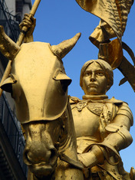
Two quite different armies faced each other at the French village of Crécy in 1346. The French had a feudal army that relied on horse-mounted knights. French knights wore heavy armor, and they could hardly move when they were not on horseback. Their weapons were swords and lances. Some of the infantry, or foot soldiers, used crossbows, which were effective only at short ranges.
In contrast, the English army was made up of lightly armored knights, foot soldiers, and archers armed with longbows. Some soldiers were recruited from the common people and paid to fight.
The longbow had many advantages over the crossbow. Larger arrows could be fired more quickly. The arrows flew farther, faster, and more accurately, and could pierce the armor of the time. At Crécy, the longbow helped the English defeat the much larger French force.
The French Fight Back The French slowly chipped away at the territory the English had won in the early years of the war. In 1415, after a long truce, English King Henry V again invaded France. This time, the English met with stronger resistance. One reason was that the French were now using more modern tactics. The French king was recruiting his army from commoners, paying them with money collected by taxes, just as the English did.
Another reason for increased French resistance was a new sense of national identity and unity. In part, the French were inspired by a 17-year-old peasant girl, known today as Joan of Arc. Joan claimed that she heard the voices of saints urging her to save France. Putting on a suit of armor, she went to fight.
In 1429, Joan led a French army to victory in the Battle of Orléans (OR-lay-uhn). The next year, the “Maid of Orléans” was captured by English allies. The English pushed certain Church leaders to accuse Joan of being a witch and a heretic [heretic: a person who holds beliefs that are contrary to a set of religious teachings] and to burn her at the stake.
Joan of Arc’s heroism changed the way many French men and women felt about their king and nation. Twenty-two years after Joan’s death, the French finally drove the English out of France. Almost 500 years later, the Roman Catholic Church made Joan a saint.
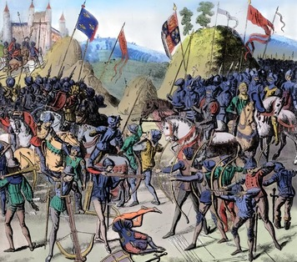
The Impact of the Hundred Years’ War The Hundred Years’ War contributed to the decline of feudalism by helping to shift power from feudal lords to monarchs and to common people. During the struggle, monarchs on both sides had collected taxes and raised large professional armies. As a result, kings no longer relied as much on nobles to supply knights for the army.
In addition, changes in military technology made the nobles’ knights and castles less useful. The longbow proved to be an effective weapon against mounted knights. Castles also became less important as armies learned to use gunpowder to shoot iron balls from cannons and blast holes in castle walls.
The new feeling of nationalism also shifted power away from lords. Previously, many English and French peasants felt more loyalty to their local lords than to their monarch. The war created a new sense of national unity and patriotism on both sides.
In both France and England, commoners and peasants bore the heaviest burden of the war. They were forced to fight and to pay higher and more frequent taxes. Those who survived the war, however, were needed as soldiers and workers. For this reason, the common people emerged from the conflict with greater influence and power.

Summary
In this lesson you learned about the decline of feudalism in Europe in the 12th to 15th centuries. The major causes of this decline included political changes in England, disease, and wars.
Cultural Interaction The culture of feudalism, which centered on noble knights and castles, declined in this period. The spread of new military technologies such as the longbow and cannon made the armored knight and fortified castle less important. The disaster of the plague influenced culture, causing some to celebrate life in the face of mass death. Others had the opposite reaction and fixated on death and the afterlife, which was reflected in art.
Political Structures In England the signing of Magna Carta and other political reforms laid the foundations for more democratic forms of government. The Hundred Years’ War between France and England shifted power away from feudal lords to both the monarchy and the common people. It also increased feelings of nationalism, as people began to identify more with the king than with their local lord.
Economic Structures The feudal system of agriculture and land ownership declined in this period. The plague caused trade and commerce to slow. Due to the death of one third of the population of Europe from the plague, labor shortages occurred. This created greater economic opportunities for peasants, and they demanded increased wages.
Social Structures The hierarchical social structure of feudalism was destabilized as a result of the plague, which affected all social classes equally. When the plague passed and feudal lords attempted to reestablish their authority, peasant rebellions occurred as commoners refused to accept the old social order. The common people also gained greater power as a result of the Hundred Years’ War.
Human-Environment Interaction The bubonic plague spread over trade routes from Asia to western Europe and killed one third of the population of Europe. Its spread was aided by the fact that most people lived in unhygienic conditions at this time, especially in the cities. In the wake of the plague many peasants left their manors for greater opportunities in the cities.

