Name:________________________________________________Date_________

What is History?

Section 1 - Introduction
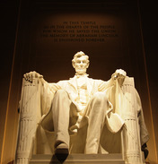
More than 200,000 people gathered at the Lincoln Memorial in
Washington, D.C., on a hot August day in 1963. There they heard Reverend Martin Luther King Jr. give one of the most powerful speeches in U.S. history. His "I have a dream" speech was a watershed event of the civil rights movement.
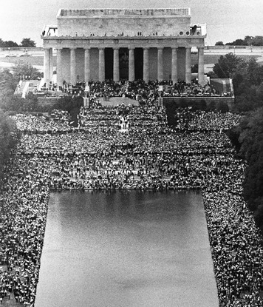
Flip Schulke/Corbis
Martin Luther King Jr. speaking from the Lincoln Memorial in 1963

MAWHYYOUARE/Shutterstock
Abraham Lincoln, the 16th president of the United States, remains one of the most honored leaders in American history. Lincoln is best remembered for holding the nation together through the Civil War and helping end slavery.

By speaking on the steps of the memorial, King underscored the historical connection between the civil rights movement and President Abraham Lincoln's efforts to end slavery. In 1863, at the height of the Civil War, Lincoln had signed the Emancipation Proclamation, freeing slaves in Confederate states. Later that year, in his famous Gettysburg Address, Lincoln reminded the nation why slavery must end: "Fourscore and seven years ago," he began, "our fathers brought forth, upon this continent, a new nation, conceived in liberty and dedicated to the proposition that all men are created equal." The words of the Gettysburg Address are carved on a wall of the Lincoln Memorial.
Speaking a century later, King echoed Lincoln's words:
Five score years ago, a great American, in whose symbolic shadow we stand today, signed the Emancipation Proclamation. This momentous decree came as a great beacon light of hope to millions of Negro slaves who had been seared in the flames of withering injustice. It came as a joyous daybreak to end the long night of their captivity. But one hundred years later, the Negro still is not free. . .Now is the time to rise from the dark and desolate valley of segregation to the sunlit path of racial justice.
—Martin Luther King Jr., "I have a dream" speech, 1963
By beginning his speech with a reference to the past, King made the point that history matters. What happened long ago shapes how we live today. What he said next made another point: We are not prisoners of the past. If we can dream of a better tomorrow, it lies in our power to shape the history to come.

Section 2 - History: The Past and the Stories We Tell About It
The term history can mean several related things. It can refer to events in the past, as in the history of a family. It can also refer to the stories we tell about the past. In this way, just about anyone can be a historian, or someone who reconstructs and retells stories of the past. History is also an academic, or scholarly, discipline—like economics, physics, or mathematics—and is taught and studied in schools.
This chapter considers history in each of these dimensions: as the past, as stories about the past, and as an academic subject. Its main focus, however, is on the writing, or reconstruction, of history and on how historians do their work.
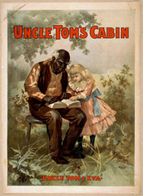
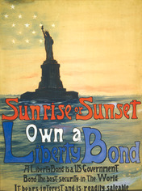
History Begins with a Question or Problem Historians begin their work with a question they hope to answer or a problem they wish to solve. For example, a historian might start with the question, Was the Civil War inevitable? Next, he or she gathers facts and information related to the question. This material becomes the evidence the historian uses to reconstruct the past. Evidence is information that can be used to prove a statement or support a conclusion.
_{Library of Congress}
In the 1850s, Uncle Tom’s Cabin was a best seller. Today it is read as a historical novel and a primary source of that time

Library of Congress: Posters from the past are today’s _{historical artifacts.}

Historical evidence can come in many forms. It might be an old letter or manuscript. Or it might be an artifact—a human-made object—such as a tool, a weapon, or part of a building. Evidence can also be found in photographs, recorded music, and old movies. And, of course, it can be found in books, magazines, and newspapers, as well as in interviews with experts or historical figures.
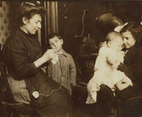
Historians refer to these various forms of information as sources. There are two basic types of sources on which historians typically rely when writing history. A primary source is a document or other record of past events created by people who were present during those events or during that period. An eyewitness account, such as a Civil War soldier's diary, is an example of a primary source.
Library of Congress
Photographs are visual primary sources that show what life was like in the past.

Examples of a secondary source include a book or commentary from someone who was not present at the events or perhaps not even alive during that period. Many secondary sources are created long after the events in question. One example is a book about the Civil War written in the 1990s.
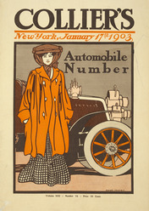
Historians Select and Weigh Evidence All historical evidence, whether primary or secondary, must be critically evaluated. Historians carefully examine each source for the creator's point of view, perspective, or outlook on events. This outlook may be shaped by many factors, such as the person's age, gender, religion, occupation, or political views. For example, a historian would expect that a southern plantation owner in the 1850s would have had a point of view different from that of a northern factory worker.
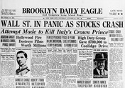
_{Library of Congress}
Magazine covers can reveal a lot about the cultural values of the years in which they were created.

_{FPG/Getty Images}
Newspapers provide historians with eyewitness accounts of past events.

Sometimes a source contains information or conclusions that reflect a distinct point of view. This is not necessarily a bad thing, but historians are careful to look for signs of bias when analyzing evidence. In general, bias is any factor that might distort or color a person's observations. Bias takes many forms, ranging from a simple friendship or preference for someone to an unfair dislike of a person or group. Whatever its form, bias can make a source less than trustworthy.
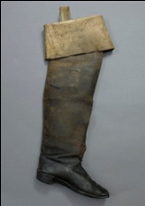
Historians Reconstruct and Interpret the Past Once their evidence is selected and evaluated, historians begin to reconstruct what happened. They often begin by establishing a chronology, or sequence of events in time. Once historians are certain of the correct order of events, they are better able to make connections among those events. They can identify causes and effects. They can also begin to look for long-range changes and trends that may have developed over many years or even decades. For example, in considering whether the Civil War was inevitable, a historian would examine the events leading up to the war. He or she would also look for points at which war might have been averted.
Library of Congress
Everyday artifacts, like John Wilkes Booth’s boot, help connect us to the lives of historical figures.

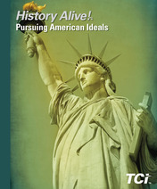
General histories like this book help readers develop a broad view of the past.
When writing history, historians do not focus only on facts or chronologies. If they did, history books would be little more than a chronicle, or a simple listing, of what happened year by year. The more challenging part of a historian's task is to interpret the past—to weave together the evidence and produce a story that helps readers understand and draw meaning from history.
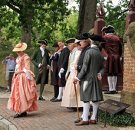
Andrew F. Kazmierski / Shutterstock.com
Historical interpreters bring history to life at living museums, such as Colonial Williamsburg.
The process of finding the meaning or significance of historical events is called historical interpretation. By interpreting history, historians add their analysis of events to the facts they have judged to be true. They consider not only what happened, but also how and why it happened and what effect it had on the people involved. They also consider how those events may have shaped the world today. Each historian brings a particular point of view to this task. At the same time, historians try to ensure that their interpretations are faithful to the facts of history and are supported by the evidence.
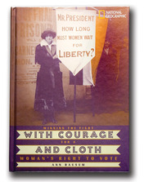
Specialized histories, such as this book, provide in-depth information about a specific subject.
History Is Never Finished History is not science, and it cannot be rigorously tested and proved. Much of history is still open to interpretation. Because historians have their own distinct backgrounds and points of view, their historical interpretations will often differ. They publish their work with the understanding that it will be reviewed, and often criticized, by other historians.
In this way, history continues to be debated and revised. In fact, some people describe history as an ongoing argument about the
Specialized histories, such as this book, provide in-depth information about a specific subject.
past. Differences of opinion about how to interpret the past make the academic study of history interesting and vital. This public debate also makes it possible for mistakes made by one historian to be corrected by later historians.
With each new generation of historians come new arguments. As historian Frederick Jackson Turner once wrote, "Each age tries to form its own conception of the past. Each age writes the history of the past anew with reference to the conditions uppermost in its own time." In other words, our understanding of the past is always being shaped by what we, in the present day, bring to it. In that sense, history is never finished.

US HISTORY

Name___________________________________Date______________

Use the information from the reading and define the following terms.
• Primary source

• Secondary source

• Point of view

• Historical Interpretation

Section 3 - Why Study History?
_{Jose Gil / Shutterstock.com}
Voting may not seem like making history, but each time Americans cast ballots, they are shaping the history their grandchildren will read about in school. Studying history can develop the critical-thinking skills that will help you make good decisions when you vote.

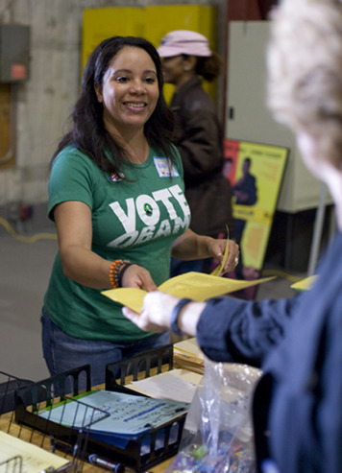
"History is more or less bunk!" said automobile industrialist Henry Ford in a 1916 interview. They were words he would live to regret. Not only was Ford making history by putting Americans into cars they could afford, but he also discovered that learning about the past was fun. Ultimately, he used much of his fortune to create a collection of historic buildings and everyday objects from his era. "We're going to build a museum that is going to show industrial history," he announced when he began his collection, "and it won't be bunk." The result was the largest indoor-outdoor museum in the world.
For the more than 1 million people who visit the Henry Ford Museum and Greenfield Village in Dearborn, Michigan, each year, history is anything but bunk. As visitors wander through Greenfield Village, they can imagine what life was like more than a century ago. Re-creations of Thomas Edison's workshop and the Wright brothers' bicycle shop bring visitors face to face with the excitement and frustration of inventing a light bulb or an airplane. By touring the automobile collection, visitors learn how this machine has changed our world. Just as Ford had hoped, seeing the past his way is highly entertaining. But that is only one reason to study history.
History Helps Us Develop Empathy for Others Studying history can help us develop empathy for others. Empathy is the ability to imagine oneself in another's place and to understand that person's feelings, desires, ideas, and actions. It involves more than just feeling sympathy for other people. Empathy also enables one to "walk in other people's shoes"—to feel "with" them or "as one" with them.
History makes us aware of problems, sorrows, joys, and hardships faced by people in other times and places. As that awareness grows, we have a better chance of understanding our own experiences—both good and bad. We also become more skilled at empathizing with people whose lives are different from our own. As we mature, empathy becomes a useful guide in our relations with other people. As the American writer Robert Penn Warren observed,
History cannot give us a program for the future, but it can give us a fuller understanding of ourselves, and of our common humanity, so that we can better face the future.
—Robert Penn Warren, The Legacy of the Civil War, 1961
As Henry Ford discovered when he set out to create a history museum, learning about the past can be fun. It can also help you develop empathy by introducing you to a wide range of human experiences. In this history classroom, students are learning what it was like to be an immigrant trying to enter the United States through Ellis Island around 1900.
History Makes Us Better Thinkers "History is a Greek word," wrote British historian Arnold Toynbee, "which means, literally, just investigation." The process of investigating what happened long ago involves analyzing evidence and making judgments about what sources are credible. It also requires evaluating different points of view about what is important and why.
These are all essential critical-thinking skills, not just in the history classroom but also in life. You will need to exercise these skills whenever you make an important decision about your own future. These skills will also help you make more informed decisions about public issues as a citizen and voter.
History Teaches Us to Avoid Errors of the Past A century ago, Spanish philosopher George Santayana proposed another reason for studying history: "Those who cannot remember the past are condemned to repeat it." History is full of examples of failed peoples and nations, and the study of history can reveal what they did—or did not do—that contributed to their doom. Looking at the failures of the past, novelist Maya Angelou wrote, "History, despite its wrenching pain, cannot be unlived, but if faced with courage, need not be lived again."
The more we learn today about the errors of the past, the better chance we have of avoiding them in the future. Viewed in this way, observed writer Norman Cousins, "history is a vast early warning system."
History Is Interesting "At the heart of good history," wrote screenwriter and journalist Stephen Schiff, "is a naughty little secret: good storytelling." And he should know. For decades, screenwriters and moviemakers have mined history for good stories and brought them to life on screen. Even movies that do not seem particularly historical are often based in part on historical events or settings. Knowing about the history behind these stories can increase your enjoyment of such films.
At a deeper level, figuring out the what and why of historical events is a lot like solving a puzzle or a mystery. Figuring out what happened can be challenging enough. Deciding what is important and why is even more of a challenge. Even so, anyone can do this detective work. And the more of the mystery of history you solve, the more alive the past will become for you.

